This assignment was originally created by Joey Lee and altered by SH and AS for 2016.

Assignment:
We've gone through the whole data viz pipeline and now you're equipped with a bunch of code to fetch some data, do some stuff with it, and then visualize it. It's time to go off-roading and learn how to tweak the code and workflow to a new dataset - the Vancouver Crime Data.

Data:
- Vancouver Crime Data: the original file was slightly altered for this assignment. The file for download is published on the course web site with this document.
- 250 m Hex Grid (Joey Lee generated this and you will copy it from his github site)

Web map requirements:
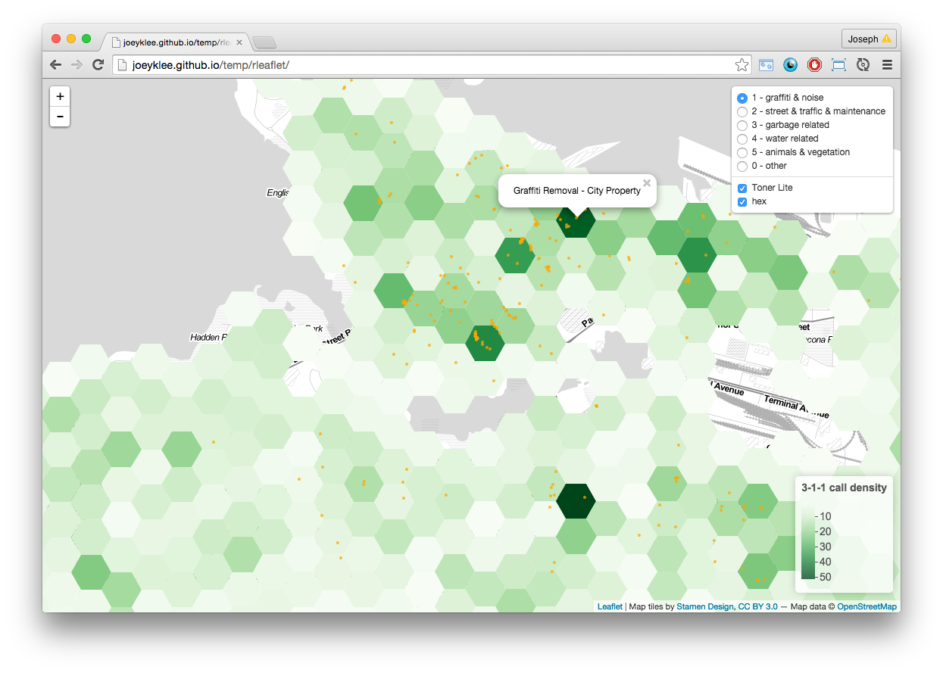
Using the skills you picked up from the last 2 weeks, you will be assigned 1 year of data from 2003 to 2015 of crime data from the Vancouver Open Data Catalog and generate a visualization with the functionality of the interactive map above. Instead of the 3-1-1 call categories, you would imagine that crime types might fill their place.
Your web map will include:
- toggle-able point layers for the different crime types (feel free to classify the different crimes into groups if you can justify it)
  - with a popup on click
- a toggle-able polygon layer for the crime density for your year using the hex bin.
  - a legend showing the scale of the crime densities.
  - with a popup on click
- suitable basemap tiles
- appropriate colors and point sizing

Deliverables:
- an .html file:
  - that you will export from R Studio and name it with this naming convention:
vancrimeYYYY_firstname_lastname.html
for example, Joey Lee would turn in:
vancrime2014_joey_lee.html
  - and email to Andras (aszeitz@gmail.com) and Sally (sally.hermansen@ubc.ca)
  - Unfortunately, you cannot post your html file on your wordpress blog for someone to run in wordpress. You can though post it for someone to copy and run it, and you can take screen shots of your interactive map to post! I know, this defeats the purpose but, at least gives readers a sense of what you have done, and they can copy the code and run it if they want.
- your code:
  - Generic Solution: Posted to your blog page using the pre tags in the html editor of your blog. In the html editor of your blog page you would type:
<pre> <!-- you need an opening pre tag -->

# install the leaflet library
devtools::install_github("rstudio/leaflet")

# add the leaflet library to your script
library(leaflet)

# initiate the leaflet instance and store it to a variable
m <- leaflet()

# we want to add map tiles so we use the addTiles() function - the default is openstreetmap
m <- addTiles(m)

# we can add markers by using the addMarkers() function
m <- addMarkers(m, lng=-123.256168, lat=49.266063, popup="T")

# we can "run"/compile the map, by running the printing it
print(m)

</pre> <!-- and a closing pre tag -->
  - For Wordpress: if you're using wordpress, you can simply wrap your code with these [code:language="r"][/code] commands on the visual editor,
[code language="r"]

# install the leaflet library
devtools::install_github("rstudio/leaflet")

# add the leaflet library to your script
library(leaflet)

# initiate the leaflet instance and store it to a variable
m <- leaflet()

# we want to add map tiles so we use the addTiles() function - the default is openstreetmap
m <- addTiles(m)

# we can add markers by using the addMarkers() function
m <- addMarkers(m, lng=-123.256168, lat=49.266063, popup="T")

# we can "run"/compile the map, by running the printing it
print(m)

[/code]
- A write up about your process and some insights from your visualization and a reflection on learning R and leaflet
Process:
- You will need to demonstrate that you understand each step of the process of the data visualization pipeline as it relates to the work you've done. For each chunk of code that you've written, you will need to explain in writing on your blog what each step is doing - imagine if you needed to go step by step with your methods to the City of Vancouver Open Data Department, how would you document each step? This is in addition to commenting your code.
    - After you finish creating the final data file to map, comment on: Understanding this data:
      - Lost records of data: How many records did you start with? After running the data through parsing and geocoding and filtering, how many values did you end up with?
      - Error: Do you think this is a lot or a little ‘error’? How reliable is this data?
      - File formats: What is the difference between a shape (shp), csv, excel, geojson file. Which one did you create? Why? Given an example of when you would use each file.
Visualization:
    - Discuss the following. Be creative and thoughtful in your responses.
      - cartographic design: What are the cartographic constraints you encountered?
      - Discuss some insights you've found in your visualization upon using it: the spatial distribution, the types of crimes, what other data might be useful in this context, the interactivity - is it useful or not, etc?
Reflection
    - You have experience with expensive proprietary software packages ArcGIS and Adobe Illustrator that are supported by the UBC geography labs. Reflect on these few weeks of learning enough of an open source tool, R and leaflet, to create this interactive map. In your reflection discuss pros and cons of proprietary software and FOSS.
- your data:
  - please send your processed .csv file with the lat/lon coordinates that your geocoded. Follow the naming convention below:
vancrimeYYYY_firstname_lastname.csv
so Joey Lee's would be:
vancrime2014_joey_lee.csv

Marking :
You will be marked on:
- successful submission of the .html file
- successful submission of your dataset as a .csv file that includes that lat/lon coordinates of your geocoding.
- your map aesthetics and functionality
- your code - well commented and runs
- your documentation - is your code well explained? do you demonstrate an understanding of the data viz process?
- your write up on the process, data and visualization - is your insight regarding the visualization thoughtful and justified?

Things to keep in mind:
- You can use R to make your final project!
- Comment your code and make sure it is clean and readable -and that it runs!

Sign up Sheet:
- 2015:
  - Tristan
  - Kiana
- 2014:
  - Jovita
  - Audrey
- 2013:
  - Cherry
  - Annie
- 2012:
  - Beth
  - Mana
- 2011:
  - Sydney
  - Romel
- 2010:
  - Christy
  - Jonathan
- 2009:
  - Shuchen
  - Cassidy
- 2008:
  - Melanie
  - Celeste
- 2007:
  - Katie
  - Grace
  - Allie
- 2006:
  - Kasper
  - Naiyu
- 2005:
  - Shinan
  - Matt
- 2004:
  - Karen
  - Rui Jerry
- 2003:
  - Ziyu
  - Stella

