Enhancing Continuous Support for Teaching Assistants at the UBC Department of Computer Science

For
Ms. Sharon Craddock
HR Manager, UBC Department of Computer Science
Ms. Michaela Butler
HR Administrator, UBC Department of Computer Science

By
Byung-Sun Park
ENGL 301 Student, University of British Columbia

March 29, 2023

Table of Contents

- Introduction …………………….…………………….……………….………....... 1
  - Definition of Teaching Assistantship …………………….………….…….….... 1
  - Background on Computer Science Teaching Assistantship …………….….…... 1
  - Main duties of Teaching Assistants at Department of Computer Science ..……. 1
  - Purpose of the Report ………………….………………………....…………...... 2
  - Research Methods …………………………………………………………...…. 2
  - Scope of Inquiry and Summary of Final Recommendations ………………...… 3

- Data ….………………….…………………….……………….………................... 4
  - Data Collection Process and Results …………………….……………….……. 4
  - Overview of Current Departmental Resources for Teaching Assistants ……….. 5
  - Studies of Teaching Assistants’ Perspectives ……….…………….……………. 7
  - Studies of Students’ Perspectives …….……………….……………….………. 8
  - Possible Solutions for Improvement …………………………………………… 9

- Conclusion ……………………………………………………………………….. 12
  - Summary and Overall Interpretation of Findings …………………………….. 12
  - Recommendations …………….………………………….……………............ 12
  - Limitations of the Study …….………………………….…….……….……..... 13

- Appendix ……………….……………….………........…………….…………….. 14
- Works Cited …….………........…………….………….………........…………..... 15

List of Figures

Figure 1. Importance of Support for Teaching Assistants .................................................... 6
Figure 2. Status of Current Resources for Teaching Assistants ........................................... 7
Figure 3. Limitations of Current Resources for Teaching Assistants ................................... 8
Figure 4. Importance of TAs in the Learning Process ......................................................... 9
Figure 5. Lack of Feedback from Students .......................................................................... 9
Figure 6. Opinions on regular one-on-one meetings with instructors ................................ 10
Figure 7. Opinions on Mentor/Mentee Assignments ......................................................... 11

Abstract
[To be completed]

- Introduction

A. Definition of Teaching Assistantship
The teaching assistantship program at the University of British Columbia is a type of student appointment designed to provide support for delivering large undergraduate courses to students. Teaching assistants are individuals who are accredited undergraduate or graduate students with excellent knowledge of the contents of assigned courses.

B. Background on Computer Science Teaching Assistantship
According to the information provided by the UBC Computer Science department, there are currently 2,763 undergraduate students and 248 graduate students who major in Computer Science (“By the Numbers”). Furthermore, there are 16,029 registrations recorded for Computer Science (CPSC) courses offered by the department (“By the Numbers”). Compared to a large number of students in the department, there are only 65 tenured or tenure-streamed faculty members and 20 full-time and sessional lecturers who teach courses in the Computer Science department (“By the Numbers”). Therefore, the teaching assistantship program has played a crucial role in delivering large courses to resolve the gap between a large number of students and a limited number of instructors.

C. Duties of Teaching Assistants at the Department of Computer Science
Teaching assistants are involved in various aspects of course delivery such as leading weekly tutorial and lab sessions, holding office hours, invigilating exams, and grading assignments (“Policy for Teaching Assistantship”). In addition to providing teaching support to instructors, some teaching assistants are in charge of developing an auto-grading system and creating course content with help from the instructors for the specific course. Most undergraduate teaching assistants are appointed for 8 hours a week while most graduate teaching assistants are appointed for 12 hours a week in each semester (“Policy for Teaching Assistantship”).

D. Purpose of the Report
The purpose of this report is to provide suggestions for implementing regular support practices for teaching assistants to improve their performance and teaching skills throughout the term. Although there are training sessions in the first week and the performance review in the last week of the term, the department does not have an in-between support program for teaching assistants to continuously review and improve their performance and teaching skills throughout the term. Insufficient support for teaching assistants throughout the term can lead to inadequate performance and poor quality of course delivery. This report investigates and analyzes the current departmental resources and suggests recommendations to enhance regular support for teaching assistants at the UBC Department of Computer Science.

E. Methods of Research
The primary source of data for this report is the surveys with both students and teaching assistants from the department of Computer Science. In both surveys, an ethical introduction is included as a heading to indicate the purpose of the survey and let the participants know that the response to the survey is voluntary and anonymous. Details of the survey process and results are addressed in the Data Collection Process and Results part of the Data section.

F. Scope of Inquiry and Summary of Final Recommendations
F-1. Scope of Inquiry
The following five areas of inquiry are pursued in this report:
- How are teaching assistants involved in delivering computer science courses at UBC?
- Why do teaching assistants need departmental support?
- What are the limitations of resources for teaching assistants currently available at the department?
- What changes/additions can be made to current departmental resources for teaching assistants to ensure continuous improvement of the teaching quality of the courses?
- What are the potential benefits of implementing practices to provide continuous support to teaching assistants?

F-2. Summary of Final Recommendations
Based on investigations and analysis of the above areas of inquiry, this report suggests the following recommendations:
- Enhancing interaction between teaching assistants and instructors.
- Promoting interaction between teaching assistants to help each other efficiently.
- Implementing regular opportunities for students to provide a review of teaching assistants’ performance not only at the end but also in the middle of the term.

- Data

A. Data Collection Process and Results
The online survey questionnaires for the research were created and distributed using the UBC Survey Tool provided by Qualtrics, which complies with the BC Freedom of Information and Protection of Privacy Act (FIPPA) (“Survey Tool”). All responses to surveys were completely voluntary and anonymous.

A-1. Survey with Teaching Assistants
A survey was prepared for current and former teaching assistants to investigate and analyze the status of current departmental resources available for teaching assistants. The online survey questionnaire was distributed to the current teaching assistants in five Computer Science courses: CPSC 103, CPSC 110, CPSC 221, CPSC 304, and CPSC 310. A total of 7 responses from teaching assistants were collected between March 21st and March 28th, 2023.

A-2. Survey with Computer Science Students
A survey was prepared for students who have registered in at least one Computer Science course to gather various perspectives and experiences with the role of teaching assistants in the learning process. The online survey questionnaire was distributed to both students in Computer Science major registered in upper-level CPSC courses and students from other departments registered in lower-level CPSC courses as electives. A total of 22 responses from students were collected between March 21st and March 28th, 2023.

B. Overview of Current Departmental Resources for Teaching Assistants
B-1. The Expectation for Quality Teaching by Teaching Assistants
All teaching assistants at the Computer Science department are expected to meet the expectations for quality teaching. The department’s expectation for quality teaching of teaching assistants includes a solid knowledge of the course contents to teach, strong communication skills in English to deliver the course content effectively, and organization skills to be well-prepared for each session in advance (“Policy for Teaching Assistantship”). However, Teaching assistants may not always be familiar with the specific course logistics and teaching methods. Furthermore, most teaching assistants are graduate and undergraduate students who do not have a background in teaching. Therefore, it is important that the department can provide regular support to help teaching assistants meet the expectations for quality teaching throughout the term.

B-2. Importance of the Departmental Support for Teaching Assistants
From the survey with teaching assistants, 28.57% of the participants answered that support from the department throughout the term is very important, and 71.43% of the participants answered that it is somewhat important to ensure the quality of teaching. There are no participants who answered that departmental support is not important at all. The result of the survey question implies that support from the department plays important role in ensuring the quality of teaching of the teaching assistants.

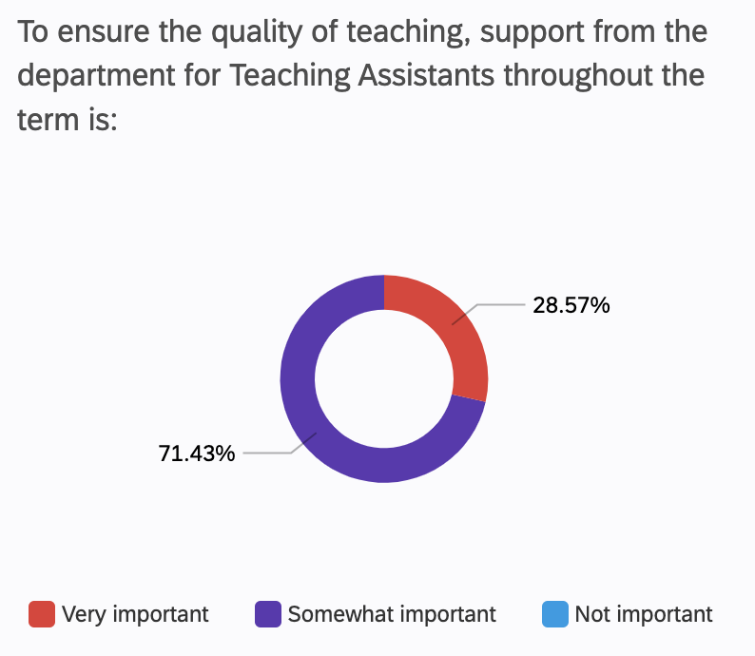
Figure 1. Importance of Support for Teaching Assistants

B-3. Status of Current Support Resources Available for Teaching Assistants
From the survey with teaching assistants, 85.71% of the participants answered that the current resources available for supporting teaching assistants from the department are somewhat helpful but there is room for improvement. The remarkable fact of the result is that only 14.29 % of the participants answered current resources are not enough at all, and none of the participants answered the resources are complete and always helpful. The result implies that the majority of the teaching assistants utilize the departmental resources but there are limitations to current departmental resources. A detailed analysis of the limitations of current departmental resources is addressed in the next part of the Data section: Studies of Teaching Assistants’ Perspectives.

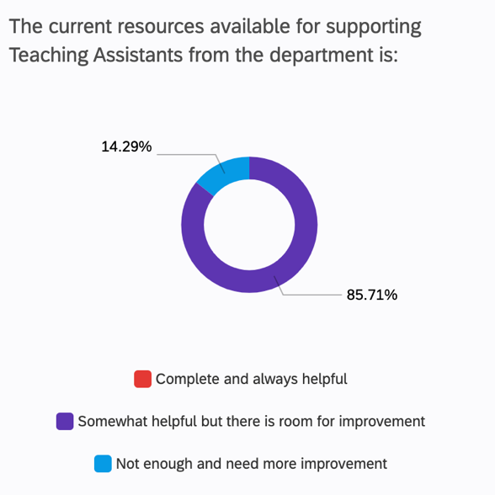
Figure 2. Status of Current Resources for Teaching Assistants

C. Studies of Teaching Assistants’ Perspectives
There are two major resources that the Computer Science department provides to teaching assistants: one is the training sessions in the first week of the term and the other is the performance review by the students in the last week of the term. However, there is no in-between departmental support program for teaching assistants to regularly review and improve performance and teaching skills throughout the term. From the survey with teaching assistants, 42.86% of the participants received enough feedback and support regularly while 57.14% of the participants needed more feedback and support regularly throughout the term. The result of the survey implies that more than half of teaching assistants need more feedback and support regularly between the training session in the first week and the performance review in the last week of the term.

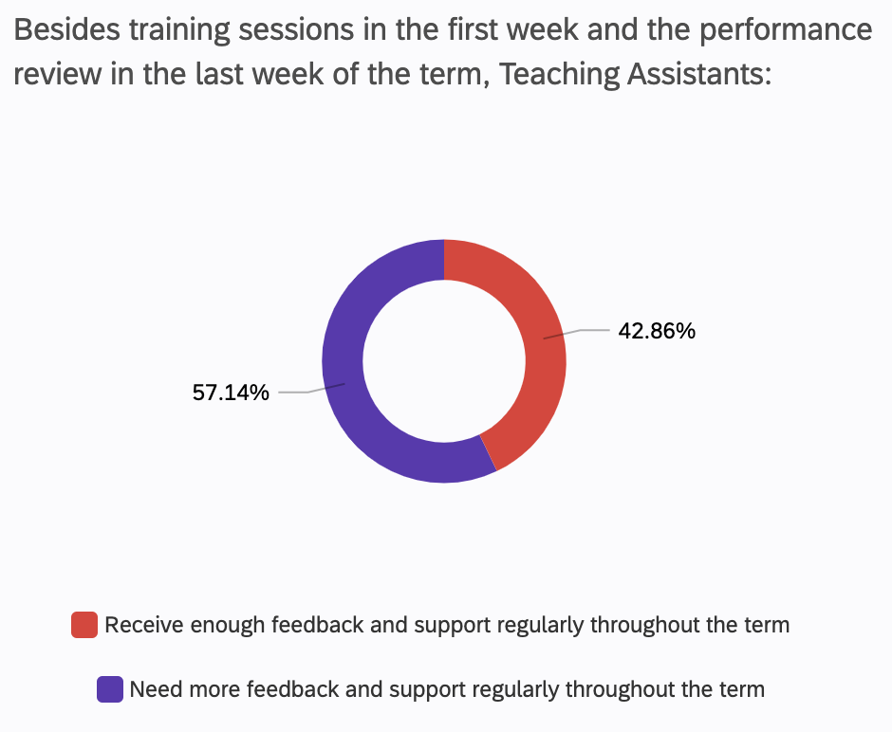
Figure 3. Limitations of Current Resources for Teaching Assistants

D. Studies of Students’ Perspectives
Teaching assistants directly interact with students in various parts of the course delivery. Besides lectures run by instructors, there are many other course components run by teaching assistants such as labs, tutorials, and TA office hours. Therefore, the performance of teaching assistants directly influences the learning quality of students. Inadequate performance and poor teaching skills of teaching assistants can result in the failure of delivering course content to students. From the survey with students, 77.27% of the participants answered that the involvement of teaching assistants is very important in the process of learning course materials. However, 59.09% of the participants answered that students do not have enough chances to provide feedback for teaching assistants besides the performance review in the last week of the term. The result of the survey implies that teaching assistants lack the opportunities to receive feedback from the students although the performance of the teaching assistants is crucial in the learning process of the students.

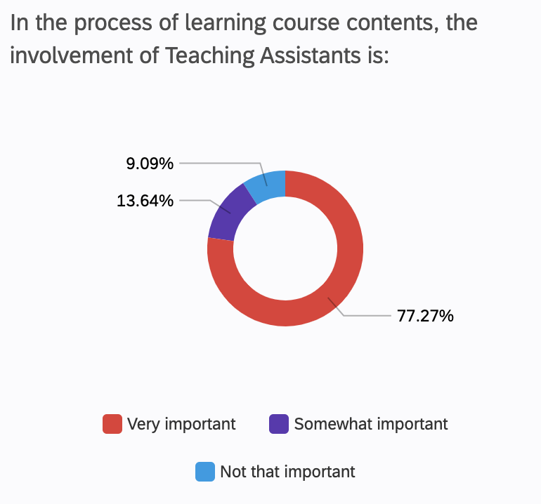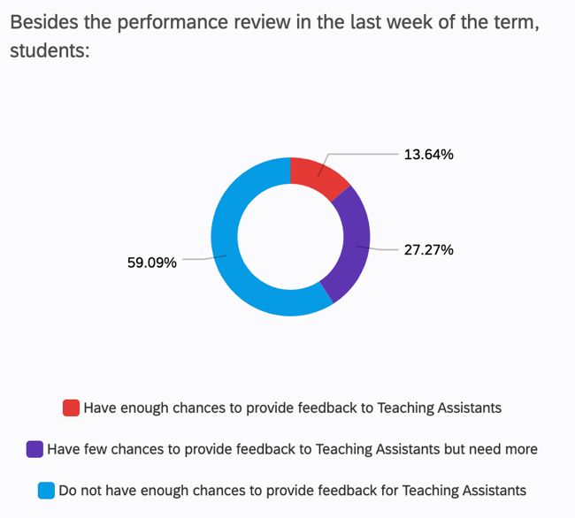
Figure 4. Importance of TAs in the Learning Process Figure 5. Lack of Feedback from Students

E. Possible Solutions for Improvement
E-1. Regular one-on-one meetings between teaching assistants and instructors
Most large courses offered at the Computer Science department are composed of two components: lecture sessions run by instructors and activities run by teaching assistants such as labs and tutorial sessions. To be fully prepared for interaction with students, teaching assistants need to keep track of the latest course content and logistics with supervision from instructors. Implementing regular one-on-one meetings can allow teaching assistants to review performance and address any concerns with the instructors. From the survey with teaching assistants, 28% of the participants answered that regular one-on-one meetings will be very helpful while 57.14% of the participants answered it will be somewhat helpful to enhance continuous support for teaching assistants. To make the one-on-one meeting process workable and cost-effective, teaching assistants can complete a survey prior to the meeting to summarize any concerns or questions to be discussed during the meeting.

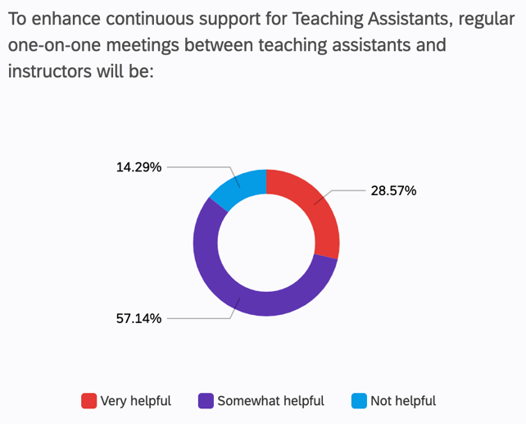
Figure 6. Opinions on regular one-on-one meetings with instructors

E-2. Mentor-mentee assignment between experienced teaching assistants and newly hired teaching assistants
Newly hired teaching assistants are expected to have a solid knowledge of the course content but may not have a background in teaching. Mentor assignments with experienced teaching assistants can help newly hired teaching assistants smoothen the onboarding experience and clarify to whom the questions should be addressed. From the survey with teaching assistants, 71.43% of the participants answered that mentor-mentee assignments between experienced and newly hired teaching assistants will be very helpful.

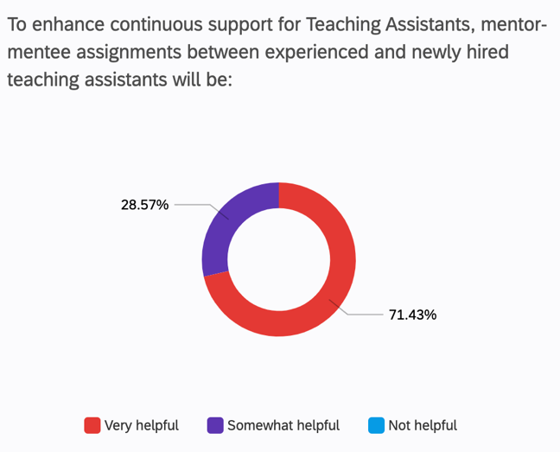
Figure 7. Opinions on Mentor/Mentee Assignments

- Conclusion

A. Summary and Overall Interpretation of Findings
The teaching assistants are involved in delivering large courses to students by providing instructional support to instructors at the department of Computer Science at UBC. The involvement of teaching assistants is crucial in the learning process of students. Therefore, adequate department support must be provided to teaching assistants to ensure the quality delivery of the courses. The findings of the study imply that the Computer Science department currently lacks continuous support for teaching assistants throughout the term despite training sessions in the first week and the performance review in the last week of the term. Continuous support throughout the term is important for teaching assistants to review performance regularly and improve teaching skills progressively. The findings of the study demonstrate that implementing new departmental practices to provide continuous support to teaching assistants is highly demanded by both students and teaching assistants.

B. Recommendations
Based on investigations and analysis of data collected from the surveys, the following recommendations can be suggested to enhance continuous support for teaching assistants at the UBC Department of Computer Science:
- Enhancing interaction between teaching assistants and instructors.
  - For example, regular one-on-one meetings between teaching assistants and instructors
- Promoting interaction between teaching assistants to help each other efficiently.
  - For example, mentor-mentee assignments between experienced teaching assistants and newly hired teaching assistants
- Implementing regular opportunities for students to provide a review of teaching assistants’ performance not only at the end but also in the middle of the term.

C. Limitations of the Study
[To be completed]

- Appendices
[To be completed]

- Works Cited

1. “By the Numbers.” Computer Science at UBC, 23 June 2020, https://www.cs.ubc.ca/about/numbers.
2. “Policy for Teaching Assistantship.” Computer Science at UBC, 25 Sept. 2017, https://www.cs.ubc.ca/students/grad/awards-financial-support/policy-teaching-assistantship.
3. “Survey Tool.” UBC Information Technology, 27 Mar. 2023, https://it.ubc.ca/services/teaching-learning-tools/survey-tool.

