Revising Library Procedures

Upon Prevention of Stress and Distractions

in UBC Libraries

for
Charlotte Lawson
Director of Development, Library Development
Irving K. Barber Learning Centre
University of British Columbia

by
Delsther James Edralin
English 301 Student

March 28, 2023
Table of Contents
Introduction 3
Background on UBC Library Policies and Procedures 3
An Overview of the Issues from Current Procedures 3
Purpose of the Report 3
Background on Library Practices that Focuses on User Experiences 3
Research Methods 4
Limitations of the Study 4
Scope of Inquiry 4
Conclusion of Inquiry 5
Data Section A: Student Perceptions on the Current and Revised Library Procedures 5
Library Usage Profile 5
Libraries and types of spaces frequently used and visited 5
Libraries usage frequency 6
Perceptions on Noise Level Quality 8
Perceptions on Privacy Quality 9
Perceptions on Closing Procedures 10
Opinions on the Current and Proposed Revisions for the Library Procedures 12
Data Section B: UBC Libraries and its Current Environment 14
Silent Study Areas in UBC Libraries 14
Closing Procedures 14
Data Section C: Case Studies of Possible Solutions 14
Research on Noise and Privacy Interventions by Policy, Layout, and Zoning Changes 14
Research on Sound Masking 15
Research on Library Support for Late Night Procedures 15
Research on Applying Visual Cues 16
Conclusion 16
Summary and Interpretation of Findings 16
Recommendations 17
References 18

Introduction

Background on UBC Library Policies and Procedures
The University of British Columbia (UBC) Library Policies and Procedures are established to follow the values of UBC Library’s Strategic Framework. The procedures are separated into categories to focus on the values of different aspects of the framework, such as sustaining an inclusive environment, protection, and preservation of the libraries’ properties, and building strong relationships with people. These procedures help the quality of the library spaces and resources for the students and researchers to use whenever they need it. Furthermore, the spaces are leaning on inclusivity and collaboration, which can help students prioritize their group assignments more productively.

An Overview of the Issues from Current Procedures
UBC Library Policies and Procedures are designed to promote inclusivity and collaboration, but unfortunately, their current practices surrounding the way the library is structured can cause stress and disruption for their users. The library's noise policies, study space layouts, and closing announcements may not be enough to create an environment that facilitates effective studying. Additionally, the library's focus on collaboration may lead to distractions for students who need to work on individual assignments or projects. As a result, these factors can negatively impact the user experience and academic success, which goes against the library's mission to support student learning.

Purpose of the Report
This report will explore the current state of stress and distractions in UBC libraries, identify specific procedures that may be contributing to these issues, and provide recommendations for how these procedures can be revised to better support the academic success and well-being of UBC students, faculty, and staff. The report aims to provide an evidence-based approach that can enhance the user experience and promote academic success while reducing stress and disturbances in UBC libraries.

Background on Library Practices that Focuses on User Experiences
To address the issues of stress and disturbance in UBC libraries, the libraries can adopt several strategies based on best practices and successful case studies. One approach is to revise noise policies with a focus on visual cues, such as color-coded signs on designated quiet areas, to clearly indicate noise levels and create a more consistent and enforceable policy. Another strategy is to adjust the layouts of study spaces to provide users with more private and comfortable areas for individual study or exam-taking. Finally, the library can explore new closing procedures that are less disruptive and more considerate of patrons, such as gradually dimming lights or using automated announcements. By implementing these changes, UBC libraries can create a more welcoming and productive environment that supports effective studying and enhances the user experience for all patrons.

Research Methods
An online survey was conducted among thirty-four UBC students in random by posting it on various student groups on Facebook, WhatsApp, and other social tools that students used. The survey was designed to analyze the perspective of students, researchers, and users of UBC Libraries on their current policies and procedures being practiced. In addition, case studies of other academic libraries that have implemented similar changes have been reviewed to understand the challenges and benefits of different practices of library procedures.

Limitations of the Study
The primary limitation of this study is the small range of primary data, as the survey is limited to UBC students. Therefore, the results may not be generalizable to other UBC Libraries that the survey results might not have experienced. Further research may be required to obtain a larger range of primary data and collect more accurate representations of user opinions on the current practices in UBC Libraries.

Scope of Inquiry
This report proposal will only focus on the feasibility of implementing revised library procedures at UBC Libraries and address the following questions:
- What are the current library procedures and practices of UBC libraries?
- How are the users experiencing the current library procedures of UBC libraries?
- What are the potential benefits and drawbacks of revising the procedures and practices of UBC libraries?
- How large is the size of the population that demands less stress and disturbances in UBC libraries? What is the demand to change the current procedures?
- What are the perspectives and possible challenges on implementing these revisions to the UBC Library Team that manages these procedures?
- What are the potential costs associated with implementing revised library procedures and practices, including expenses on hardware, software, and staff training?
The proposal will not address other issues or concerns related to library operations or services.

Conclusion of Inquiry
The report concludes by acknowledging the various benefits associated with revising the current library procedures to establish spaces that can enhance the user experience and academic success of their patrons.

Data Section A: Student Perceptions on the Current and Revised Library Procedures
This section reports survey responses from a random sample of UBC students and interprets their opinions on the current library procedures and environments focusing on their individual perceptions in: noise level quality, privacy quality, closing procedures, and overall experiences. Additionally, their perceived impact on revising those categories as well and their other suggestions are collected.

Library Usage Profile
Thirty-four respondents were asked to note what UBC Library they used, their time schedule, and frequency they use these libraries to accurately identify the which libraries are being evaluated by the survey answers in relation to the users’ experiences.

Libraries and types of spaces frequently used and visited
There were 112 responses from the 34 respondents on which libraries they have experience with. The respondents’ libraries they have the most usage is tabulated in order below:
- Irving K. Barber Learning Centre (28 responses)
- David Lam Management Research Library and Canaccord Learning Commons (19 responses)
- Music, Art & Architecture Library (19 responses)
- Woodward Library (19 responses)
- Koerner Library (18 responses)
Most of the respondents have used silent study spaces, amounting to 29 respondents, 24 respondents use group study spaces, and only 11 respondents use technology spaces. These responses suggest that the libraries tabulated above and the type of spaces they used will be reflected from the responses of the other aspect of the survey that evaluates their user experience.
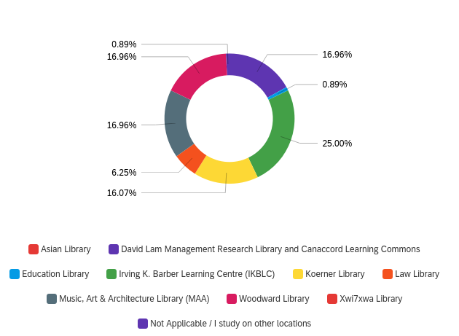
Figure 1. Survey responses on which UBC Libraries they use

Libraries usage frequency
This subsection determines the respondents time they use UBC Libraries, how long do they spend in a day, and how much do they visit in a week/month. Most responses visit at least on a weekly basis. Twelve out of 34 respondents visit 2-3 times a week (37.50%) , nine respondents visit 4-6 times a week (28.13%), and 6 respondents answered once a week (18.75%).
In terms of library usage timeframes, 27 out of 34 respondents visit in the afternoon (12 PM – 5 PM), 26 respondents visit at night (5 PM – 12 AM), and only four respondents go to libraries in the morning (7:30 AM – 12 PM). Most of the respondents use the UBC Libraries in 3-5 hours in one day (25 out of 34 respondents), followed by 19 respondents using it by 6-8 hours.
The collected data suggest that the sample of students may have an accurate response for the other aspects of the survey relative to their frequency of usage and the time they use UBC Libraries.
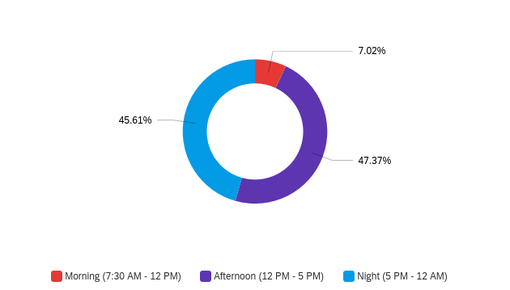
Figure 2. Survey responses on what time they use libraries

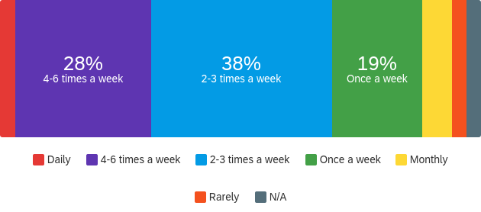
Figure 3. Survey responses on how much they use the libraries on a weekly/monthly basis

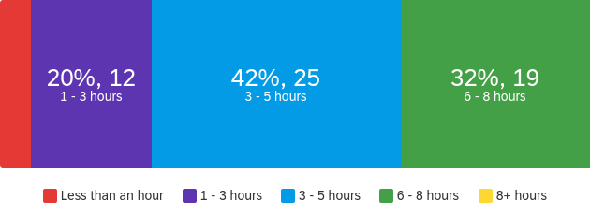
Figure 4. Survey responses on how much time they spend inside the libraries
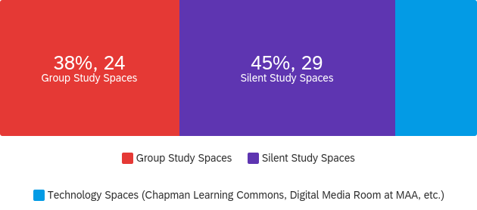
Figure 5. Survey responses on what type of spaces they use

Perceptions on Noise Level Quality
The findings suggest that the noise levels in UBC Libraries are perceived as largely distracting by most students, with only a very small proportion finding them pleasing. Specifically, 21 out of 34 respondents found the current noise levels to be distracting, while only 1 each found them very pleasing or pleasing.
In terms of finding quiet study spaces, a majority of respondents (20 out of 34) reported that it was either difficult or very difficult to find such spaces in the libraries, with only 2 finding it very easy or easy. 9 respondents were neutral on this question.
These suggest that the noise levels in UBC Libraries may need to be addressed in order to better accommodate students who seek a quieter study environment. Additionally, efforts could be made to improve the availability of quiet study spaces to better meet the needs of students seeking such environments.
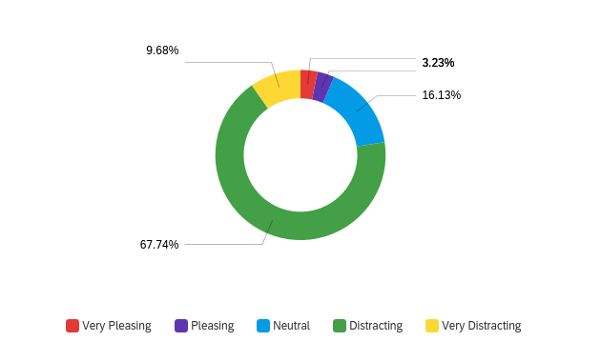
Figure 6. How the respondents find the current noise levels in libraries

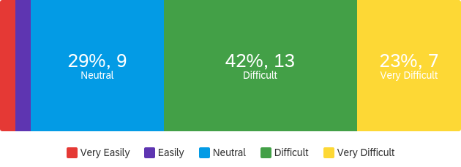
Figure 7. How the respondents easily find quiet study spaces

Perceptions on Privacy Quality
Privacy is an important consideration for students when studying in UBC Libraries, with most respondents (24 out of 34) indicating that it is either moderately, very, or extremely important to them. However, a significant number of respondents expressed dissatisfaction with their current level of privacy in the library environment, with 20 out of 34 reporting that they are either somewhat dissatisfied or extremely dissatisfied with their level of privacy.
Furthermore, a small proportion of respondents (2 out of 34) reported being somewhat satisfied with their level of privacy, while none were extremely satisfied. An additional 7 respondents did not provide an answer to the question on their satisfaction with privacy in the current library environment.
The results show that although privacy is valued by the majority of students, the current level of privacy in UBC Libraries may not be meeting their expectations. Efforts could be made to improve privacy measures and policies in the libraries to better address the concerns of the students. Additionally, encouraging more students to provide feedback on privacy issues may help identify areas for improvement and lead to a better understanding of their needs and expectations.
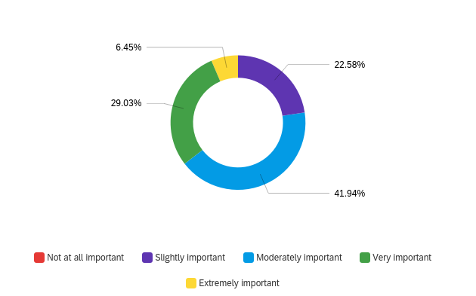
Figure 8. Respondents’ view on the importance of privacy on libraries
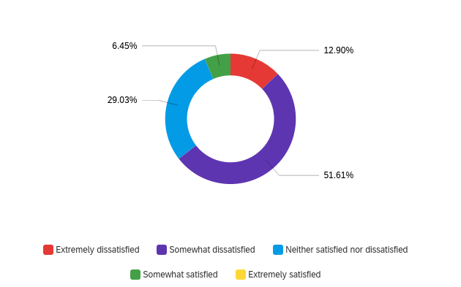
Figure 9. Respondents’ satisfaction of the current privacy level they have on libraries

Perceptions on Closing Procedures
It can be concluded that many students are currently being notified of the library's closing time through PA/aural or verbal announcement, while a significant proportion of them find the current closing procedures to affect their experience to some extent. Moreover, the majority of respondents prefer visual announcement as a means of notification for closing times in libraries.
Specifically, 20 out of 34 respondents indicated that they are either extremely affected or affected by the current closing procedures, while only 6 out of 34 reported being unaffected or very unaffected. Additionally, 20 out of 34 respondents preferred visual announcement as their preferred method of notification for closing times, while 8 out of 34 preferred verbal announcements, and 5 out of 34 preferred PA/aural announcement.
These findings suggest that incorporating more visible cues such as digital signage or alerts could improve the closing procedures in the libraries and provide a more positive experience for the students. Libraries could consider incorporating visual cues in addition to or in replacement of the current verbal and PA/aural announcements to better meet the students' preferences and improve their overall experience.
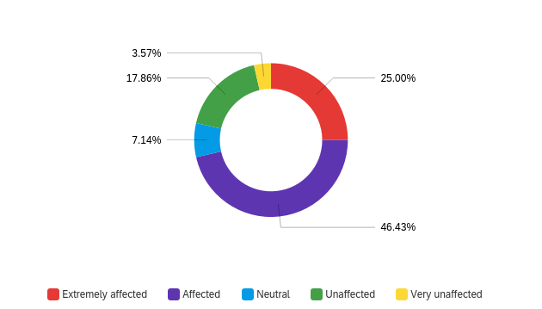
Figure 10. How affected are the respondents when they experience closing announcements
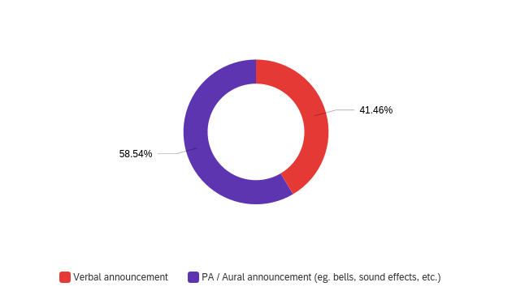
Figure 11. What type of announcements the respondents experience
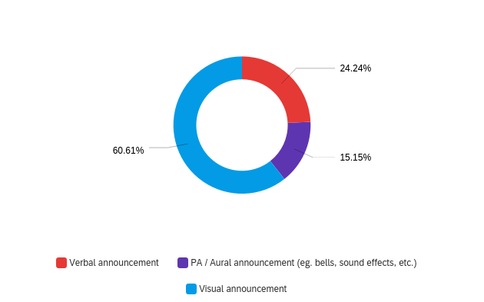
Figure 12. The respondents' preferred method of closing announcements

Opinions on the Current and Proposed Revisions for the Library Procedures
It can be concluded that most students are generally satisfied with their overall user experience at UBC Libraries. Although, most respondents showed support for revising the noise policies/procedures and changing the layout of study spaces in libraries to provide more privacy. Moreover, a significant proportion of respondents supported the idea of changing the closing procedures in libraries to be less disruptive.
Specifically, 13 out of 34 respondents reported being satisfied with their overall user experience at UBC Libraries, while 11 out of 34 indicated a neutral stance. Additionally, 25 out of 34 respondents showed support for revising the noise policies/procedures in libraries to be more responsive, while 21 out of 34 supported changing the layout of study spaces in libraries to provide more privacy. Furthermore, 19 out of 34 respondents supported changing the closing procedures in libraries to be less disruptive.
These findings suggest that students are generally receptive to revising the procedures in UBC Libraries to improve their overall experience. Specifically, incorporating changes to the noise policies/procedures and providing more privacy in study spaces were the most supported ideas among the respondents. Furthermore, changing the closing procedures in libraries to be less disruptive was also met with a significant level of support. Libraries could consider implementing these suggested changes to better meet the needs and preferences of the students and improve their overall experience.
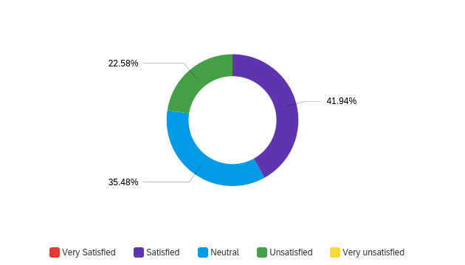
Figure 13. Overall experience in UBC Libraries
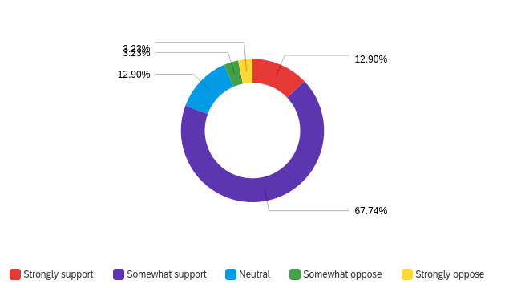
Figure 14. Respondents' support on revising noise policies to be more responsive
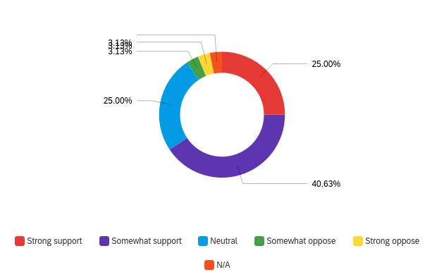
Figure 15. Respondents' support on revising the layout on study spaces to provide more privacy
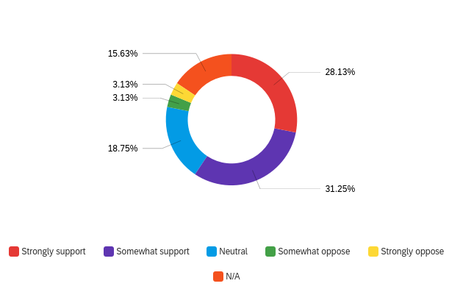
Figure 16. Respondents' support on revising closing procedures to be less disruptive

Data Section B: UBC Libraries and its Current Environment

Silent Study Areas in UBC Libraries
Silent study areas on nearly all UBC Libraries across campus are spaces where users are required to be respectful and keep unnecessary noise or distraction to a minimum. However, some of these spaces are not consistently monitored or there are visual or aural sources of distractions that can inhibit the students’ experiences.
One case study that portrays this issue is the Nass Reading Room in Irving K. Barber Learning Centre (IKBLC). The space was renovated to cater a silent study area with high dividers and dedicated individual-use spaces ("Nass Reading Room in IKBLC," 2021). However, there are two group study rooms (rooms 460 & 461) with glass partitions. These rooms create audible noises and visual distractions absorbed to the quiet study space and disrupts the users of the Nass Reading Room. The lack of not having other solutions for the noise being prevented also does not help the students that use this space.

Closing Procedures
The closing procedures in UBC Libraries vary from different locations, which makes some more disruptive than others. Following are some of the observed libraries and their procedures tabulated below:
- The IKBLC uses verbal announcements by the staff going around spaces and shuts lights off.
- The MAA Library, which is inside IKBLC, uses a PA announcement that can also be heard from other spaces in IKBLC.
- Woodward Library uses bells in every 5-10 minutes and flickers the lights on and off.
- Koerner Library also uses bells to remind students about the time.
Due to the closing procedures in UBC Libraries are not standardized, it's important for library users to be aware of the specific closing procedures in their preferred libraries to help make their clean-up process smoother and more efficient.

Data Section C: Case Studies of Possible Solutions
This section provides a summary of the existing research and implementations surrounding tools and interventions for public and academic libraries to enhance the user experience of their patrons.

Research on Noise and Privacy Interventions by Policy, Layout, and Zoning Changes
The University of Limerick’s Glucksman Library have created noise management interventions between 2007 and 2014 when the library faced noise problems. In response, a noise management policy was created, and all staffed service desks were removed from library floors and centralized on the ground floor. The library also increased patrols by staff and security, increased signage, and comprehensively zoned all areas of the library as silent, quiet, group, or phone. Silent zones were relocated to naturally quiet areas, group tables were moved out of main reading areas, and desks were moved away from stairwells and replaced with shelving. The library also employed a student noise monitor, clarified, and communicated the policy regarding access for non-University of Limerick users, and issued staff badges to facilitate patrolling. These interventions were resource-intensive in terms of staff time and effort but resulted in a positive impact on library users and staff, as demonstrated by the increased desired scores for quiet space from 2007 to 2014 (Phillips and Morris, 2017).

Research on Sound Masking
Sound masking, which involves adding ambient sound to a space to reduce the intelligibility of unwanted sound, can be an effective tool for creating a more comfortable and focused environment for students in academic libraries. Several libraries have implemented and examined its results in creating a quieter and more productive study environment such as Williams College Schow Science Library. They provided practical recommendations for implementing sound masking systems in academic libraries, including considerations for system design and installation, as well as tips for managing user expectations and addressing technical issues (Cambridge Sound, 2017).

Research on Library Support for Late Night Procedures
Academic libraries at times may provided a late-night or overnight service hours, where libraries do not close for the time being when there are demands. UBC Libraries have implemented this in IKBLC during final exams.
Other academic libraries that have implemented late night services was the Memorial University Libraries: Grenfell and Queen Elizabeth II Libraries. The difference between the IKBLC service compared to these is that they have additional services and programs to address mental health concerns among students. The Grenfell library introduced "Late-Night Hours" during the last three weekends of the semester, remaining open until 2:00 am on Friday, Saturday, and Sunday evenings. In addition to extended hours, the library provided complimentary coffee, tea, hot chocolate, and healthy snacks like popcorn to students. These snacks and beverages gave students a chance to take a break from studying, interact with peers, and relax (Rose et al., 2015).
The QEII library partnered with its cafe to provide a limited number of free coffees for students during the exam period. This initiative allowed students to take a short break, recharge with a free cup of coffee, and return to their studies (Rose et al., 2015).

Research on Applying Visual Cues
Controlling noise levels in libraries is essential to maintaining a productive and pleasant environment for patrons. While traditional methods of communicating important information, such as using a PA system or sound announcement, can be effective, they can also be disruptive and interrupt patrons' concentration, especially during study or reading time. To address this issue, libraries can adapt the technique of visual cues used by a second-grade teacher, as discussed in an article on the NEA website. The teacher used visual cues in the form of face signs to control classroom noise levels and form quiet lines, and this method can be adapted for libraries to control noise levels and to indicate closing time or other important information (NEA, 2020).
By using visual cues, such as face signs, libraries can communicate desired noise levels or closing time without disrupting patrons' concentration. For instance, holding up a face sign with a small smile can indicate an appropriate noise level for study or reading time, and holding up a face sign with a crying face can indicate closing time. This method is less disruptive and more effective in managing noise levels and communicating important information than traditional methods of using a PA system or sound announcement.

Conclusion

Summary and Interpretation of Findings
The University of British Columbia (UBC) Libraries offer a variety of services to their patrons that facilitate student collaboration and inclusivity. While most respondents report satisfactory experiences in these libraries, there are certain aspects that could be improved upon to enhance academic success and support student learning. Respondents generally support revising procedures related to noise level, privacy quality, and closing practices, in order to create a more user-friendly environment.
Secondary research conducted on the current environment of UBC Libraries suggests that the zoning layout, noise quality, and closing procedures are areas of focus for improvement. Case studies from other academic libraries has demonstrated the benefits of changing library layout and zoning, using sound masking, providing late-night services, and relying more on visual cues for non-emergency announcements, such as library closures. Such studies underscore the importance of enhancing user experience and illustrate how UBC Libraries can best serve their students and researchers, while adhering to the libraries’ guiding principles

Recommendations
Creating a set of guidelines that can be implemented across all UBC libraries is challenging due to varying levels of success in catering to user experience. Nonetheless, tested solutions can be provided that can be tailored for each UBC Library’s unique spatial envelope. Please consider the recommendations tabulated below:
- Implement guidelines to improve noise level, privacy quality, and closing practices that are more catered to user experiences. This can help enhance users' academic success and support student learning.
- Consider adopting solutions that have been proven and tested by other academic libraries, such as changing the layout and zoning of the libraries, using sound masking, and offering better late-night services.
- Focus more on visual cues for non-emergency announcements, such as library closures, to improve the user experience.
- To tailor adopted solutions, conduct regular surveys and assessments for the libraries to gather more accurate feedback from the students’ experience throughout the space to identify the areas that are in need of further improvement
- Provide training and resources to library staff to ensure that they are equipped to implement the changes effectively and efficiently.
By implementing these recommendations, UBC Libraries can improve their services and create a more inclusive and collaborative environment that supports student learning and academic success.

References
University of British Columbia Library. “Nass Reading Room in IKBLC Reopens with New Quiet Study Spots and Accessible Group Tables.” UBC Library, 19 Oct. 2021, https://about.library.ubc.ca/2021/10/19/nass-reading-room-in-ikblc-reopens-with-new-quiet-study-spots-and-accessible-group-tables/.
Phillips, Ashleigh R., and Sarah E. Morris. “Quiet in the Library: An Evidence-Based Approach to Improving the Student Experience.” ResearchGate, 2017, https://www.researchgate.net/publication/308975505_Quiet_in_the_Library_An_Evidence-Based_Approach_to_Improving_the_Student_Experience.
Cambridge Sound Management. “Case Study: Williams College Library.” Cambridge Sound Management, Feb. 2017, http://cambridgesound.com/wp-content/uploads/2017/02/Case-Study-Williams-Feb-2017.pdf.
University of British Columbia Library. “IKBLC Open 24/7 for Exam Period.” Irving K. Barber Learning Centre, 8 Dec. 2020, https://ikblc.ubc.ca/ikblc-open-247-for-exam-period/.
Farrelly, Regina. “Librarian as Educator: A Journey to Understanding the Student Experience through Noise.” Partnership: The Canadian Journal of Library and Information Practice and Research, vol. 11, no. 2, 2016, https://journal.lib.uoguelph.ca/index.php/perj/article/view/3564/3654.
National Education Association. “Controlling Classroom Noise.” NEA, n.d., https://www.nea.org/professional-excellence/student-engagement/tools-tips/controlling-classroom-noise.
American Library Association. “Privacy Advocacy Guides for Non-Technical People.” American Library Association, 2015, https://www.ala.org/advocacy/sites/ala.org.advocacy/files/content/privacyconfidentiality/NonTechPrivacy-Privacy-Advocacy-Guides_v2.pdf.
Bose, Ruchi, et al. “Noise in Online Reputation Management.” Proceedings of the ACM SIGKDD International Conference on Knowledge Discovery and Data Mining, 2012, pp. 460–468. ACM Digital Library, doi:10.1145/2414536.2414636.
Babineau, Megan, and Margaret Mackey. “Libraries, Privacy, and Surveillance: Theories, Practices, and Challenges in Ethical Prospect.” Evidence Based Library and Information Practice, vol. 14, no. 2, 2019, pp. 26-45, https://journals.library.ualberta.ca/eblip/index.php/EBLIP/article/view/29637.
Misenhelter, Meghan. “A Sound Study of Library Noise.” Emporia State Research Studies, vol. 48, no. 2, 2012, pp. 28-32, https://esirc.emporia.edu/bitstream/handle/123456789/3582/Misenhelter%20Meghan%20Manuscript.pdf?sequence=1.
Cambridge Sound Management. “Libraries.” Cambridge Sound Management, n.d., https://cambridgesound.com/industry-page/libraries/.
Price Industries. “Noise Control Case Study: Library.” Price Industries, n.d., https://www.priceindustries.com/content/uploads/assets/literature/case-studies/system-libraries/noise-control-case-study-library.pdf.
Denny, George, and Nicole Hennig. “Noise Management in Twenty-First Century Libraries: Case Studies of Four US Academic Institutions.” Performance Measurement and Metrics, vol. 15, no. 1-2, 2014, pp. 49-62, https://www.researchgate.net/publication/265389903_Noise_Management_in_Twenty-First_Century_Libraries_Case_Studies_of_Four_US_Academic_Institutions.

