Brief Literature Review Guide
For

Graduate Students

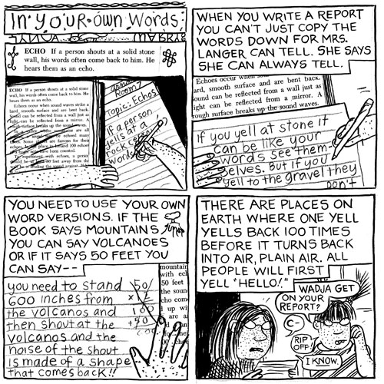

Reviewing Literature

Helpful Format

Matrix for evaluating Research Literature

Stephen Petrina

University of British Columbia

June 2016

Literature Reviews or Reviews of Research

A literature review begins with carefully selected, relevant articles, books, chapters, etc. (sources) to explore a research topic or support either the theoretical framework or the methodological approach to investigating a research problem. The key is to distinguish between a critical literature review essay and a descriptive report of sources. The first pass on a literature review may in fact be a descriptive report of sources but the best reviews are normative, providing a reader with a sense of what is included in the source (description), what is excluded, overlooked or missing, and what should have been included (judgment). The best literature reviews take an essay form, with a beginning (introduction), middle (primary argument and evidence), and end (conclusion). The beginning sets the necessary context, categories and limits, tone, and overall argument or thesis (See outlines below).

The general idea of a literature review is to provide a sense of the current state of knowledge on a topic. A literature review is detailed and concrete, or necessarily empirical.

In education and the social sciences, a literature review is often called a review of research, which suggests the limitation on the sources reviewed (i.e., research-based literature). The Review of Educational Research (RER) stands as the best source of examples of critical lit reviews in education.

In history and much of the humanities, a literature review is often called a review essay, which is understood to be a critical review essay. *See the Essay Writing Center’s explanation of a Critical Review http://essayinfo.com/essays/critical_essay.php and

Gloria Betcher (2006, p. 1) notes that
depending upon the goals of the review, the audience for whom it is intended, and the way in which that audience will use the information supplied, a review essay will incorporate a selection of the following:
- A thesis that defines the topic under review, and if appropriate, defines and clarifies the research question or problem assessed
- A summary of the current state of understanding of the topic (or question/problem) under review
- Descriptions of individual works that relate to the review topic
- An assessment of how those individual works relate to the review topic
- An assessment of how those individual works relate to each other— contradictions, gaps in knowledge, inconsistencies in how they handle information on the topic, etc.
- A suggestion of the direction further research might take or of how one might approach solving the research problem or question

Helpful Format for Reviewing Literature

- Overview/ Introduction of subject, theories and issues involved.
  - Type of literature review (theory, methodology, policy, quantitative research, qualitative research)
  - Scope: what type of resources are best
  - Search for information: wide enough and narrow enough
- Categories selected as natural divides of thesis and reviewed material:
  - Organize material around the research question or thesis
  - Include areas of controversy
- Analysis and interpretation of overarching similarities and variances of ideas: Include
  - Provenance: credentials, evidence
    - Confidence in information is typically contingent on whether it was reviewed or approved by other researchers. Peer reviewed information or reports generate higher confidence than unreviewed information.
    - But all information or reports come with different degrees of reliability.
  - Objectivity: authors’ point of view and representation of other views
  - Persuasiveness: which theses are most convincing vs least?
  - Value: Does this work contribute in a significant way to understanding the subject.
- Summation or conclusions of thesis generating idea in context with materials reviewed.
  - What is known and not known
  - Areas of further research
- Relevant, appropriate and, useful

References
Betcher, G. (2006). What is a review essay? Retrieved from ?
Boote, D. N. & Beile, P. (2005). Scholars before researchers: On the centrality of the dissertation literature review. Educational Researcher, 34(6), 3-15.
Pencil, M. (1976). Salt passage research: The state of the art. Journal of Communication, 26(4), 31-36.

Examples
Gill, T. (2014). The benefits of children's engagement with nature: A systematic literature review. Children, Youth and Environments, 24(2), 10-34.
Rickinson, M., Dillon, J., Teamey, K., Morris, M., Choi, M. Y., Sanders, D., & Benefield, P. (2004). A review of research on outdoor learning. London, UK: National Foundation for Educational Research and King’s College London.

Literature Review Matrix

Question  (author’s view) | Article Information | Analysis  (strengths & weaknesses)
Formulation of problem/issue
Clearly defined:
Scope, severity, relevance
Would another perspective be more effective?
Researcher’s orientation: interpretive, critical science, both?
Author’s theoretical framework (psychological, developmental, feminist?) what voice?
Relationship between theoretical and research perspective
Relevant and representative literature (inclusive) used?
If research, how well was it done (measurements, analysis, validity)
“Popular readership”, language use, emotional, rhetorically toned, or reasoning
Structure clear? Deconstruction possible? Cause-effect

*Matrix 1 adapted by Linda A. Cannon

Category | Criterion | 1 | 2 | 3 | 4
Coverage | Justified criteria for inclusion and exclusion from review | Did not discuss the criteria inclusion or exclusion | Discussed the literature included and excluded | Justified inclusion and exclusion of literature
Synthesis | Distinguished what has been done in the field what needs to be done | Did not distinguish what has and has not been done | Discussed what has and has not been done | Critically examined the state of the field
 | Placed the topic or problem in the broader scholarly literature | Topic not placed in broader scholarly literature | Some discussion of broader scholarly literature | Topic clearly situated in broader scholarly literature
 | Place the research in the historical context of the field | History of topic not discussed | Some mention of history of topic | Critically examined history of topic
 | Acquired and enhanced the subject vocabulary | Key vocabulary not discussed | Key vocabulary defined | Discussed and resolved ambiguities in definition
 | Articulated important variables and phenomena relevant to the topic | Accepted literature at face value | Some critiques of literature | Offered new perspective
Methodology | Identified the main methodologies and research techniques that have been used in the field, and their advantages and disadvantages | Research methods not discussed | Some discussion of research methods used to produce claims | Critiqued research methods | Introduced new methods to address problems with predominant methods
 | Related ideas and theories in the field to research methodologies | Research methods not discussed | Some discussion of appropriateness of research methods to warrant claims | Critiqued appropriateness of research methods to warrant claims
Significance | Rationalized the practical significance of the research problem | Practical significance of research not discussed | Practical significance of research discussed | Critiqued practical significance of research
 | Rationalized the scholarly significance of the research problem | Scholarly significance of research not discussed | Scholarly significance of research discussed | Critiqued scholarly significance of research
Rhetoric | Was written with a coherent, clear structure that supported the review | Poorly conceptualized, haphazard | Some coherent structure | Well developed, coherent
Boote, D. N. and Beile, P (2005). Scholars before researcher: On the centrality of the dissertation literature review in research preparation, Educational Researcher, 34(6), 3-15.

