Suggestions for an Improved Recycling/Waste Reduction Program at UBC’s University Village Food Court
Mojan Nozari, Claire Huxtable, and Dan Johnstone
Zone D Representatives on the UEL Community Advisory Council

TABLE OF CONTENTS
- Abstract……………………………………………………………………………………………1
- Working Definitions………………………………………………………………………………1
- Introduction
  - Background………………………………………………………………………………1
  - Scope of Report…………………………………………………………………………..2
  - Method of Inquiry………………………………………………………………………..3
  - Brief Description of Findings and Conclusion…………………………………………3
- Collected Data
  - Recycling UVFC Waste………………………………………………………………….3
    - Statement of Problem…………………………………………………………...3
    - Data: Poll of UVFC Patrons……………………………………………………4
    - Interpretation of Findings………………………………………………………6
  - Reducing UVFC Waste…………………………………………………………………..7
    - Statement of Problem…………………………………………………………...7
    - Investigation: Alternatives for non-recyclable containers……………………8
    - Investigation: UBC’s Green2Go………………………………………………..9
    - Interpretation of Findings……………………………………………………..10
- Conclusion……………………………………………………………………………………….11
  - Summary and Overall Interpretation of Findings..........……………………………..11
  - Recommendations………………………………………………………………………12
- Citations………………………………………………………………………………………….13
- Appendix…………………………………………………………………………………………13

I. Abstract
II. Working Definitions
The following definitions are used throughout this report:
Food ware
Recyclable
Sustainable
II. Introduction
Background
In recent years, the University of British Columbia (UBC) has established a Climate Action Plan to reduce greenhouse gas emission, water consumption, and natural gas consumption on campus. As a top-ranking climate change action university, several strategies have been implemented to reduce waste (ex. uniform recycling programs, promoting eco-friendly products). In accordance with their Zero Waste Action Plan, UBC is hoping to divert 80% of waste by 2020 (UBC Sustainability) and has unveiled a Zero Waste Food Ware Strategy to limit the amount of waste produced by all food and beverage businesses located on and servicing the UBC Point Grey Campus.
This Strategy will affect the University Village Food Court (hereafter referred to as UVFC), which is a popular location for cost-effective with diverse food options on UBC campus. Located in Zone D of the University Endowment Lands and on the lower level of University Village, the UVFC lies in an area governed by the Province of British Columbia and UBC. Although in business for several years, the UVFC’s recycling program is lacking, and the food ware does not conform to the standards set by the Zero Waste Food Ware Strategy (which comes into effect in 2020).
The purpose of this report is to then make suggestions for the design and implementation of a recycling/waste reduction program at the UVFC. Although the Zero Waste Food Ware Strategy encourages the use of more sustainable packaging, it will be important to ensure that the family businesses have the tools to make the switch, and that the food court itself has a recycling program to take full advantage of more sustainable packaging. While UBC’s Zero Waste Food Ware Strategy outlines alternatives to non-recyclable food/beverage containers across campus, this report will focus specifically on the needs of the UVFC, and suggest an appropriate solution that will significantly reduce waste.
Scope of Report
The UVFC’s waste generation can be broken up into two problems. Firstly, the UVFC recycling program currently consists of only two categories: plastic bottles and cans, and garbage; meaning a significant amount of food ware ends up in the landfill. Both a lack of recycling containers, and a lapse in recycling education/incentive would prompt customers to throw even recyclable containers (ex. Plastic beverage containers, bamboo chopsticks) into the on-site garbage bins. Secondly, the UVFC produces an abundance of non-recyclable waste, including products such as Styrofoam (eg. polystyrene) containers and plastic bags. While Styrofoam has been known to be detrimental to the environment, it is an extremely cheap material that is economically favourable for small businesses.
The following questions will be pursued in this report:
- What types of recycling programs currently exist at the UVFC? Is it effective?
- How can this recycling program be made more effective?
- What types of recycling/waste reduction programs exist? Could effective aspects be incorporated into the UFVC?
- Are consumers educated on proper recycling habits?
- What deters restaurant owners away from more environmentally friendly packaging?
  - What alternative, more sustainable options are available?
  - Will these alternatives be cost-effective?
The scope of this report encompasses two approaches to reducing waste; one which limits the amount of waste generated, and another that encourages all waste to be recycled.

Method of Report
These inquiries will be investigated via the following methods:
- A survey for customers of the UVFC:
  - To determine the amount of recycling knowledge
  - To probe the customer’s perspective on recycling initiatives
- Research into current waste reduction programs:
  - Are there aspects that could be incorporated?
- Investigations into more sustainable food ware:
  - Are they cost-effective?
  - Are there economic incentives for businesses to switch?
Brief Description of Findings and Conclusion
This report acknowledges that a change is necessary in accordance with UBC’s Zero Waste Food Ware Strategy. Included in the report are recommendations for a recycling program, that will take full advantage of these changes, and recommendations for supporting businesses through the transition to more sustainable food ware.

III. Collected Data
a. Recycling UVFC Waste
Statement of Problem
Refering to figure 1, the current recycling program at the UVFC involves two separate bins for recycling: cans and bottles, and waste. Unlike UBC buildings, which have four recycling containers, there is no option to recycle any food ware on-site at the UVFC. Due to the confined nature of the UVFC, space is an issue when determining adequate recycling bins. Additionally, the lack of recycling bins only encompasses the accessibility aspect of recycling, but equally important is recycling education. The fact that lots of recyclable food ware ends up in garbage receptacles at the UVFC can allude to a lack of recycling education/incentives.
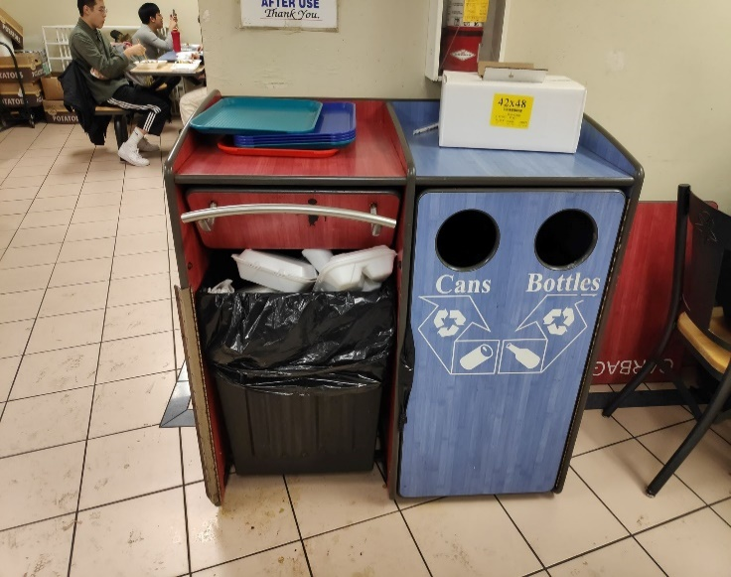
Figure 1: Current UVFC Recycling Bins
Data: Poll of UVFC Customers
Customers of the UVFC were asked several questions to determine their food court practices and their perspective on UVFC recycling (See appendix for full survey questions). This survey probes the customer base to determine what types of recycling programs could be effective and any concerns they have about a recycling program.
Firstly, according to the poll, the UVFC has a varying customer base (see Fig. 2). Over 2/3 of customers buy food at the UVFC less than 1-3 times/ 2 months, meaning they are not entirely familiar with the food ware generated at the Food Court. Similarly, the waste a single person generates 1-3 times/2 months may seem inconsequential.
Figure 2: Graph detailing frequency of UFVC visits
Secondly, most sales at the UVFC are made through “to-go” items (see Fig. 3). While this is not surprising due to the limited space in the Food Court, this generates more waste such as plastic bags. Additionally, this infers that although recycling bins will be useful for all food consumed on-site, most patrons obtaining food “to-go” will not benefit from these bins.
Figure 3: Graph of on-site vs. off-site consumption

This is a further concern when one takes into consideration recycling education. Much of the food ware generated at the UVFC is specific enough that consumers may not fully understand how to sort them. This part of the survey tested customer’s knowledge based on the four recycling container system at UBC (see Fig. 4), and found that although their knowledge tested quite well, the most confusing aspect seemed to be about what can be composted or not. For example, napkins (60% correct) and chopsticks (65% correct), can both be composted, but were the two lowest scores.
Figure 4: Data collected on UVFC customer's recycling knowledge
However, nearly all participants were adamant that the current UVFC recycling program is not effective for the space. 93% of customers rated the current recycling program below a 5/10 (1 being not effective at all, and 10 being very effective) and raised several concerns about a potential recycling program, including:
- Recycling education for patrons
- Overflow of bins (a current problem with the waste bin at the UVFC)
- The confined amount of space
- Maintenance of recycling program
- Cost-effectiveness for businesses and customers
Any recycling program must encompass all these concerns and ensure that it makes sense for the space available.
Interpretation of Findings
With the poll data in mind, it is recommended to implement a 3-bin recycling system. The above data shows that consumers are already quite familiar with the four bin system at UBC, and implementing a similar program at the UVFC will be compatible with customer knowledge. However, it is unnecessary to include a paper recycling bin at the UVFC due to the low amount of paper waste that is generated. Only clean, unlaminated paper can be recycled, so paper recycling does not even apply to paper food ware such as napkins (which are organic waste) or laminated containers (landfill waste). Additionally, paper cups can be recycled in “Mixed Containers.” In order to conserve space, only the following bins should be implemented:
- Landfill Waste
- Organics
- Mixed Containers
This system will be easily assimilated into the curb side pick up as large bins for these categories already exist at University Village. Therefore, this system will be compatible with existing recycling infrastructure and customer knowledge. The bins should be coloured the same as UBC’s existing program to avoid confusion.
The recycling bins should also include signs containing both words and pictures of how particular items at the UVFC are sorted. This will reduce the chances of customers guessing where food ware goes and ensures that all waste is recycled correctly. Photos especially are quick to read and increase the chances that customers taking food “to-go” also receive recycling information. At least two easily accessible recycling stations will create a straightforward recycling system that is easy for customers to comprehend and follow.
b. Reducing UVFC Waste
Statement of Problem
The second aspect of waste production is that much of the food ware at the UVFC is not recyclable at all. For example, many of the businesses use Styrofoam containers (see Fig. 5), which have a degradation rate of less than 1% in the first 90 days in the landfill (Ho). Consequently, even if recycling bins did exist at the UVFC, many of these containers would not qualify for recycling.
It is important to note that due to the limited space in the UVFC, “for here” or “to-go” options generate nearly the same amount of waste. For many businesses, a “for here” option means a Styrofoam plate instead of Styrofoam box, or the absence of a plastic bag. However, due to the lack of space and consumers that eat food on-site, a full on-site sustainable option (eg. reusable porcelain plates or metal utensils) has been eliminated.
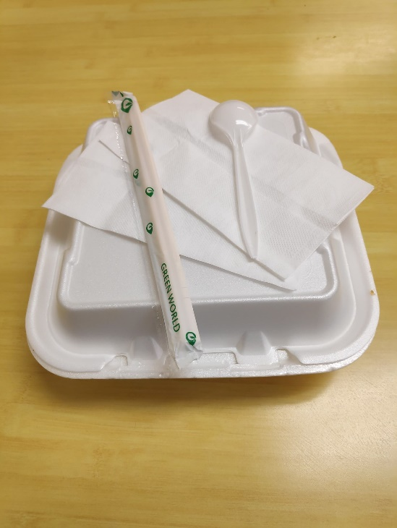
Figure 5: A depiction of the average food ware given "to-go" from a single order at the UVFC
Investigation: Alternatives for Non-Recyclable Containers
The Zero Waste Food Ware Strategy insists that all non-recyclable containers be eliminated and goes a step further to charge the customer extra for using even single-use recyclable containers. This is a smart strategy to not only encourage consumers to use reusable containers but helps offset the costs for businesses.
UBC’s Zero Waste Food Ware Strategy (coming into effect January, 2020), affects all food and beverage companies serving and operating on UBC’s Point Grey Campus, and will not allow any non-recyclable food ware by the end of 2020. In this regard, it is beneficial for the UVFC to be looking towards switching to more sustainable containers. By the standards of the Zero Food ware Strategy, consumers will be required to pay a fee for even recyclable containers such as wooden cutlery, paper containers, or paper bags. Therefore, advertising this switch will be important for customers.
Styrofoam Containers
An investigation was conducted into the cost of switching over to sustainable containers from Styrofoam. The main Styrofoam containers used at the UVFC are: a 9x9” three compartment large container, a 9x6” rectangular container, and a 6x6” small sandwich container (see Fig. 5). There are multiple companies that create recyclable alternatives to these exact products, however they cost on average 2.5 times more than their Styrofoam counterparts (see appendix for details). For example, a large Styrofoam container could cost 15 cents each, while it’s compostable counterpart would cost 42 cents, bought from the same website. Consequently, although a far less sustainable choice, Styrofoam makes sense economically for businesses, especially the small businesses situated at the UVFC. Styrofoam is detrimental to the environment, and businesses must be incentivised to switch despite the high cost. In accordance with the Zero Waste Food Ware Strategy, charging a fee of 50 cents for customers buying such a sustainable container will help offset the costs for businesses.
Straws
Although straws are not common for businesses in the UVFC, Coco Bubble Tea generates a large amount of plastic straws daily. The Zero Waste Food Ware Strategy condemns plastic straws and states that “Bubble Tea straws must meet the requirements… once alternative solutions are available.” While bubble tea may still be served with plastic straws, it is important to note that biodegradable bubble tea straws made of bamboo or sugarcane fiber are available wholesale for under 5 cents each.
Utensils
Although some plastic utensils generated at the UVFC are recyclable, the Zero Waste Food Ware Strategy requires that only compostable wood or plant fibre-based utensils be used. While the current bamboo chopsticks fit that requirement, plastic utensils will have to be phased out. The Zero Waste Food Ware Strategy suggests a cost of 10 cents per utensil in order to offset the cost of more environmentally friendly utensils.
Investigation: Waste Reduction Programs
UBC’s Green2Go
Green2Go is a UBC based initative that centers mainly around the Vanier and Totem Park Residence meal plan. To join, students pay $5 to cover the cost of a reusable food container and obtain a Green2Go branded carabiner. This carabiner can be exchanged at the Residence Dining Hall for their meal in a reusable container, with which they save 20 cents on their meal. If a disposable container is used, then the meal costs an extra 75 cents. The reusable container can then be exchanged for another meal container, or another carabiner clip. The main aspect to this program is that containers can be returned unwashed to Green2Go locations, eliminating the washing aspect for the customer.
Coffee cup shares
According to a recent article, 2.6 million disposable cups are generated by Vancouverites each week. A few coffee cup shares have started in Vancouver, including Mugshare. This program works on a $2 deposit system that allows the customer to obtain a reusable coffee cup from a participating shop and return it at any other participating shop to be cleaned (Chan). This program is effective in that it increases accessibility to reusable mugs and is of no effort for the consumer (can be returned unwashed at any participating store). Another Vancouver program is Cuppy, which works on a membership scale. With an annual membership of $5, members gain access to Cuppy’s reusable mugs which, like mugshare, can be returned at any other participating locations. A unique aspect is that Cuppy works on a positive reinforcement system, offering perks for eco-friendly behaviour, and including an app that reminds the customer to return their cup (Chan). Customers can only use two mugs at a time, encouraging them to return their mugs whenever possible.
Interpretation of Findings:
UBC’s Zero Waste Food Ware Strategy is a good starting point for businesses to begin thinking about their environmental impact. With the above information in mind, however, it is important that businesses have the tools to take full advantage of becoming more sustainable.
First, there must be support on hand to help businesses switch to more environmentally friendly food ware. Seeing as how recyclable food ware is so much more expensive than the regular Styrofoam, loans should be available to help businesses deal with the initial losses. Once businesses can recoup these losses from the customer container fee, they can repay the loan. The Zero Waste Food Ware Strategy requires the container fee starting in 2021, and businesses may prefer to phase in this fee slowly (to reduce potential loss of customers). Investing in small UVFC businesses would create an environment where the owner is still able to independently run their business.
Additionally, these smaller businesses may need support in understanding the significance of these changes. As a diverse community, many businesses owners speak limited English, and may not understand what changes need to be implemented or how they can best run their business under the changing circumstances. Support for these businesses means a complete explanation of what must be done and guiding small business owners to make informed decisions.
In terms of reducing waste, it is clear from existing programs that getting people involved in recycling is key. There should be proper signage around the Food Court explaining to customers the changes that are happening and encouraging them to bring their own reusable food ware. To help the entire program become more efficient, it will be important to keep customers in the loop about changes that are being made. During the transition period, informing customers about the changes will give them time to bring their own containers, lessening the burden on businesses to spend more on sustainable containers.
Moving forward, it will be useful for the UVFC to join a container sharing program such as Green2Go. This will be more convenient for customers and allow businesses to spend less on recyclable containers overall, therefore being economically favourable for businesses. This will also be a sustainable “for here” option, so that on-site consumers can return their dishes as soon as they are finished. However, this will require support from the University Village to acquire an industrial dishwasher, and a unifying of businesses in the UVFC to share this dishwasher.
V. Conclusion
Summary and Overall Interpretation of Findings
UBC is looking to divert 80% of landfill waste by 2020, and changes must be made in order to reach this goal.
From a consumer perspective, it is imperative to involve people in a recycling program that is convenient, on-site, and compatible with current resources. As most consumers at the UFVC are UBC students (and with data showing that students are familiar with UBC recycling practices), it is advisable to pattern a recycling program after UBC’s 4-bin recycling. Data shows that consumers are concerned about the amount of waste produced at the UVFC and shows that customers would be willing to make a change to sort out waste. In addition, concerns raised by the poll indicate that proper recycling education is essential for a recycling program to be effective.
From the business perspective, UBC’s Zero Waste Food Ware Strategy compel businesses to reduce non-recyclable waste by the end of 2020. Being smaller businesses, it is important that they are supported through this transition and have the tools necessary to sustain their business. Family businesses may not have the initial resources to fund start up cost of sustainable containers and may not understand how to implement the customer container fee required by the Zero Waste Food Ware Strategy. Clear messaging is essential for businesses to make informed decisions regarding their sustainability practices. Support from UBC and the University Village will not only clarify the significance of a sustainable food court but allow the UVFC to explore sharing options such as Green2Go.
Recommendations
A two-pronged approach is necessary to create a recycling/waste reduction program at the UVFC; One aims to limit the amount of waste generated, and the other aims to encourage good recycling practices. The solution must be beneficial to business owners and informative to customers. Additionally, solutions must make sense for the diverse environment of the UVFC and support business owners through the change.
The following recommendations are made for the UVFC:
- The implementation of a 3-bin recycling system: waste, organics, mixed containers
  - Recycling bins should use same colouring as UBC’s recycling system to comply with customer knowledge
  - Recycling bins should include wording and photos of how to sort food ware
- Support for businesses transitioning to more sustainable food ware:
  - Loans to cover initial start-up costs
  - Translators and on-site support to fully explain the significance of the waste reduction program and guide businesses through the transition
- Proper signage informing customers of upcoming changes
In the future, the UVFC should consider joining a sharing program such as Green2Go. With the support of University Village, this program will be beneficial not only for the environment, but for the businesses and customers as well.

IV. Citations
Chan, Cheryl. “ New Vancouver Mug-Sharing Programs Offer Fix for Takeout Waste.” The Vancouver Sun, 19 Oct. 2019.
“Community Advisory Council.” University Endowment Lands , www.universityendowmentlands.gov.bc.ca/community/advisorycouncil.htm.
Ho, Ba, et al. “An Overview on Biodegradation of Polystyrene and Modified Polystyrene: the Microbial Approach.” Critical Reviews in Biology, vol. 38, no. 2, 1 Aug. 2017, doi:10.1080/07388551.2017.1355293.
UBC Campus and Community Planning. “FOOD SERVICE WARE PROCUREMENT GUIDELINE .” UBC, 15 July 2019.
UBC Food Services. “Reducing Waste Is Better than Recycling!” UBC Food Services, UBC, food.ubc.ca/green2go/.
UBC Sustainability. “Sort It Out.” Sustain.ubc.ca, 24 Oct. 2019, sustain.ubc.ca/get-involved/campaigns/sort-it-out.

V. Appendix

