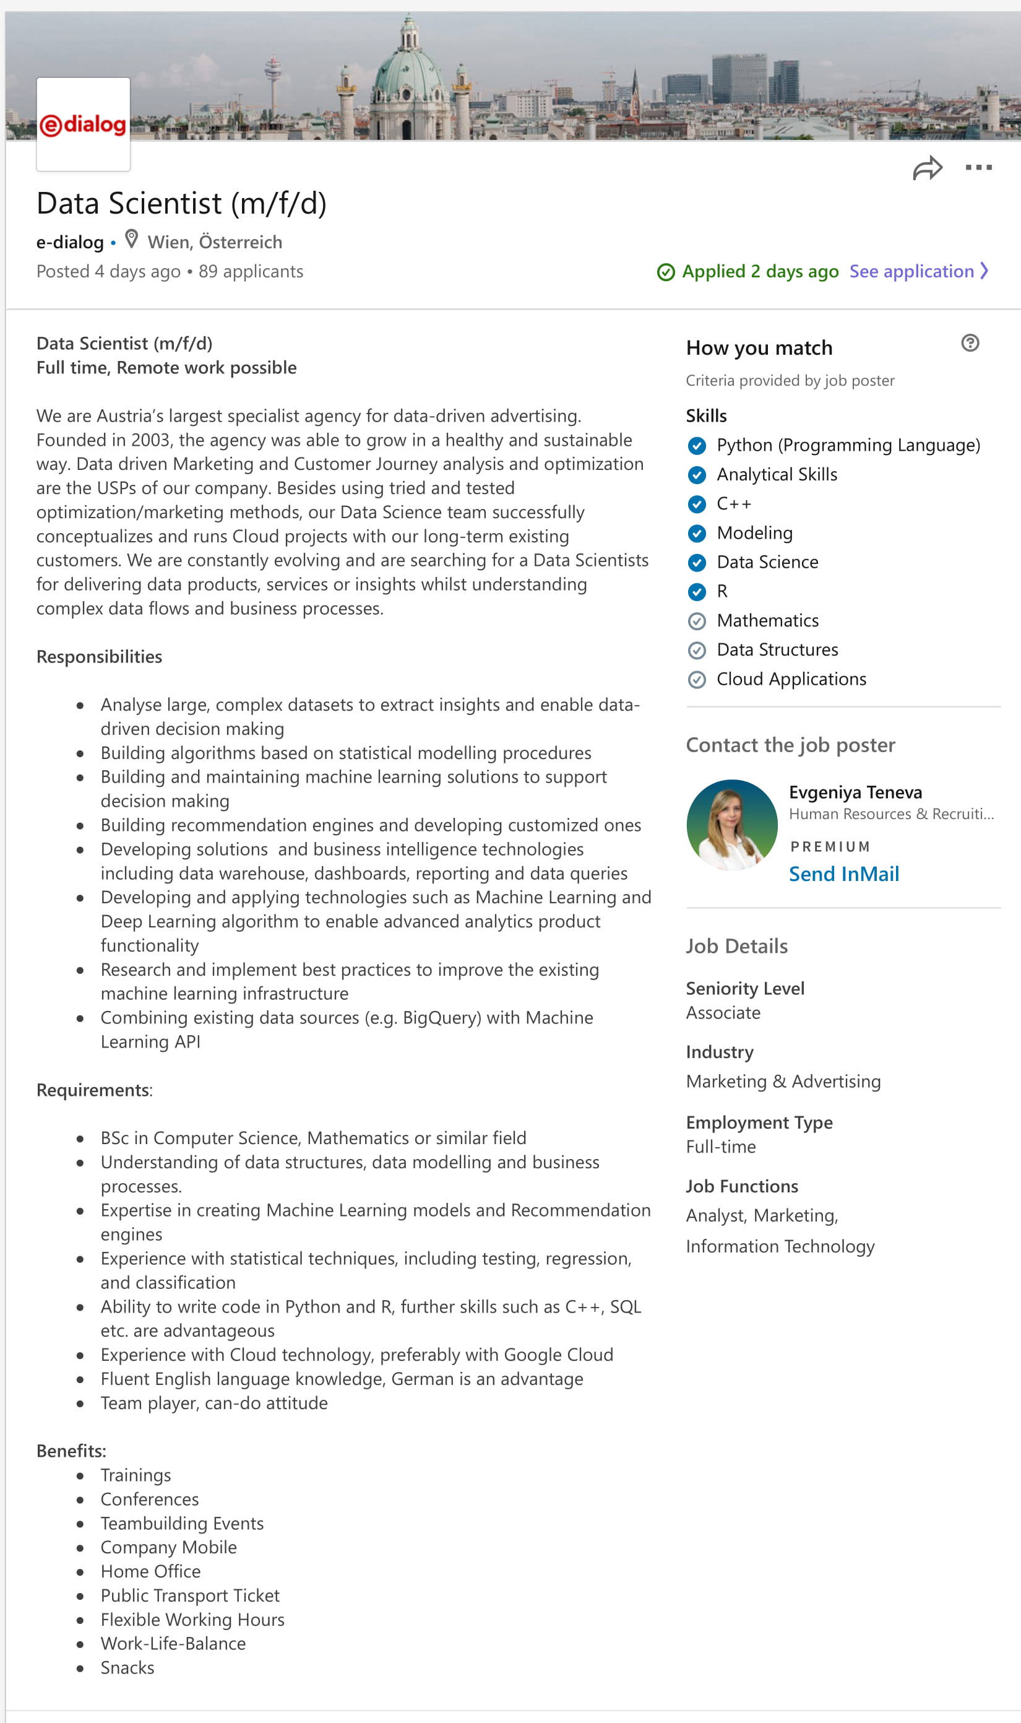
Yury Zhuk
“e-Dialog Hiring Data Scientist (m/f/d) in Wien, Österreich: LinkedIn.” Data Scientist (m/f/d), LinkedIn, 6 Dec. 2019, https://www.linkedin.com/jobs/view/1609084018/.
4131 West 16th Ave. V6R3E4
Vancouver, BC, Canada
+1 778 714 1056
yuryivz@hotmail.com

Dec 8, 2019

e-dialog GmbH
Opernring 1
1010 Vienna, Austria

Dear Evgeniya Teneva,

As a graduating Canadian student in Statistics, with experience working as a Machine Learning Developer/Engineer, a passion for learning, and a drive to succeed, I am an apt candidate for the Data Scientist position at e-dialog. I would like to contribute to the vision of providing cutting-edge data-driven services to clients.

In reference to your job description, I:
- Worked at two startups as a Machine Learning Engineer/Developer, received very positive feedback from managers
- Built a production MVP pipeline for a customer churn ML model with Apache Spark and HDP
- Created a statistical restaurant recommender system with PostgreSQL, Python, NumPy, SciPy and Sanic; deployed into production
- Am experienced and comfortable with both Agile (Scrum) team and fully-remote teams
- Am proficient with both data science (Python, R, Jupyter, SQL, NumPy, PyTorch) and software engineering tools (Spark, Scala, Hadoop, Docker). For full list of skills please consult my resume.
- Have an undergraduate degree in Statistics (May 2020), with a thematic concentration in Computer Science, from a top university (University of British Columbia)
- Am a native speaker in English and Russian, a B2 level in German, and A2 in Vorarlberg dialect
- Have a passion for learning and picking up new skills by working on independent projects, which you can find on my website (yury.cc) or my GitHub page.

I bring a genuine passion and energy to my work. This would especially be the case if I were a successful candidate at e-dialog, where I would be thrilled to learn quickly and build my skill set. I respectfully submit my resume for your review and request a meeting to discuss the opportunity further. Please let me know if you have any questions; I look forward to hearing from you!

Best Regards,
Yury Zhuk
m

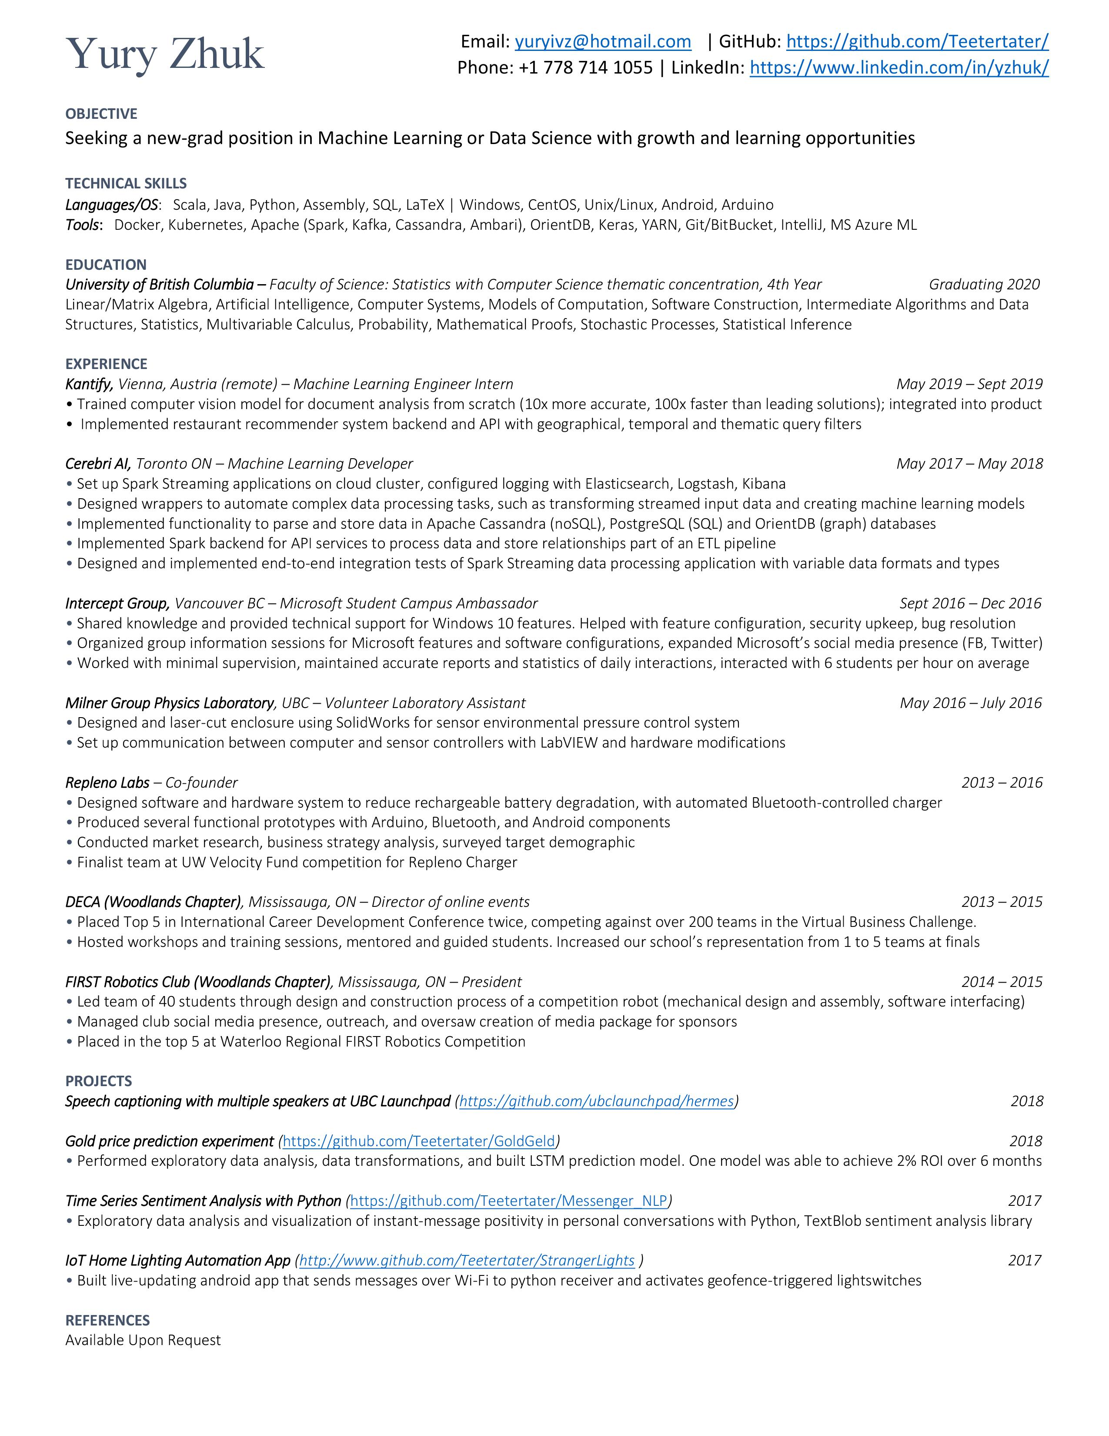
Yury Zhuk
4131 West 16th Ave. V6R3E4
Vancouver, BC, Canada
+1 778 714 1056
yuryivz@hotmail.com

Dec 11, 2019

Leonardo Spence
+1 416 559 1203
leo.spence@gmail.com

Dear Leo,
I have fond memories of us working together at Cerebri AI. Your mentorship and guidance during my year there has provided a lasting impact on my skillset and my career path. I heard from Kevin that you transitioned towards the energy sector, and I hope your expertise is well-rewarded! How are you liking it in Sarnia? I will get straight to the point – would you be willing to serve as a reference for my job application?
The company I am applying to is called e-dialog, and they are in the digital advertising and optimization space. They’re seeking Data Scientists to join their team and my set of skills match their requirements. I hope you will be able to attest to my quality of my work, my dedication to delivering the product with utmost quality, and my responsibility in working remotely while working at Cerebri. Aside from those qualities, I have continued to develop my technical abilities through the completion of personal projects and another internship.
Since we worked so closely I believe your voice would carry a lot of weight. I hope that some of the amazing feedback I have received from you in the past can be written into this reference. Please let me know if you would be comfortable with this. If you have any questions please email me at yury.zhuk@alumni.ubc.ca or give me a call at +1 778 714 1055.

Best regards,
Yury

Yury Zhuk
4131 West 16th Ave. V6R3E4
Vancouver, BC, Canada
+1 778 714 1056
yuryivz@hotmail.com

Dec 11, 2019

Rachel C. Mullings
+1 905 143 2332
rachel.c.mullings@outlook.ca

Dear Rachel,
I have fond memories of working at Cerebri under your supervision. Thank you for taking a chance on me at the start and being an awesome, understanding boss. I noticed via LinkedIn that you formed a consulting company with Henry, how is that going? The purpose of my letter is to request a reference for an ongoing job application.
The company I am applying to is called e-dialog, and they are in the digital advertising and optimization space. They’re seeking Data Scientists to join their team and my set of skills match their requirements. I hope you will be able to attest to my quality of my work, my dedication to delivering the product with utmost quality, and my responsibility in working remotely while working at Cerebri. Aside from those qualities, I have continued to develop my technical abilities through the completion of personal projects and another internship and I hope you will be able to attest to that.
Since we worked so closely I believe your voice would carry a lot of weight. I hope that some of the amazing feedback I have received from you in the past can be written into this reference. Please let me know if you would be comfortable with this. If you have any questions please email me at yury.zhuk@alumni.ubc.ca or give me a call at +1 778 714 1055.

Best regards,
Yury

Yury Zhuk
4131 West 16th Ave. V6R3E4
Vancouver, BC, Canada
+1 778 714 1056
yuryivz@hotmail.com

Dec 11, 2019

Adrienne Clavet
+32 664 73538027
adrienne@kantify.com

Dear Adrienne,
I had an amazing time working with you and the rest of the team at Kantify! It is unfortunate that the visa process didn’t work out, otherwise I truly would have loved to continue taking on projects. On that note, I am searching for other opportunities and am writing to you to request a reference letter.
The company I am applying to is called e-dialog, and they are in the digital advertising and optimization space. They’re seeking Data Scientists to join their team and my set of skills match their requirements. I hope you will be able to attest to my quality of my work, my dedication to delivering the product with utmost quality, and my responsibility in working remotely while working at Kantify. I am tempted to send them the rap you wrote for me with all those kind words!
Since we worked so closely I believe your voice would carry a lot of weight. I hope that some of the amazing feedback I have received from you can be written into this reference. Please let me know if you would be comfortable with this. If you have any questions please send me an email or give me a call at +1 778 714 1055. Please send my regards to the rest of the team and once again congratulations on the successful funding round!

Best regards,
Yury

