Understaffing issues of the Richmond Aquatics special needs program

For Brandon Kato, Aquatic supervisor
Of Richmond Aquatics special needs
Program Richmond BC

By Eric Chang
ENGL 301
Dec, 19, 2019

TABLE OF CONTENTS

INTRODUCTION
- Description of the Richmond Aquatics special needs program…………………………………………………………………………………….3
- Description of the staffing shortage……………………….………………………………………………………......3
- Description of data sources……………………………………………………………...……………………..3
- Purpose of the report …………………………………………..………………………….……………………....4
- Scope of inquiry …………………………...…………………………………………….…………………...4
DATA SECTION
- Determining the importance of the special needs program……..…………………….4
  - How it contributes to the community ...…………………………………………4
  - Why the program is needed.……………………..…………………………...…5
G. Determining the amount of staff members needed to run the program..……..……..5
- Data from interviews………………………..…………………………………….5
2. Data from surveys………………………………………………………………..8
H. Proposed Solutions for the staffing shortage..……………….………….……………..9
- Providing incentives for volunteer instructors…......…………….…………….9
- Increase marketing for the program….……………………….………………..10
- Increase of Richmond Aquatic staff members…………………………………10

CONCLUSION
I. Summary of findings…………………………………………………………….………..11
J. Recommended solutions…………………………………………………………………11

REFERENCES

INTRODUCTION
- Description of the special needs program
The Richmond Aquatics special needs program is a two hour swim class that is provided for all children with any form of physical or mental disabilities on Saturdays from 10-12pm at Minoru Aquatics centre in Richmond. The purpose of this program is to create an environment better suited for special needs children to learn swimming as regular swim classes are often times not suited for children with special needs.
- Description of staffing shortage
Due to the continuous increase in the amount of students that want to join the special needs program, the program is almost always short instructors. This is a major issue because in order for special needs children to learn swimming effectively, the ratio between students and instructor should always be 1:1 or 1:2 at worst. Yet this is consistently not the case as instructors are often times forced to teach 4 or even 5 students at a time.
- Description of the data source
The majority of the data for this report will come from primary resources which consist of both interviews and surveys. The interviews will then be conducted on the current staff members of the Richmond Aquatic special needs program as well as the volunteer instructors that took part in the program. The surveys will then be given to all of the students participating in the program currently as well as to their parents. The second source of data for this report will then come from research papers, articles, and reviews.

- Purpose of the report
The purpose of this report is to discover a solution to the problem of the Richmond Aquatics special needs program being constantly understaffed in terms of instructors.
- Scope of Inquiry
This report will cover all members participating in the Richmond Aquatics special needs program .

DATA SECTION
- Determining the importance of the special needs program
- How it contributes to the community
The Richmond Aquatics special needs program is an extremely special program as the main purpose of the program is really just to give back to the community and this is why the Richmond Aquatics special needs program is one of the only aquatics programs that is free of charge. But more important than just being a free program, staff members of the program also work extremely hard to create special events that occur after the swim lessons for the students to participate and further bond with other classmates or instructors.
- Why the program is needed
Teaching special needs children swimming in a regular class setting can be extremely difficult for the instructor as well as the special needs child for numerous reasons. The first reason is that special needs children oftentimes need individualized attention, which is extremely difficult for an instructor to provide consistently when teaching swim classes with 4-8 students. The second reason why special needs children don't learn to swim effectively in a regular group environment is because of the distractions that are present in a group setting. Special needs children learn better in an environment with less distractions, which is not something the instructor can provide in a group setting. The third and most important reason why it is difficult for an instructor to teach a special needs child swimming in a regular class setting is for safety reasons. Special needs children are usually weaker swimmers that needed to be constantly watched in order to prevent them from hurting themselves. In a group setting instructors often times need to work with students individually for short periods of time, which could put the special needs child in danger due to the fact that the instructor would not be able to focus on both students at the same time.

G. Determining the amount of staff members needed to run the program
- Data from interviews
Answers from interview with Brandon Kato head supervisor of the program
- My name is Brandon Kato and I have been the head supervisor of the Richmond Aquatics special needs program for around a year and a half now.
- I personally think that the Richmond aquatics program is an essential program for Richmond aquatics as it is the only program that is catered towards teaching special needs children. Often times parents that aren't aware of our special needs program would put their children into with special needs into a regular swim program and watch them struggle massively. This program then essentially solves this issue and creates an environment most optimal for special needs children to work in.
- The program is always growing so therefore we need more instructors and also volunteer instructors are often inconsistent with their schedule and cannot afford to regularly come out and teach classes.
- Poorer quality lessons and also are staffing shortage often caps the amount of students we are willing to accept into the program.
- While there are numerous ways to handle the problem I believe the two things that we have to do is to increase the amount of lifeguards that teach for the program and create more advertising for the volunteer instructor position.
Answers from Brian Chang volunteer instructor
- My name is Brian Chang and I am a volunteer instructor for the Richmond Aquatics special needs program.
- I wanted to become a lifeguard and needed teaching experience and I thought the special needs program would be the perfect place to gain teaching experience.
- Most volunteer instructors are busy highschool students so they are unable to consistently come out and teach for the program.
- It makes it extremely difficult to teach at times especially if you are given two special needs children who are not at the same level in regards to their swimming ability. This is because lesson sets for special needs children are usually extremely specialized.
- Two things better advertisement for the position and added incentives.

Original Interview Questions
Interview questions for Brandon Kato supervisor of Richmond Aquatics special needs program

- Describe your role at Richmond Aquatics special needs program.

- Do you think the Richmond Aquatics special needs program is an important program and if so why ?

- What is the reason that you believe that the Richmond aquatics special needs program is always short staffed ?

- What are the effects of constantly being understaffed ?

- How do you think we should address this problem in regards to the staffing shortage ?

Interview questions for Brian Chang volunteer instructor for Richmond Aquatics special needs program

- Describe your role at Richmond Aquatics special needs program.

- Why did you volunteer to be a volunteer instructor for the Richmond Aquatics special needs program ?

- Why do you think the Richmond Aquatics special needs program is constantly understaffed ?

- How does constantly being understaffed affect your role as a volunteer instructor ?

- What do you think Richmond Aquatics should do in order to attract more volunteer instructors for the program ?

- Data from surveys 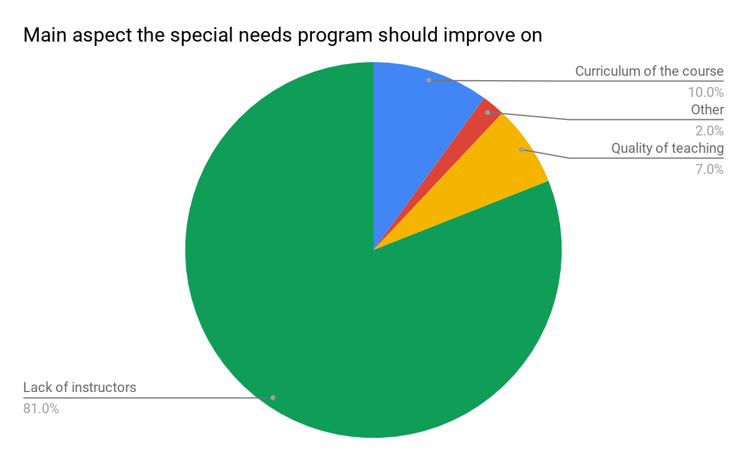
Fig 1. Main aspect of the program to improve on
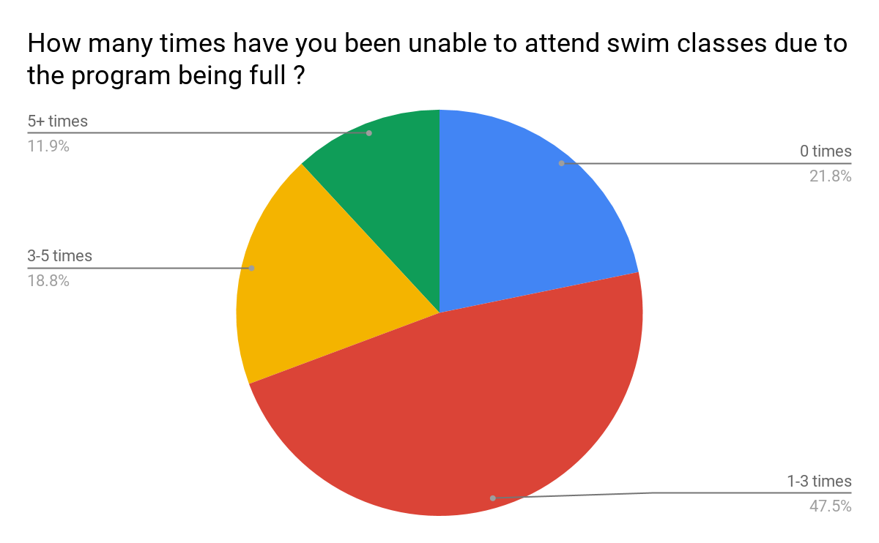
Fig 2. Amount of times students were forced to miss class due to class size
From the two pie graphs above it should be fairly obvious that the staffing shortage is a rule issue that the program desperate addressed. From fig.2 you can see that out of the 28 people that responded to the survey around 70% of the students of the special needs class had been forced to miss class due to staffing issues the program has been going through. Fig.1 then shows that around 80% of the people that filled out the survey regarded lack of instructors as the main aspect of the program that should be improved upon.

H. Proposed solution for staffing shortage
- Providing incentives to volunteer instructors
As of right now, out of the total 19 instructors for the program 4 of the instructors are lifeguards that work for the city of Richmond while the other 15 instructors are all volunteer instructors who do this in their spare time. A majority of the volunteer instructors are high school students who are using this program to gain teaching experience in order to apply one day to become a lifeguard. As of right now the program provides no benefit to the volunteer instructors when applying for a lifeguarding job other than teaching experience they gain when teaching the students. A method to attract more people to become volunteer instructors for the program would be to provide the students that enter the program a leg up when applying to become a lifeguard. For example the lifeguard hiring process is split into three sections teaching, physicals, and interviews. For students that teach as volunteer instructors for the special needs program for more than 3 months, they get to skip the teaching section of the hiring process and move straight into physical portion of the testing. This is because the volunteer instructors that join the special needs program will gain tons of experience teaching children to swim which means that this is a skill that they most likely do not need to be tested on.

- Increase marketing of the program
As of right now the only marketing there is for volunteer instructors to join the program is through word of mouth from instructors to students after they complete their certification for Water Safety Instructor. By advertising the position on the Richmond Aquatics website, the program then should be able to find and attract much more volunteer instructors.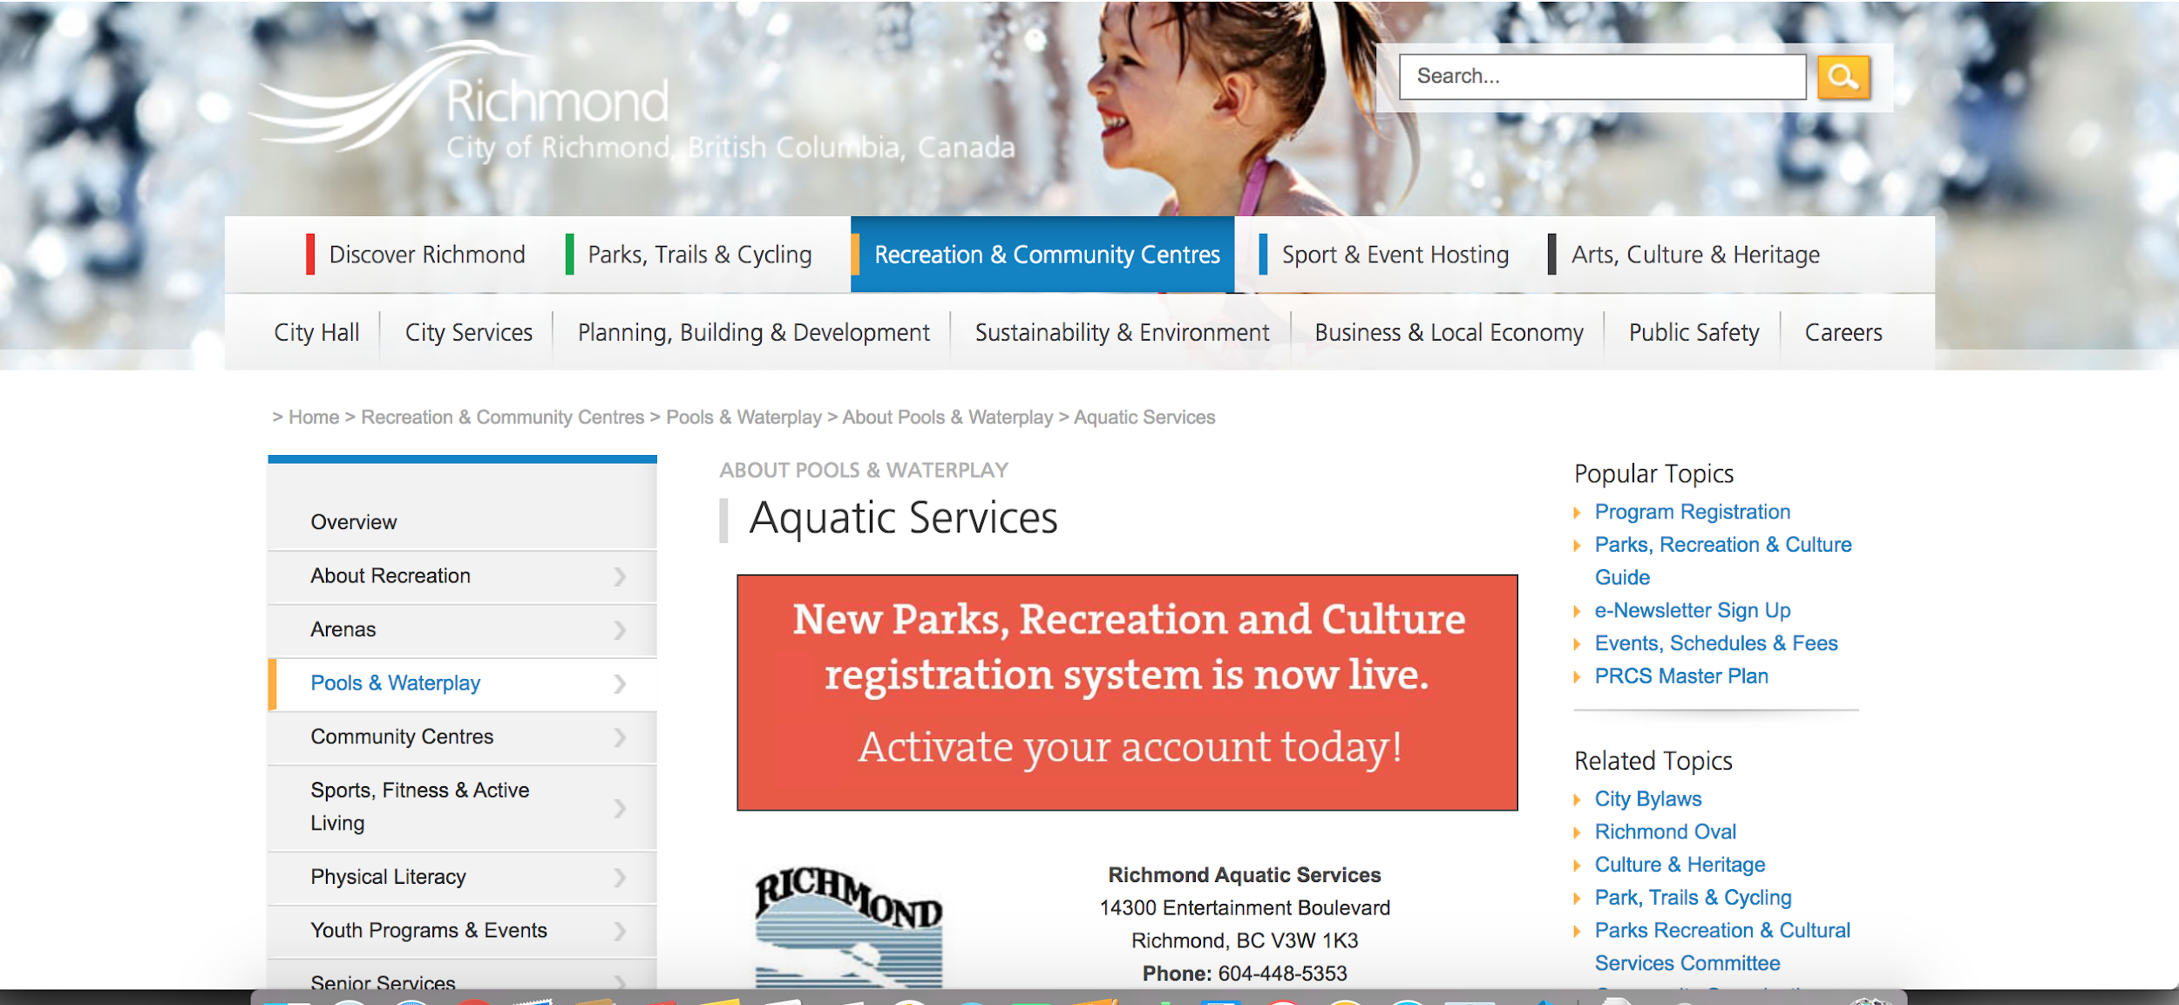
Figure 2. Current construction of the Richmond Aquatics website
- Increase of Richmond Aquatic staff members

Currently there are three official lifeguards that work as instructors during the special needs program while the rest of the instructors are usually volunteer instructors. Due to the fact that the official lifeguards typically have more teaching experience then volunteer instructors, official lifeguards are usually capable of teaching two special needs kids if they had to. So by increasing the number of lifeguard instructors to four or five would drastically improve the staffing shortage as lifeguard instructors are capable of teaching multiple students at a time.

- Summary of findings

From the two interviews conducted with both the head supervisor of the program Brandon Kato and volunteer instructor Brian Chang, it was discovered that the staffing shortage issue is a problem that the majority of the instructors of the program are aware of but aren't unsure how to solve. Brandon believes that the city needs to allocate more lifeguards to be instructors for the program as volunteer instructors are often inconsistent in the amount of times they show up to teach the program. Lifeguard instructors are also generally better instructors then volunteer instructors so therefore could teach more students at a time. The interview with volunteer instructor Brian then demonstrated how he believes that adding incentive to the volunteer instructor position of the program would immediately make the position more attractive due to the fact that a lot of people want to become lifeguards. The two pie charts then demonstrated how even the students are aware that the program desperately lacks instructors and is an area that needs to be improved upon.

J. Recommended solutions
From this report it should be obvious that there are two solutions that would drastically improve the staffing shortage the special needs program is currently facing. The first solution would be to create an incentive for the volunteer instructor position in order to attract more volunteer instructors. The most optimal incentive would then be to allow the volunteer instructors to skip the teaching section of the wet interview. It is no secret that the majority of the volunteer instructors at the special needs program in order to gain teaching experience which would help them land a job as a lifeguard. By creating this incentive, more people would be inclined to become volunteer instructors as this will make the interview process easier for them when they apply to be a lifeguard. The second solution then would be to increase the advertising for the volunteer instructor position for the Richmond aquatics special needs program. As of right now the only form of advertising for the volunteer instruction is through word of mouth by other instructors which is not a very effective method at attracting instructors. By advertising the position on either the aquatics website or booklet, a lot more people will become aware of both the program and the position which would most likely result in more volunteer instructors for the program.

REFERENCES
“SpecialNeeds.com.” Teaching Special Needs Kids to Swim | SpecialNeeds.com, https://www.specialneeds.com/children-and-parents/general-special-needs/teaching-special-needs-kids-swim.

