Increasing Access and Awareness to the AMS Food Bank for UBC Students

For
Frank Laezza
Vice President of Finance and Operations
University of British Columbia
Vancouver, BC

By
Helen Zhou
English 301 Student
University of British Columbia

March 29, 2023

Table of Contents
I. Introduction 3
A. Definition of Food Security, Food Insecurity and Food Accessibility Resources 3
B. Background on the AMS Food Bank and Prevalence of Student Food Insecurity at UBC 3
C. Barriers and Challenges for Student Food Bank Access 3
D. Purpose of Report 3
E. Description of Data Sources 3
F. Scope of Inquiry 4
II. Data Section 1: Analysis of Collected Data 4
A. Analysis of Surveys from UBC Students 4
B. Summary of Secondary Research 4
III. Data Section 2: Barriers for access and awareness of the AMS Food Bank among students 4
A. Current Stigma Surrounding Accessing Food Accessibility Resources 4
B. Limited Funding Opportunities 4
C. Low Food Security Initiative Engagement and Involvement among Students 5
IV. Data Section 3: Proposed Solution and Feasibility 5
A. Feasibility of Increasing Funding for the AMS Food Bank 5
B. Potential Benefits of Increased Promotion of the AMS Food Bank 5
V. Conclusion 5
A. Summary and Overall Interpretation of Findings 5
B. Recommendations for Improving Access and Awareness for the AMS Food Bank 5
VI. References 6

Introduction

Definition of Food Security, Food Insecurity and Food Accessibility Resources

With food being one of the basic necessities of life, it is essential to ensure that individuals have equitable access to this resource for optimal health and wellness. Having access to sufficient safe and nutritious food that meets an individual’s dietary needs and food preferences is classified as food security (Health Canada, 2020). Contrastingly, food insecurity can be defined as a lack of regular access to safe and sufficient food due to financial constraints or other restrictions (FAO, 2018). It is estimated that 821 million people worldwide experience food insecurity (FAO, 2018), which indicates a major public health concern that can have detrimental impacts on physical, mental, and social health. To combat the prevalence of food insecurity among the population, food access and accessibility resources are provided to ensure individuals are able to obtain safe and nutritious food. Food access can be defined as legal, political, economic, and social arrangements that provide access to adequate resources for individuals (Health Canada, 2020). Student food banks on campus are an example of a vital food accessibility resource as it aims to address the issue of food insecurity by offering accessible and nutritious food for students in need.

Background on the AMS Food Bank and Prevalence of Student Food Insecurity at UBC

In the effort to mitigate the prevalence of student food insecurity on campus, the AMS Food Bank works to provide a food relief service for UBC students by offering perishable and non-perishable food items at their on-campus site (AMS, 2022). Most of their resources are provided through university funding, sponsors, and community donations, which highlight the importance of financial support in sustaining operations. Additionally, the availability of the AMS Food Bank is an essential service in times where 38.5% of the UBC student population have reported being food insecure, which is a growing concern as food insecurity can negatively impact overall health and academic success (Carry, et al., 2019). Moreover, the rising cost of living and food may further exacerbate the problem and create more limitations in food access and availability.

Barriers and Challenges for Student Food Bank Access

Currently, there remains several barriers and challenges for accessing student food banks, including the AMS Food Bank. This includes the stigma or shame associated with using food security resources, which prevents students from seeking support. Another challenge includes an overall lack of understanding of the importance of the AMS Food Bank on campus due to limited promotion and education opportunities. Combining both the current stigma as well as lack of understanding, it creates the challenge of low student involvement with food bank operations, which are critical in the support of operations and continued advocacy for food accessibility resources.

Purpose of Report

The purpose of this report is to determine the feasibility of increasing access and awareness to the AMS Food Bank for UBC students. In addition, recommendations and potential solutions will be proposed for the UBC Finance team regarding improving AMS Food Bank resources to increase effectiveness in addressing student food insecurity. Exploring this area of focus is important as it places emphasis and priority on the health and wellbeing of UBC students. Furthermore, acknowledging this concern can help reduce the stigma against accessing student resources by promoting respectful discussion and a supportive community.

Description of Data Sources

The primary data source for this report includes responses from an anonymous survey conducted with UBC students regarding their current awareness on the AMS Food Bank as well as perceptions of food insecurity prevalence at UBC.

Secondary data sources were derived from peer-reviewed research regarding the concerns surrounding student food insecurity as well as potential benefits and recommendations for increasing access and awareness to student food banks on campus. Additionally, results from UBC AMS Student Experience surveys were analyzed to determine the significance of food accessibility resources on campus.

Scope of Inquiry

The report will explore the following questions:
- What proportion of UBC students are already aware of the AMS Food Bank and know how to access it?
- How many UBC students have faced or currently face food insecurity? What percentage of these students have a difficult time reaching out due to current stigma?
- How large is the current demand for the AMS Food Bank?
- What are the potential benefits and drawbacks for increasing funding for the food bank?
- How do students gain awareness on the resources available to them at UBC?
- What are the most effective ways to reach UBC students and let them know about this resource?

Data Section 1: Analysis of Collected Data

Current Awareness for the AMS Food Bank and the Presence of Food Insecurity at UBC

A total of 25 responses was received from the anonymous student survey. Out of the 25 responses, 24% of students indicated that they were aware of the AMS Food Bank and have utilized this resource in the past. 44% of students reported being aware of the food bank, but have never had to access this resource, while 32% reported being unaware of the presence of a food bank on campus. Moreover, 56% of students stated ‘strongly agree’ to the statement that student food insecurity is a prevalent issue at UBC. 40% of students stated, ‘somewhat agree,’ 4% were neutral and no students disagreed with the statement. These results indicate that there is still an overall need for the sustainability of the student food bank. However, there are still many students who are unaware of certain food accessibility resources even though majority of respondents have stated that food insecurity remains a significant concern among the UBC population. In addition, when asked whether they agree with the statement that there is a stigma associated with accessing food resources, such as the food bank, 48% of students indicated that they strongly agree, 44% of students somewhat agree, 8% of students were neutral while none disagreed (Figure 1). This also indicates that students are aware of the stigma that is present when seeking assistance and support.

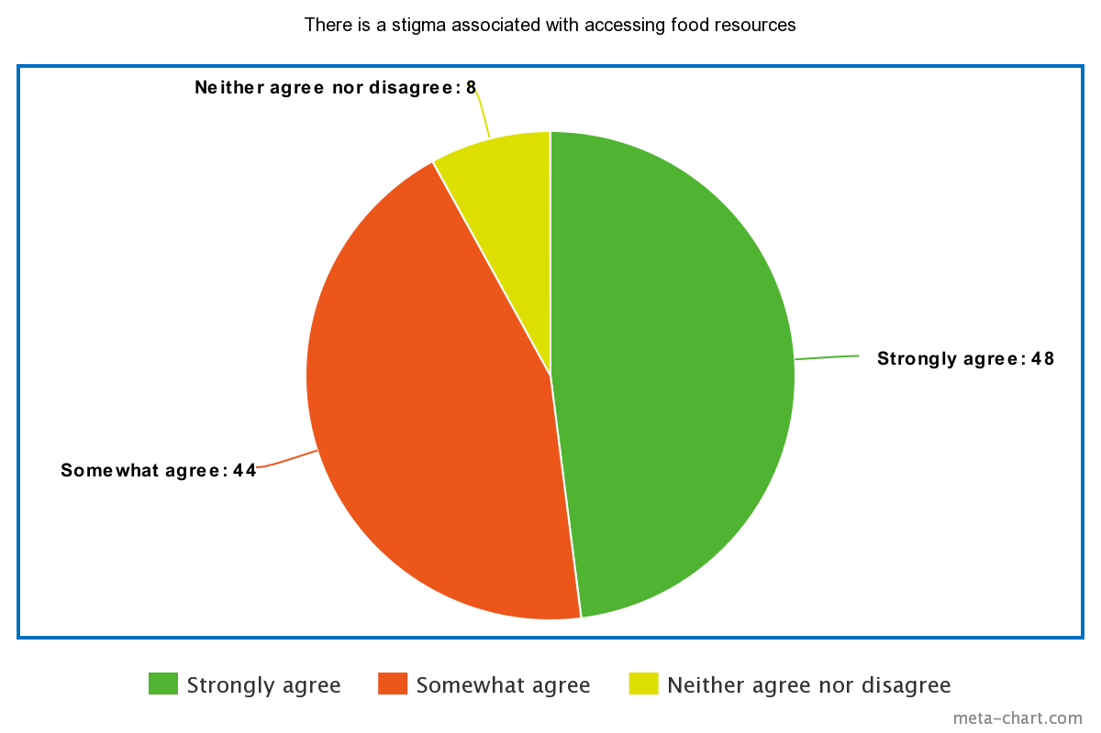
Figure 1: Student opinions on the stigma associated with accessing food resources.

Importance for Food Accessibility Resources at UBC

44% of students stated that it was extremely important for UBC to provide food accessibility resources and 4% of students somewhat agreed with the statement. 8% felt neutral while 4% somewhat disagreed. Overall, these results suggest that the availability of food accessibility resources is an essential component on campus and provide vital support to those in need.

Significance of Information and Updates regarding Food Accessibility Resources

When asked whether students agreed that it was helpful to receive information and updates about UBC food accessibility resources, 36% of students indicated that they strongly agree, 36% of students indicated that they somewhat agree, and 28% were neutral (Figure 2). Furthermore, students were asked to rank their preference in receiving updates regarding student resources and social media was the top choice for many respondents. Digital newsletters, physical posters, and the UBC website followed closely behind, while other methods included, in class lecture announcements, Piazza discussion board posts, and student club announcements. These results suggest that students value the ability to remain connected to the student network and in receiving news regarding student resources.

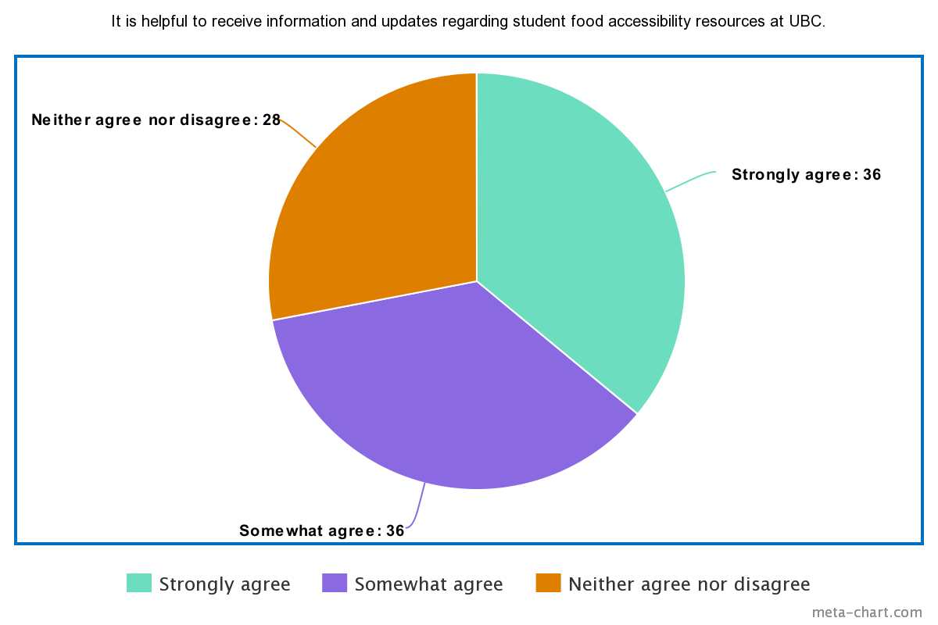
Figure 2: Student opinions of the importance of receiving information and updates regarding UBC food accessibility resources.

Summary of Secondary Research

According to results from the 2019 AMS Student Experience survey (AMS, 2019), which received 2926 responses from UBC students, approximately 45% of undergraduate students have reported concern about their ability to feed themselves, including 16% who reported experiencing this challenge monthly. For the graduate student population, 40% of graduate students report having been concerned about their ability to feed themselves, while 17% of graduates report experiencing this challenge on a monthly basis. This indicates a growing concern in food affordability and access within UBC.

Moreover, research studies state that the most significant barriers for student food bank access include, social stigma, lack of knowledge on food bank policies, and inconvenient hours (El Zein, et al., 2018). To reduce barriers affecting access, many studies outline the benefit of raising awareness on campus-based programs and educating students on their eligibility and the policy associated with student food banks (Hagedorn-Hatfield, et al., 2022).

Data Section 2: Barriers for access and awareness of the AMS Food Bank among students

Current Stigma Surrounding Accessing Food Accessibility Resources

Despite the availability of the AMS Food Bank for students on campus, many students still face the stigma of accessing this resource due to societal perceptions, such as the attitude and stereotypes towards individuals experiencing financial hardship. Additionally, many students may feel isolated and alone in the struggle of food insecurity due to lack of awareness, which contributes to the reluctance to seek assistance.

Limited Funding Opportunities

According to recent UBC and AMS financial reports, the AMS Food Bank currently receives $89,350.00 in funding from AMS (AMS, 2022) and $25,000 in funding from the UBC President’s Office (UBC, 2022). However, in recent months, funding from the UBC President’s Office was reduced from $90,000 to $25,000 (Asuncion, 2022). The funding provided to the food bank allows staff to maintain essential operations, such as food sourcing, staff salaries, administrative expenses, etc. As need continues to increase among food insecure students, more funding is required to sustain operations and meet demand.

Low Food Security Initiative Engagement and Involvement among Students

The AMS Food Bank primarily relies on student support and involvement to maintain operations, such as supervising the overall food bank, restocking supplies, etc. However, with a lack of awareness as well as current stigma associated with accessing food accessibility resources, there is potential for reluctance to be involved in food security initiatives.

Data Section 3: Proposed Solution and Feasibility

Feasibility of Increasing Funding for the AMS Food Bank

The possibility for increased funding for the AMS Food Bank creates greater opportunities for access and awareness. With an increased budget, the food bank can potentially enhance overall student education on the importance of food accessibility resources. Additionally, there would be sufficient means to look into improving operations, such as increased hours, or sourcing culturally safe foods to improve the experience for students in need. However, it is also important to consider several factors, such as the ability to reallocate funding to increase support as well as assessing the current demand for the AMS Food Bank. One opportunity to address increased funding is to consider external grants or donations from philanthropic organizations or partner with community food banks for greater resources.

Potential Benefits of Increased Promotion of the AMS Food Bank

The potential benefits of increasing promotion of the AMS Food Bank includes challenging the stigma of accessing food accessibility resources as well as increasing engagement and involvement with food accessibility initiatives. By increasing awareness and engagement with the AMS Food Bank and other food accessibility resources, students are more informed about the community of support available and the importance of these resources. This can help students feel more comfortable accessing food accessibility resources in a safe and supportive environment. Furthermore, increasing involvement to the AMS Food Bank can encourage a community of students in supporting each other during times of need. It also serves as motivation for students to be involved in other food security initiatives and raise awareness of their impact and availability.

Conclusion

Summary and Overall Interpretation of Findings

Overall, student awareness and demand for the AMS Food Bank is quite strong and will continue to remain in demand as cost-of-living increases. Many student respondents were also aware of the stigma present in accessing food resources, but continue to value the opportunity to receive information regarding updates on resources. Additionally, results from secondary research aligned with the statements of student food insecurity becoming a growing concern on campus. These results emphasize the importance of creating equitable, inclusive, community-focused solutions for access to challenge current stigma and increase understanding and opportunity for all students.

Recommendations for Improving Access and Awareness for the AMS Food Bank

Drawing from analysis of survey responses as well as the summary of secondary sources, such as literature reviews, the following recommendations are proposed to improve access and awareness to the AMS Food Bank:
- Adjust funding and budget to support AMS Food Bank operations, including promotion, food sourcing, administrative duties, etc. by considering external grants, donations, and community partnerships.
- Increase promotion to the AMS Food Bank through social media, digital newsletters, physical posters as well as lecture and student club announcements.
- Introduce education campaigns to raise awareness on the vital importance of food accessibility resources to challenge current stigma while also promoting a positive and supportive community of students.

References (MLA)

AMS. 2019, 2019 Academic Experience Survey Report.

AMS. “Financial Reports.” AMS of UBC, 2 Nov. 2022, https://www.ams.ubc.ca/about-us/finances/financial-reports/.

AMS. “Food Bank.” AMS of UBC, 17 Feb. 2023, https://www.ams.ubc.ca/support-services/student-services/food-bank/.

Carry, A., Dolf, M., Parr, A., Rideout, C., Buszard, D., & Thistle, B. M, Addressing Food Insecurity at UBC, 2019, September 18. http://bog3.sites.olt.ubc.ca/files/2019/09/8.3_2019.09_Addressing-Food-Insecurity.pdf

El Zein, Aseel et al. “Why Are Hungry College Students Not Seeking Help? Predictors of and Barriers to Using an On-Campus Food Pantry.” Nutrients vol. 10,9 1163. 25 Aug. 2018, doi:10.3390/nu10091163

Food and Agriculture Organization (FAO). The State of Food Security and Nutrition in the World 2018: Building Climate Resilience for Food Security and Nutrition. United Nations, 2019.

Hagedorn-Hatfield, Rebecca L et al. “A Decade of College Student Hunger: What We Know and Where We Need to Go.” Frontiers in public health vol. 10 837724. 25 Feb. 2022, doi:10.3389/fpubh.2022.837724

Health Canada. “Government of Canada.” Canada.ca, / Gouvernement Du Canada, 18 Feb. 2020, https://www.canada.ca/en/health-canada/services/food-nutrition/food-nutrition-surveillance/health-nutrition-surveys/canadian-community-health-survey-cchs/household-food-insecurity-canada-overview.html.

UBC. “Financial Reports.” Financial Reports | UBC Finance, 2022, https://finance.ubc.ca/reporting-planning-analysis/financial-reports.

