Extending Ergonomic Setup at UBC: an Assessment of Ergonomic Benefits and Feasibility of Implementation

for
Dr. Ainsley Carry
UBC Vice-President, Students
University of British Columbia

by
Sangita Dutta
English 301 Student

March 29, 2023

Abstract
Ergonomics is defined as the scientific study of the interaction between the workplace environment and human capabilities, aiming to optimize human health and performance.
This report examines the benefits of proper ergonomics on students’ health and well-being, investigating awareness of ergonomic effects and opinions on the current setup in University of British Columbia (UBC) study spaces. The impact of poor ergonomics on health and productivity is discussed and the significance of ergonomics in creating a safe, comfortable, and productive workplace is emphasized. The current study spaces in UBC are evaluated by 26 UBC students. The results demonstrates that discomfort is experienced by students for the current study setup. This report also provides recommendation for the successful implementation of ergonomic setups to promote students’ well-being and productivity at UBC.

Introduction
Definition of Ergonomics
Ergonomics is the scientific study of the interaction between the workplace environment and human’s physical, physiological, biomechanical, and psychological capabilities (Fernandez, 1995). The goal of ergonomics is to optimize human health, performance and reduce risk of injury, discomfort, and stress through safe, comfortable, and efficient work-place designs (Fernandez, 1995). The application of ergonomic principles in the workplace have been found to increase worker’s productivity, health, job satisfaction, and work quality (Fernandez, 1995).

Background information on the Impact of Ergonomics on one’s health and well-being
The impact of ergonomics on one's health and well-being can be significant. Poor ergonomics can lead to a range of health problems, including musculoskeletal disorders, repetitive strain injuries, and fatigue. It can also lead to reduced productivity and increased absenteeism from work. Musculoskeletal disorders are among the most common health problems associated with poor ergonomics. These include back pain, neck pain, shoulder pain, and carpal tunnel syndrome. These conditions can be caused by poor posture, repetitive motions, and awkward positions. In contrast, good ergonomics can help to prevent these problems and promote overall health and well-being. For example, ergonomic chairs can help to reduce back and neck pain, while adjustable workstations can help to reduce the risk of repetitive strain injuries. By designing products and work environments with ergonomics in mind, employers can help to create a safer, more comfortable, and more productive workplace for their employees (Singh & Wadhwa, 2006).

Description of the current setup in UBC study spaces
The University of British Columbia is an internationally renowned educational institution that welcomes thousands of students to its beautiful campus every year. While the aesthetic appeal of the campus is undoubtedly impressive, it is crucial to recognize that universities are primarily meant to be functional learning environments. As students devote considerable amounts of time studying and completing assignments on campus, UBC has a fundamental duty to ensure that its learning environment is conducive to its student’s health and well-being. Currently, UBC has an abundance of study spaces available, including Irving K. Barber Learning Centre, Walter C. Koerner Library, and Woodward Library. However, most of these facilities are fairly outdated with non-adjustable chairs that are often wooden. These chairs are hard, uncomfortable and usually at an awkward height from the table. This may cause disruptions in student’s workflow and decrease their productivity. It also discourages them from wanting to study on campus.
To change this, UBC can prioritize ergonomic setups in study areas to provide students with a comfortable and safe study environment to promote their well-being, prevent long-term musculoskeletal injuries, and maximize productivity. In addition, with the rising reliance on technology and the transition towards online and remote learning, ergonomic study setups have assumed greater significance than ever before.

Purpose of Report
The purpose of this report is to assess the benefits of proper ergonomics on various dimensions of student’s health, investigate student’s awareness of the effects of ergonomics and an opinion on the current setup, as well as the feasibility of implementing ergonomic setups at UBC.

Research Methods
Primary data source will include data pulled from an online survey to gather UBC student’s knowledge and opinion on ergonomic study setups. For this report, 26 student responses were recorded. Secondary data source will come from published journal articles on the importance and benefits of having an ergonomic setup.

Scope of Inquiry
To assess the feasibility of adding more ergonomic setups in student study areas at UBC, I plan to assess the following areas of inquiry:
- What can be improved about the existing setup in the study areas at UBC?
- How do students feel about adding more ergonomic setups?
- Do students know the importance and benefits of ergonomic setups?
- What type of ergonomic setups would students most like to see on campus?
- Which type of ergonomic setups would best fit students?
- Are there any drawbacks to adding more ergonomic setups?
- What is the estimated cost of implementation/ renovation?

Data Section A: Evaluation of current study setup in UBC study spaces
To evaluate the ergonomics of a study setup, ergonomics specialists typically assess whether the setup promotes comfortable, safe, and efficient use of equipment and space. This can involve looking at the design and arrangement of furniture, computer equipment, and other tools, as well as assessing how people interact with these items (SPI Canada, 2015). For the purpose of this report, three UBC libraries - Irving K. Barber Learning Centre, Walter C. Koerner Library, and Woodward Library - were observed and evaluated on the level of comfort in ergonomics.
Pros and Cons of Current Setup
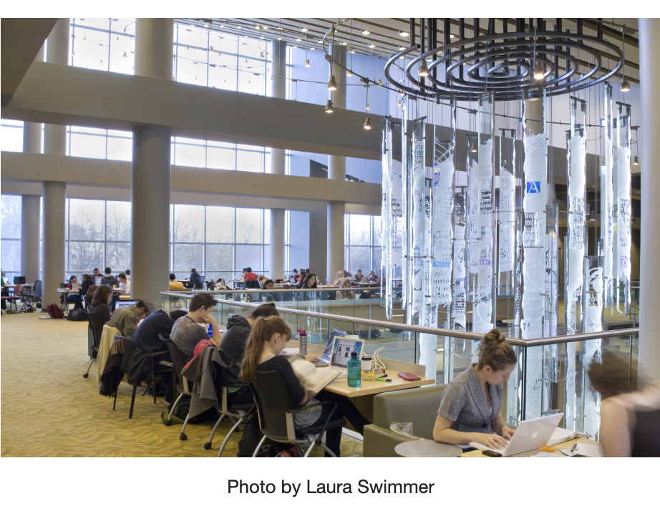
Figure 1. Example of study setup at Irving K. Barber Learning Centre

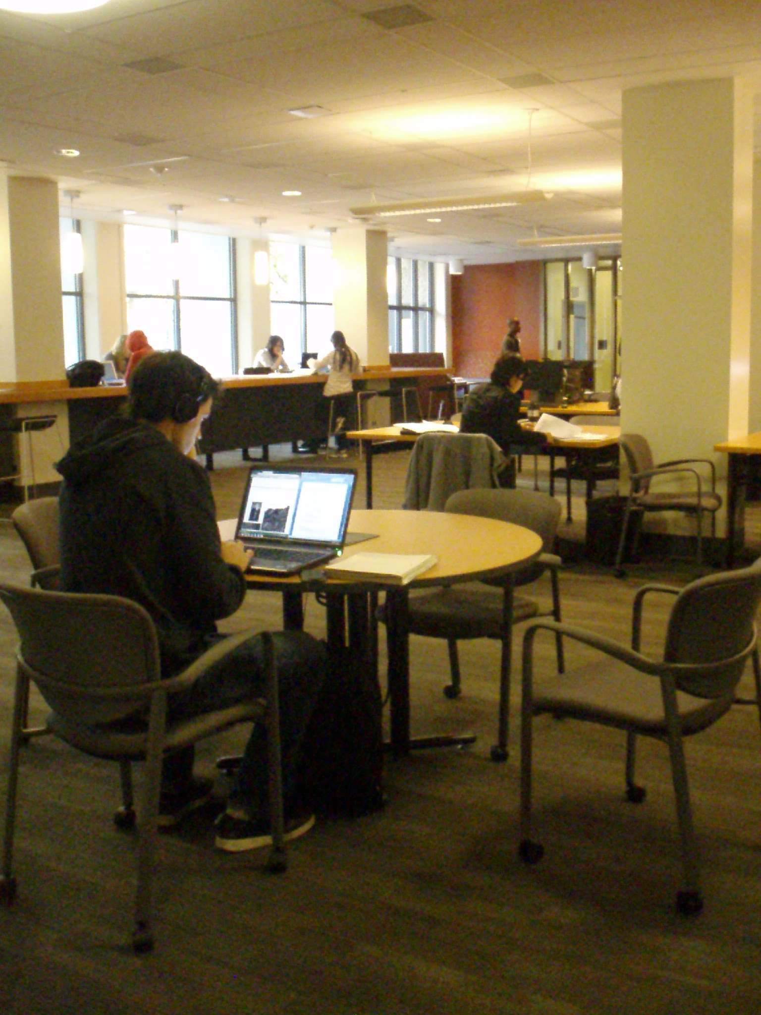
Figure 2. Example of study setup at Woodward Library
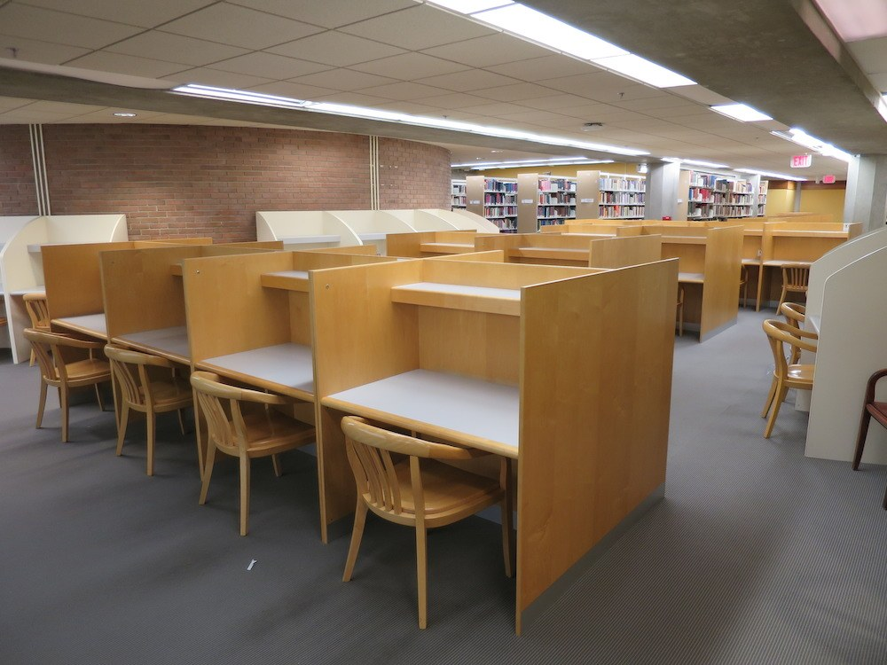
Figure 3. Example of study setup at Walter C. Koerner Library

From Figure 1, 2 and 3, it is observed that the UBC libraries have a variety of different study setups. Having different seating options is beneficial as it can help students find a comfortable position that suits their individual needs, reducing the risk of physical discomfort and promoting overall well-being. This may help students feel more comfortable and engaged in their learning.
However, from Figure 1 and 2, it can be observed that students are sitting with very poor posture - rounded shoulders and hyper-flexing their necks because they must look down in order to see their screen. There are an abundance of empirical data providing support that a correct sitting at a desk should include:
- Screen at eye level to prevent neck strain.
- Sitting upright to prevent spinal stress.
- Relaxed shoulders with elbows at 90 degrees.
- hips are level with your knees and your feet are flat on the ground or on a footrest.
Improper sitting posture can be encouraged by non-ergonomic chair or desk designs; therefore it is important to implement designs that allow for comfortable use of study setup over extended periods of time.

Student Opinion on Current Setup
Comfortableness of Current Study Setup
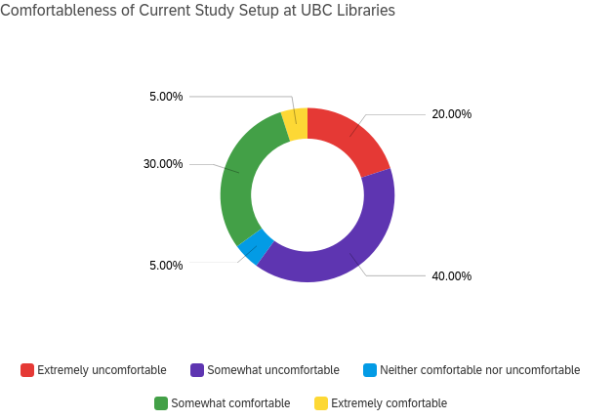
Figure 1a.
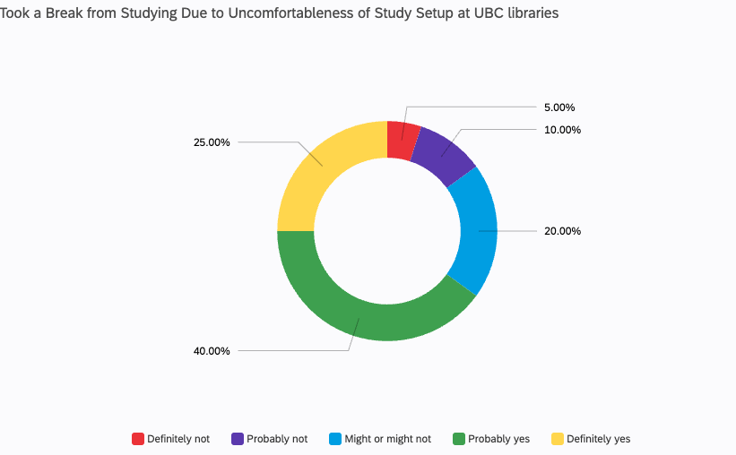
Figure 1b.
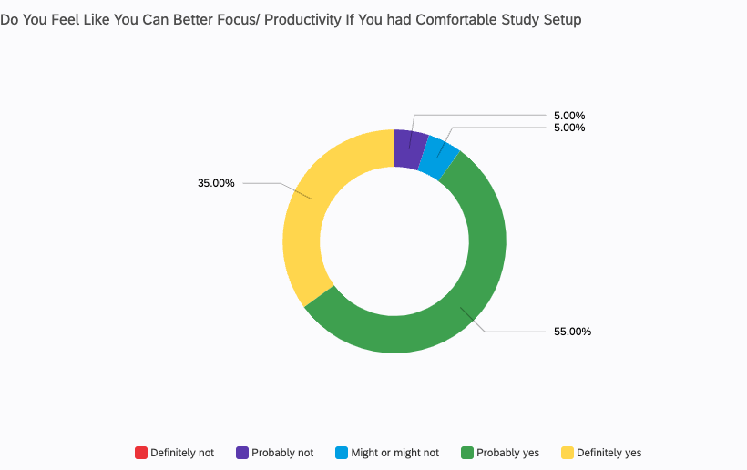
Figure 1c.
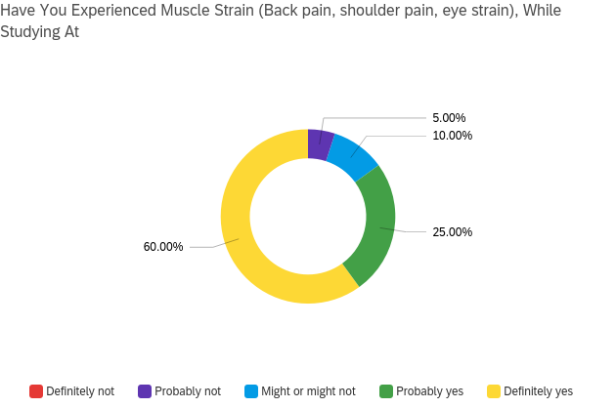
Figure 1d.
When asked about the comfortableness of the study setup at UBC libraries, 40% of the 26 recorded student responses stated that it was somewhat uncomfortable, and another 20% stated it was extremely uncomfortable. 65% of the surveyed students indicated that they have had to take a break from studying because the setup was uncomfortable. 75% indicated that they have experienced muscle strain while studying at UBC study areas. Moreover, 55% of students stated that they will probably be more productive if the study setup was more comfortable, and another 35% asserted that they will definitely be more focused and productive. This result clearly indicates that the current study setup at UBC libraries is not optimal for students and is causing discomfort and physical strain. A significant number of students reported having to take breaks from studying due to the uncomfortable setup, which can have a negative impact on their academic performance. The majority of students expressed a desire for a more comfortable setup, with a substantial portion indicating that it would likely improve their productivity and focus. These findings suggest that UBC libraries may benefit from reevaluating and improving their study areas to better accommodate students' needs and enhance their overall academic experience.

Student Awareness and Knowledge of Ergonomics
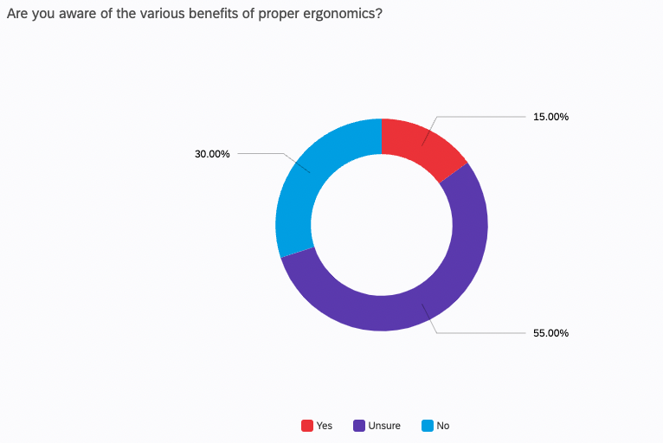
Figure 2a.
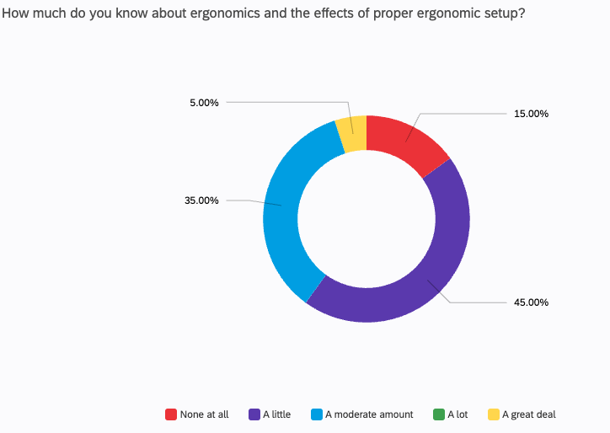
Figure 2b.
When students were asked about how much they know about the effects and benefits of proper ergonomics, an overwhelming majority said they had little to no knowledge. This demonstrates that there is a significant lack of awareness and education regarding the importance of proper ergonomics among students. This is concerning, as poor ergonomics can lead to long-term health problems, including musculoskeletal disorders, and can have a negative impact on academic performance. It is important for educational institutions to prioritize educating students on the benefits of proper ergonomics and providing them with the necessary resources and tools to maintain good posture and prevent discomfort and injuries. By doing so, students can develop healthy habits early on, which can benefit them throughout their academic and professional careers.

Student Opinion on Adding Ergonomic Setups at UBC
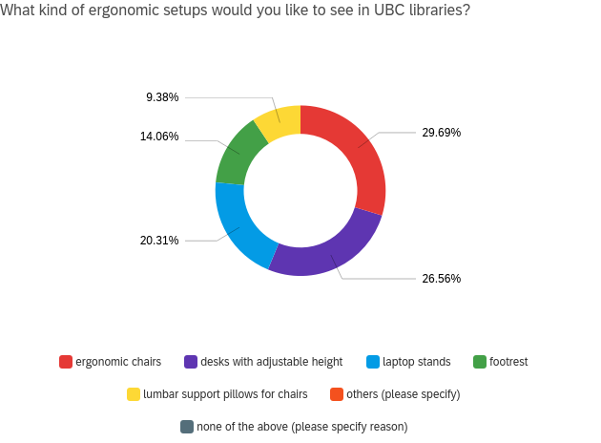
Figure 3a.

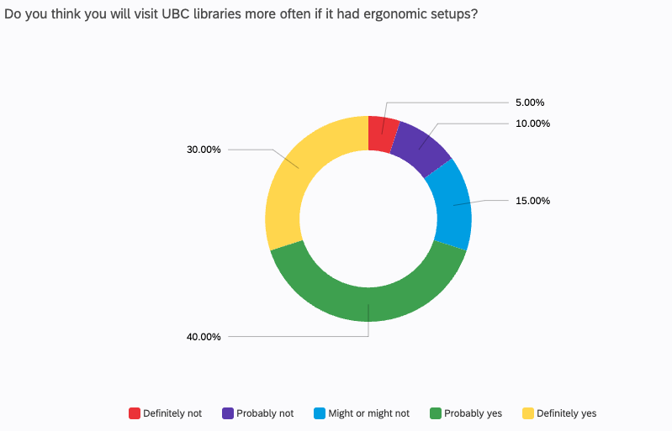
Figure 3b.

When students were asked whether they would visit UBC libraries more often if it had more ergonomic setups, 70% expressed that they would. They would also like to see ergonomic chairs, desks with adjustable height, and laptop stands. This highlights the potential impact that investing in ergonomic setups can have on student engagement and utilization of study spaces. By incorporating these types of ergonomic features, UBC libraries could create a more comfortable and accommodating environment that would appeal to a larger proportion of the student body. This could ultimately lead to increased usage of the library facilities and a more positive and productive experience for students. Additionally, by listening to student feedback and incorporating their needs and preferences into the design of study areas, UBC libraries can demonstrate their commitment to promoting student well-being and success.

Data Section B: Benefits of Proper Ergonomic Setup for a Student
Implementing proper ergonomic setup in a study environment can provide several benefits for students in terms of their health and well-being, injury prevention, and productivity. From a health perspective, ergonomic setups can help students maintain good posture, reduce discomfort, and prevent long-term musculoskeletal problems such as back and neck pain. Additionally, ergonomic setups can help students prevent eye strain and headaches by providing appropriate lighting and minimizing glare. Furthermore, ergonomic setups can help prevent injuries by reducing the risk of repetitive strain injuries and other injuries caused by poor posture. By incorporating ergonomic setups, students can also improve their productivity by reducing the amount of time lost due to discomfort or pain. They can work for longer periods of time without experiencing fatigue or discomfort, leading to increased focus, concentration, and productivity. Overall, implementing proper ergonomic setups can contribute to students' overall health, reduce the risk of injury, and enhance their productivity and academic performance (Singh & Wadhwa, 2006).
Data Section C: Best type of ergonomic setup for a student
There is no one-size-fits-all approach when it comes to selecting the best type of ergonomic model for students, as individual needs and preferences may vary. However, based on relevant literature on the proper ergonomics for desk workers, there are some key features and considerations that can help guide the selection process. One important factor to consider is adjustability. The ideal ergonomic setup should be adjustable to accommodate the individual needs and preferences of the student, such as adjustable desk height, adjustable chair height and tilt, and adjustable monitor position. This can help ensure proper alignment and reduce strain on the body (Chandra et al., 2016). Another factor to consider is comfort. The ergonomic setup should be comfortable for the student to use for extended periods of time, with appropriate padding and support for the back, arms, and wrists (Chandra et al., 2016). In terms of specific models, some popular options for ergonomic setups for students include standing desks, sit-stand desks, ergonomic chairs, and laptop stands. Ultimately, the best type of ergonomic model for students is one that is tailored to their specific needs and preferences, with adjustable features, comfortable design, and appropriate support for their body (Chandra et al., 2016).

Data Section E: Logistics of Implementing Ergonomic Setup at UBC
Location of Implementation
Ideally, all study setups UBC should be renovated to be more ergonomic for its students. However, it may be more feasible to pick one of the three major libraries and implement ergonomic setups in one study area before implementing it in all areas. An optimal choice would be the Irving K. Barber Learning Centre as it is one of the newest study spaces on campus, so it would be more straightforward to implement something new in this space, such as one of the silent study rooms. By starting with one library, the university can test out the effectiveness of the new ergonomic setups, gather student opinion, and make necessary adjustments before expanding to other areas.

Cost Analysis
The overall cost of implementing ergonomic setups at a university can vary widely depending on the scope of the project. Some of the potential costs associated with implementing ergonomic setups could include:
- Equipment and Furniture Costs: This includes the cost of adjustable chairs and desks, monitor stands, and other ergonomic equipment.
- Installation Costs: This includes the cost of installing the equipment and furniture, which may require hiring contractors or specialized personnel.
- Training Costs: This includes the cost of training staff and students on the proper use of the new ergonomic equipment and furniture to ensure that they are being used effectively.
- Maintenance Costs: This includes the cost of repairing or replacing any equipment or furniture that may break or wear out over time.
- Disposal Costs: This includes the cost of disposing of any old or outdated equipment or furniture that is being replaced by the new ergonomic setups.

Potential Drawbacks
While there are many potential benefits to implementing ergonomic setups at a university, there are also some potential drawbacks that should be considered. These include:
- Cost: As mentioned earlier, the cost of implementing ergonomic setups can be significant, particularly for larger universities like UBC. This may require diverting resources from other areas of the university's budget.
- Resistance to Change: Some students and staff may resist the changes to their study or work environments, particularly if they are used to the current setups. This may require additional communication and education efforts to help them understand the benefits of the new ergonomic setups.
- Space Limitations: Some study areas may have limited space available, making it difficult to implement certain ergonomic solutions such as standing desks or larger chairs.
- Accessibility: While ergonomic setups can benefit many people, they may not be accessible or suitable for everyone. For example, students with disabilities or mobility issues may require different types of setups that may be more expensive or difficult to implement.

Overall, it is important to carefully consider the potential drawbacks of implementing ergonomic setups at a university, and to weigh them against the potential benefits. With proper planning, communication, and maintenance, however, ergonomic setups can greatly improve the study and work environments at a university and contribute to the overall health and well-being of students.

Conclusion
Summary and Overall Interpretation of Findings
The overall finding suggests that a significant number of UBC students find the current study setups uncomfortable, with a majority reporting experiencing physical strain and having to take breaks from studying as a result. These findings indicate that the current setup may negatively impact academic performance. However, the study also reveals that a substantial proportion of students believe that a more comfortable setup would likely improve their productivity and focus. It also suggests that there is a significant lack of awareness and education among students regarding the importance of proper ergonomics. This lack of knowledge is concerning, as poor ergonomics can lead to long-term health problems and negatively impact academic performance. The study highlights the need for educational institutions to prioritize educating students on the benefits of proper ergonomics and providing them with resources and tools to maintain good posture and prevent discomfort and injuries. Lastly, the results suggest that a significant proportion of UBC students would visit the libraries more often if they had more ergonomic setups, with 70% expressing that they would. The study also identified specific ergonomic features that students would like to see, such as ergonomic chairs, adjustable-height desks, and laptop stands. These findings highlight the potential impact that investing in ergonomic setups can have on student engagement and utilization of study spaces. By incorporating these features, UBC libraries could create a more comfortable and accommodating environment that appeals to a larger proportion of the student body, potentially leading to increased library usage and a more positive and productive experience for students.

Recommendations for successful implementation of ergonomic setups at UBC
Based on the prompts above, the following recommendations can be made for the successful implementation of ergonomic setups at UBC:
- Conduct a cost analysis to determine the feasibility of implementing ergonomic setups in one area of the UBC library for initial implementation.
- Provide educational materials and training sessions for students and staff on the importance of proper ergonomics and how to use the new ergonomic equipment correctly.
- Incorporate the specific ergonomic features that students have identified, such as ergonomic chairs, adjustable-height desks, and laptop stands.
- Continuously monitor and assess the effectiveness of the new ergonomic setups and gather feedback from students to make improvements.
- Consider collaborating with experts in ergonomics to ensure that the implemented setups are evidence-based and meet industry standards.
- Integrate ergonomic design principles into the planning and construction of future study spaces and renovations.

By following these recommendations, UBC can successfully implement ergonomic setups that promote student well-being and academic success.

Appendix
Survey Questions
- Q1: Which common study areas/ libraries have you studied in at UBC? (Select all that apply)
- Q2: How often do you use the common study areas/ libraries at UBC?
- Q3: How comfortable do you find the current study setup at the study areas/ libraries you have studied in at UBC?
- Q4: Have you ever felt that you had to take a break from studying because the chair/ desk setup is uncomfortable at the study areas/ libraries you have studied in at UBC?
- Q5: Do you feel like you can have better focus/ productivity when you have a comfortable study setup?
- Q6: Have you ever experienced muscle strain (e.g. back pain, leg pain, eye strain) and/or restlessness while studying at one of UBC's study facilities?
- Q7: How much do you know about ergonomics and the effects of proper ergonomic setup?
- Q8: Are you aware of the various benefits of proper ergonomics on your health and wellness?
- Q9: If you can choose, what kind of ergonomic setups would you like to see in study areas/ libraries at UBC? (Select all that apply)
- Q10: Do you think you will use study facilities at UBC more frequently if it had more ergonomic setups?
- Q11: Do you have any questions or anything that you would like to add regarding adding more ergonomic setups at UBC?

References
Chandra, A., P. Chandna, S. Deswal, & Kumar, R. (2016). Ergonomics in the Office Environment: A Review. https://www.semanticscholar.org/paper/Ergonomics-in-the-Office-Environment%3A-A-Review-Chandra-Chandna/fa11f2fc06206bffda840202d2d2309ea2296fd1

Fernandez, J. E. (1995). Ergonomics in the workplace. Facilities, 13(4), 20–27. https://doi.org/10.1108/02632779510083359

Linton, S. J., Hellsing, A.-L., Halme, T., & Åkerstedt, K. (1994). The effects of ergonomically designed school furniture on pupils’ attitudes, symptoms and behaviour. Applied Ergonomics, 25(5), 299–304. https://doi.org/10.1016/0003-6870(94)90044-2

Shin, S.-J. H., & Aburas, R. (2014). A Study of College Studying/Seating Areas from an Ergonomics Perspective. The International Journal of Learning in Higher Education, 20(1), 13–21. https://doi.org/10.18848/1447-9494/cgp/v22i01/58969

Singh, S., & Wadhwa, J. (2006). Impact of Computer Workstation Design on Health of the Users. Journal of Human Ecology, 20(3), 165–170. https://doi.org/10.1080/09709274.2006.11905922
SPI Canada. (2015). SPI Canada. https://www.spi.com/

