Feasibility Analysis of Installing a Mirror Inside Each Change Room at Aritzia

for
Pippa Morgan
Executive Vice President
Retail Division, Aritzia
Vancouver, British Columbia

by
Angie Zhou
University of British Columbia
ENGL 301 Student

March 28, 2023

TABLE OF CONTENTS

INTRODUCTION........……...…...…………..…………..…………..……...…….……..…….1
- Background……….....…………………..…………..…………..………..……….……1
- Statement of problem....……………………..…………..………………..…...…...…....1
- Purpose of this report and intended audience...…………………..………..……..…….1
- Description of data sources……..…………....…………………..………...……..…….2
- Scope of inquiry……..…………………..…………..……………...………….………2

DATA SECTION….....…………..…………..…………..…………..………….……..………2
- Costs and Places to Purchase Mirrors..………………………………………………...2
- Survey Results.….........…………..…………..……………..………….……..………..2
  - Area of focus and objective…………..……………..………….……..………..2
  - Current Aritzia customers’ preferences and perspectives….…………………..3
- Proposed Solutions.......…………..…………..……………..………….……..…….....10
  - Installing a mirror inside each change room.……..……………..…………….10

CONCLUSION..…........………..…………..…………..…………..………….……..…….….11
- Summary and interpretation of results...………..……………..……………..………..11
- Recommendations.......…………..…………..……………..………….……..………..11

INTRODUCTION
- Background
Aritzia is a popular Canadian fashion brand that mainly caters to women of all ages. The brand offers a mix of both in-house and third-party designs, with a focus on creating high-quality clothing that is both versatile and timeless. Aritzia places a strong emphasis on customer service and has implemented several initiatives to enhance the customer experience. Some ways that Aritzia tries to deliver excellent customer service include personalized styling, easy returns, efficient customer support, and an engaging shopping experience.

Despite the brand's efforts and popularity, customers often express concerns about the change room experience. Rather than incorporating a mirror inside each change room, Aritzia places one large mirror in the shared space outside the change rooms to be used amongst all customers. Although this may be a sales tactic to provide sales representatives the opportunity to style customers with more items or flatter customers into buying, customers may find the lack of privacy unsettling.

- Statement of Problem
Despite Aritzia's effort to provide customers with a unique and personalized shopping experience, many customers have expressed concerns about the change room design and experience. By implementing a single mirror in a shared space outside the change rooms instead of equipping each individual change room with a mirror, customers' ability to try on clothes comfortably in privacy is limited. As a result, customers may buy items without first trying them on, which may lead to increased number of purchase returns and a less efficient shopping experience. Overall, the current Aritzia change room design may discourage customers from trying on clothes and ultimately decrease customer satisfaction.

- Purpose of report and intended audience
This report aims to address customer concerns about the change room design at Aritzia and to assess the feasibility of installing a mirror inside each Aritzia change room to improve customer experience and satisfaction. Since Aritzia prides themselves on creating immersive and outstanding shopping experiences, the main goal of this report it to improve customer experience and satisfaction shopping at Aritzia. This report is intended for Pippa Morgan, the Executive Vice President of Retail at Aritzia. As a member of the Aritzia executive team and a leader in retail, Pippa Morgan oversees the company’s commitment to creating exceptional shopping experiences and building lasting relationships with its clients.

- Description of data sources
To determine the current Aritzia customers’ perspectives on the current Aritzia change room design and to assess the feasibility of installing a mirror inside each Aritzia change room, this report considers primary data sources collected from an anonymous online survey. This survey was completed by 23 current Aritzia customers. Secondary sources for this report include online research pertaining to the costs and best places to purchase full-length mirrors.

- Scope of Inquiry
This report focuses on improving customer experience and satisfaction at Aritzia. These findings may be applied more generally to improve customer experiences at other clothing stores, although the primary sources used in this report surveys current customers of Aritzia only.

DATA SECTION
- Costs and Places to Purchase Mirrors
The cost of full-length mirrors varies. For example, the Arch Metal Floor Mirror on the Wayfair website retails for $206.99 CAD. This mirror is grand and elegant, which perfectly fits Aritzia’s aesthetics. In contrast, cheaper options, such as the UNIVERSITY Full Length Mirror on the JSYK website, retails for as low as $12.99 CAD. Alternatively, the Jarrett Rectangle Wood Floor Mirror by Wayfair is a good in-between option that is relatively aesthetic while retailing for a slightly lower price of $99.99 CAD. However, unlike the other mirrors, this mirror cannot be mounted on a wall. For a mirror with a similar wood-like aesthetic but that can be mounted, the Full-Length Mirror with Wood-Like Frame by Bouclair is a good option. It retails for $149.99 and is slightly larger in width and height.

- Survey Results
  - Areas of focus and objective
Current Aritzia customers were surveyed to determine the current customers’ preferences and perspectives on the current Aritzia change room design. The survey asked customers about their opinions regarding their satisfaction with the current Aritzia change room design and comfortability with using a communal mirror, as well as their preference for having a mirror inside change rooms or not. The survey also asks whether not having a mirror inside the Aritzia change rooms impacts their overall shopping experience at Aritzia, and their overall opinions about the current Aritzia change room design.

  - Current Aritzia customers’ preferences and perspectives
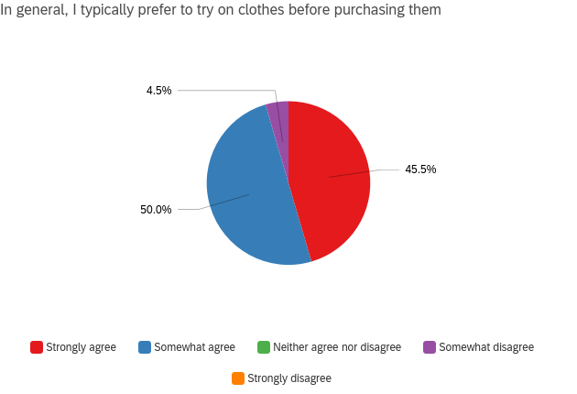
Figure 1. Customer preferences in regards to trying on clothes before purchasing

According to the data collected from the anonymous survey, nearly all survey respondents said that they either strongly agree (45.5%) or somewhat agree (50%) to the statement, “In general, I typically prefer to try on clothes before purchasing them” (Figure 1). On the other hand, only 4.5% of respondents said that they somewhat disagree with this statement (Figure 1).
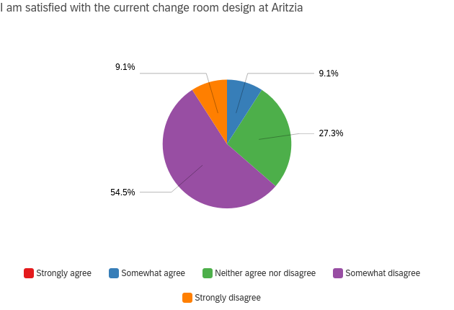
Figure 2. Customer satisfaction with the current Aritzia change room design

The majority of survey respondents said that they strongly disagree (54.5%) with the statement, “I am satisfied with the current change room design at Aritzia” (Figure 2). This is supported by the responses to the survey question that asks for overall opinions about the current change room design at Aritzia, which included “mediocre.”

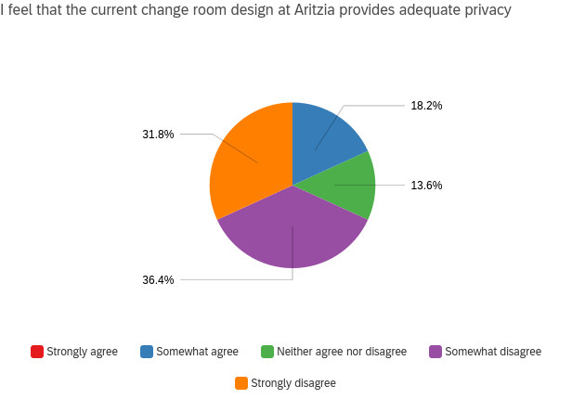
Figure 3. Customer perspectives on the current Aritzia change room design in regards to privacy

As indicated above, more than half of the respondents said that they either somewhat disagree (36.4%) or strongly disagree (31.8%) with the statement, “I feel that the current change room design at Aritzia provides adequate privacy” (Figure 3). This is supported by the responses to “overall opinions about the current change room design at Aritzia,” which included that “the current change room design at Aritzia offers minimal privacy.”

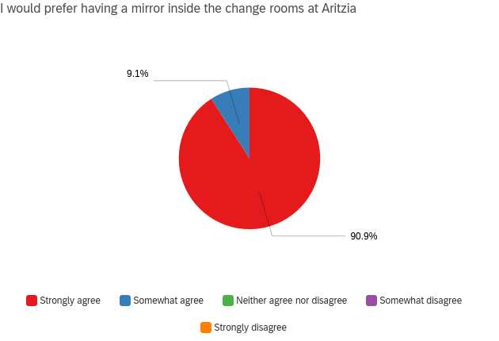
Figure 4. Customer preferences in regards to having a mirror inside the change rooms at Aritzia

90.9% of respondents strongly agreed with the statement, “I would prefer having a mirror inside the change rooms at Aritzia” (Figure 4). The remainder of the respondents (9.1%) somewhat agreed with this statement (Figure 4). This is supported by the responses to “overall opinions about the current change room design at Aritzia,” which included that “mirrors inside the changing room would be a welcome addition” and the change current change room design at Aritzia “could be better with mirrors” as it would be “more convenient,” “more spacious,” and “a more comfortable experience.” One respondent also mentioned that having a mirror inside the change rooms would allow customers to “try out intimate wear like sports bras.” Additionally, another respondent said “more time is used going in and out of the change rooms to look at the shared mirror.” However, one respondent said it’s “not a super big deal to have mirrors inside the changing room” although it would be preferred.

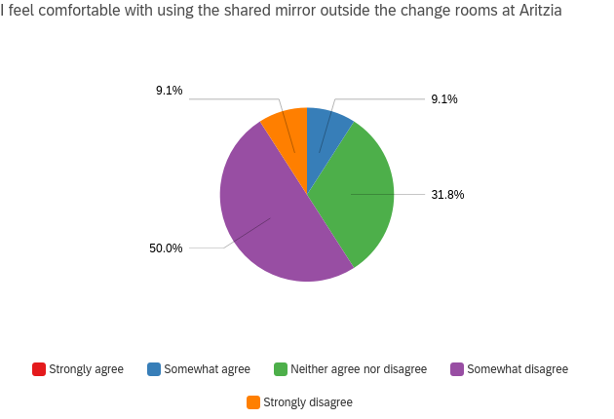
Figure 5. Customer perspectives on using a shared mirror outside the change rooms at Aritzia

Half of the respondents somewhat disagreed with the statement, “I feel comfortable with using the shared mirror outside the change rooms at Aritzia” (Figure 5). This is supported by the responses to “overall opinions about the current change room design at Aritzia,” which included “I am often hesitant to walk out and use the public mirror” since “it gets crowded when it’s busy” and due to “lack of privacy.” One respondent also said “mirrors inside the change rooms would help because I am shy.” Additionally, another respondent said they prefer change rooms with mirrors inside because they “feel exposed otherwise.”
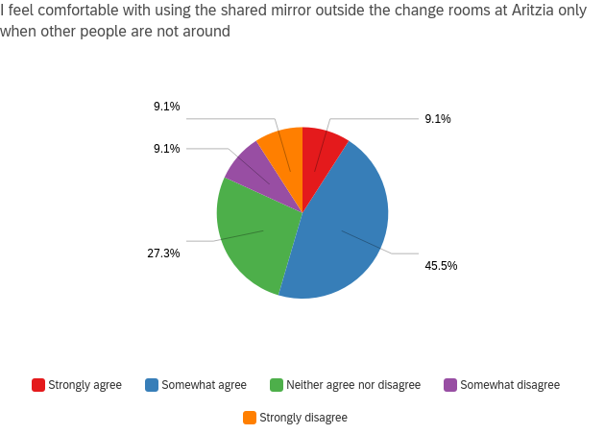
Figure 6. Customer perspectives on using a shared mirror outside the change rooms at Aritzia when other people are not around

The majority of respondents (45.5%) said that they somewhat agree with the statement, “I feel comfortable with using the shared mirror outside the change rooms at Aritzia only when other people are not around” (Figure 6). This is supported by the responses to “overall opinions about the current change room design at Aritzia,” which included “I don’t like being watched by other customers” and “clothes don't always fit right and I don't want other people to see that.” Additionally, one respondent expressed that they “feel uncomfortable when people who are not trying on clothes are in the communal try on area,” “loitering around the area waiting.” Another respondent also expressed, “I do not need the employees to give me their biased opinion.”
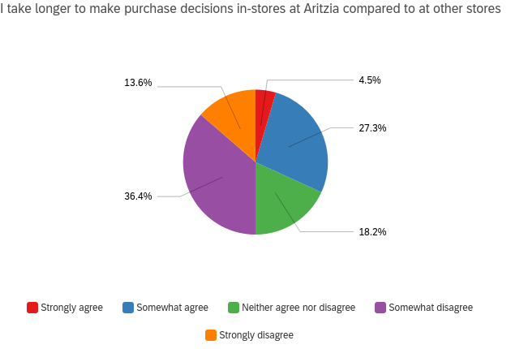
Figure 7. Customer perspectives on time taken to make purchase decisions in-stores at Aritzia compared to at other clothing stores

The statement, “I take longer to make purchase decisions in-stores at Aritzia compared to at other stores,” generated a mixture of responses (Figure 7). This includes 36.4% of respondents who somewhat disagreed with this statement and 27.3% of respondents who somewhat agreed with this statement (Figure 7). In response to “overall opinions about the current change room design at Aritzia,” one respondent stated that communal mirrors make them “feel pressured to make a decision quickly.” Another respondent said that they “feel more confident purchasing when able to try on the clothing” but they “avoid Aritzia’s change rooms knowing they do not have mirrors.” Similarly, another respondent said, “sometimes I try something on but don't look in the mirror if I suspect it won't look nice so I just don't consider buying it.”

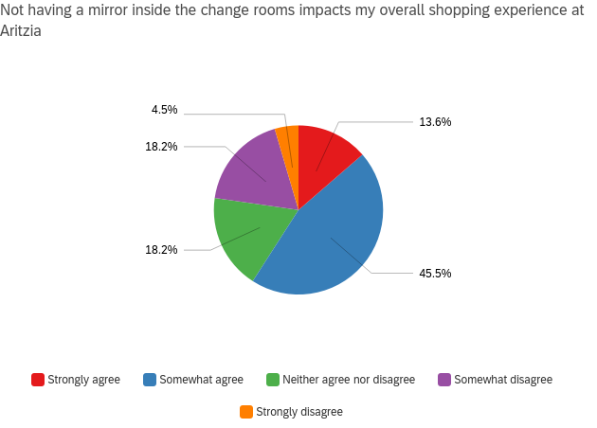
Figure 8. Customer perspectives on how not having a mirror inside the change rooms impacts overall shopping experience at Aritzia

The majority of respondents said that they somewhat agree with the statement, “Not having a mirror inside the change rooms impacts my overall shopping experience at Aritzia” (Figure 8). This is supported by the responses to “overall opinions about the current change room design at Aritzia,” which included “it would be a better shopping experience to have mirrors inside the change rooms.”

- Proposed solutions
  - Installing a mirror inside each change room
Aritzia can enhance its customers’ in-store shopping experience by installing a mirror inside each change room. This would enable customers to try on clothes in privacy, eliminating the discomfort of feeling watched by others. Additionally, this would enable customers to make more informed decisions regarding the item’s fit and appearance on their body, which would allow customers to make more confident purchase decisions. Having a dedicated mirror in each change room would also reduce the time spent going back and forth between the change room and the store floor, which would increase the efficiency of customers’ shopping experiences. Ultimately, installing a mirror inside the change rooms at Aritzia would enhance customer experience and satisfaction.

CONCLUSION
Aritzia should install a mirror inside each change room. The current Aritzia change room design does not implement mirrors inside each change room, and instead, provides a single communal mirror outside the change rooms. Installing a mirror inside each change room would enhance comfortability and increase privacy, which would ultimately improve customer experience and satisfaction. Additionally, the data collected on costs and places to purchase mirrors shows that there are many mirror options available at a wide range of price points, including ones that would suit the aesthetics at Aritzia. Overall, the data suggests that installing a mirror inside each change room at Aritzia is feasible and would be beneficial.

- Summary and overall interpretation of results
Based on the data collected from the anonymous online survey, many Aritzia customers are not satisfied with the current Aritzia change room design. Although many customers typically prefer to try on clothes before purchasing them, they feel discouraged to try on clothes at Aritzia due to discomfort and privacy concerns surrounding the use of a communal mirror. Therefore, current Aritzia customers would prefer to have a mirror inside the Aritzia change rooms. Access to a mirror inside change rooms is also more convenient, prevents overcrowding, and would allow customers to try on intimate wear or clothing outside their comfort zone. However, no consistent pattern of responses was observed in regards to whether customers take longer to make purchase decisions in-stores at Aritzia compared to at other stores. Nonetheless, not having a mirror inside the change rooms ultimately impacts customers’ shopping experience at Aritzia and Aritzia should take action by installing a mirror inside their change rooms. According to the data collected on costs and places to purchase mirrors, the installation of mirrors would be financially feasible.

- Recommendations

This report assessed the feasibility of installing a mirror inside each change room at Aritzia to improve customer experience and satisfaction. Installing a mirror inside each Aritzia change room was determined to be a reasonable method to increase customer privacy and comfort. In general, a greater focus on addressing customer concerns regarding the change room design is important to preventing customers from feeling discouraged to try on clothes at Aritzia. This would allow customers to feel more confident purchasing and enhance customers’ overall shopping experience.

