University of British Columbia

ASSIMILATING AI ETHICS AWARENESS INTO COMPUTER SCIENCE COURSE PROJECTS

Jade Duan
ENGL 301: Technical Writing
Computer Science department Associate Head of Operations Prof. Steve Wolfman,
and the teaching team of CPSC 210
March 29, 2023

TABLE OF CONTENTS
I. INTRODUCTION 3
A. Background information 3
B. Problems arisen from AI usage 3
D. Methods of study 4
E. Limitations of the study 4
F. Brief conclusion 4
II. METHODS OF STUDY 5
A. Primary method 5
B. Secondary method 5
III. LITERATURE REVIEW 6
A. Existing views on AI ethics 6
a. Opposing views 6
b. Supportive views 6
B. Current educational methods 7
IV. COLLECTED DATA 7
A. Students’ exposure to AI tools 7
B. Students’ general awareness of AI ethics 8
C. Students’ opinion about AI regulations 10
D. Students’ attitude toward relevant adjustment in courses 11
E. Students’ opinion on an alternative solution 12
F. An instructor’s suggestions on the topic 13
V. CONCLUSION 14
A. Summary of findings 14
B. Recommendations 14
a. Proposed solutions 14
b. Further investigations 14
VI. APPENDICES 15
VII. REFERENCES 15
TABLE OF FIGURES 15

ASSIMILATING AI ETHICS AWARENESS INTO COMPUTER SCIENCE COURSE PROJECTS
Jade Duan

I. INTRODUCTION

A. Background information
In recent years, artificial intelligence (AI) has emerged as one of the most transformative technologies in the world. From self-driving cars to virtual assistants, AI is now a part of our daily lives, changing the way we create, construct, and collaborate.

B. Problems arisen from AI usage
Such rapid advancement is not without side effects. One of the most pressing concerns surrounding the development and deployment of AI is the issue of fair use and ethical considerations. To rectify this situation, computer science education can help disseminate knowledge about the ethical implications of AI to students, and encourage them to use this knowledge to influence people around them. In addition to incorporating ethics into computer science curricula, it is also important to foster interdisciplinary collaboration between computer science and other fields, such as law, philosophy, and social sciences. This can help ensure that AI is developed and used in a manner that is aligned with broader social and ethical values.
C. Purpose and intended audience
This report aims to explore the current state of awareness of AI ethics among computer science students at UBC, and provide insights into whether the university can contribute to the aforementioned cause by making adjustments to course syllabuses. The report will be presented to UBC Computer Science department Associate Head of Operations Prof. Steve Wolfman, and the teaching team of CPSC 210. By examining the research results, the audience could better decide whether to help elevate the public’s awareness of AI ethics by delivering virtuous ideologies through their computer science courses.

D. Methods of study
This research employs a main method of data collection through online surveys addressed to UBC computer science students, to which twenty students responded. Besides that, a short questionnaire was sent to a computer science instructor to gain a complementary set of opinions. The secondary method is collection of relevant literature materials, and a summary of experts’ views on the subject. By combining diversified perspectives, this research aimed to provide a comprehensive assessment of the current state of AI ethics awareness and education in UBC's computer science program.

E. Limitations of the study
It is important to acknowledge that this study has several limitations. Firstly, the sample size of twenty students may not be representative of the entire population of UBC computer science students, and thus the findings of this study may not be generalizable to other populations. Additionally, the survey method used in this study may have limitations in terms of the depth and breadth of information collected, and other methods such as interviews or focus groups may provide more in-depth insights into the subject.

F. Brief conclusion
Findings of this research suggest that UBC computer science students are aware of the ethical implications of AI and are interested in learning more about this topic. By integrating light-weight AI ethics elements into computer science courses, students can become better equipped to apply this knowledge in their future careers.

II. METHODS OF STUDY
This research employed two main methods for data collection: an online survey and a literature review.

A. Primary method
The online survey was designed to investigate the current state of awareness and interest in AI technologies among UBC computer science students. A total of twenty-two current computer science students responded to the survey, providing valuable insights into their recognition of the development and applications of AI. An analysis of students’ willingness, potential academic integration approaches, and costs of operations was performed based on the data. Additionally, a short questionnaire was sent to a computer science instructor to collect a complementary set of opinions on the relations between AI ethics and computer science courses.

B. Secondary method
To complement the primary method of data collection, a secondary method of summarizing existing articles and reports about the subject in a literature review was adopted. The literature review provides an overview of the present state of the situation and ongoing studies that are trying to solve the problems. Various perspectives and opinions from experts and scholars were synthesized and analyzed, including concerns about the risks of AI, optimistic views about its potential, and efforts to promote ethical usage of AI. Additionally, the literature review highlights current methods of educating the public about AI ethics, as well as the limitations and challenges in achieving effective public awareness. By utilizing both primary and secondary methods of data collection, this research aimed to provide a comprehensive assessment of the current state of AI ethics awareness and education in UBC's computer science program.

III. LITERATURE REVIEW

A. Existing views on AI ethics

a. Opposing views
Although AI is merely a tool, concerns have been raised by scholars in various fields about its potential misuse by humans. Brundage et al. pointed out the risks of AI in digital security, physical security, and political security domains (Brundage and et al.). Additionally, the Public-Private Analytic Exchange Program highlighted the threat of deepfakes and synthetic media (Public-Private Analytic Exchange Program (AEP) Team). Healthcare professionals have also expressed skepticism about the fairness and biases of AI applications (Gerke et al.). These experts have called for stricter regulations on AI technologies to prevent potential misuse and mitigate any negative impacts.

b. Supportive views
On the other hand, there are also optimistic views regarding the application of AI. Graus et al. argue that it is possible to develop an AI system that can have the greatest potential for a positive future of work, although the long-term impact is yet to be evaluated (Graus et al.). In the field of economics, some scholars believe that AI can have a positive impact on economic growth, and have developed predictive growth models based on this assumption (Lu). Additionally, some experts believe that AI can be used to combat disinformation by employing automation, which could help identify and remove false information more efficiently (Meyer and Marsden).

B. Current educational methods
To address these debates, various organizations hold conferences enabling attenders to share ideas and discuss, such as the Roundtable on the Ethics of Artificial Intelligence held by UNESCO (UNESCO). Academic program is also an effective way to increase public awareness and understanding of the ethical implications of AI, such as the The IEEE Global Initiative’s Ethics Certification Program (“The Ethics Certification Program for Autonomous and Intelligent Systems (ECPAIS)”). However, these methods primarily target industry professionals and may not reach the general public, including those who have been exposed to consumer-level AI applications like ChatGPT.
In summary, there is a need to elevate public awareness of the ethical implications of AI. The division of views on AI can cause confusion, and educational campaigns may not be designed to enlighten individuals with less technical knowledge about AI.

IV. COLLECTED DATA
In the main source of data, six questions were asked and responded by survey takers. Statistics of each question will be presented in the following six subsections.

A. Students’ exposure to AI tools
For Question 1 “What consumer-facing AI application(s) have you used?”, only 7.14% of survey takers chose “None”. Among those who have used AI applications, ChatGPT is the most popular response.
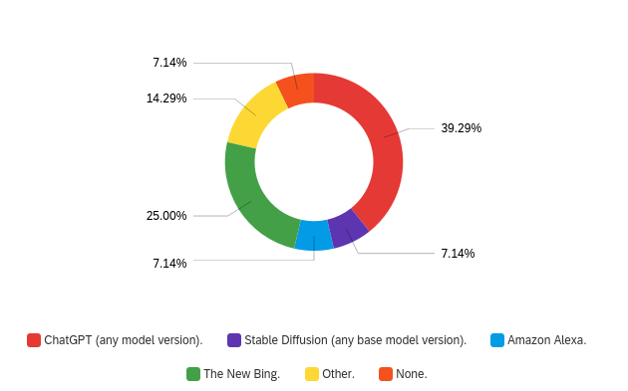
This suggests that most students are already exposed to consumer-level AI applications, and are likely interested in exploring more advanced applications in the field. As these are computer science students, such a level of interest may drive them to learn more about the technology behind these tools, and pursue further study in the field of AI.

B. Students’ general awareness of AI ethics
In response to Question 2, "Have you heard of any recent copyright cases involving AI applications?", a significant majority of respondents (60%) indicated that they had not heard of any.
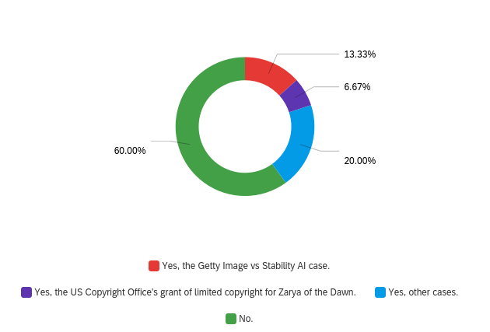
This finding is concerning since legal cases represent one of the most publicly visible aspects of ethical AI usage. Legal concerns surrounding the use of AI are becoming increasingly important, and awareness of such issues is crucial for the development and deployment of responsible AI applications. To expand, the potential lack of awareness of various negative consequences caused by misuse of AI can have undesirable ramifications. It is particularly important for computer science students, who are likely to become future developers and users of AI, to be well-informed about these ramifications. Without such awareness, there is a risk that they may inadvertently contribute to the negative consequences of AI misuse.

C. Students’ opinion about AI regulations
In response to Question 3, “To what extent do you think AI usage should be regulated…”, the mainstream preference was “legal regulations”, which means government endorsed rules and codes that have legal binding (Woll).
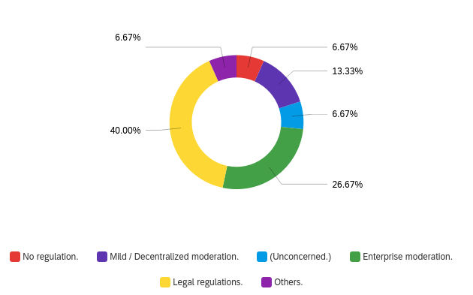
This result shows a slight deviation from that of Question 2, where a majority of respondents showed a lack of awareness regarding outstanding legal cases involving AI. One explanation for this discrepancy is that the two article titles provided in the question body regarding AI disinformation may have enabled respondents to form more informed opinions. Nevertheless, the willingness demonstrated by respondents to regulate the unethical usage of AI presents a promising starting point for students to gain a deeper understanding of the relevant ethical considerations.

D. Students’ attitude toward relevant adjustment in courses
For Question 4 “If, hypothetically, you were offered the choice of doing a predefined practice project…”, the majority of students (62.5%) expressed a desire to participate in such a project.
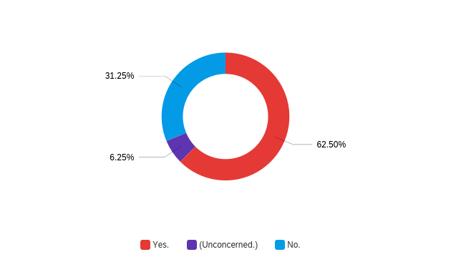
This result is consistent with the observation that many students are willing to undertake extra work for bonus marks, as seen in the CPSC 121 course in term 2022W1. While it is unclear whether students' motivation is driven by their interest in AI, the prospect of additional marks, or other factors, this finding highlights an opportunity for incorporating AI ethics into the curriculum to engage and incentivize students.

E. Students’ opinion on an alternative solution
For the question conditionally shown in Question 5, which asked if students would consider doing a shortened challenge assignment under peer guidance for a few bonus marks, three out of the five students who triggered this question responded positively.
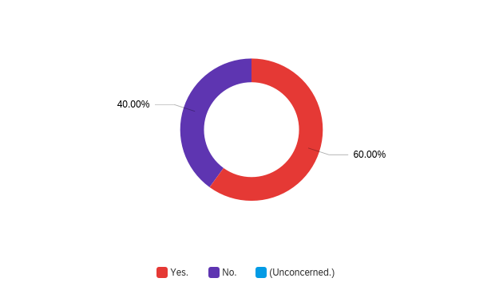
It is worth noting that this question only appeared for students who had indicated they were not interested in the predefined project proposed in Question 4, which explains the small number of respondents. Nonetheless, this result suggests that instructors can use alternative methods, such as designing a shorter extra assignment, to engage students who are not interested in the main project. However, it is also important to consider that only three out of twenty survey takers were in favor of this option. Therefore, it may not be an effective strategy to engage the majority of the class.

F. An instructor’s suggestions on the topic

There were three questions sent to Professor Steve Wolfman to discuss this topic:
- To what extent do you think computer science education could be involved in the movement of AI fair use?
- Have there been many, some or few students asking about the ethics of using AI applications?
- Would it require light, moderate or significant effort to add some non-functional AI ethics knowledge presentations in the practice projects of CPSC 210?
For the first question, Professor Steve Wolfman expressed his belief that computer science education can play an important role in promoting fair use of AI by appropriately using copyrighted content for training AI systems. He also suggested that similar considerations should be integrated into other courses, such as law, commerce, and creative-discipline courses like art or film. This response underscores the importance of augmenting computer science courses with relevant materials to address this issue.
For the second question, Professor Wolfman reported that he had not received many inquiries about AI ethics from students. This finding, combined with the results of survey Question 1, highlights the potential concern that students may not feel comfortable discussing the matter with instructors despite their use of AI tools.
For the third question, Professor Wolfman proposed that adding thought-provoking questions at a certain phase of a CPSC 210 course project could be a relatively light touch way of incorporating AI ethics knowledge. However, for a more impactful approach, they suggested redesigning a lab “with some exercises that tie in to existing conceptual learning goals of the course”, which would require moderate effort. Given the finding from survey Question 5, the second suggestion might be less efficient, making the first suggestion a more viable choice.

V. CONCLUSION

A. Summary of findings
The findings from this study demonstrate the need for computer science education to actively participate in promoting ethical use of AI. The study suggests that adjusting course syllabi is a plausible approach to encourage students to learn more about AI ethics, without requiring significant effort from instructors or course designers. This can be achieved through the addition of extra questions in course projects or light redesigns of lab tasks to enhance students' understanding of AI ethics.

B. Recommendations

a. Proposed solutions
Based on findings, this report present two recommendations on possible solutions:
- Adding thought-provoking questions at a certain phase of computer science course projects would encourage students to be more aware of the issues caused by misuse of AI technologies.
- Assimilating AI ethics elements in re-designed lab tasks can serve as an alternative approach, but further research into the cost of implementation needs to precede it.

b. Further investigations
There is a need to conduct further investigation into two areas:
  - Determining the cause of students' reluctance to discuss AI ethics with instructors can enhance collaboration between students and instructors.
  - Experimenting with appropriate implementation methods for the suggested adjustments can pave the way to a cost-effective approach to influence students.
Overall, incorporating AI ethics elements in computer science courses can increase students' awareness of the ethical implications of their work, promote the development of responsible and ethical AI applications, and be executed within a reasonable budget. It is a cause that merits the attention of the computer science department.

VI. APPENDICES
(To be completed)

VII. REFERENCES
(To be completed)

TABLE OF FIGURES
(To be completed)

