Increasing Academic Support for Student Athletes at the University of British Columbia

Natalie O'Leary
Academic Support Coordinator
University of British Columbia
Vancouver, British Columbia

Sonja Tang
ENGL 301 Student
University of British Columbia
April 12, 2023

TABLE OF CONTENTS
- ABSTRACT
- INTRODUCTION
- Background of current academic support for student athletes at UBC
- Overview of lack of academic support and description of benefits
- Purpose and Intended Audience
- Data Sources
- Scope of Inquiry
- DATA SECTION
  - Analysis of collected data: Surveys of student athletes on the Men’s and Women’s varsity golf team
  - Proposed solution and feasibility discussion
    - Feasibility of offering free tutoring sessions for athletes only
    - Feasibility of hiring more academic advisors
  - Potential risks and limitations
- CONCLUSION
  - Summary of Findings
  - Recommendations
- APPENDICES
  - Student Survey Questions
- REFERENCES

- ABSTRACT

- INTRODUCTION
  - Background of Current Academic Support for Student Athletes at UBC
Currently there are a few resources is offered by UBC Student Athlete Services to provide support and enhance learning experience at UBC. One of them are Varsity Team Academic Coaches (VTACs) who are experienced students who can help student athletes with navigating university life. They can provide advice on understanding course syllabi and tracking grades, creating a study plan, preparing for exams, essay writing, managing an athletics and academic schedule, and working with professors and TAs (teaching assistants). VTACs are available during the Winter Session (September to April), excluding exam period and stat holidays. If a student does not have a VTAC assigned to them, they can contact student.varsity@ubc.com for help.
Student Athlete Services also provide academic workshops during the year to support student athletes in developing their academic abilities. The workshops cover various topics, such as creating an academic plan, understanding learning styles, taking notes effectively, and writing multiple choice exams. All student athletes are welcome to attend, and some may be required to attend based on the academic plan they have created with their coach. A complete list of workshop dates is available on the Student Athlete Portal in August.
Additionally, first year athletes receives New T-bird Orientation and seminars.
At the start of the school year, UBC Student Athlete Services offers an orientation course that is mandatory for all new Thunderbird student athletes. The course is held online and runs from mid-May to the end of June to ensure that everyone is ready for registration. It covers topics such as UBC's history and culture, contacts on campus, eligibility, and registration help. Each module requires 30-60 minutes of work and there are 5 modules in total. Additionally, there is a seminar for first year student athletes whose last school of attendance was high school and some lower year transfer students. This seminar takes place from mid July - mid August and is also online. It helps to provide the skills and knowledge for a successful year at UBC and requires about an hour of work each week.
  - Overview of lack of academic support and description of benefits
According to At UBC, the athletic program has been struggling to receive enough academic support for their athletes. This lack of academic support has had a negative impact on the academic performance of student athletes, as they are often forced to choose between their athletics and their studies. There is also not a lot of support and flexibility from university professors for allowing more test/exam options, such as taking on-the-road exams and rescheduling. This is due to the fact that professors are not familiar with he specific requirements of these exams. Additionally, many professors may not have the time or resources to provide such support.
  - Purpose and Intended Audience
The purpose of this report is to assess the demand, feasibility, and potential impact of increasing academic support for student athletes at UBC. The results are analyzed, compared to, and supported by current research, and recommendations are made on how to offer the best academic support for student athletes at the University of British Columbia. The primary audience for this report is Natalie O'Leary who is the Academic Support Coordinator for UBC Athletics Services, The secondary audience consists of Dr. Erika Patterson, Professor of ENGL 301.
  - Data Sources and Method of Inquiry
The primary method will be to create and distribute a survey to examine and evaluate the student athlete experience. The survey will be made from Google Forms and I will ask permission from the head coach of the golf team to distribute them to the team. I will contact the I will contact Natalie O'Leary who is the Academic Support Coordinator for UBC Athletics Services, and enquire about the cost of offering tutoring for varsity athletes. Secondary methods for this proposal include my own research of the athletics department.
  - Scope of Inquiry
These are four main points of inquiry.
    - How great is the demand for increasing the availability of academic tutoring?
    - What is the cost of hiring academic tutoring dedicated to varsity athletes?
    - Would more awareness on the demands of athletic pursuits among professors help student athletes to feel supported and treated fairly?
    - Do student athletes feel like they’d get higher grades and more life satisfaction from accessible tutoring both in-person and online?
- COLLECTED DATA
  - Analysis of collected data: Surveys of Student athletes on the Men’s and Women’s Varsity Golf Team
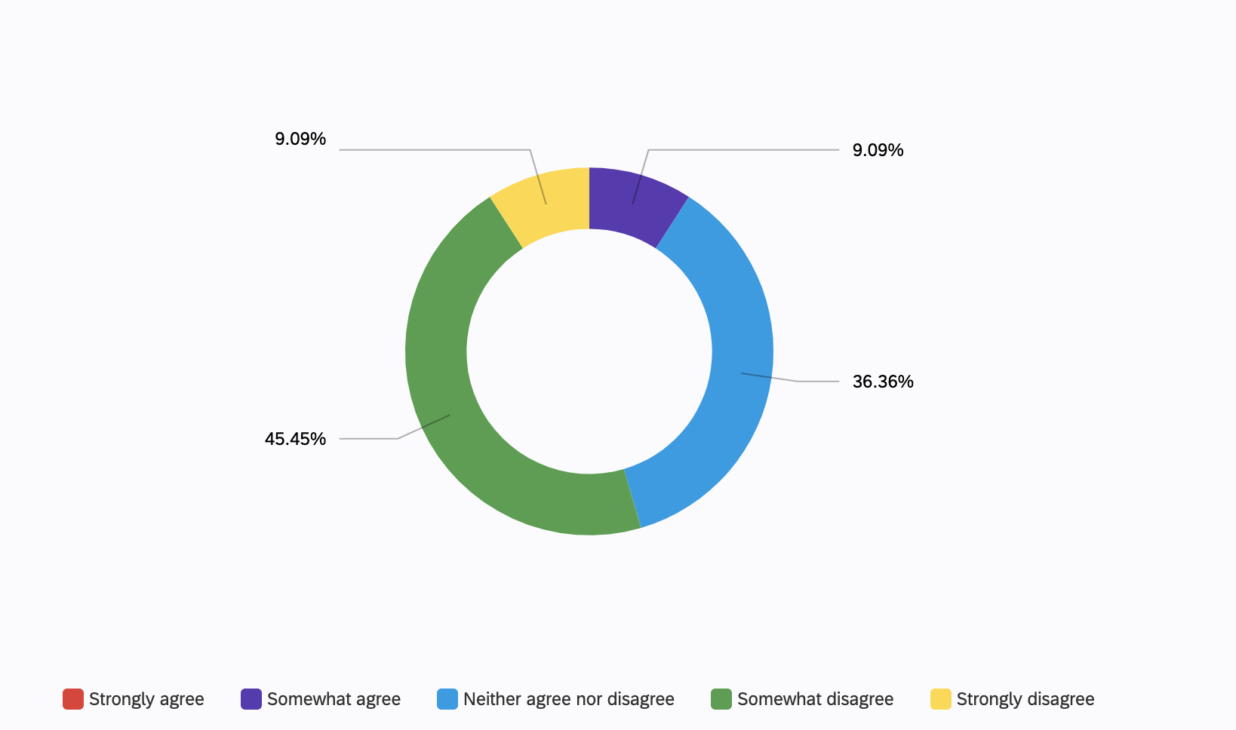
Figure 1. Students Satisfaction with Current Academic Support
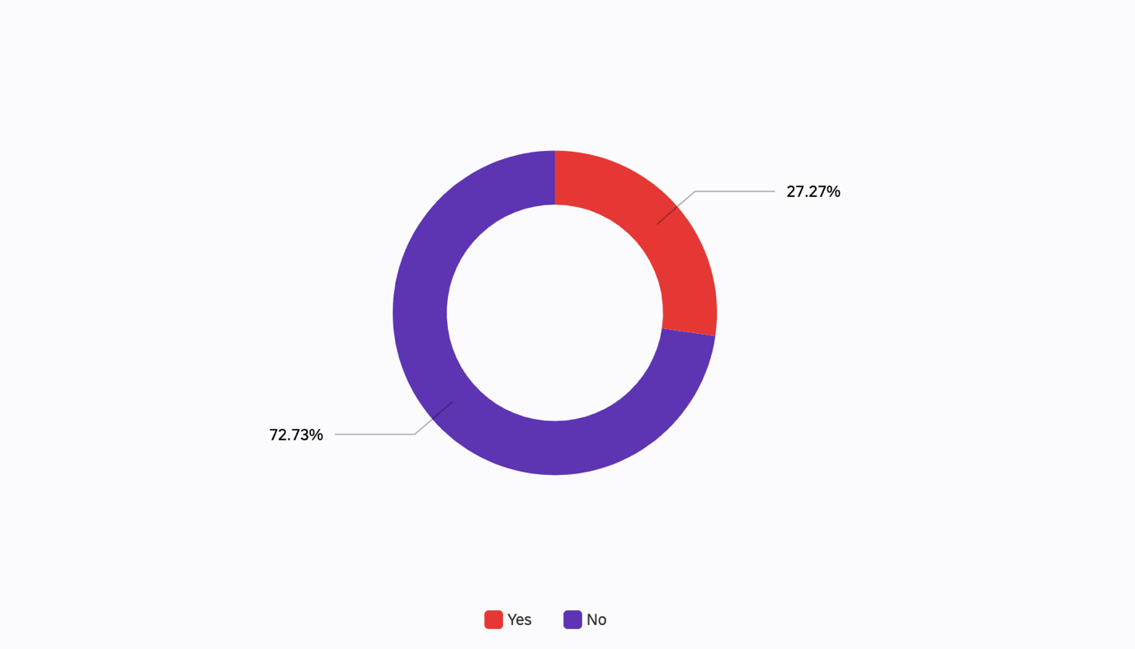
Figure 2. Do you feel that you receive enough academic support to help you succeed in the classroom?
Figure 3. How Often Students Meet with Academic Advisors
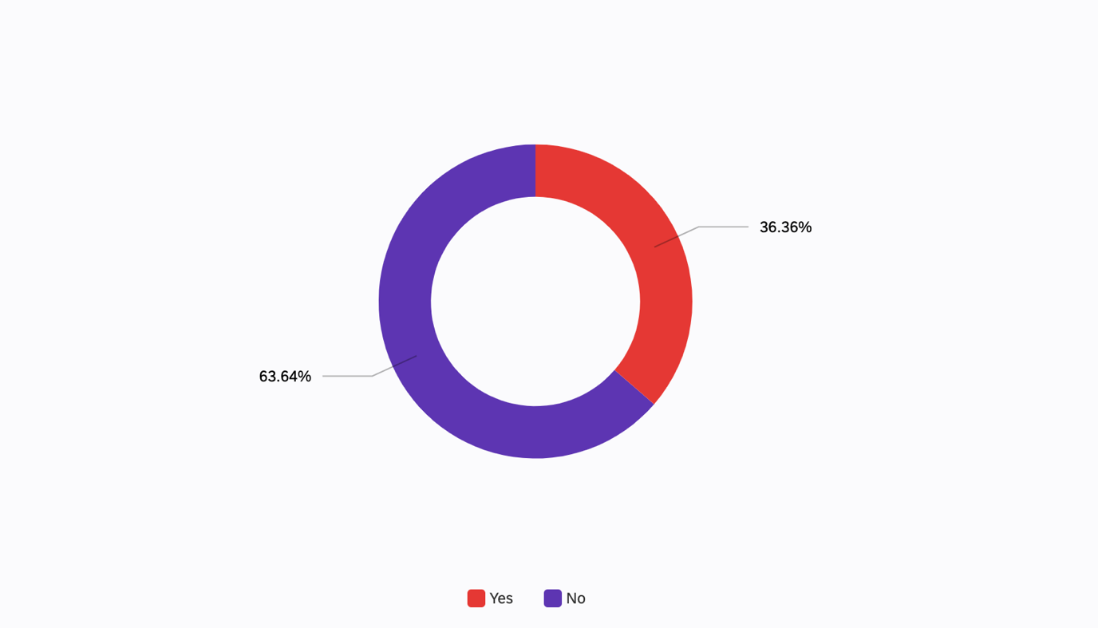
Figure 4. Are you provided with enough resources to help you succeed academically?
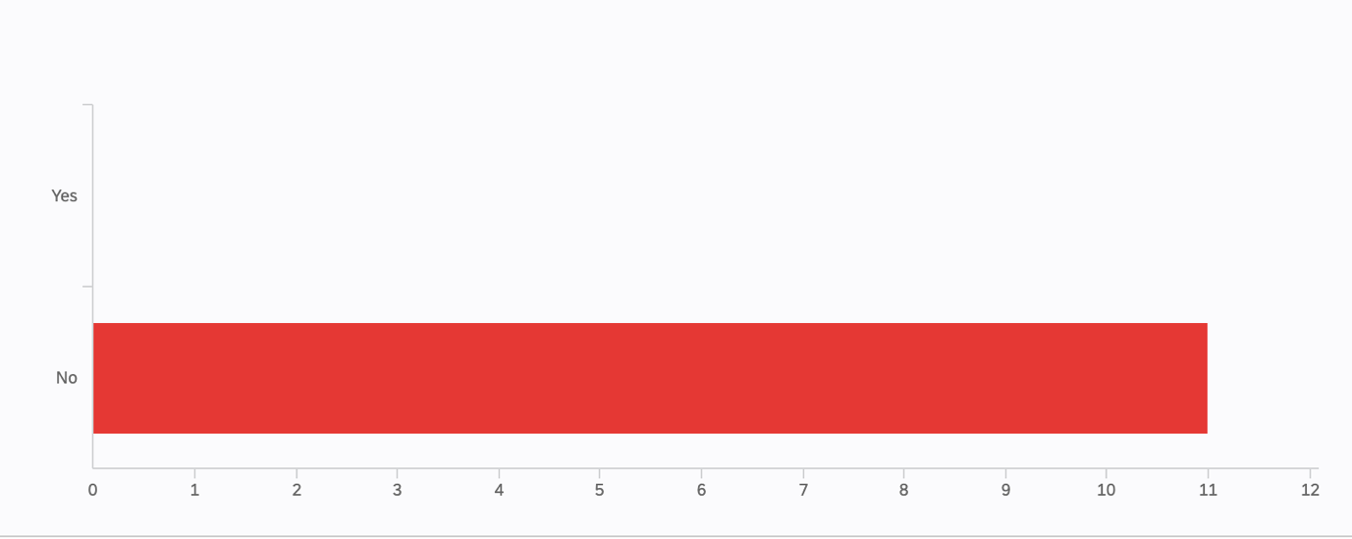
Figure 5. Do you feel like there is enough communication between your academic and athletic departments?
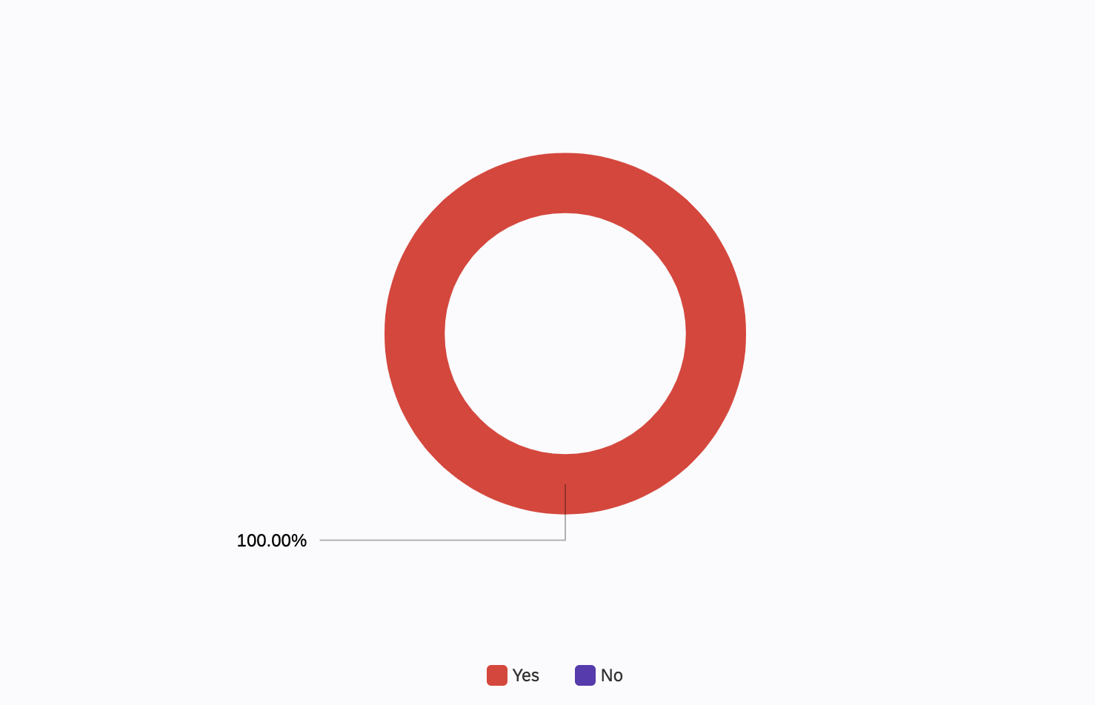
Figure 5. Do you think it will be beneficial to have free tutoring sessions for athletes only?
  - Proposed Solution and Feasibility Discussion
- Feasibility of offering free tutoring sessions for athletes only
A proposed solution of offering free tutoring sessions for student athletes only has the potential to be a viable and beneficial option for universities. Student athletes are often some of the most academically successful students on campus and offering them free tutoring can help them excel even further academically. It can also help those athletes who are struggling in their courses to get the extra help they need in order to keep up with their studies. Hiring upper year students to provide the tutoring would be beneficial for several reasons. Firstly, upper year students would have a better understanding of the course material, having gone through it already. This would allow them to provide more effective assistance to the student athletes. Secondly, upper year students would have a better understanding of the student athletes' academic and time commitments, as they have likely gone through similar situations. Lastly, upper year students may be more likely to offer their services at a discounted rate or even for free, making the tutoring sessions more affordable for the university. In conclusion, offering free tutoring sessions for student athletes only and hiring upper year students to provide the tutoring could be a feasible and beneficial solution for universities. It would provide student athletes with the extra help they need to excel academically, while also providing the university with an affordable and effective tutoring option.
- Feasibility of improving communication and understanding between UBC Athletics and Academic Faculties
- Establish a formal communication system between university professors and athletic services:
  - designate a point of contact between the two departments to facilitate communication.
  - Develop a system that allows professors to quickly and easily access athlete’s records and progress reports.
  - Utilize a shared calendar system to schedule meetings and check-ins.
- Create a dedicated student athlete support team:
  - Assign a team of faculty, administrators, and coaches to communicate with and support student athletes.
  - Establish a system of regular check-ins with student athletes to ensure academic and athletic progress.
- Develop a comprehensive student athlete support program:
  - Create a program that outlines expectations for student athletes and provides resources for academic and athletic success.
  - Establish a series of seminars and workshops to help student athletes develop essential skills such as study habits, time management, goal setting, and communication.
  - Provide ongoing training and education to professors and athletic staff: a. Train professors on how to support student athletes in the classroom. b. Educate athletic staff on how to support student athletes in their sport.
- Create a system of accountability:
  - Establish a system of accountability for athletic staff and professors to ensure they are meeting their obligations to student athletes.
  - Develop a system of rewards and recognition for those who demonstrate exemplary support for student athletes.

- CONCLUSION
  - Summary of Findings
UBC student athletes would benefit immensely from free tutoring dedicated to the athletics department due to the hectic nature of their schedules and the pressure to perform both academically and athletically. This study assessed the benefits and drawbacks of the current academic support for student athletes and identified current student athletes’ perspectives and satisfaction with the current amount of academic support. Good communication between the academic faculties and the athletics department would ensure that the athletes receive the support they need to succeed in both areas. It would allow the athletes to focus more on their studies, while still being able to compete at their highest level. This would ultimately help them to perform to their best ability and reach their full potential.

  - Recommendations
Below are several recommendations for how to improve tutoring services for student athletes.
- Increase Communication: Student athletes should have clear and frequent communication with their tutor in order to ensure they understand the material and are making progress. It is important to check in with the student athlete regularly to ensure they are staying on top of their work.
- Provide Flexibility: Tutoring sessions should be flexible and tailored to the student athlete’s needs. For example, if the student athlete has a game or practice, the tutor should be willing to adjust the tutoring session to accommodate their schedule.
- Use Technology: Technology can be a great tool to help student athletes stay organized and on top of assignments. Tutors should use applications such as Google Classroom and other online resources to help the student athlete stay up to date with their work.
- Set Goals: Setting goals can be a great way to measure progress and stay motivated. Tutors should work with student athletes to set short and long-term goals to help them stay on track.
- Offer Tutoring for Teams: Offering tutoring for teams can help student athletes stay organized and on track. Tutors can provide group sessions to help the student athletes with their academic work and review material from their classes.

- APPENDICES
  - Student Survey Questions
(to be completed)
- REFERENCES
https://gothunderbirds.ca/sports/2009/10/19/athserv-support.aspx
(to be completed)

