Implementing Pedestrian Safety Measures
on the Arbutus Greenway

for
Engineering Services
City of Vancouver, Greenway Program

by
Jennifer Dunbar
University of British Columbia
ENGL 301 Student
Dr. Erika Paterson

April 12, 2023

TABLE OF CONTENTS
(page #’s still to come)

ABSTRACT

INTRODUCTION

- Background on the Arbutus Greenway
- Background on the Increase of Electric Bicycle and e-Scooter Use
- Purpose of Report and Intended Audience
- Description of Data Sources and Methods of Inquiry
- Limitations of the Report
- Scope of Inquiry

DATA SECTION

- Sources of Potential Injury
- City of Vancouver Bylaws
- Current Safety Measures on Arbutus Greenway
- Electric Transportation Devices Causing Pedestrian Injury
- Analysis of Collected Data & Feasibility Discussion

CONCLUSION

  - Summary and Interpretation of Findings
  - Recommendations

REFERENCES

Figures and Tables

Figure 1: 8.8km, 8 zone Arbutus Greenway
Figure 2: Projected increase of e-bicycle and e-scooter use
Figure 3: Public opinion on the need for improvements
Figure 4: Public’s recognition of increase in electric bicycle and e-scooter use on AG
Figure 5: Public’s witnessing or being involved in an incident with e-bikes or e-scooters on AG
Table 1: E-bicycle and e-scooter bylaws in Vancouver

ABSTRACT (still to come)

INTRODUCTION
          - Background on the Arbutus Greenway
In 2016, the City of Vancouver purchased 8.8 kilometers of land from the Canadian
Pacific Railway with the vision of transforming it into a public corridor for walking, running
and cycling. Officially known as the Arbutus Greenway (AG), this urban pathway currently runs
from False Creek to the Fraser River. Phase 1 has been completed, with phases 2 to 4 scheduled
for completion within the next 10 years (City of Vancouver, n.d.).
The City of Vancouver’s original vision was to encourage active and sustainable modes
of transportation and social experiences (Point, 2018). Its undeniable popularity reveals success
with this goal, becoming a significant piece of the Vancouver landscape. The design of the AG
consists of eight zones (Figure 1) and is situated on the unceded traditional homelands of
Musqueam, Squamish, and Tsleil-Waututh Nations (MST). Development to date, and all future
phases include collaboration with the MST Nations to ensure historical and cultural diversity
continued (Arbutus Greenway, 2018).

          - Background on the Increase of Electric Bicycle and e-Scooter Use
Like many cities worldwide, Vancouver has seen a notable spike in the use of
electric bicycles and e-scooters. As research shows, there is no sign of a decline (Figure 2).
Factors contributing to the incline include eco-friendly alternatives, rapidly increasing fuel
prices, and overall health and fitness (E-bike Market Size, Trends, Growth, Report 2022-2030).
The entire 8.8km distance of this urban pathway currently consists of two marked lanes; one for
pedestrians and one for personal wheel transport such as traditional bicycles, scooters,
skateboards and roller blades. While this ensures that a diverse group of people can enjoy the
space, electric transport devices (ETDs) such as e-bikes, e-scooters, e-skateboards, Segways,
hoverboards and one-wheels are also permitted. The presence of these motorized devices
arguably impact the dynamic of one’s experience, both good and bad.

          - Purpose of Report and Intended Audience
The purpose of this report is to assess public opinion surrounding the increased use of e-bikes and e-scooters on the Arbutus Greenway, the current safety measures that are in place and comfort levels. The feasibility of increasing pedestrian safety and providing recommendations for implementing safety rules and regulations will also be addressed.
The primary audience for this report is the manager(s) overseeing the AG design and development in Engineering Department at the City of Vancouver Greenway Project. At this time, a contact name has not been provided. The secondary audience is Dr. Erika Paterson, Professor of ENGL 301 at the University of British Columbia.

          - Description of Data Sources and Methods of Inquiry

Primary data for this report consists of gathered information through email correspondence with the Greenways Team at the City of Vancouver, an online survey via Reddit and observations of e-bike and e-scooter use on the Arbutus Greenway. The latter took place over a three-hour period (10am – 1pm) on two separate days (March 26, 2023 & March 27, 2023).
To date, correspondence with the Greenways Team has not been successful, therefore, collecting any data through this primary source may pose as a limitation to this report. The survey, which was created on Qualtrics and consisted of nine multiple choice questions (see Appendix), assessed various demographics, their use of and comfort level on the Arbutus Greenway. Twenty-Nine surveys were completed and analyzed.
Secondary sources include publications and reports on ETD use, the increase of e-bike and e-scooter use, the potential dangers that they pose on urban pathways and successful safety measures that have been implemented in other cities within Canada and internationally.
          - Limitations of the Report
Two limitations to this report are to be noted. First, minimal and ineffective communication with the Greenways Team at the City of Vancouver. Second, an important demographic did not participate in the survey. Though efforts have been made, accessing direct contact with the person(s) responsible for the design and future phase development of the Arbutus Greenway has been unsuccessful to date. Additionally, the twenty-nine completed surveys did not capture data from those aged 25 – 44 years, and therefore, this report fails to reflect a significant number of those using the AG, e-bikes and/or e-scooters.

          - Scope of Inquiry
This report covers five main points of inquiry:
- What rules and regulations are currently in place for electric bike and e-scooter use in Vancouver and across Canada?
- Do any of the future phases of the Arbutus Greenway development include additional safety measures?
- What is the public’s opinion of the current safety on the Arbutus Greenway regarding electric bicycles and e-scooters?
- What is the average number of electric bikes and e-scooters that use the Arbutus Greenway daily?
- What other cities have benefited from setting speed limits and/or barriers to public bike paths?

DATA SECTION
  - Sources of Potential Injury
The use of ETDs has increased significantly worldwide (E-bike Market Size, Trends, Growth, Report 2022-2030), and in Vancouver, rates have doubled since 2019 (Electric Bikes, n.d.). Bike share companies such as Mobi by Shaw Go, added 500 e-bikes to their inventory in September 2022 (Chan, 2022), reflecting the overall popularity. On the Arbutus Greenway, e-bikes and e-scooters are arguably the most popular choices. In a March 2023 report on the top five choices for electric bicycles, all models have 500w motors and reach a top speed of 32 km/h (Topcanada.com, 2023) adding to the potential for injury to both the pedestrian and rider.
  - City of Vancouver Bylaws
According to the City of Vancouver bylaws, e-bikes cannot have a motor exceeds 500 watts, or 32 km/h, and riders must be sixteen years old and wear a helmet (Electric Bikes, n.d.) E-scooters have similar bylaws. In July 2021, the Province of B.C. approved a three-year pilot program for their use on local streets and protected cycle lanes; they must also not have a motor power output that exceeds 500W, but are limited to 24km/hr. Additionally, there must be a breaking system and lights, a helmet must be worn, and the operator must be sixteen years of age or older (E-scooters, n.d.).
** Adding Table 1 here to illustrate bylaws clearly

  - Current Safety Measures on Arbutus Greenway
The July 2018 design vision for the Arbutus Greenway indicates sufficient separation between the pedestrian and cycling lanes (Point, 2018). However, the current phase of the greenway does not reflect these renderings. Currently, the pathway is shared with a single painted line separating the pedestrians from the cyclists, with no barriers preventing anyone from crossing the line. For ETDs, there fails to be any measures encouraging slower speeds which could result in their full speed potential being reached very quickly. No enforced rules regarding high speeds and no barriers make pedestrian injury imminent.
** including photo of rendering and photo of current greenway
  - Electric Transportation Devices Causing Pedestrian Injury
Pedestrian injury has increased with the rise of ETDs, with powdered bicycles carrying a higher risk of severe injury versus traditional bicycles (Chandler, 2019). A 2019 report reveals that individuals with vision and hearing impairments, young children, the elderly and those distracted by mobility devices are the most likely to sustain injuries from incidents with electric bicycles and scooters (Sikka, 2019). In the United States, hospital visits related to e-bike and e-scooter injury increased from “4881 in 2014 to 29,628 in 2019” (Lin, 2023) highlighting an unsettling trend that is likely reflective of increased use in Canada.

  - Analysis of Collected Data & Feasibility Discussion
Over a period of two days between 10am and 1pm, observational data was collected. On March 26, 2023, a total 103 bicycles and 42 e-bikes were recorded crossing at the intersection of Arbutus Street and West 37th Avenue in Vancouver. On March 27, 2023, the numbers were slightly less; 67 bicycles and 33 e-bikes. E-scooter use was significantly less with 18 recorded on March 26, 2023 and only 8 recorded on March 27, 2023.
Data from twenty-nine completed surveys revealed that half (47%) of the participants feel the current safety measures for pedestrians on the greenway are low and need improvements, with another 47% feeling measures are satisfactory, but some improvements could be made (Figure 3).

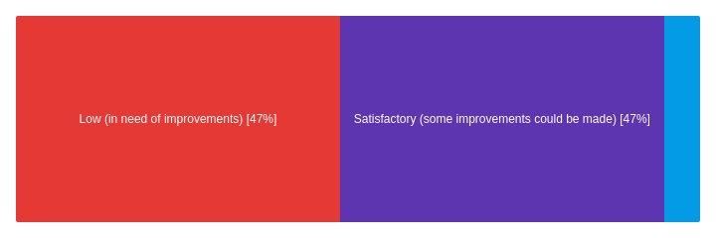
Figure 3. Public opinion on the need for improvements

Data also reveals that 79% of participants (Figure 4) have noticed a significant increase in the use of e-bikes and e-scooters on the greenway. Furthermore, 42% have witnessed incidents between pedestrians and e-bikes and/or e-scooters, with another 42% revealing they themselves have been involved in one (Figure 5).
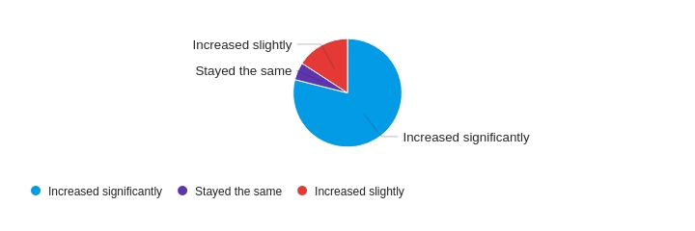
Figure 4. Public’s recognition of increase in electric bicycle and e-scooter use on AG

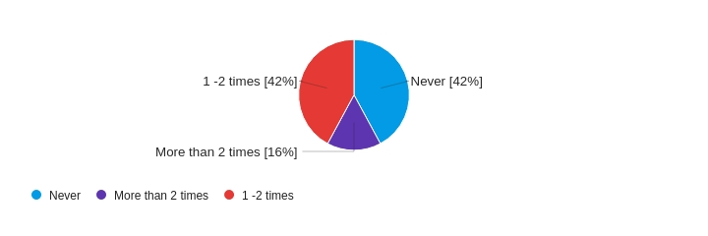
Figure 5. Public’s witnessing or being involved in an incident with e-bikes or e-scooters on AG

CONCLUSION
  - Summary and Interpretation of Findings

The Arbutus Greenway is a welcomed addition to Vancouver’s Westside, enjoyed by hundreds of people daily, however, improvements can be made to ensure it continues to safely serve residents and visitors across all demographics. While the sample size for the online survey was small, it does shed light on the public’s concerns surrounding pedestrian safety along the greenway due to the increase of both electric bikes and e-scooters. It also highlights that elements of the original vision for the greenway have not been implemented to date but need to be considered for immediate implementation, including signage, speed limits and sufficient distance between pedestrian and cycling. With the popularity of ETDs increasing each year, fuel costs remaining high and the warmer weather approaching, these numbers will only rise and increase potential injury.

  - Recommendations
Through education to operate at ETDs in a safe and responsible manner, immediate design upgrades to the AG and bylaw changes mandating speed limits and helmet use, pedestrian safety can be increased. The implementation of, (1) increased signage for rules surrounding ETD use, (2) speed limits for all ETDs, and (3) safety barriers at strategic points along the greenway are three recommendations.
  - Signage outlining the rules for e-bikes and e-scooters to be erected at the entrance of each section (eg. Arbutus Street & 37th Ave). Each sign should include a speed limit, a minimum age of use, mandatory helmet use and a visual indicating that crossing the dividing line is prohibited and dangerous.
  - Signage along greenway with a speed limit. This would act as a reminder to riders on their journey.
  - Barriers separating the pedestrian and cycling paths, as well as barriers at the end of each greenway section to force the slowing down of ETD traffic.

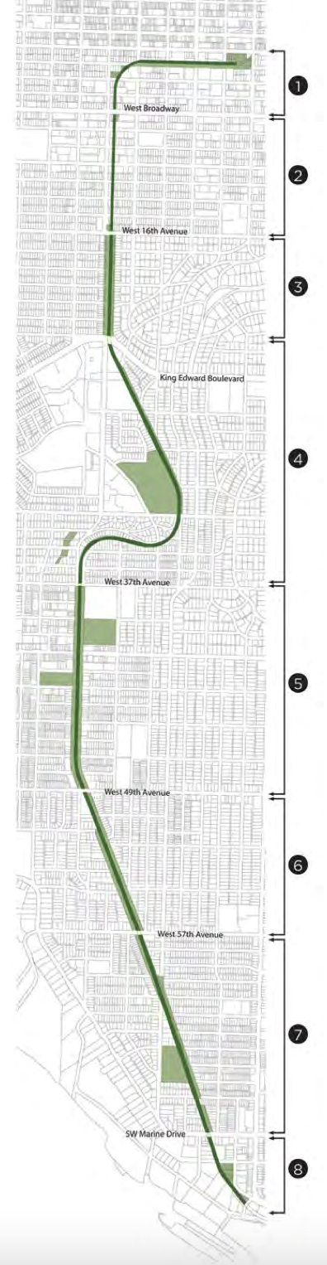 Figure 1. Zones 1-8, The Arbutus Greenway (8.8km)
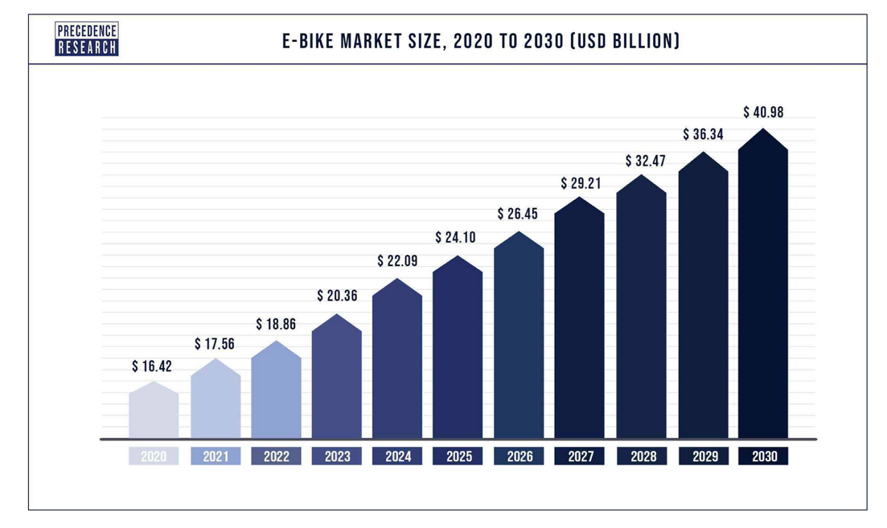
Figure 2. Projected E-bike market growth from 2020 to 2030 (E-bike Market Size, Trends, Growth, Report 2022-2030)

