Encouraging Exercise Among TWU Students: A Marketing Campaign for City Center Community Center

For
Nelson Chiu
Fitness Coordinator of City Center Community Center

By
Long You
University of British Columbia
ENGL 301 99C: Technical Writing

Mar 29, 2023

Table of Contents
Introduction 3
Data Section 4
Literature Review 4
Methodology 5
Results 7
Conclusion 7
References 8

Introduction

Trinity Western University (TWU) is a globally recognized Christian university offering diverse academic programs. TWU's Richmond campus allows students to pursue a bachelor’s degree in leadership or an MBA degree at locations in Lansdowne and Minoru. TWU Richmond's Minoru location is situated above the City of Richmond's City Centre Community Centre (C4), which provides recreational facilities and programs for the local community. The C4's fitness center is an essential resource supporting neighborhood residents' health and well-being, it is also considered an on-campus gym for TWU students.
University can be a challenging time for many students, and regular physical activity has been shown to have numerous benefits for physical and mental health, including improved academic performance and stress reduction (UBC, n.d.).
To promote fitness activities among TWU students and increase C4’s membership enrollment, TWU and C4 collaborated to launch the TWU Student Kick-off Week Promotion in January 2023. During this week, students could participate in free fitness classes and workshops and receive free admission to the fitness center. Despite the student-centered incentives, the promotion failed to elicit high levels of student participation, and only a few students signed up for the membership. Moreover, we lack sufficient data on TWU students' familiarity and attitudes toward the C4 fitness center. Additionally, there is currently no available information about students' preferences for program offerings. Without this critical information, it is difficult to understand the level of student engagement and to recommend improvements to increase participation and access to the fitness center among TWU students. Both TWU Richmond and C4 recognize the need to explore the motivations and barriers that impede student engagement with the fitness center. This report aims to investigate the unique motivations and barriers that TWU students face to exercise at the C4 fitness center through an online survey among TWU Richmond students. Findings from this investigation will inform the design of future campaigns, with the next campaign scheduled for September 2023. This report also aims to design a marketing campaign that is tailored to TWU students’ needs and preferences to encourage TWU students to exercise at C4’s fitness center.

Data Section

Literature Review
According to the Canadian Physical Activity Guidelines by the Canadian Society for Exercise Physiology (CSEP), adults should aim to accumulate at least 150 minutes of moderate-to-vigorous-intensity aerobic physical activity per week, in bouts of 10 minutes or more. In addition to aerobic activity, adults should also perform muscle and bone-strengthening activities at least twice a week. For university students, the Canadian Physical Activity Guidelines are highly significant. By following the Canadian Physical Activity Guidelines, university students can improve their overall health and well-being, increase their energy levels, and reduce their risk of chronic diseases (UBC, n.d.). Making physical activity a regular part of a student's routine can also help to develop positive habits that can be sustained throughout their lives. Despite the benefits of exercise, A systematic review conducted by Kwan et al. (2020) indicated that 72.2% of students were physically inactive. This data aligns with a study conducted by a group of UBC students that displayed that students at UBC were not meeting the fitness guideline recommended by CSEP (UBC, 2015). These findings can also be hypothesized to TWU university students. While barriers such as a lack of time and motivation, and multiple commitments are most common (ASEP, 2008), this report asks TWU students to identify the specific factors that potentially compromise their exercise adherence. Recommended interventions need to be directed at assisting TWU students in overcoming barriers, capitalizing on the motives for exercise, and increasing the likelihood that students will begin and continue to exercise.

Methodology
The study will use a survey research design to collect data from TWU students who use or potentially use C4's fitness center. The survey will be designed by C4’s fitness team, with input from TWU Student Services, and will be administered by TWU Student Services to ensure a representative sample of the student population is surveyed. The study’s core research question is to find out the barriers and motivations for TWU students to work out at the C4 fitness center. At the beginning of the survey, the participants fill out a consent form in which they could consent or not consent to participate in the survey. The survey questions would include the following subsections:
- Demographic questions: The survey will include demographic questions to information on the age, ethnicity, and other relevant characteristics of the participants.
- Physical activity participation rate questions: The survey will also include questions about the participants' exercise habits, including how often they work out, what types of exercises they engage in, and how long they typically exercise for.
- Gym accessible questions: The survey will also ask questions about the participants' accessibility to the C4's fitness center, including how they get to the center, how convenient it is for them to get there, and whether they face any barriers to accessing the gym.
- Fitness program questions: The survey will also include questions about the participants' use of the fitness programs offered by the C4, including whether they have used any of the programs, what they thought of them, and what types of programs they would be interested in.
- Barriers and motivations to working out: Finally, the survey will include questions about the barriers and motivations to working out at the C4. This will include questions about what factors prevent the participants from using the gym and what factors motivate them to use the gym. The survey will also ask for suggestions on how the gym can be improved to better meet the needs of TWU students.
The survey will be conducted using the UBC Qualtrics survey tool, which is an online platform for creating and administering surveys. The data collected from the survey will also be analyzed using the UBC Qualtrics survey tool. The tool provides a range of features for data analysis, including the ability to create graphs and charts, conduct statistical tests, and generate reports. The integration of the UBC Qualtrics survey tool into the research process will enable the data to be collected and analyzed in a streamlined and efficient manner. By using a single tool for both data collection and analysis, we will be able to save time and resources; and ensure that the data is analyzed consistently and accurately. The use of the UBC Qualtrics survey tool will also adhere to ethical guidelines for conducting research with human subjects, including ensuring confidentiality and anonymity of participants' responses and protecting the data from unauthorized access or use. The results of the data analysis will be presented using the UBC Qualtrics survey tool, with tables, graphs, and charts used to illustrate the findings. These results will be interpreted by us and used to inform recommendations for improving the fitness center at the City Center Community Center.
The study aims to collect a minimum of 50 student surveys. This sample size was determined based on the need to collect enough data to ensure the statistical validity and generalizability of the findings. We plan to collect 50 student surveys within 10 survey collection days between Mar 20, 2023, to Apr 4, 2023. This time frame was selected based on the availability of our team and the participants.

Results

Please note that the survey is ongoing, and additional data will be collected in the future. As such, the findings presented here should be considered preliminary and subject to change as more data is collected.
Of the 15 participants who completed the survey by Mar 28, 2023, not all respondents answered every question. The number of respondents who answered each question varied, with the highest number of responses received for Question 1 (n=4) and the lowest number of responses received for Question 4 (n=1). It appears that some TWU students engage in regular fitness activities, with a small proportion spending 4-6 times a week on such activities. Additionally, a few respondents provided information about their age range, with at least one student between the ages of 25-34 and two students over the age of 34. As many TWU Richmond students are MBA students who are over the age of 25, it is important to develop a fitness program that is specifically tailored to meet their needs. This could include incorporating exercises and activities that are suitable for this age group, as well as considering their busy schedules and academic demands. By creating a program that is designed with their unique needs in mind, we can help ensure that TWU Richmond students are able to achieve their fitness goals while maintaining a healthy work-life balance. It is important to note, however, that the sample size was very small and not all participants answered all questions, limiting the generalizability of these findings.
Out of the TWU students who responded to the survey question about fitness activities, 60% indicated that they enjoy S&C (Strength and Conditioning) training, while 40% indicated that they enjoy a variety of other exercise types such as group fitness, cardiovascular activities, yoga, and Pilates.
It is important to note that when asked about their preferred time of day for fitness activities, 100% of the TWU students who responded indicated that they prefer to exercise between 10 am and 2 pm, with 20% indicating a preference for other time frames (Table 1). If TWU students are all in favor of exercise time between 10 am to 2 pm, it is important for C4’s fitness center to consider this preference when scheduling classes and activities. By offering fitness options during this time, we can better accommodate the needs and schedules of TWU students, which may help increase their participation and engagement in the program. It's also important to ensure that the fitness program is diverse and includes a range of activities and exercises that cater to different fitness levels and interests. This can help attract a wider range of students and keep them engaged in the program over the long term. Additionally, it may be helpful to provide resources and support for students who may not be able to participate during the preferred time period, such as offering personal training or making gym facilities available during non-traditional hours.
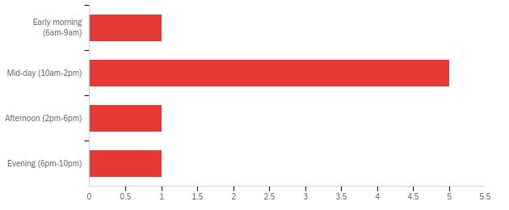
Table 1: Preferred time of day for fitness activities

When asked about the barriers that prevent them from working out at a local fitness center, 66.7% of the respondents cited a lack of motivation, while 33.3% cited other factors such as the cost of gym membership, lack of access to a gym, and health or physical limitations (Table 2).
This indicates that lack of motivation is the primary barrier preventing TWU students from working out at C4’s fitness center. Therefore, we recommend C4’s fitness center keep the focus on providing motivational resources and support to its members. One way to do this could be to offer regular motivational events or challenges that encourage TWU students to set and achieve fitness goals. This could include things like fitness classes, personal training sessions, or group workouts. The fitness center could also consider offering rewards or incentives for students who consistently attend classes or achieve certain fitness milestones. In addition, C4’s fitness center could work to create a positive and supportive community atmosphere that motivates students to continue coming back. This could include organizing social events or creating TWU student online forums where students can connect and support each other in their fitness journeys.

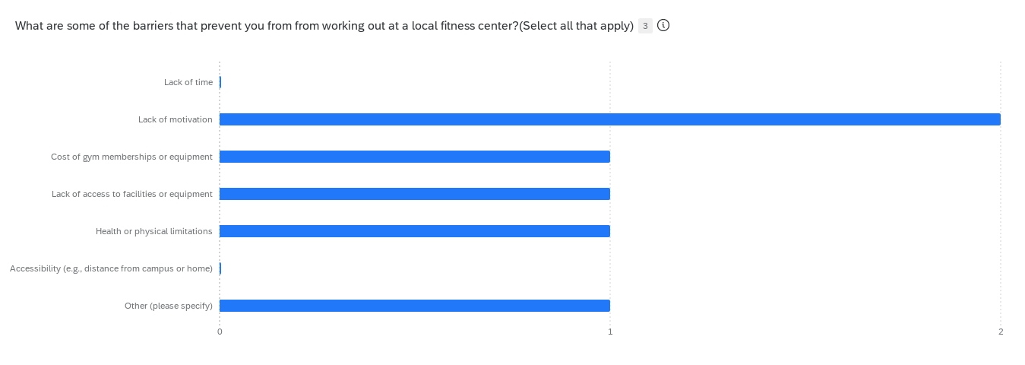
Table 2: Barriers that prevent TWU students from working out at a local fitness center.

Based on the responses provided by the participants, the following are the reasons why they engage in physical activity:
- 100% of the participants selected "Improving mental health" as a reason for engaging in physical activity.
- 66.7% of the participants selected "Improving physical health" and "Enjoyment of the activity" as reasons for engaging in physical activity.
These findings suggest that improving mental health is the primary reason why TWU students engage in physical activity, followed by the desire to improve physical health and the enjoyment of the activity. These results highlight the importance of promoting physical activity as a means of improving mental health, in addition to its well-known benefits for physical health.
When asked question Q19: Given that the annual fee for a community center gym in Richmond is $360, are you interested in joining the gym membership at a discounted price of $294 for TWU students?
Neither respondent is interested in joining the gym membership. However, one of the respondents was more specific in indicating that the discounted price offered to TWU students was not a motivating factor in their decision not to join.
It's important to note that this is a very small sample size, and the data should not be generalized to the entire population. Additionally, we do not know the reasons behind the respondents' lack of interest, which could be influenced by various factors such as personal preferences, financial constraints, or lack of time.

Conclusion
Based on the preliminary findings of the TWU student survey, it is recommended that C4 fitness center be tailored to meet the unique needs and preferences of MBA students at TWU who are over the age of 25. This may include incorporating exercises and activities that are suitable for this age group, taking into account their busy schedules and academic demands, and offering fitness options during the preferred time frame of 10 am to 2 pm.
To address the reported barriers to working out, it is recommended that C4 fitness center provide motivational support and resources to students. This can be achieved by offering personal training, creating a supportive environment, and promoting the benefits of physical activity, particularly in improving mental health.
The C4 fitness center should also aim to provide a diverse range of activities and exercises that cater to different fitness levels and interests. This can help attract a wider range of students and keep them engaged in the program over the long term.
While the survey findings suggest that the discounted price offered to TWU students for C4 gym membership is not a significant motivator, it may still be worthwhile to explore additional incentives or discounts that could encourage participation in the fitness center program.
Overall, it is important to keep in mind the small sample size of the survey and the need for additional data to be collected in the future to refine and validate these recommendations.

References

Ball, James W., et al. "EXPLORING THE RELATIONSHIP BETWEEN COLLEGE STUDENTS' BARRIERS TO EXERCISE AND MOTIVATION." American Journal of Health Studies, vol. 33, no. 2, spring 2018, pp. 61+. Gale OneFile: Health and Medicine, link.gale.com/apps/doc/A560556782/HRCA?u=ubcolumbia&sid=bookmark-HRCA&xid=d4f818a1. Accessed 20 Mar. 2023.
Ebben, William, and Shawn Grunewald. "Exercise Motivations and Barriers." Journal of Exercise Physiology Online, vol. 11, no. 5, 2008, pp. 1-9, https://www.asep.org/asep/asep/EbbenJEPonlineOctober2008.pdf.
Kwan, M.Y., Faulkner, G.E., Arbour-Nicitopoulos, K.P. et al. Prevalence of health-risk behaviours among Canadian post-secondary students: descriptive results from the National College Health Assessment. BMC Public Health 13, 548 (2013). https://doi.org/10.1186/1471-2458-13-548
“Sustain.ubc.ca.” Sustain.ubc.ca, University of British Columbia. https://sustain.ubc.ca/.

