Letter of Transmittal
[To be continued]

Implementing Joining Online Waitlists

and

Viewing Wait Times Online at Cactus Club Cafes

For:
Richard Jaffray
Cactus Club Cafe, CEO

Software Developers
Cactus Club Cafe, Employee

By:
Carman Chu
English 301 Student
The University of British Columbia

March 29, 2023
Table of Contents

Abstract 4
Introduction 5
A. Background of Cactus Club Cafe 5
B. Overview of the Current Situation 5
C. Purpose of Report 6
D. Research Methods 6
E. Scope of Inquiry 6
Data 7
A. Dissection of Methods 7
B. Analysis of Data 7
C. Limitations 8
D. Proposed Solution and Feasibility 9
Conclusion 9
A. Summary of Findings 9
B. Recommendations 9
C. Discussion 9
Appendix 9
Works Cited 11

Figures and Tables

[To be continued]

Abstract

[To be continued]

Introduction

Background of Cactus Club Cafe
Cactus Club Cafe is a Canadian chain restaurant that opened in 1988, with locations across Canada, mainly in British Columbia, where it was initially started. This premier casual dining restaurant has become a staple in the lives of many British Columbians. Famous for its unique menu, aesthetic ambiance, and quality happy hour, Cactus Club Cafe has built a reputable name as an established restaurant.
The restaurant does allow customers to reserve tables online. However, due to its popularity amongst the general population, wait times on certain days tend to be extreme. Those who decide to make the last-minute decision to dine in at Cactus Club Cafe may not be able to make a reservation, leaving them to have to walk in and put their names on the waitlist. This time-consuming and inefficient process can leave customers feeling frustrated and unwilling to return.

Overview of the Current Situation
Cactus Club Cafe’s wait times are very unpredictable. On certain days the wait could be over an hour long. During busy times, phoning the restaurant for this information may not be an option because employees may be too busy to come to the phone. Customers who could not make reservations online due to no more time slots or those looking to spontaneously dine out are forced to enter their Cactus Club Cafes and put their names on the waitlist. Walking into the restaurant and putting your name down can be inefficient because customers must stay in the restaurant or nearby if a table becomes available. Customers who go into the restaurant and if told the wait times to exceed the time they were willing to wait have now wasted their time and efforts and must find an alternative.

Purpose of Report
The purpose of this report is to gather insight into the current wait time and waitlist situation at Cactus Club Cafes and propose a feasible solution to this problem. This report aims to gain customer satisfaction for those who dine at Cactus Club Cafes.

Research Methods
The primary data source will be online surveys distributed to customers and employees of Cactus Club Cafe. The survey will include questions about the wait times and ask for suggestions for some solutions. More research was also gathered through online sources.

Scope of Inquiry
To assess the current situation of the wait options at Cactus Club Cafe, six areas of inquiry will be researched:
- What are the average wait times at Cactus Club Cafe on normal and busy days?
- What are some customers’ thoughts and opinions about the current wait times at Cactus Club Cafe?
- How difficult would it be to implement a system like this?
- What opinions do employees have about the current system?
- What is Cactus Club Cafe’s current solution to combat wait times?
- How many customers stay or leave after hearing the wait times?

Data

Dissection of Methods
The solutions and recommendations suggested in this report are based on the results of a survey distributed to employees and customers of Cactus Club Cafes. The survey of 9 questions about customer and employee experience with wait times at Cactus Club Cafes. The survey was about 10 minutes long and consisted of 8 questions with multiple choice. The last question was a write in your text for suggestions of solutions that the customers or employees might have on the situation.

Analysis of Data
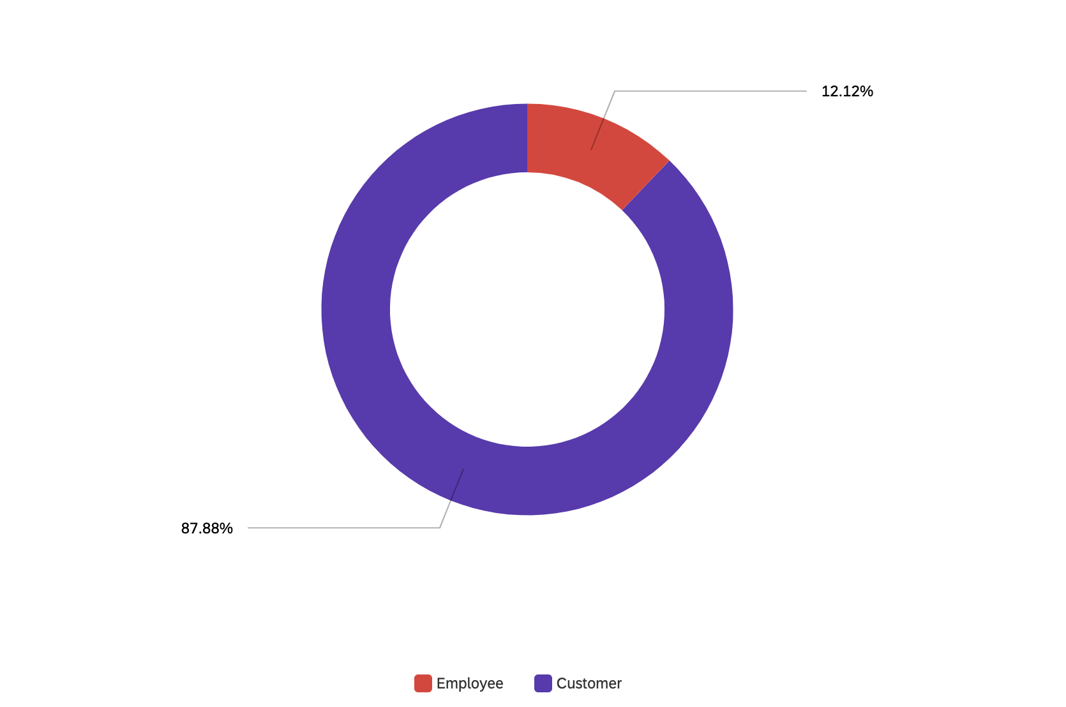
The survey results were based on 33 responses, 4 of which were employees and 29 were customers of Cactus Club Cafe. The participants were anonymous, and the surveys were distributed as a link on social media for users to do at
Figure 1: Customer and Employee Distribution
their own will. Employee and customer responses are not separated but put together for the final results

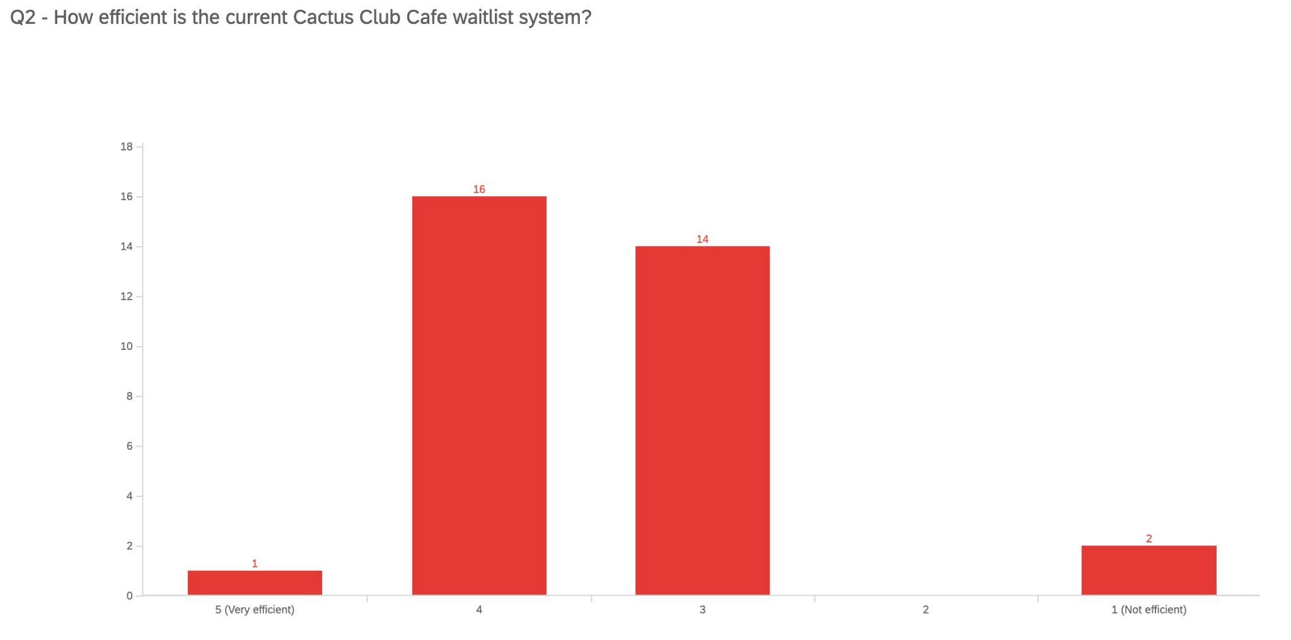
Figure 2: Current Waitlist Efficiency

According to the 33 participants, the majority (16 participants) found the current Cactus Club Cafe waitlist system to be somewhat efficient, closely followed by neither efficient or not efficient (14 participants).

Limitations
Some limitations in this report may not give as accurate a result as planned. One limitation was the participant pool. The 33 people that participated cannot speak for the thousands of customers that Cactus Club Cafes receive daily. The small sample size gives insight into how most of the population may feel. Another limitation would be that the survey and research are only based around the Greater Vancouver Area. Cactus Club Cafes are located across Canada, but most of the locations are located in the Lower Mainland of British Columbia. The data results are slightly biased toward locations across BC.

Proposed Solution and Feasibility
The proposed solution would be to implement this online waiting system for easy accessibility for customers. Implementing an online placeholder and estimated wait times would allow customers and employees to estimate how long it would take for the customers to get a table for dining in and for the employees to prepare accordingly. The feasibility of implementing this system is relatively high. Software developers would devise a plausible way to code the system into the existing websites. The developers would be able to fit the system in without disturbing the aesthetics of the current website.

Conclusion

Summary of Findings
The results from the survey distributed showed that most participants were satisfied with the current situation. However, the participants also showed a consensus toward implementing an online waiting system. 24 of the 33 participants voted “definitely yes” when asked if they would like a system like this to be applied to the existing website. Although participants were already satisfied with the current wait time problem, many still favour this system for easier accessibility, saving customers and employees time.

Recommendations
The list of recommendations is as follows:
- Implement an online waiting system for customers to access on the Cactus Club Cafe website
- Have the option to join the waitlist online
- Display wait times for customers to view online on the website
- Gather opinions from customers and employees across the different Cactus Club Cafe locations

Discussion
To increase customer satisfaction and accessibility at Cactus Club Cafe, more research must be done with a larger population size to gather a more accurate sense of the public’s opinion on the current wait times situation. The problem with the wait times at Cactus Club Cafe can be seen at multiple locations across the Greater Vancouver Area. Cactus Club Cafe was recently acquired by the Fuller Family (Schisler 2022), which now makes them a part of the Earls and Joey’s restaurant family group. Implementing this system for Cactus Club Cafes could also be beneficial to bring into the other restaurants under the same restaurant group.

Appendix
[To be continued]

Works Cited

https://en.wikipedia.org/wiki/Cactus_Club_Cafe

https://www.westerlynews.ca/business/founders-of-earls-joey-restaurants-acquire-ownership-of-cactus-club-cafe/#:~:text=Cactus%20Club%2C%20Earls%20and%20Joey,founder%20and%20president%20Richard%20Jaffray.

[To be continued]

