Teaching Strategies for a Learner-Centered Classroom

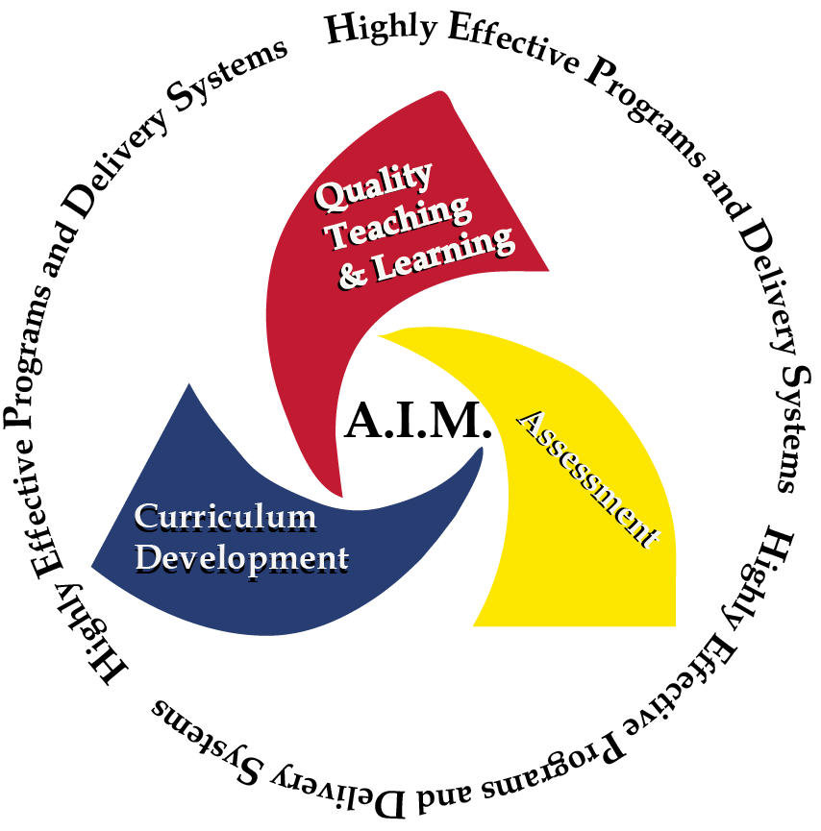
Strategy: Silent Socratic Dialog

Time: 30-45 minutes

Intent: Silent Socratic Dialog is a silent form of inquiry and debate between individuals with opposing viewpoints based on writing responses and answering questions to stimulate critical thinking to clarify ideas. As it may not always be easy to listen effectively when someone is talking, reading a partner’s response may be a more efficient method to “listen.”
Process:
- Ask each student to pair up with another student.
- Explain the process (write it on the board or project via overhead):
  - There will be NO talking and the only communication (or “dialog”) will be written.
- Writing begins with an open-ended question that the instructor will pose.
  - For example "Should moral considerations enter into the conduct of a war?”
  - The students will have five minutes to write a response to the question.
- After five minutes, have students switch papers with their partners.
  - Each student will read his/her partner’s response and write a question in reference to the response.
  - Return the paper to the original writer. Each student will read the question written by his/her partner.
- Repeat the process (response, question) two more times.
- Each student will write a final thought on his/her partner’s paper.
(The pattern is Question, Response; Question, Response; Question, Response; Question, Response; Final Thought.)
Uses:
- Promotes thoughtful questioning. Students must have an understanding of their partners’ responses to write a relevant, thought-provoking question.
- Allows students who are not comfortable speaking up in class to share their thoughts, opinions, etc., via silent discussion.
- Promotes individual accountability – Each student must participate in discussion with his/her partner.
- Requires potentially deeper understanding as writing may provide an opportunity for a more in-depth thought process than speaking.
Variation:
- This activity can be used as a guideline for classroom discussion, or Socratic dialogue, in which the instructor provides a well-formulated question that requires personal responses from students. These responses elicit further questions and so on.

Additional Information/Video:
Video (to be edited) - Tim Martin, Baker College of Cadillac, Dean of Business
The Silent Socratic Dialogue http://www.oncourseworkshop.com/Learning010.htm
G:ETL_TeachingStrategies_SilentSocraticDialog_4/2012

