International Society for the Scholarship of Teaching & Learning
2016 Conference

Session authors and contact information:

Dr. Gary Poole, gary.poole.@ubc.ca
Roselynn Verwoord, rverwoor@uvic.ca or http://blogs.ubc.ca/rverwoord/
Dr. Isabeau Iqbal, isabeau.iqbal@ubc.ca or isabeauiqbal.ca

Handout for

Session 1, Pre-conference workshop: Using Personal Networks and Social Network Theory to Improve Teaching and Learning (Wednesday, October 12, 1:30 pm – 5 pm)

Session 2, Main conference workshop: Tales of teaching and learning: Whose stories matter to you and why? (Friday, October 14, 11 am – 12:30 pm)

Guiding Questions for Workshops

1) How are educators using networks in their own contexts to expand, refute or build their stories of teaching and learning and of SoTL?
(2) Do instructors perceive greater similarity among network members than among randomly chosen colleagues?
(3) Are there relationships among perceived similarity, value of interactions, and impact of the network on one’s teaching and research on teaching?

Key Terms

Significant networks
- A network consists of individuals and the interactional links between them.
- Network participants come together on a common objective
- Networks allow for the exchange of resources and for capacity building; they allow members to collaboratively develop knowledge

Significant conversations

Significant conversations have the potential to help university teachers see things through someone else’s perspective. They may shape and/or expand an individual’s identity as teachers.

- Private
- Trustful
- Intellectually intriguing

Social network theory

- Is the study of how people, organizations or groups interact with others inside their network (Claywell, 2016)
- Can be applied to small groups as well as those that are global (Kadushin, 2004)
- Can be used to describe various forms of interactions, i.e., the exchange of advice, knowledge, materials, and resources (Pataraia et al., 2013).

Williams et al. model (2013)

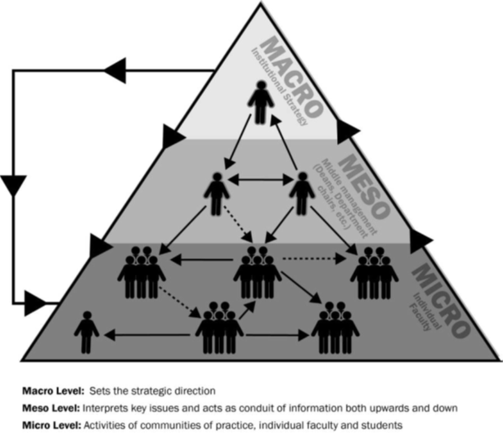

My notes

References
Hogan, J., & Hogan, R. (2002). Leadership and sociopolitical intelligence. In RE Riggion, SE Murphy & FJ Pirozzolo (Eds.), Multiple Intelligences and Leadership (76-89). Mahwah, NJ: Erlbaum and Associates.

Kadushin, C. (2004). Introduction to social network theory. Chapter 2: Some basic network concepts and properties. Retrieved from www.cin.ufpe.br/~rbcp/taia/Kadushin_Concepts.pdf

Kenny, N., Watson, G., & Desmarais S., (in press). Building sustained action: Supporting an institutional practice of SoTL at the University of Guelph. New Directions in Teaching and Learning.

Mårtensson, K. (2014). Influencing teaching and learning microcultures. Academic development in a research-intensive university. (Unpublished doctoral dissertation). Lund University, Sweden.

Pataraia, N., Falconer, I., Margaryan, A., Littlejohn, A., & Fincher, S. (2014). ‘Who do you talk to about your teaching?’: Networking activities among university teachers. Frontline Learning Research, 2(2), 4-14.

Pataraia, N., Margaryan, A., Falconer, I., Littlejohn, A., & Falconer, J. (2013). Discovering academics’ key learning connections: An ego-centric network approach to analysing learning about teaching. Journal of Workplace Learning, 26(1), 56-72.

Pyorala, E., Hirsto, L., Toom, A., Myyry, L., & Lindblom-Ylanne, S. (2015). Significant networks and meaningful conversations observed in the first-round applicants for the Teachers’ Academy at a research-intensive university. International Journal for Academic Development, 20(2), 150-162.

Roxå, T. & Mårtensson, K. (2015). Microcultures and informal learning: A heuristic guiding analysis of conditions for informal learning in local higher education workplaces. International Journal for Academic Development, 20(2), 193-205.

Roxå, T. & Mårtensson, K. (2012.) How effects from teacher training of academic teachers propagate into the meso level and beyond. In Teacher Development in Higher Education: Existing Programs, Program Impact, and Future Trends, edited by Eszter Simon and Gabriela Pleschova, 213-233. London: Routledge.

Roxå, T. & Mårtensson, K. (2009). Significant conversations and significant networks: Exploring the backstage of the teaching arena. Studies in Higher Education, 34(5), 547-559.

Van Waes, S., Moolenaar, N. M., Daly, A. J., Heldens, H. H., Donche, V., Van Petegem, P., & Van den Bossche, P. (2016). The networked instructor: The quality of networks in different stages of professional development. Teaching and Teacher Education, 59, 295-308.

Verwoord, R., Williams, A., Beery, T., Strickland, K., McKinnon, J., Pace, J., Dalton, H., & Poole, G. (2013). Weaving SoTL into institutional cultures: Two models for supporting institutional and cultural change. A presentation at the International Society for the Scholarship of Teaching and Learning (ISSoTL), International Conference, October 2-5, 2013, Raleigh, NC, USA.

Verwoord, R., & Poole, G. (2014). Exploring a model using networks and leadership to make SoTL part of an institution’s fabric. A presentation at the Society for Teaching and Learning in Higher Education 2014 Annual Conference, National Conference, June 17-20, 2014, Kingston, ON.

Wenger, T., Trayner, B., & de Laat, M. (2011). Promoting and assessing value creation in communities and networks: A conceptual framework. Heerlen: Open University.

Williams, A., Verwoord, R., Beery, T., Dalton, H., McKinnon, J., Pace, J., Poole, G., & Strickland, K. (2013). The power of social networks: A model for weaving the scholarship of teaching and learning into institutional culture. Teaching and Learning Inquiry, 1(2), 49-62

Creative Commons License: Attribution-NonCommercial 4.0 International

