Culture Jam Assignment
By: Jasmeen Dhaliwal
GRSJ 300 Dr. Christopher Shelley
2017WA 99A

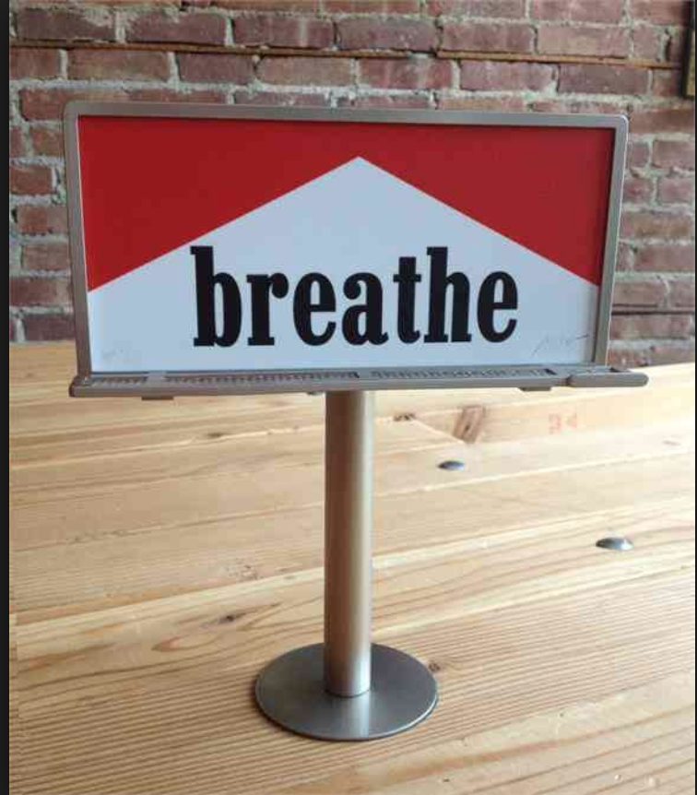
Figure 1

The figure shown above (figure 1) is an advertisement that mimics a very well known tobacco cigarette brand named Marlboro. The advertisement achieves such mimicry by making use of the distinctive design of the Marlboro logo, specifically the same red and white colours, shapes and font type. The company name “Marlboro” has however been replaced by the word “breathe”. The word “breathe” is used to encourage the breathing in of fresh air as opposed to cigarette smoke, in order to advocate for a non-smoking society. Furthermore, the word “breathe” may also be used to represent the addictive nature of cigarettes. Just as humans are dependent, reliant and routinely activated to breathe in oxygen, smokers are dependent, reliant and routinely activated to breathe in the tobacco smoke of cigarettes. For example, it has been found that out of all the smokers that attempt to quite smoking on their own, 80% relapse within a month and only about 3% of smokers can successfully quit (Benowitz, 2010). The target audience for this advertisement include smokers and potential smokers because the advertisement is promoting non-smoking and highlighting the dependent nature of smoking. The simplicity of this advertisement causes it to lack clarity of it’s exact meaning and message. For instance, smokers may interpret the word “breathe” as cigarettes being as vital and important a process in their lives as breathing is. This could therefore distort the meaning of the advertisement by strengthening a smoker’s psychological dependence on smoking as opposed to decreasing it. Nevertheless, modification to this advertisement can cause it to relay a very effective message against smoking.

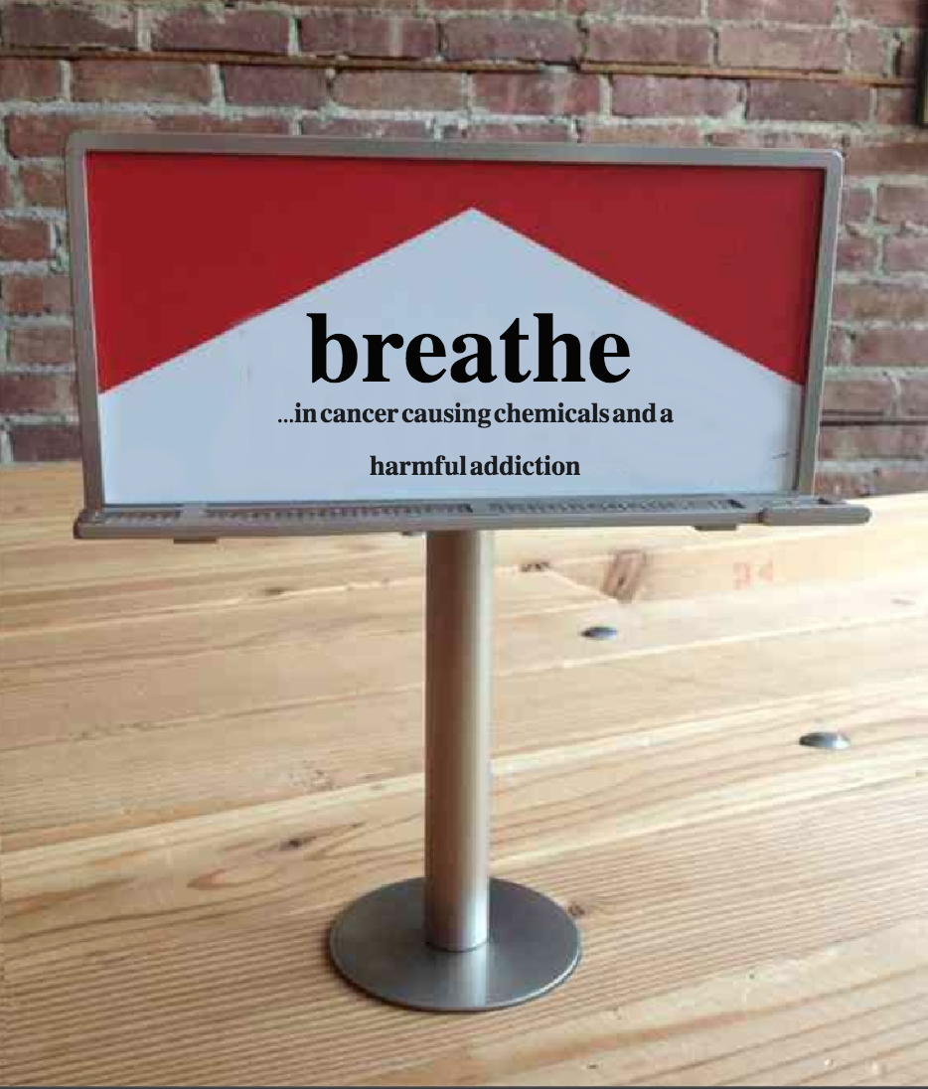
Figure 2

Figure 2 shows my cultured jammed version of the original advertisement that was shown in Figure 1. Through the simple addition of eight words “…in cancer causing chemicals and a harmful addiction”, I have created an advertisement that better communicates the message of the original advertisement, which is to abstain from smoking. The reason why this addition has led to a more effective advertisement is because the words explicitly highlight some of the negative consequences that result from smoking.
Of the thousands of chemicals that are contained in tobacco smoke, 70 of them cause cancer while some others are known to cause different types of diseases (American Cancer Society, 2017). With this being said it has been found that both women and men have a 25% increased risk of developing lung cancer in comparison to non-smokers. Additionally, tobacco smoke contains a chemical called nicotine which causes smokers to have a physical dependence and therefore addiction to cigarettes (Hwang and Yun, 2015). Although strong evidence regarding the harmful effects of smoking exists, smoking is still the leading cause of preventable death in the United States (Center for Disease Control and Prevention, 2017). This advertisement will better benefit society because it will bring better awareness to the negative consequences of smoking. This will therefore also allow the target audience who are smokers and potential smokers, to make a more informed and conscious decision against smoking.

References:

American Cancer Society:
Harmful Chemicals in Tobacco Products. Retrieved October 20, 2017, from https://www.cancer.org/cancer/cancer-causes/tobacco-and-cancer/carcinogens-found-in-tobacco-products.html#references

Benowitz, N. L. (n.d.). The Nature of Nicotine Addiction. Smoking: Risk, Perception, & Policy,159-187. doi:10.4135/9781452232652.n8

Center for Disease Control and Prevention:
Smoking & Tobacco Use. (2017, May 15). Retrieved October 20, 2017, from https://www.cdc.gov/tobacco/data_statistics/fact_sheets/health_effects/effects_cig_smoking/index.htm

Hwang, J., & Yun, Z. (2015). Mechanism of psychological distress-driven smoking addiction behavior. Journal of Business Research, 68(10), 2189-2197. doi:10.1016/j.jbusres.2015.03.019

