ENGL 301 - Technical Writing

Increasing Student Motivation and Engagement
nwHacks 2020

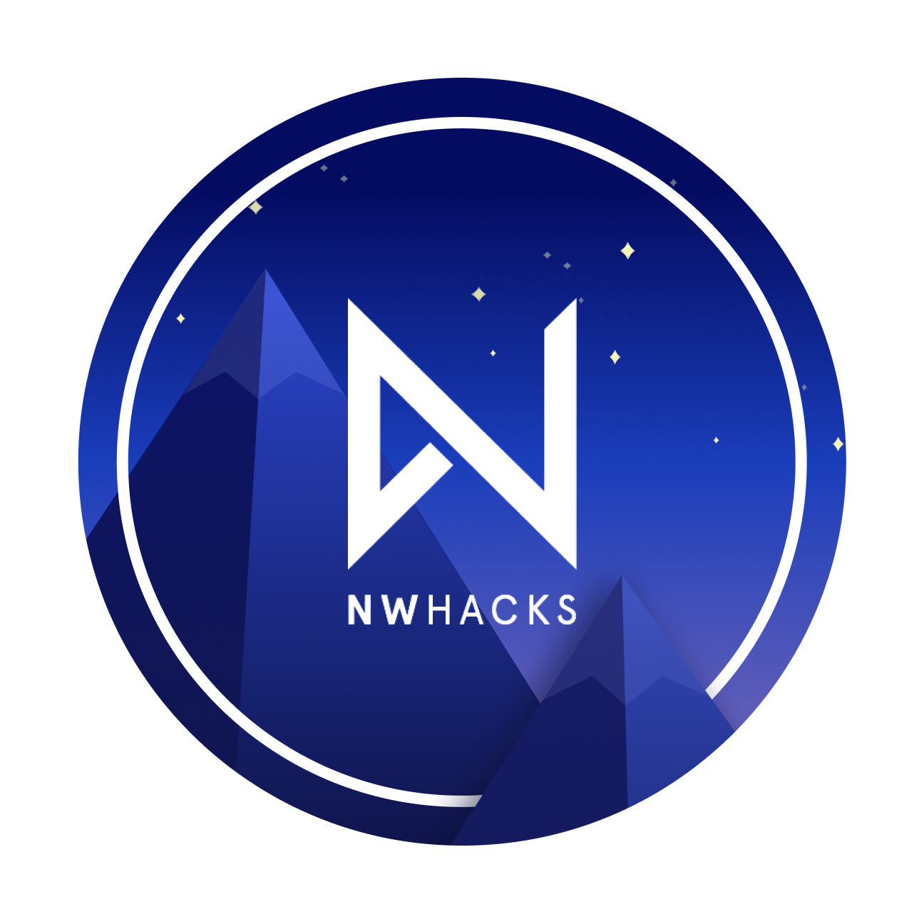

Jason Smith
ENGL 301 Student
University of British Columbia

Introduction 3
Data and Analysis 5
Historical Data 5
Survey 8
Interviews 13
Conclusion 14

Introduction
The term hackathon was formed by the portmanteau blend of the words “hack” and “marathon”, defined as coming up with innovative solutions for our societies problems. This is a collaborative event where engineers, designers, product managers with an entrepreneurial ambition work together in teams to develop a tech based project within a tight time limit. Due to the lack of innovative and entrepreneurial tech culture at UBC, nwHacks was created by a computer science alumni from UBC who wanted a place for students to work on their entrepreneurial skill sets in a supportive atmosphere. nwHacks has successfully completed 4 events, and the next event is expected to occur in January 2020. Ultimately, this event requires a lot of energy and hard work which means not everyone is successful in submitting a project due to a lack of motivation and a variety of other factors which will be discussed in this report.

The aim of this study is to determine new methods and strategies to increase student motivation and engagement throughout the hackathon such that there is a higher number of projects submitted per capita. It is difficult to determine the work ethic of an applicant due to a lenient screening process to attend the event. In previous hackathons, majority of the attendees have never been to a hackathon before, thus the lack of experience may be a contributing factor to completing the full run of the hackathon.

This report covers the current student engagement and motivational issues faced by nwHacks, proposed solution, collection of data through interviews and surveys and quantitative measurements of possible outcomes. Given that I am an ex nwHacks marketing and sponsorship executive, I feel the accountability and pride in the future success of the next upcoming nwHacks event. Given that Vancouver is one of Canada’s largest technology hubs and one of the largest in North America, nwHacks is a vital event for UBC’s recognition as a target school for technology companies. One quantifiable metric these technology companies use to hire students is their ability to complete an innovative solution to a problem that they are facing. Ultimately, if there are a lack of project submissions by students, companies may feel less obligated to hire from UBC, therefore it is important to engage students at this hackathon for potential job opportunities which is part of nwHacks goal.

Data and Analysis
Historical Data
To outline an idea on the demographics of nwHacks, below are statistics from nwHacks 2016. This was the first nwHacks event ever hosted, and the event had 1739 applications in total, 653 accepted applicants and 518 attendees checked in.
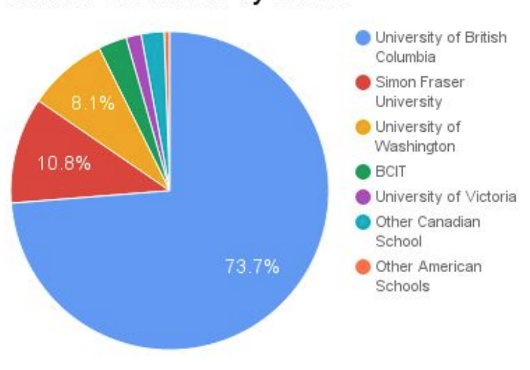
- Figure 1: Breakdown of Students by School
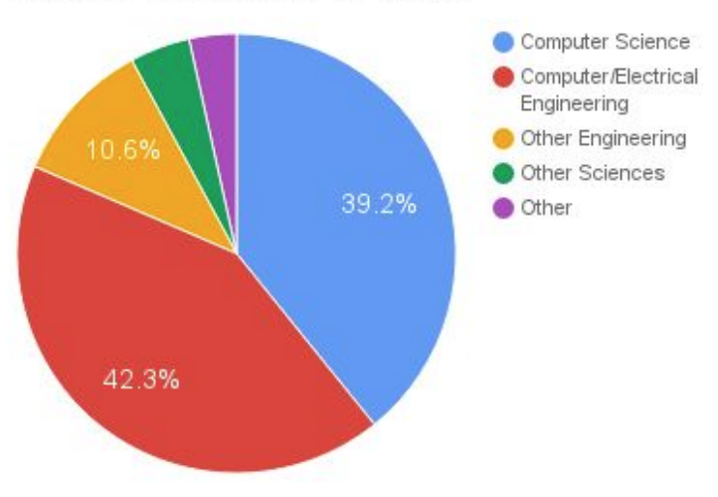
- Figure 2: Number of Students by Major

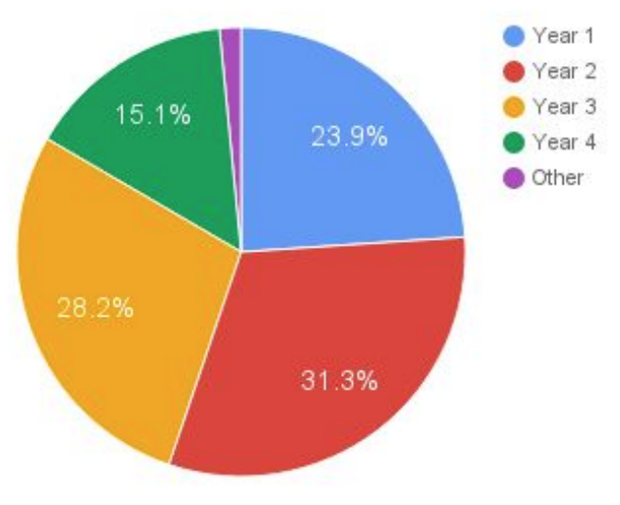
- Figure 3: Number of Students by Year

In the above figures we can note we have a fairly typical distribution of demographics for a tech based hackathon. The majority of students tend to surface around individuals with less industry experience trying to obtain a job, which is given by figure 3, we can see that Year 2 is the largest pool.
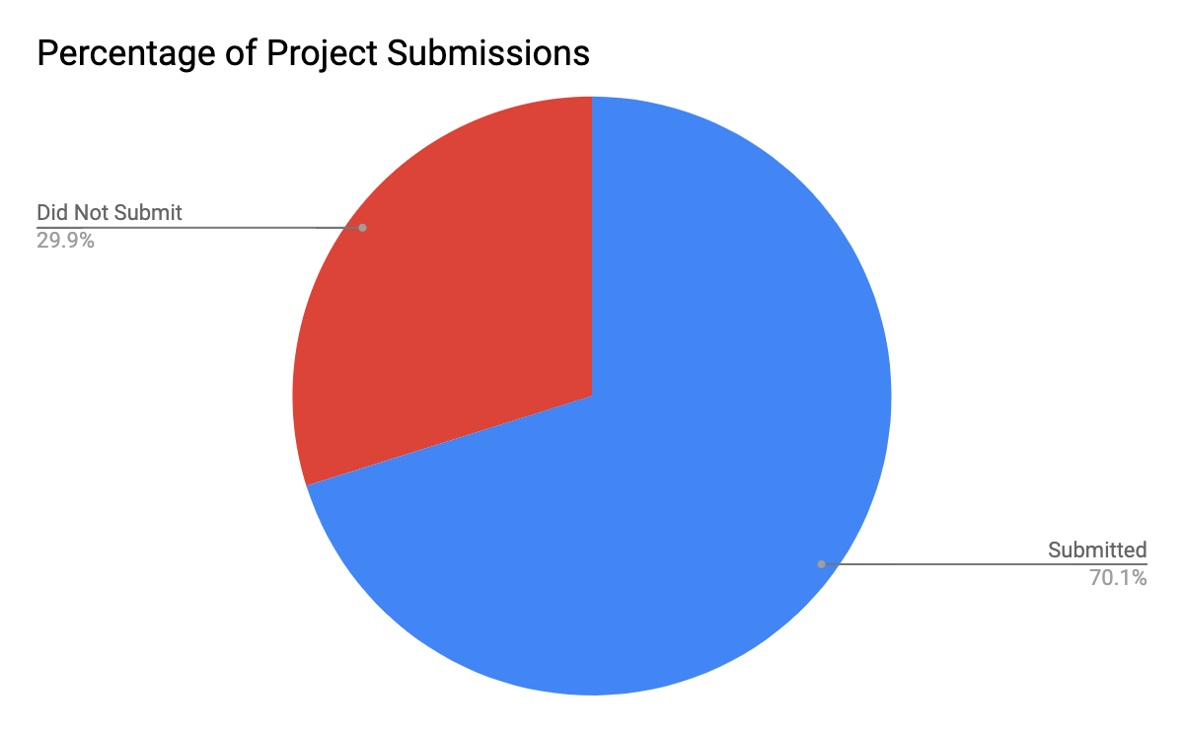
- Figure 4: Percentage of Project Submissions

Given that this report is focusing on increasing student motivation, we must quantify our results. We will determine engagement and motivation by calculating the percentage of project submissions. During nwHacks 2019 we can note that there were only 70.1% of projects submitted.

Survey
The underlying purpose of this survey was to compose a strategy in order to further engage students and increase motivation such that there is a higher likelihood of them submitting a project. This survey was posted on the UBC Computer Science Class of 2019/2020/2021/2022 Facebook group chats. Sixty-seven students in this chat completed this survey which offered detailed insight of the underlying issues the event has not been addressing in order to increase student motivation.

The following photo outlines a breakdown of the different years that survey takers are distributed amongst.
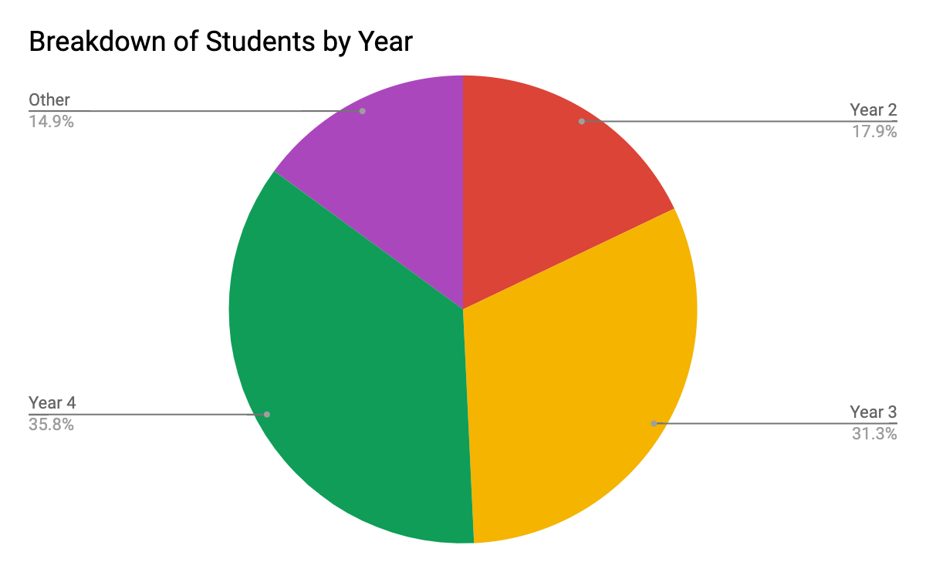
- Figure 4: Breakdown of Students by Year (Survey Results)

Given this data, the year distribution of students are fairly similar to the distribution seen in previous years of nwHacks.

One of the first questions asked was “Would you be more inclined to submit a project if there were prizes that you valued more?”. Here are the statistics:
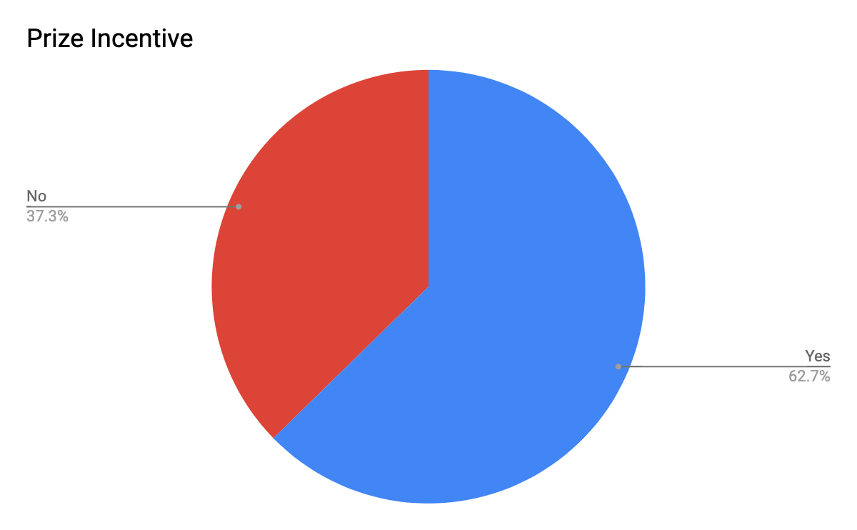
  - Figure 5: Breakdown of Prize Incentive (Survey Results)

For the most part it is tough to cater prizes valued by all participants, however we can note that there are only 62.7% of survey takers in a sample size of 67 that are incentivized by prizes. Following this data, this survey asks a follow up question: “What category of a prize would you value the most?” (Figure 5)

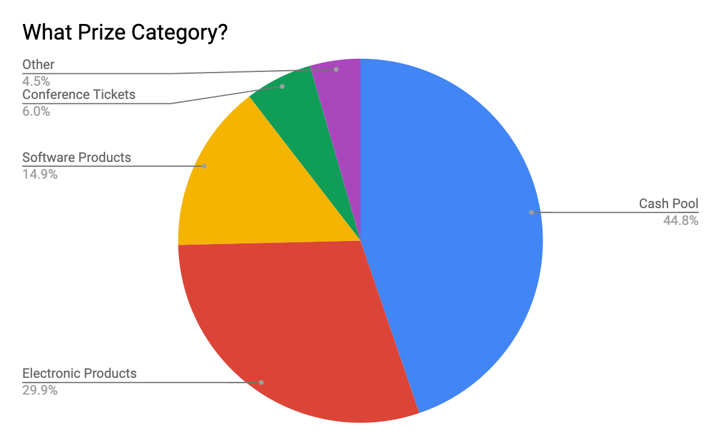
  - Figure 6: Breakdown of Prize Incentive (Survey Results)

In this data, all of the students that are not incentivized by prizes fall into the electronic products or cash pool categories. However, nwHacks already offers these as part of the prize pool, this means that there is a moderate correlation between student motivation and prize incentives. The rest of this paper will research and devise methods to determine how to engage the final 29.9% of students to submit a project.

One of the last few questions included asking the following: “If submitting a project gave you a better shot with landing an interview with one of the sponsors, would you be more inclined to submit?”. The results here are much more interesting.
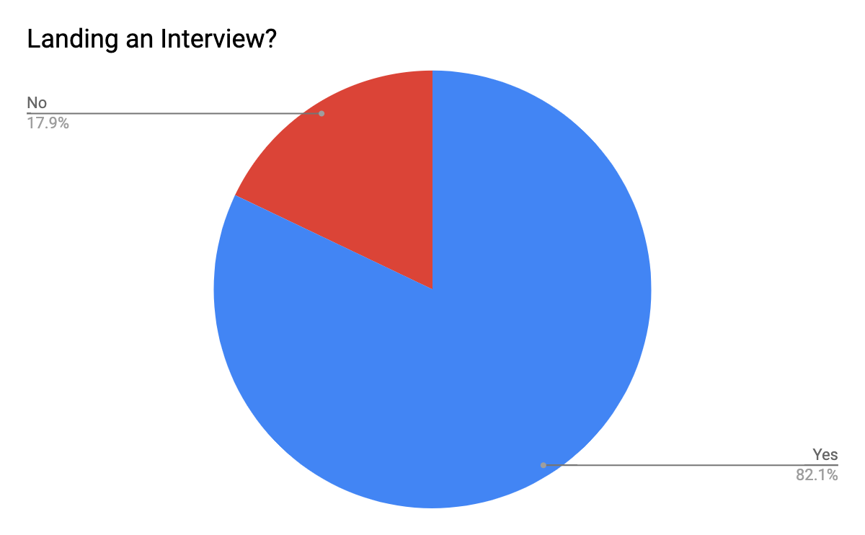
  - Figure 7: Breakdown of Prize Incentive (Survey Results)
Here we can note that figure 7 outlines a much higher incentive correlation between student engagement and securing a job interview. In this chart, all of the students who answered “No” to submitting a project given a prize incentive fall into the “Yes” category for landing an interview in figure 7.
The results from this data portray great insight for what steps the organizers need to take in order to incentivize all participants to submit a project. To develop a strategy to convince all students to submit a project would simply be to provide both prizes and guarantee an interview for submissions.

Interviews
Along with the survey results, I conducted interviews across ex and current nwHacks organizers and executives. The underlying reason I conducted these interviews was to understand the past techniques as well as the up to date strategies incorporated into nwHacks. After conducting interviews, one takeaway was that “Mentorship is one of the top priorities when trying to assist students to achieve their goals, which is why nwHacks tries to recruit as many mentors as possible” (Tse). After talking with the current president of nwHacks, this statement was passed on to one of the past presidents and his response was “Although mentorship is a high priority at this event, it is tough for students to bother reaching out to a mentor without a goal set in the first place” (Leung). The data presented here seems to be in line with the data presented, most of the students are willing to submit a project regardless if they are incentivized by either prizes or interviews. This illustrates that regardless of the mentorship, incentivizing participants with either prizes or interviews is the best data driven factor for reaching a quantifiable goal of the highest percentage of projects submitted. “nwHacks tries to increase the percentage of project submissions so our sponsors are gratified with solutions to problems they are facing in their organization, mass student submission gives a wider spectrum to choose from.” (Lin). After conducting these interviews it becomes much more coherent that there needs to be a better partnership between nwHacks and sponsors to put a strategy in place which offers higher interview offer acceptance upon participants.

Conclusion
Vancouver is starting to become a hot spot for technology innovation and new hackathons. nwHacks is not seeing an improvement in project submission percentages over the years. The survey results show that there is potential to get close to 100% project submissions as long as the incentives are put into place. This information needs to be presented to the current executives of nwHacks so that they can formalize a deal with sponsors to offer more interviews to project submission applicants rather than applicants who are passing their resume through cold applications. A proposed solution would be to keep the current prize incentives, however add more incentives along the lines of offering interviews for submitting a project under a sponsored category. In conclusion, it is difficult to force all participants to submit a project because you will always have a small margin of students attending the hackathon for various reasons such as obtaining free swag or simply there for the free food while they are studying for an exam.

Citations
“Hackathons.” OpenBSD, www.openbsd.org/hackathons.html.
Tse, Anita. Personal interview. 26 Nov 2019.
Leung, Max. Personal interview. 28 Nov 2019.
Lin, Patrick. Personal interview. 28 Nov 2019.

