CTLT Teaching Assistant (TA) Institute
Communications Toolkit
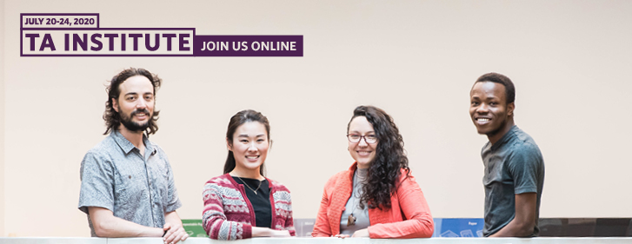

Background
The CTLT Teaching Assistant (TA) Institute is a week long event of free professional development workshops open to UBC graduate students and undergraduate TAs. The TA Institute from July 20 - 24, 2020, includes a collection of workshops designed to support TAs as their roles change with the move to online courses. Sessions include; supporting inclusive online classrooms, TA’ing large online classes, preparing for technical difficulties, time management, and leading both asynchronous and synchronous discussion groups. View the full schedule of events and learn more at https://institute.ctlt.ubc.ca/ta-institute/july-2020-ta-institute/.

Audience
UBC graduate students and undergraduate teaching assistants who are supporting current or upcoming courses.

Key Messages/Call to Action
UBC graduate students and undergraduate TAs are encouraged to participate in the CTLT Teaching Assistant Institute to help prepare to teach online courses in the summer and fall.

Sample Twitter Posts
- #UBC grad students and TAs! Are you interested in developing your online teaching and learning practices? Register for the @UBC_CTLT TA Institute from July 20-24 to help you prepare for your upcoming online courses http://ow.ly/gUTE50AlSrO

- Are you TA’ing an online class this summer or fall? The @UBC_CTLT Teaching Assistant Institute features FREE workshops on topics such as online teaching fundamentals, managing large synchronous classrooms, and more. Sign-up: http://ow.ly/gUTE50AlSrO

- From July 20-24 the @UBC_CTLT TA Institute for #UBC grad students and TAs includes a collection of workshops designed to support TAs as their roles change with the move to online courses. Register for the free interactive online workshops today! http://ow.ly/gUTE50AlSrO

Sample Website, Newsletter, or Facebook Post
- As the roles of Teaching Assistants change with the move to online courses, the CTLT Teaching Assistant (TA) Institute from July 20 - 24, 2020, is a time for graduate students and undergraduate TAs to come together to develop and reflect on their online teaching and learning experiences. Register at https://institute.ctlt.ubc.ca/ta-institute/july-2020-ta-institute/.

Contact
If you have any questions about this Communications Toolkit, please contact:

Sukhi Ghuman
Manager, Marketing and Events, CTLT
sukhi.ghuman@ubc.ca

