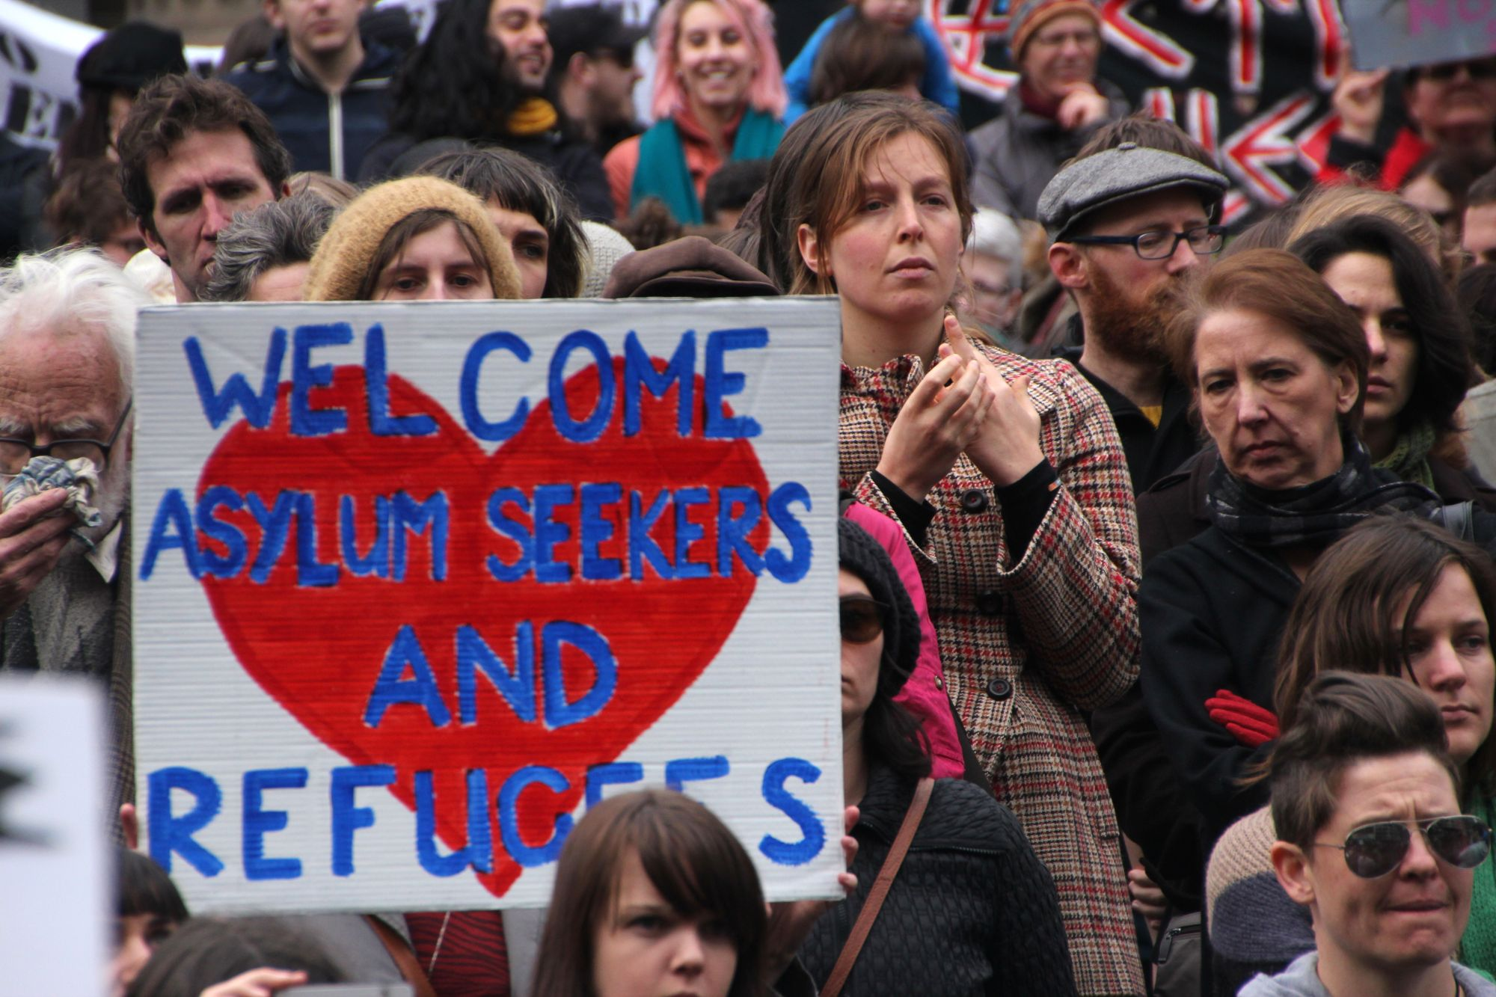**GMST 229-101/347-101 - Germ 206/301 (3) Germanophone Literature after 1945: Displacement, Exile, Flight and Migration**

Prerequisite: none

Instructor: Prof. Markus Hallensleben, Email: [mhallen@mail.ubc.ca](mailto:mhallen@mail.ubc.ca)

Office Hours: T 3:30-4:30 by appointment only either on Zoom or in person at BuTo 922

**Place: BUCH B303**

**Time: T** **2-3:30pm (T1 2023/24)**

The course is taught in a hybrid format, with the class meeting in person every Tuesday. **Important: The Tuesday lectures will not be recorded.** In lieu of the Thursday lectures, you need to do your home studies on UBC Canvas.

***Important Note: You can get credit for only either one of GMST 229-10, Germ 206, GMST 347-101, or Germ 301.***

**COURSE DESCRIPTION**

This course aims to introduce to the current themes and historical settings of displacement, exile, flight and migration from a decolonial point of view. We will critically discuss topics such as diasporic and national belonging, asylum and integration politics, multiculturality and European cultural identity. We will not only look at the representation of refugees in literary texts, but also in mass media. All readings are in translation and focus on contemporary transnational German-language literature affected by migration. While the beginning of the course covers Jewish and political exile during National Socialism, the other parts deal with Germany as an immigration country since the fall of the wall in 1989, including its “Welcome Culture” as response to the global “refugee crisis” in 2015.

**All course material is in English**. Major texts and films are available either as ebooks or through Library Online Course Reserves (LOCR). Additional resources will be available on UBC Canvas. **The course follows a hybrid structure of online and in-person instruction: All assignments for the online parts and all lecture notes (ppt) of the in-person lessons on Tuesdays will be posted on Canvas**.

**LEARNING OBJECTIVES**

Upon successful completion of this course (i.e., with active attendance and participation, completion of reading and writing assignments), students will be individually and cooperatively able to:

1. analyse elements of the German-language cultural and historical context that are reflected in the literature of the period;
2. link the historical background to current immigration politics and policies of Germany within a European context;
3. learn about refugee and immigrant experiences, as well as citizens’ and Indigenous responses;
4. identify collective core-narratives of migration, belonging and non-belonging across cultures and nations;
5. recognize the impact that displacement, exile, flight and immigration have on individuals and society;
6. develop and manage in-class group work that addresses course themes/objectives in regards to values that differ from one’s own.

**List of textbooks and primary material available as ebook*:**

“The Afghan Girl.” *National Geographic* 6 (1985) & 4 (2002). (journalistic essays and “[Search for the Afghan Girl](https://www.youtube.com/watch?v=zKSM5sc3bIg),” documentary, 2002). On Reserve.

Arendt, Hannah. "We Refugees." (1943, essay). On Reserve.

Czollek, Max."Gegenwartsbewältigung [[Overcoming the Present](https://escholarship.org/uc/item/82j1524z)]." *TRANSIT* 12:2 (2020).

Czollek, Max, et al. "Radical Diversity and De-integration: Towards a Political and Artistic Project." *Red Thread* 4 (2017). On Reserve.

Göktürk, Deniz,* et al., eds. *Germany in Transit: Nation and Migration.* (2007; diverse primary sources: literary essays, song lyrics, political speeches, journalistic editorials, legal frameworks, historical chronology). Excerpts on Reserve.

Heppner, Ernest G.* *Shanghai Refuge:* *A Memoir of the World War II Jewish Ghetto.* (1997; memoirs). Optional Purchase (kindle). Excerpts (chpts. 3 & 4) on Reserve.

Kermani, Navid.* *Upheaval: The Refugee Trek through Europe.* (2019; journalistic essay). Optional Purchase (kindle). On Reserve.

**GRADING SYSTEM**

|  |  |
| --- | --- |
| **Component** | **Weight** |
| **Class Participation (Attendance 10% and home study participation 30% based on self-assessment)** | **40%** |
| **Midterm on CANVAS (Lockdown Browser): 9 November 2023** | **30%** |
| **Either Final Essay to be submitted on CANVAS, due on 7 December 2023 at midnight** | **30%** |
| **Or Final Exam on CANVAS (Lockdown Browser): 7 December 2023** | **30%** |

**Note:** All requests for academic concessions concerning the midterm, final exam and final essay (e.g. rescheduling due to illness or university activities) must be directed to academic advising. If you miss marked coursework (assignment, exam, presentation, participation in class) and are an Arts student, review the Faculty of Arts’ [academic concession page](https://students.arts.ubc.ca/advising/academic-performance/help-academic-concession/) and then complete Arts Academic Advising’s [online academic concession form](https://students.air.arts.ubc.ca/academic-concession-form/), so that an advisor can evaluate your concession case. If you are a student in a different Faculty, please consult [your Faculty’s webpage on academic concession](https://students.ubc.ca/enrolment/academic-learning-resources/academic-concessions), and then contact me where appropriate.

**Acknowledgement**

UBC’s Point Grey Campus is located on the traditional, ancestral, and unceded territory of the xwməθkwəy̓əm (Musqueam) people. The land it is situated on has always been a place of learning for the Musqueam people, who for millennia have passed on in their culture, history, and traditions from one generation to the next on this site.

**SYLLABUS (T1 2023/24)**

| **Date** | **Topic/Primary Readings** |
| --- | --- |
| *Sep 5* | *UBC Imagine Day, no classes* |
| Sep 7  Sep 12 | **1. Overview and Introduction: Transnational Narratives of Displacement, Exile, Flight and Migration** |
| Sep 14 Sep 19 | **2. Jewish Diaspora in the 40s – Arendt, Hannah: “We Refugees”**  **Witnessing Auschwitz Conference (Details t.b.a.)** |
| Sep 21  Sep 26 | **3. Jewish Exile in the 30s – Guest Lecture by Dr. Uma Kumar (CENES): Heppner, Ernest G. *Shanghai Refuge*** |
| Sep 28 Oct 3 | **4. “Guest Workers” and Displaced Persons in West Germany – Guest Lecture by Dr. Ben Bryce (History)** |
| Oct 5  Oct 10 | **5. *Germany in Transit* after 1945 *–* Immigration Debates from “Guest Worker” to “Leitkultur” (Guiding Culture)**  Group Work and Group Presentations |
| Oct 12-  Nov 2 | 6. Decolonization and Critical Diversity –Czollek, Max: “Overcoming the Present”; “Radical Diversity and De-integration” |
| Nov 7 | **Midterm Review** |
| Nov 9 | **Midterm on Canvas (20%)** |
| *Nov 11-15* | *Midterm Break* |
| Nov 16  Nov 21 | Final Essay Draft Due (Optional)  **7.** **Guest Lecture by Dr. Biz Nijdam (CENES):** **Refugees in the Media – “The Afghan Girl.” *National Geographic;*** Photojournalism 1984/2002 |
| Nov 23  Nov 28 | **8. “Refugee Crisis” 2015 – Kermani, Navid: *Upheaval*** |
| Nov 30 Dec 1  Dec 5 | **9. Welcome Culture? –** [**Welcome App**](http://ankommenapp.de/APP/EN/Startseite/startseite-node.html) **(for asylum seekers in Germany)** Group Work with Peer Review  **Final Exam and Final Essay Peer Reviews** |
| Dec 7 | **Final Exam on Canvas (30%) or Final Essay due at midnight** **(30%)** |