**GMST 346-201/GERM 301-002  
Germanophone Literature 1900 - 1945: Mass Movements and the Individual**

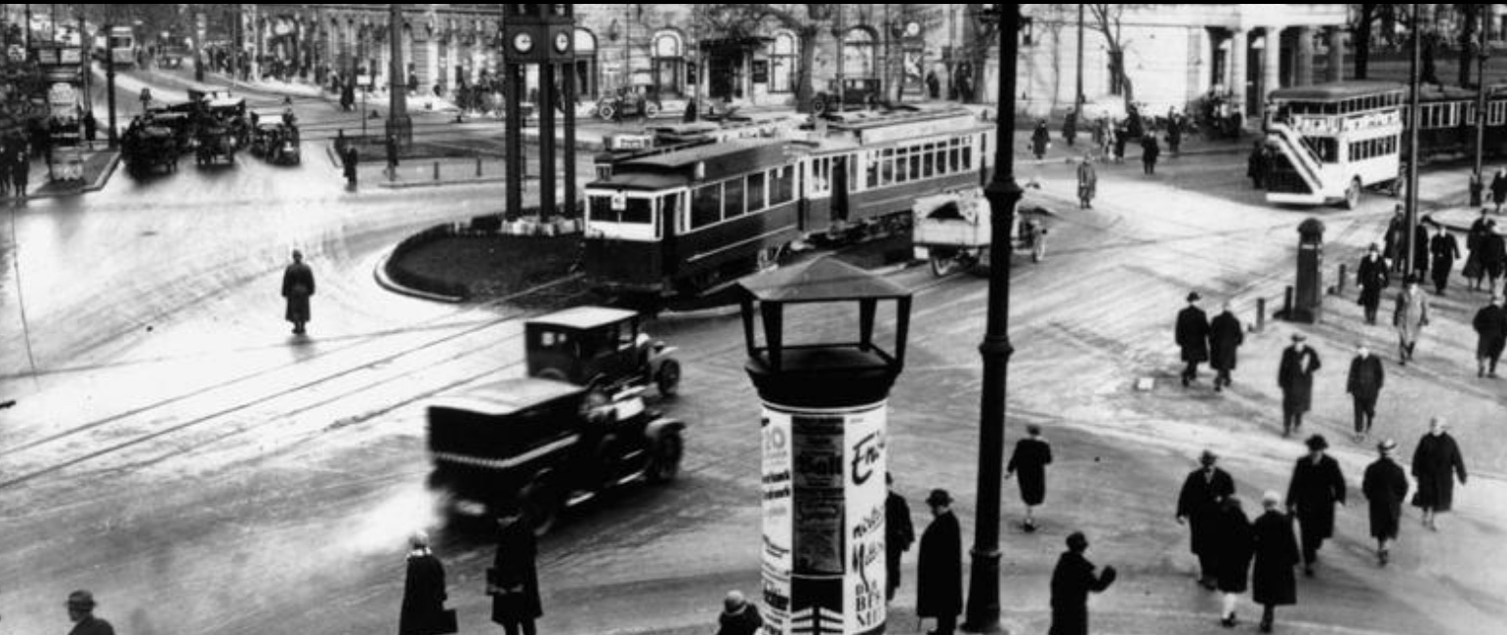

**Term 2 (2023/24),** 3 credits  
Prerequisite: none (taught in English)

***Important Note: You can get credit for either Germ 301-002 or GMST 346-201, but not both.***

**Instructor:** [**Markus Hallensleben   
E-mail: mhallen@mail.ubc.ca**](mailto:mhallen@mail.ubc.ca?subject=Germ%20301)**Office Hours: T 12:30-1:00pm PST** only by appointment on either Zoom or at BuTo 922

**Time: T 11am-12:30pm PST.**

**Place: BUCH B218.**

**COURSE DESCRIPTION**  
Reading and discussion of literary works, theatre and film, from early 20th century bestsellers to minor literature, from avant-garde literature to visual art, from Expressionism to DADA, from the Austrian-Hungarian Empire to Weimar cinema, from WWI to WWII, and from the Great Depression to National Socialism. This course is designed to critically engage with Eurocentric history and thought by addressing topics such as fascism and capitalism, industrialization and individualism, power and place, imperialism and colonialism, exile and emigration.

**All course material is in English**. Major texts and films are available either as ebooks or through Library Online Course Reserves (LOCR). Additional resources will be available on UBC Canvas. **All assignments for the online home study parts and all lecture notes (ppt) of the in-person lessons on Tuesdays will be posted on Canvas**.

**LEARNING OBJECTIVES**

Upon successful completion of this course (i.e., with active attendance and participation, completion of reading and writing assignments), students will be individually and cooperatively able to:

1. analyse elements of the German-language cultural and historical context that are reflected in the literature of the period;
2. link the historical background to current societal issues such as an ongoing colonialism, discourses of power and place, concepts of inclusion and exclusion within a European context;
3. learn about mass movements and minority experiences during industrialization, urbanization and National Socialism;
4. identify collective core-narratives of belonging and non-belonging across cultures and nations;
5. recognize the impact that avant-garde literature and art have had on individuals and society;
6. develop and manage in-class group work that addresses course themes/objectives in regards to values that differ from one’s own.

**List of textbooks and primary material available as ebooks:**

- Franz Kafka: “[Before the Law](http://www.kafka.org/index.php?id=162,165,0,0,1,0).”

- Franz Kafka: *The Metamorphosis: A New Translation by Susan Bernofsky\**.

- Joseph Roth: *Job*\*.

*-* Selected avant-garde manifestos, poetry (from *Dawn of Humanity*) and artwork from Expressionism and DADA

*-* Selected writings by Brecht, Freud, Kafka, Kracauer, Marx, Simmel, Spengler and Roth   
- Bertolt Brecht: *Saint Joan of the Stockyards*.*

**Films and Videos** (excerpts online or on Canvas):

- Helmut Herbst: [*Dada*](https://www.ubu.com/film/herbst_dd1.html) (Documentary, Germany, 1968/69)

- Fritz Lang: [*Metropolis*](http://www.kino.com/metropolis/) (Silent Film, Germany, 1927)

- Walter Ruttmann:[*Berlin, Symphony of a Great City*](http://www.german-films.de/app/filmarchive/film_view.php?film_id=571) (Silent Film, Germany, 1927)

- Thédore Ushev: [*The Man Who Waited*](http://www.nfb.ca/collection/films/fiche/?id=53918&v=h&lg=en) (Short Film, Canada, 2006)

- Orson Welles: *The Trail* (France/Germany/Italy, 1962, [excerpt](http://www.youtube.com/watch?v=pqPeI7-eVgc&feature=related))

- Selected Documentaries on Berlin and German History (excerpts)

**GRADING SYSTEM**

|  |  |
| --- | --- |
| **Component** | **Weight** |
| **Class Participation (**includes active participation in home study assignments through self-assessment on Canvas (20%), as well as attendance of in-person lectures (10%**)** | **30%** |
| **2 Short Reflections to be submitted on CANVAS (each 10%)** | **20%** |
| **Midterm on CANVAS (Lockdown Browser): 15 February 2023, 11am-12.30pm PST** | **20%** |
| **Either Final Essay to be submitted on CANVAS, due on 11 April 2023 at midnight PST** | **30%** |
| **Or Final Exam on CANVAS (Lockdown Browser): 11 April 2023, 11am-12.30pm PST** | **30%** |

**Acknowledgement**

UBC’s Point Grey Campus is located on the traditional, ancestral, and unceded territory of the xwməθkwəy̓əm (Musqueam) people. The land it is situated on has always been a place of learning for the Musqueam people, who for millennia have passed on in their culture, history, and traditions from one generation to the next on this site.

# Syllabus

| **Date** | **Topic** |
| --- | --- |
| **Jan 9** | **1. Overview and Introduction** |
| *I. Power and Place during the Austrian-Hungarian Empire* | |
| Jan 11  **Jan 16** | **2. Franz Kafka: “Before the Law“ (1915)**  Ushev: *The Man Who Waited* (2006, Short Film); Orson Welles: *The Trail* (1962, [excerpt](http://www.youtube.com/watch?v=pqPeI7-eVgc&feature=related)) |
| Jan 18  Jan 22  **Jan 23** | **3. Franz Kafka: *The Metamorphosis* (1912/15)**  **1st Marked Assignment (Short Reflection 10%)** |
| Jan 25  **Jan 30**  Feb 1  **Feb 6**  Feb 8  **Feb 13** | **4. Emigration: Joseph Roth: *Job* (1930)*; Wandering Jews* (1926/27, excerpts*)***  **Midterm Review** |
| Feb 15 | Midterm Exam on Canvas (20%) |
| *Feb 19-23* | *Reading Week* |
| *II. Mass Movements and the Individual from WW I to WW II* | |
| **Feb 27** | **5. Avant-Garde Art and Poetry:**  **Expressionism: *Dawn of Humanity* (1919)**(Group Work) |
| Feb 29  **Mar 5** | **6. DADA Art, Poetry and Manifestos;** Helmut Herbst: [*Dada*](https://www.ubu.com/film/herbst_dd1.html) (1968/69, Documentary) |
| Mar 7  **Mar 12**  Mar 14 **Mar 19** Mar 21  **Mar 26** | Final Essay Draft Due (Optional)  **7. Weimar Cinema: Walter Ruttmann: *Berlin, Symphony of a Great City* (1927);** Marx/Engels, Spengler, Simmel (short excerpts)  **2nd Marked Assignment: Short Reflection (10%) and Group Work**  **Fritz Lang: *Metropolis* (1927, excerpts)** |
| Mar 28  **Apr 2**  Apr 4 **Apr 9** | **8. The Great Depression before National Socialism: Brecht, Bertolt: *Saint Joan of the Stockyards*** (1931/1959); selected other material  *Note, that this play will also be performed by UBC Theatre, and that we will arrange for attending one of the evening performances.* |
| t.b.a. | **Final Essay Peer Review and Final Exam Review** |
| Apr 11 | **Final Exam on Canvas (30%) or Final Essay due at midnight** **(30%)** |