**GMST 424/ Germ 408 Selected Issues in German Culture: Narratives of Belonging**

**Credits:** 3

Prerequisite: none (taught in English)

**Date and Time:** **Winter 2023/24 | Term: 2, T 3:30-5pm PST**

**Place:** **Buchanan D209**

**Instructor:** Prof. Markus Hallensleben, [mhallen@mail.ubc.ca](mailto:mhallen@mail.ubc.ca)

**Office Hours:** T 12:30-1:30pm (only by appointment on either Zoom or at BuTo 922)

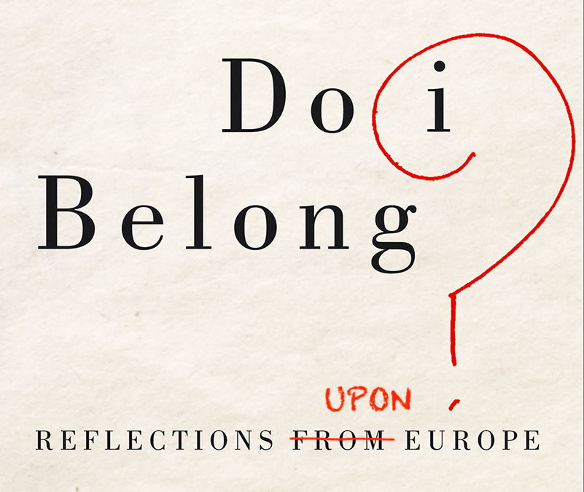

**COURSE DESCRIPTION**  
This course focuses on narratives of belonging from a transdisciplinary cultural studies perspective. How do people relate to place? Does the question “Where are you from?” assume a linear narrative and sedentarist perspective of exclusion? How do we narratively create and perform collective belonging, cultural spaces, phenomenological borders, national and ethnic identities? With an emphasis on contemporary postmigrant narratives from German-language literature that have become central to Germany as a plural society, as well as to European social studies, we will investigate counter-narratives to Eurocentric, ethnically and nationally centred visions of identity and belonging.

**Primary sources** will include texts by authors such as Abbas Khider, Zafer Şenocak, YōkoTawada and Ilija Trojanow.

There are no prerequisites. **Students are welcome to read the textbooks in the original language and to incorporate their own research fields/study backgrounds**. **The course follows a hybrid structure of online instruction: All assignments for the online home study parts and all lecture notes (ppt) of the in-person lessons on Tuesday will be posted on Canvas**.

**Reading List of Primary Sources (on Reserve and as ebooks*)**

**Khider, Abbas.** *Slap in the Face.*\* Seagull Books, 2019. **Required**. (*Ohrfeige,* Carl Hanser, 2016, German eBook version at Goethe Institute Onleihe). Optional.

**Lerman, Antony,** editor**.** *Do I Belong? Reflections from Europe*.* Pluto Press, 2017. (**Required** **excerpts** on Reserve.) Purchaseoptional**.**

**Şenocak, Zafer.***Perilous Kinship.\** Hafan Books, 2009.**Required (***Gefährliche Verwandtschaft*, Babel, 1998, available as pdf through the Instructor. Purchase Optional.)

**Tawada, Yōko.\*** *Where Europe Begins/Talisman* (excerpts of literary essays). **Required**.

**Trojanow, Ilija.** "Fleeing, and Then? (excerpt, pp. 1-6 **required**). On Reserve. (*Nach der Flucht*.* S. Fischer, 2017, German eBook version at Goethe Institute Onleihe). Optional.

**LEARNING OBJECTIVES**

Upon successful completion of this course (i.e., with active attendance and participation, completion of reading and writing assignments), students will be individually and cooperatively able to:

1. analyse elements of the German-language cultural and historical context that are reflected in the literature of postmigration;
2. link the historical background to current societal issues such as an ongoing colonialism, discourses of power and place, displacement and integration, concepts of inclusion and exclusion within a European context;
3. learn about *Leitkultur* (hegemonic German culture) and minority experiences after the fall of the wall (1989) until today;
4. identify collective core-narratives of belonging and non-belonging across cultures and nations;
5. recognize the impact that diasporic experiences have had on individuals and German society;
6. develop and manage in-class group work that addresses course themes/objectives in regards to values that differ from one’s own.

**GRADING SYSTEM**

|  |  |
| --- | --- |
| **Component** | **Weight** |
| **Class Participation (**includes active participation in home study assignments through self-assessment on Canvas (20%), as well as attendance of in-person lectures (10%**)** | **30%** |
| **2 Short Reflections to be submitted on CANVAS (each 10%)** | **20%** |
| **Midterm on CANVAS (Lockdown Browser): 15 February 2023, 3:30-5pm PST** | **20%** |
| **Either Final Essay to be submitted on CANVAS, due on 11 April 2023 at midnight PST** | **30%** |
| **Or Final Exam on CANVAS (Lockdown Browser): 11 April 2023, 3:30-5pm PST** | **30%** |

**Participation: Attendance and Marked Assignments**

required and will be evaluated based on **weekly self-assessments**. It is the students’ responsibility to keep their attendance and activity trackable for each session, whether asynchronous or in-person coursework. Only two **classes (all dates marked in the syllabus schedule in bold)** can be missed without official excuse. Only exceptions are illness or UBC-sponsored activity. Late submissions of assignments will result in 5% deductions unless communicated otherwise.

**Acknowledgement**

UBC’s Point Grey Campus is located on the traditional, ancestral, and unceded territory of the xwməθkwəy̓əm (Musqueam) people. The land it is situated on has always been a place of learning for the Musqueam people, who for millennia have passed on in their culture, history, and traditions from one generation to the next on this site.

**Syllabus**

| **Date** | **Topics and Primary Readings** |
| --- | --- |
| **Jan 9** | **1. Overview and Introduction: Narratives of Belonging** |
| **I. Constructing Plural Belongings: Decolonization in Canada and Two Examples from Germany** | |
| Jan 11  **Jan 16** | **2. Belonging in Unceded Territories: Dupuis-Rossi, Riel, et al. "**[**Disrupting** **Current Colonial Practices and Structures in the Immigration and Non-Profit Sector**](https://www.amssa.org/resource/amssa-booklet-disrupting-current-colonial-practices-and-structures-in-the-immigration-and-non-profit-sector/)**."** |
| Jan 18  **Jan 23** | **3. Overview and Introduction: Narratives of Belonging in Europe; Lerman: *Do I Belong* (excerpts)** |
| Jan 25  Jan 29  **Jan 30** | **4. Trojanow, Ilija. *After the Flight*/*Nach der Flucht,* 2017 (excerpts**)  **1st Marked Assignment (Short Reflection 10%)** |
| Feb 1-  **Feb 13** | **5.** **Writing across Borders –Tawada, Yōko: *Where Europe Begins* (*Talisman;* excerpts);** “Writing in the Web of Words” (“Schreiben im Netz der Sprachen”); |
| Feb 15 | **Midterm Exam on Canvas (20%)** |
| ***Feb 19-23*** | ***Reading Break*** |
| **II. Deconstructing Hegemonic Narratives: Three Examples from Germany** | |
| **Feb 27** | **6. Intro: Narratives of Postmigration** |
| Feb 29-  **Mar 12** | **7. De-Essentializing Identity: Against Between – Şenocak, Zafer: *Perilous Kinship (Gefährliche Verwandtschaft,* 1998*);***  Final Essay Draft Due (Optional) |
| Mar 14**-Apr 2** | **8. Postmigrant Hybridity – Khider, Abbas: *Slap in the Face (Ohrfeige,* 2016*)***  **2nd Marked Assignment: Short reflection in the Canvas Discussions Forum (10%)** |
| **Apr 9** | **9. Final Essay Peer Review and Final Exam Review** |
| Apr 11 | **Final Exam on Canvas (30%) or Final Essay due at midnight** **(30%)** |