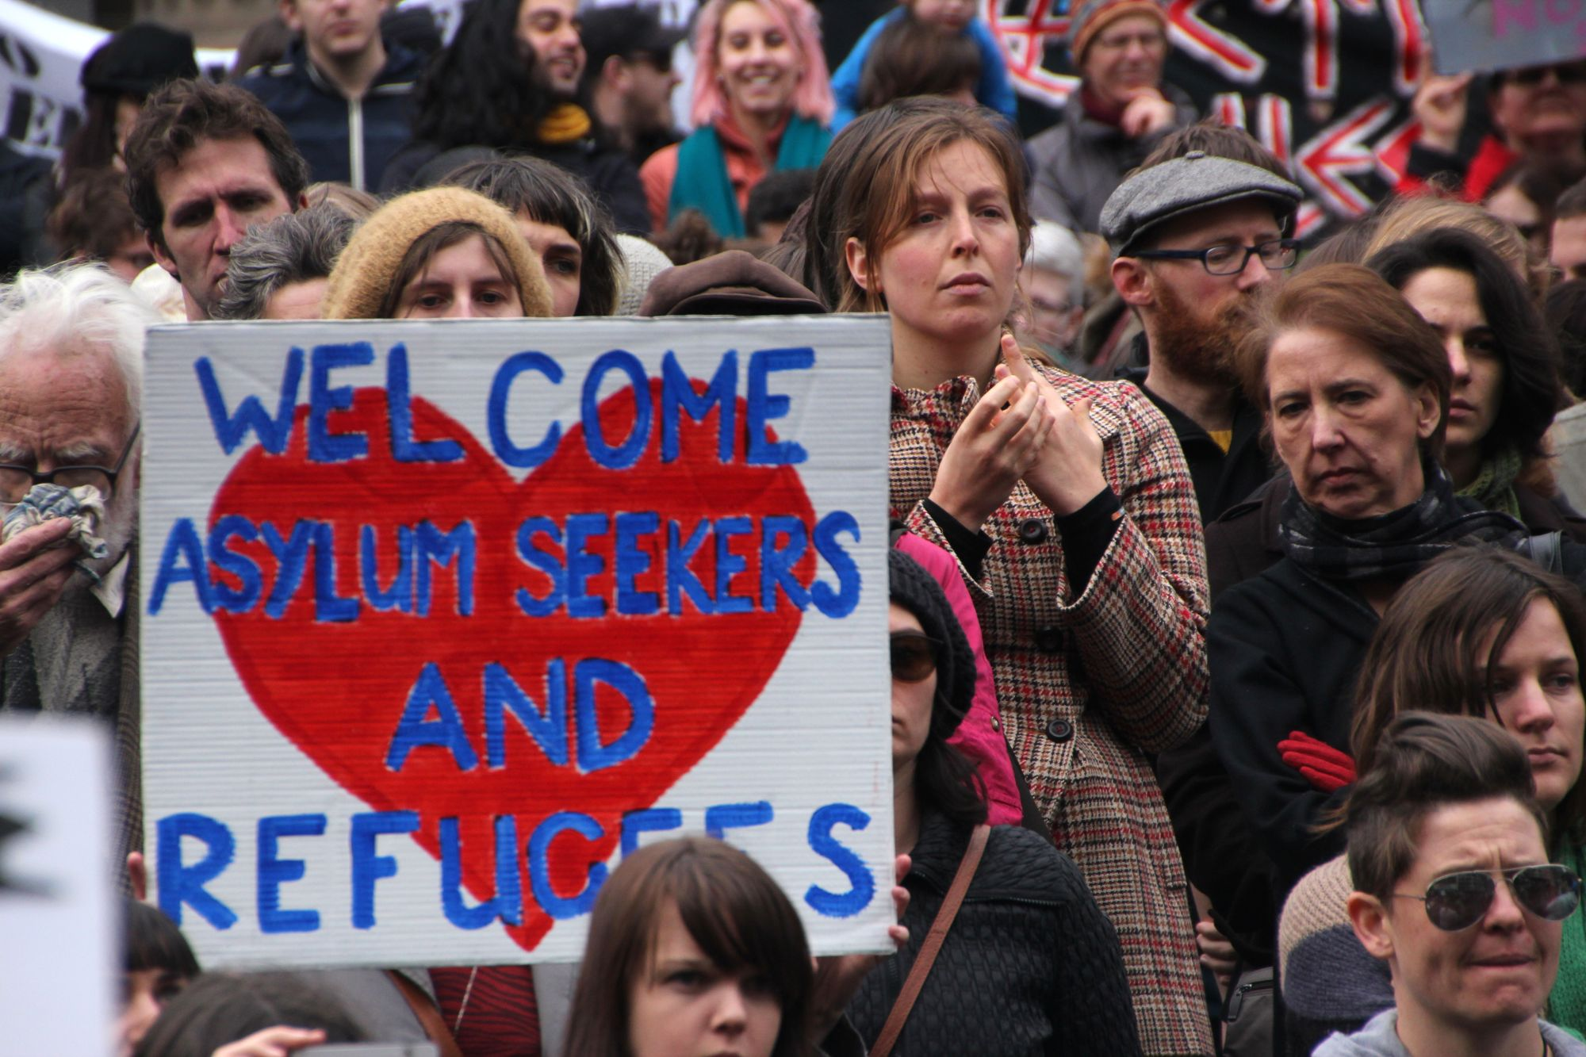**GMST 229-201/347-201 - GERN 347-201 301 (3) Germanophone Literature after 1945: Displacement, Exile, Flight and Migration**

Prerequisite: none

Term 2 (2025/26)

Instructor: Prof. Markus Hallensleben, [mhallen@mail.ubc.ca](mailto:mhallen@mail.ubc.ca)

Office Hours: W 12:30-1:00 PST only by appointment on [Zoom](https://ubc.zoom.us/meeting/register/u5Usde6hqDMuGt29HewCVrWYj6QEO-sWa6Za)

**Time: W** **2-3:20pm PST**

**Place: t.b.a.**

The course is taught in a hybrid format, with the class meeting in person every Wednesday. **Important: The Wednesday lectures will not automatically be recorded.** In lieu of the Monday lectures, you need to do your home studies on UBC Canvas.

***Important Note: You can get credit for either one of GMST 229, GMST 347, or GERN 347. Readings for GERN 347 have to be done in German, with assignments to be done either in English or German.***

**COURSE DESCRIPTION**

This course aims to introduce to the current themes and historical settings of displacement, exile, flight and migration from a practical decolonial and convivial point of view. We will critically discuss topics such as diasporic and national belonging, asylum and integration politics, multiculturality and European cultural identity in Germany. We will not only look at the representation of refugees in literary texts, but also in mass media. All readings are in translation and focus on contemporary transnational Germanophone narratives of belonging and migration. While the beginning of the course covers political exile and German immigration politics from a historical perspective, the second part focuses on the “refugee crisis” and the “Welcome Culture” from 2015 up to the present.

**All course material is available in English translation**. Major texts and films are available either as ebooks or through Library Online Course Reserves (LOCR). Additional resources will be available on UBC Canvas. **The course follows a hybrid structure of online and in-person instruction: All assignments for the online parts and all lecture notes (ppt) of the in-person lessons on Wednesdays will be posted on Canvas**.

**LEARNING OBJECTIVES**

Upon successful completion of this course (i.e., with active attendance and participation, completion of reading and writing assignments), students will be individually and cooperatively able to:

1. analyse elements of the German-language cultural and historical context that are reflected in the literature of the period;
2. link the historical background of exile to current immigration politics and policies of Germany within a European context;
3. learn about refugee and immigrant experiences, as well as citizens’ and Indigenous peoples’ responses;
4. identify collective core-narratives of displacement and migration, belonging and non-belonging across cultures and nations;
5. recognize the colonial impact that displacement, exile, flight and immigration have on individuals and society;
6. develop and manage in-class group work that addresses course themes/objectives in regards to values that differ from one’s own.

**List of textbooks and primary material available as ebooks*, with copied excerpts at UBC Library Online Course Reserves (LOCR):**

“The Afghan Girl.” *National Geographic* 6 (1985) & 4 (2002). (journalistic essays and documentary). On Reserve.

Arendt, Hannah. "Wir Flüchtlinge./We Refugees." (essay). On Reserve.

Czollek, Max.*Gegenwartsbewältigung.\** (excerpt)/"Overcoming the Present." (essay), <https://escholarship.org/uc/item/82j1524z>.

Göktürk, Deniz, et al., eds. *Transit Deutschland/Germany in Transit: Nation and Migration.* (diverse primary sources: literary essays, song lyrics, political speeches, journalistic editorials, legal frameworks, historical chronology). Excerpts on Reserve.

Kermani, Navid.* *Einbruch der Wirklichkeit/Upheaval: The Refugee Trek through Europe.* (journalistic essay). Optional Purchase (kindle). On Reserve.

Trojanow, Ilija. *Nach der Flucht.*/ After the Flight.* Excerpts on Reserve.

**GRADING SYSTEM**

|  |  |
| --- | --- |
| **Component** | **Weight** |
| **Class Participation (Attendance 10%, Group Work and Home Study Participation: 30% based on self-assessment)** | **40%** |
| **Midterm on CANVAS (Lockdown Browser): 23 February 2026, 2-3:30pm PST (80 min)** | **30%** |
| **Either Final Essay to be submitted on CANVAS, due on 8 April 2026 at midnight PST** | **30%** |
| **Or Final Exam on CANVAS (Lockdown Browser): t.b.a., 2-3:30pm PST (80min)** | **30%** |

**Acknowledgement**

UBC’s Point Grey Campus is located on the traditional, ancestral, and unceded territory of the xwməθkwəy̓əm (Musqueam) people. The land it is situated on has always been a place of learning for the Musqueam people, who for millennia have passed on in their culture, history, and traditions from one generation to the next on this site.

**SYLLABUS**

| Date | **Topic/Primary Readings** |
| --- | --- |
| Jan 5-**7** | **1. Overview and Introduction: Transnational Narratives of Displacement, Exile, Flight and Migration** |
| Jan 12-**14** | **2. Hannah Arendt: “We Refugees”; Edward Said: "Reflections on Exile."** |
| **Jan 21** | **3. Guest Workers and Displaced Persons in West Germany** |
| Jan 26-**28** | **4. *Transit Deutschland/Germany in Transit* after 1945 *–* Immigration Debates from “Guest Worker” to “Leitkultur” (Guiding Culture)** (excerpts)  **Group Work and (1-2 PPT slides) Group Presentations on definitions:** “Guest Worker” (“Gastarbeiter”); Guiding Culture (“Leitkultur”); Homeland (Heimat); Multicultural (“multikulti”); Bastardizised Language, “Kanaki” (“Kanak[en]”) Literature |
| Feb 2-9 | **5.Cultural Confluences *–* Ilija Trojanow:“Fleeing and Then”*/Nach der Flucht*** (excerpts);Trojanow and Hoskote: Confluences (chpt. 1); |
| **Feb 11** | **6. Midterm Review** |
| Feb 13 | Final Essay Draft Due (Optional) |
| *Feb 16 -20* | *Reading Week* |
| **Feb 23** | **Midterm on Canvas (30%)** |
| **Feb 25** | **7.** **Refugees in the Media – “The Afghan Girl.” (*National Geographic* Documentary, 2002)** |
| Mar 2-**4** | **8. “Refugee Crisis” 2015 – Kermani, Navid: *Einbruch der Wirklichkeit/Upheaval*** (Journalistic Essay) |
| Mar 9-**11** | **9. Welcome Culture? – Group Work** with Peer Review: Compare your findings of the [Welcome App](http://ankommenapp.de/APP/EN/Startseite/startseite-node.html) (for asylum seekers in Germany |
| Mar 16-**Apr 1** | **10. Practical Decolonization and “Radical Diversity”** – Max Czollek: *Gegnwartsbewältigung* [Introduction]/“Overcoming the Present” |
| **Apr 8** | ***Final Exam Review;* Final Essay due at midnight** **PST** **(30%)** |
| t.b.a. | **Final Exam (30%) on Canvas** |