Content Module: Unit 3 - Grade 8 Poetry – Express Yourself!

Jenny Lee Northey, Kirsten Ng, Melissa Lavoie, Pamela Jones

ETEC 565A: 66B

University of British Columbia

Content Module: Unit 3 - Grade 8 Poetry – Express Yourself!

“*The task of the online course designer and teacher is to choose, adapt and perfect (through feedback, assessment and reflection) educational activities that maximize the affordances of the Web.*”

~ Terry Anderson, 2004, p. 55

The development of our Content Module moved forward according to the models selected for use in Assignment 2. Fink’s Model of Course Design and McTighe & Wiggins’s Theory of Backward Design are well aligned, in that they both promote the creation of learning goals first, in order to identify the desired outcomes in a course. (This we accomplished in the Introductory Module.) Secondly, assessments are determined in order to prioritize the skills and performance tasks required of the students. Finally, instructional activities are designed to link the learning goals with the planned assessments. While we had loosely identified some generalized categories of assessment for the Introductory Module, we required significantly more time to specifically develop our assessments and learning activities.

The development of suitable assessments, relevant instructional activities and online opportunities necessary for students to learn and to show learning are at the heart of Unit 3, the Content Module created for Assignment 3. This documentation will provide an overview of the selection and rationale for our chosen content elements, assessment procedures, communication tools, and a continued exploration of the affordances and constraints of our chosen LMS’s, Eliademy.org and Edge.EdX.org.

**Content Elements**

We divided our content module into three units that are each two weeks long. We decided to develop the final unit, Unit 3, in its entirety because it allowed for the greatest integration of learning goals, instructional activities, and assessment opportunities. However, in order to visualize and plan for Unit 3, we required a road map that would highlight what had been accomplished along the way in Units 1 and 2. We created a unit plan outline that described the content objectives, assignments and assessments for Weeks 2, 3, 4, and 5, prior to focusing on Weeks 6 and 7.

Attached as Appendix A, the unit plan for Express Yourself! Grade 8 Slam Poetry lists the learning objectives, success criteria, and instructional activities planned, at least superficially, for the first four weeks, and in depth for the final two weeks. By going through Unit 1 and 2 of the Express Yourself! course, students would become comfortable with the format and the communication and collaboration tools used in the course. We determined that we would divide our units into two-week chunks to provide students with enough time to absorb new information in the first week, and to practice using their new skills further in the second week. For each week we identified one slam poet whose work was available to view on YouTube, and whose work connected to the content we intended to teach. We chose these slam poets based on their appeal to our target audience age and reflect diversity in topics and backgrounds. These choices would require further consideration to ensure that all poets are Canadian, and represent greater social diversity.

**Instructional Activities**

Every week was given the same structure to facilitate predictability and to allow students to focus on learning, rather than on navigating the online LMS. As it is, there is significant interaction with websites, collaboration and communication tools both inside and outside of the LMS. The major components of each week’s learning activities are reading poetry, watching a slam poetry performance on YouTube, writing, performing, and recording original poetry, and self-assessing their efforts in the realms of writing and performing. Additionally, students are expected to contribute to the community of learners by posting answers to weekly discussion forum questions and by responding to the posts of others.

The instructional activities chosen were intended to align with Fink’s six domains of significant learning, as described and considered in Assignment 2. In an effort to evaluate the activities and assessments we propose, we can re-consider our efforts in each of the six domains:

|  |  |
| --- | --- |
| Domain | Content Module Integration |
| Metacognitive Goals | Self-assessment constitutes a significant portion of a student’s learning activities each week. A student is required to use the poetry rubric to self-assess their original written poem and to use the performance rubric to self-assess their recorded spoken word performance. The results of this reflection will ideally drive student growth. |
| Foundational Knowledge Goals | We experienced significant growth in our understanding of this dimension of learning. As successful researchers and users of “the Internet”, we are well aware of the breadth and depth of information available online. It soon became apparent, in adding links and content, that we would easily overwhelm our students if the content was not precisely considered and chosen. We ended up removing several poetry apps that didn’t fit with a specific unit and several videos that were not by our chosen slam poets. We made sure to include any required content, facts, and information within the LMS for students to locate and study in situ. Any extraneous material was identified as ‘optional’ to ensure students know that they are working beyond expectations in accessing those resources. |
| Application Goals | For our early poetry writing assignments (Poems 1, 2, and 3) students are to be given a framework which can be used entirely, to some degree, or not at all when writing their original poems. They can apply these structures and poetic devices to their later assignments (Poems 4 and 5) and to their own efforts at writing poetry. At the least, students should become aware that poems can be used to inspire further works. |
| Integration goals | In the interests of maintaining integration throughout course components, we embedded Google Hangouts, Docs, Slides, and Forms and YouTube videos into the online LMS’s. Additionally, all student and instructor communication is directed to the discussion forums, except for private emails that may travel between participants and the instructor. |
| Caring Goals | We designed our content modules to scaffold students in becoming aware and comfortable with their own feelings, interests, and ideas about poetry, as well as writing their own poetry. We prepared an entry survey to gauge students’ opinions and familiarity with poetry. We also utilized the discussion forum to reflect on certain poems each week, focusing on particular aspects of poetry writing and performing, and having students apply their learning to their own poems for that week. Their growth is to be documented through self-assessments kept in the Google Slides e-portfolios, which then support students in the poetry slam, the final summative assignment. As part of each unit, students are asked to record themselves performing poems, with the aim that they become comfortable speaking out their poems and hearing themselves out loud. We aim for students to be inspired by their own voice and those of others as well, learning how slam poetry is one vehicle through which one’s passions, interests, and questions can be expressed. |
| Human Dimension Goals | In working in an online environment, it is vital to build in opportunities for students to see one another as fellow students and people. Discussion forums, mandatory casual video hangouts (for the dual purpose of practicing the technology and connecting with others) and peer assessment have all been integrated into the unit for the purposes of facilitating contact between students.  In hindsight, we were extremely fortunate in the selection of our topic. Three of the four members of our group were content to work within the area of literacy instruction. We thought an online module for poetry could be worth exploring. Our fourth group member was every bit the professional and was willing to work within the topic, despite her own inaccurate preconceptions of her poetic shortcomings. Upon reflection, it turns out a close family member of this participant is in fact a slam poet in his own right and was willing to create an original video for our purposes. It is a compelling activity and is elaborated further, below. |

Table 1. Instructional activities sorted by significant learning domain.

**Guest Speaker**

We were delighted to have the opportunity to have Vancouver-based poet and actor Omari Newton perform an original poem for our “Slam Poem: Using Your Own Voice to make an Impact” unit. Omari is a professional actor, writer, Slam poet and MC whose work can be found on television, film, stage or radio. He is currently a City of Vancouver funded Artist in Residence (Playwright) with urban ink productions, and frequently works with youth to provide skills training in the elements of hip hop and theatre. He recorded an interactive video for the students, whereby he engages them to participate in two challenges to spark the starting point for their final project: the online poetry slam. Omari’s presence, and the easy delivery in which he speaks about his motivations and beginnings of his poetry career, work to alleviate any potential reservations students may be having prior to their final project recording session. Clark and Mayer (2008) provide six empirically-based principles based in cognitive psychology theory to guide multimedia inclusions as it pertains to virtual learning environment. The Personalization principle specifically states that using a conversational tone and/or a personalized learning agent to enhance learning via social conventions to listen and respond meaningfully. Additionally, Mandernach reports that student feedback in courses with instructor-personalized multimedia attested to an increased interest in further study in the content area, and that the online course provided an unexpectedly more personal learning experience (Mandernach, 2009).

**Poetry Slam: Summative Assignment**

In brainstorming ways we could make learning interactive, we thought of Google Hangouts on Air as an appropriate tool for the Poetry Slam summative assignment. It is free of charge and hosted online, and as students would already have Google accounts, this tool is readily available. It would also enable every student to participate both as an audience member and performer on the same platform. The video clips of the poetry slams can also then be uploaded to YouTube as unlisted videos, so that they are available for review after the live performances. Though Hangouts on Air cannot be embedded into Eliademy as it can be with Edx, these affordances make it a worthwhile tool to use for our purposes.

Students will use the Google Hangouts on Air tool to record their final product (virtual poetry slam), so it made sense for them to also use this tool for their practice recordings in Unit 1, and again in Unit 2. This exposure will help students become more comfortable with seeing and hearing themselves in a broadcast. A Slideshare presentation is embedded into the “Tech Tips and Tuts” to guide students through the steps to create a broadcast. A combination of screenshots and text will help to illustrate this for students.

**Revisions**

As noted within the commentary of Fink’s six types of significant learning, several resources, technologies and ideas that were proposed in the Introductory Module were reconsidered and eliminated. In some cases, the ideas we initially had for learning activities or assessments proved both too burdensome and complicated for students, or not appropriately correlated to the learning objectives we wished to achieve. Additionally, we made several revisions to our initial Readings & Resources to reflect our process of selecting appropriate and relevant slam poetry artists for our content modules. Technologically, both calendar functions and discussion forum functions proved complicated and difficult to manage on first pass. Each is to be discussed further in this documentation.

**Graphic and Media Elements: Integration of Google Apps For Education (GAFE)**

**Google Docs: Poems**

A Google Doc would be created by the instructor, containing all necessary instructions for the assignment. By changing the URL of the Google Doc from “/edit” to “/copy”, the instructor would force the student to “make a copy” of the assignment when the student clicks on the link in the LMS, so that the student would have his/her own copy created in their Google Drive. Students would then share the Google Doc with the instructor by clicking on the Share button and typing the instructor’s email address and allow editing permissions (this is the default). This is where the instructor would then be able to access every student’s work, even while they are typing, and provide that vital immediate and ongoing feedback to the student. Fink’s article urges educators to think about what [they] can do that will help students learn, as well as give [them] a basis for issuing a course grade.

**Google Docs/Slides: Student Reflection**

A Google Doc and Slides would be created by the instructor, containing all necessary instructions for the Reflection. The student would choose between these two applications to develop their reflection. As well, we would allow the students to choose how they will present their self-reflection. For example, they can write in paragraph form, they can use screenshots of feedback on their work, and/or they can directly cut and paste feedback, etc. By changing the URL of the Google Doc and Slides from “/edit” to “/copy”, the instructor would force the student to “make a copy” of the reflection when the student clicks on the link in the LMS, so that the student would have his/her own copy created in their Google Drive. Students would then share the Google Doc or Slides with the instructor by clicking on the Share button and typing the instructor’s email address and allow editing permissions (this is the default).

**Google Docs / Forms: Rubrics**

The instructor would develop each rubric on a Doc, and place a Force Copy command in the link shared within the course (see above for Force Copy instructions). Students would be instructed to click on the link whenever they are called to evaluate a peer’s work, annotate directly on the rubric by highlighting levels and typing in feedback, and then share their feedback via email to the instructor. The students will be instructed as to how they should title their rubrics so that the instructor will be able to keep track of participation. Then, to inform the student's Self Reflection, the teacher would simply email all rubrics to the individual student in Eliademy.

Alternatively, the instructor would develop two rubrics in Google Forms. The students would refer to the same rubrics throughout the course, in order to promote consistency. One rubric would assess student written poems, and the other would assess the poetry slam/recording of their poems. Therefore, not only will students be submitting a hard copy of their poems, but they will also submit a recording of their performance. We believe that students should record themselves performing each of their original poems throughout the course, so that they can develop their craft and increase their comfort level when it comes time to participate in the final assessment (the virtual poetry slam). The instructor will provide a link to each of these rubrics in Eliademy (they can also be embedded), where the instructor and peers can provide evaluation/feedback to the student, as well, the student is to use the same rubric to evaluate him/herself. All responses will be collected on a communal spreadsheet so that the instructor can easily track all submissions, and determine what mark to give the student at a glance. A Google Form can be “turned off” by clicking “Responses” at the top of the Form, and then clicking off the “Accepting responses” option, as illustrated below. This could be useful when the instructor does not necessarily wish to receive miscellaneous responses from another class, etc. It helps to protect the integrity of the results. The instructor could also unlink the Form from the corresponding spreadsheet, create another spreadsheet, and choose this one to change the response destination.

**Google Slides / Slideshare: Technical How-To Guide**

Eliademy does not support embedding Google Slides, but we were able to upload our Slides into Slideshare and then embed into Eliademy through the URL. Since they are two separate platforms, there was some format collision in terms of the fonts. The Slides deck was created using a third-party template repository specifically for Google Slides called Slides Carnival, as the templates native to Slides are fairly limited. This could have also contributed further to the formatting issues we encountered; the actual content delivery was not at risk, it was mostly font choices that were affected, along with some minor positioning issues. Our rationale for embedding a Slides deck as opposed to simply posting the steps and screenshots was the fact that we were concerned about the number of steps needed to relay the information to the students. We determined that a lengthy thread would not serve to hold a student’s attention, and a Slides deck by its very design serves as a “chunking” accommodation to help with alleviating information overload. It naturally breaks down the information into easy to manage steps. Since the original Slides deck was created in Google Slides, a link to the presentation was also provided for the students so that they can also add to their personal Drives for future reference.

**YouTube Videos**

One of the affordances of Eliademy and of Edge EdX is the ability to embed YouTube videos directly. We made use of this tool throughout the course to vary our media elements and for students hear a diversity of poems and poets. With a single Google sign-on, students are able to also curate their own list of slam poets for inspiration.

**Assessment**

The assessments chosen for Weeks 6 and 7 are intended to help students achieve the success criteria associated with our learning objectives. Step 3 in Fink’s Guide to Designing Courses for Significant Learning asks the instructor to design assessment opportunities for learning with four main components: 1) forward-looking assessment, 2) criteria and standards, 3) self-assessment, and 4) feedback. Each of Fink’s four components of assessments are embedded multiples times in our content unit.

**Forward-Looking Assessments**

*Forward-looking assessments* are intended to generate or replicate situations which could arise in real life. Thus, the assessment is forward-looking in terms of its possible applicability to real life. In Unit 3 we ask students to use poetry for self-expression, to collaborate online using Google+ Hangouts, and to self-reflect against a set of standards for the purpose of improving their writing and presentation skills. These are each activities which could easily be encountered later in a student’s academic career or personal life.

**Criteria and Standards**

The incorporation of *criteria and standards* is relevant to the creation of our two original rubrics, the Poetry Rubric and the Performance Rubric. Students are asked, every week, to self-reflect within these frameworks of criteria and associated levels of achievement. Students can know specifically, and quickly, to what degree they are meeting expectations. This incorporates Fink’s next component, *self-assessment*. We expect students to self-assess their written poems and the performance of their poems on recorded video beginning in the second week of the Poetry module. Ideally their ability to self-reflect and to improve their writing and performances based on these self-reflections will show growth throughout the module.

A well-developed rubric is ideally created in partnership with students who help to determine the success criteria and outcome descriptors for an assignment (Ontario Ministry of Education, 2010). This is difficult to achieve in an online course. Instead, we have relied on the consistent use of just two rubrics to facilitate a deep understanding of both the expectations of written poetry within this module and the expectations for the spoken word summative performance. A well-built rubric also allows students to improve their understanding of quality work, how to identify criteria that indicate quality and the relative levels of those criteria. This in turn can help students to feel more agency in their learning, to improve their vocabulary, and to transfer all of this skills to different learning contexts (Alberta Assessment Consortium [AAC], n.d.)

Alongside rubrics, it is beneficial for students to see exemplars of work levelled according to the rubrics which they are to use (AAC, n.d.; Ontario Ministry of Education, 2010). As such, the use of ‘professional,’ adult, slam poets as exemplars is problematic in some respects. While their use does present slam poems written and performed at a high level, this is likely unattainable for a student in grade 8. In further iterations of this course it would be hoped that student performances from earlier cohorts could be used to enhance a student’s perspective on what is an appropriate level to achieve. This could also be a plausible way to secure examples of written poems.

We have also made use of technological affordances to support students in *self-assessment* as integral to their learning. As a change from our Introductory Module, we determined that we would not use formal e-portfolios, once we considered the various tasks and assignments students had to manage simultaneously. Instead, students will collect their revised, final copy poems into a Google Docs or Slides presentation, as part of the evidence-gathering process, to capture ponderings, writing revisions, comments and feedback from the instructor as well as from their peers. Students will be able to reflect on their growth as a writer and reader of poetry. Maximizing the affordances of Google tools aligns with two of Fink’s 6 types of significant learning - “metacognitive learning” and “human dimensions of learning,” as well as with our Learning Goal #4. We allow students to choose how they will present their self-reflection - for example, they can write in paragraph form and/or use screenshots of feedback on their work and/or directly cut and paste feedback into the Google Slides document. Students will curate pieces of feedback from their poetry in Google Docs and in the discussion forum thread in order to inform their 10% Reflection mark.

**Feedback**

Finally, Fink highlights *feedback* as a vital component of assessment. Wiggins (2012) notes that “whether feedback is just there to be grasped or is provided by another person, helpful feedback is goal-referenced; tangible and transparent; actionable; user-friendly (specific and personalized); timely; ongoing; and consistent” (p.13). Feedback is embedded in many stages of Unit 3. Feedback is trickier to provide online than in a face-to-face setting. Tools need to be chosen to facilitate the provision of formative feedback in a manner that can be received and acted upon. Aligned with Learning Goal #4 (“I can reflect on, and identify my strengths in poetry and next steps for improvement in my writing”), we set out to facilitate students’ own formative feedback. Initially, we wanted to use Google Forms to create rubric documents that would be force-created as copies for each student for self-assessing their poetry writing and poem recordings. This same form would also be used for peer and instructor feedback. However, we soon realized that for students to have this feedback, the instructor would have to process each rubric, and to copy and paste each student’s respective feedback to email out weekly. In addition, pivot tables would have to be used, requiring a higher level of technology savviness. We decided to use Google Docs instead for the rubrics, providing students clear instructions in the LMS as to how they are to hand in their feedback. Students can directly annotate the rubrics (either with comments or highlighting the appropriate criteria) for self-assessment and peer-assessment and then send to the instructor by clicking the “Share” button, and ensuring the instructor’s email address is there with Edit rights. By receiving instructor and peer assessment, in addition to self-assessment, at the end of each unit, students will become more comfortable with the expectations and format of the summative assignment. For student convenience, a printable .pdf version of each rubric has also been uploaded to Eliademy and Edge EdX.

**Tasks, Grading and Analytical Tools**

Our grade breakdown is as follows:

* Discussion posts: 40%
* Written poems: 30%
* Virtual poetry slam poem and participation: 20%
* Poetry reflective self-assessment: 10%

The assignment grade weightings of the course reflect the focus on student collaboration and growth in their writing skills through regular formative assessment and reflection. In order for students to be successful in this course, regular participation in both discussion forum postings and writing tasks is essential. With repeated practice and reflection, we hope that students will realize the benefits of collaborative discussion and course engagement.

We found that the Eliademy Gradebook functions were limited; only whole values of 0 to 100 can be assigned. For the purposes of formative and summative assessment, we decided to use GAFE tools, as described above, to better align with the learning objectives and instructional activities. Unfortunately, this implies that instructors will become entirely responsible for an alternative record-keeping system. Though Eliademy’s holistic grading feature is not flexible enough for our assessment purposes, it should be mentioned that Eliademy does allow the instructor to track how many students have submitted their graded assignments. It also allows for students to track the percentage of tasks completed.

With regards to assessing a student’s participation and achievement in the discussion forums, the instructor may need to maintain some type of anecdotal log and checklist, outside of the LMS, to ensure students are posting with the appropriate content and rigour. Unfortunately, although this might seem thorough, it does defeat the purpose of teaching and learning in an online capacity. Typically, students can monitor the completion of tasks that are entered into the LMS as distinct activities. In Eliademy, tasks can be noted as ‘No submission required’ in the event an instructor wishes to remind students about a responsibility without assigning a mark. Although a convenient feature, it was not possible to edit the nature of a Task after it is created (e.g. changing it from “Written text or file upload” to “No submission required”). A plausible work around discovered in the Eliademy Help forums suggests asking students to cut and paste their initial discussion post into their task pane for easy viewing by the instructor. Again, this defeats the purpose of streamlining conversations into one place, but might make assessment and evaluation simpler for the instructor. Whether instructors ask students to copy and paste discussion posts or use an external paper-based mark book, constructive feedback can be relayed in a more timely fashion when the instructor has the information in a space that is conducive to their personal workflow.

The online LMS grading and reporting systems for both Eliademy and EdX are comprehensive and thorough. So much so that despite the time dedicated to learning Eliademy and Edge EdX, there are still many features that our group has yet to uncover and maximize to their full potential. We have scaffolded the use of new tools for our students and it is worth remembering that features and affordances can be gradually implemented and maximized. An online instructor does not need to adopt every available feature from the onset. Pedagogical needs will dictate which features are necessary, and courses will grow organically both within and between iterations.

**Communication and Collaboration**

Raffo et al. (2015) state that understanding what can be controlled is a first step to more effective balancing of the instructor’s course delivery activities. Our group adopted their time management suggestions for online course delivery, including strategically integrating technology, clearly organizing and labeling course information on Eliademy and Edge Edx, explicitly stating due dates and other time requirements, and being clear about discussion forum and assignment expectations. These suggestions will help limit student misunderstandings or confusion, and in so doing, provide the instructor with more control over time demands. Additionally, we posted the ways and tools by which students can communicate with the teacher and with one another at the outset of our course site.

**Instructor-Student Interactions**

**Instructor’s email and virtual office hours.** The instructor’s availability and contact information are posted at the start of the course.

**Course calendar.** Clear communication via a course calendar is a strategy to help students stay on top of tasks. In our Introductory Module, we created a Google Calendar and then embedded it within Eliademy. Upon further exploration, we discovered that we could add, modify or delete calendar events directly in Eliademy. The “Add event” widget is fully customizable, allowing us to create custom events such as virtual office hours. We particularly liked that all course tasks and assignments with due dates will be automatically shown in the calendar for all students the moment we create or change any information using the “Tasks” feature. There is also a List View which lists events alongside the course calendar.

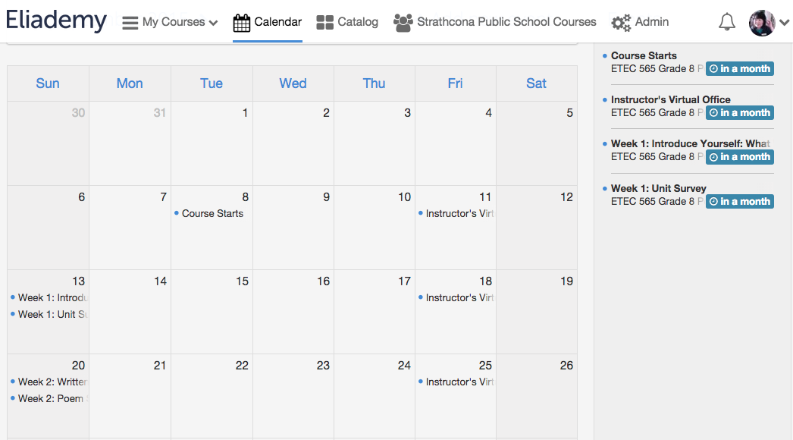

Another reason to use the Eliademy Calendar is that students can plan their personal schedule by entering their own events directly in the calendar to stay organized. These events will automatically be indicated by red dots to distinguish them from the blue ones entered by the instructor.

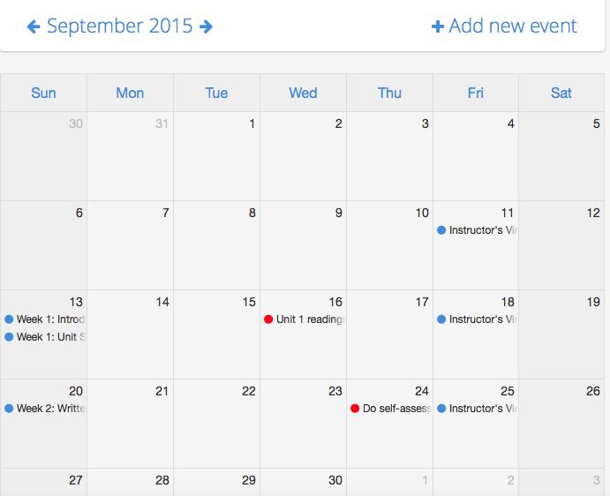

The Eliademy calendar can also be synced with Google Calendar, iCal, Outlook or any other compatible application, so students can have it on their tablets or smartphones.

Edge EdX also allows a Google Calendar to be embedded. Alternatively, an HTML code template is provided in EdX documentation to build a dynamic HTML calendar. This was added for Assignment 3 in the Course Orientation / Course overview section for comparison. The coded calendar would support internal links to content and would save students time in locating resources and information.

**Evidence of instructor engagement.** Research on effective online learning suggests that it is not enough for the instructor to log in and monitor a course. Instructors need to show that they are active in the course in order to motivate students. When a course is in session, students need to see evidence of instructor engagement such as weekly announcements and forum discussion posts (Kelly, 2014). One of the limitations of Eliademy is the absence of announcement tools within the platform. However, a “Messages” option to send email messages to students directly in Eliademy is available through the “Participants” page. It should be noted here that your course needs to be set to “Public” to be able to use the internal messaging system. Unfortunately, this option is not available in closed group courses.

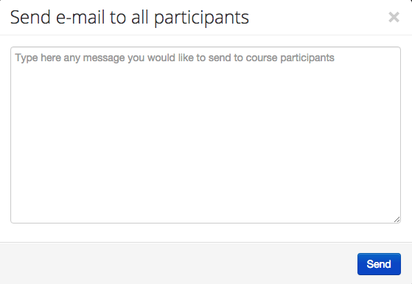 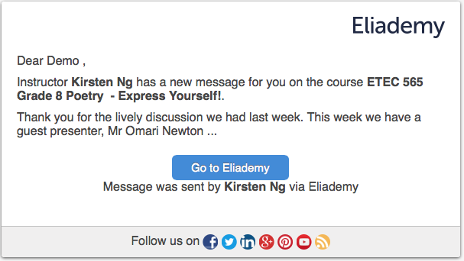

Designing for instructor presence, we plan to have regular routines of communication, such as email messages to students at the beginning of each week to recapitulate the learning highlights of the previous week and to get students excited about the learning in the new week. An advantageous feature in Eliademy is the ability to track whether a student has actually read an email and to re-send the message if necessary. Although this might seem ‘Big Brotherish’, it helps the instructor know if any student is missing important messages.

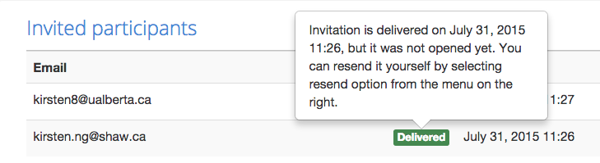

Ideally, email messages should stay archived in a Sent folder so that the instructor can come back to them and see the communication with the students. However, this feature is not available in Eliademy.

**Discussion Forums**. Another routine we want to establish is the moderation of the weekly discussion forums without being too teacher-centric, posing thought-provoking questions and/or insights to encourage active participation. As Anderson (2004) posits, quality online learning provides many opportunities for interactions that involve the instructor and that also exploit the influence and expertise of peers and external experts. Just as it does not allow the creation of sub-menus (mentioned in our Introductory Module), Eliademy does not allow the creation of sub-forums. There is no workaround other than creating individual thematic forums with clear headings. A nice affordance is that instructor presence is clearly indicated in forum posts with a corresponding icon and label. Another affordance is that the most recent posts are displayed here in the discussion forums, allowing instructor and students to jump straight to a discussion or select a forum from the side panel. The instructor and students also receive email notifications and alerts within Eliademy about updates that have been posted and have the ability to change the default settings.

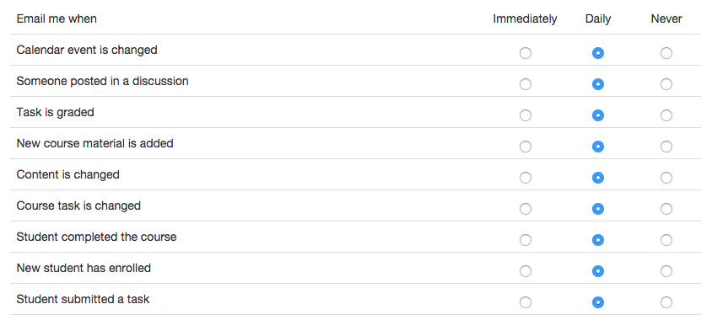

Edge EdX has a stronger hierarchy in the Discussion Forums. Questions and seeded posts can be described with both a category and a descriptor. In our case, we organized discussion post questions by week. An anomaly was noted when four of the discussion questions would not order themselves correctly. Regardless of the order in which they were created, the descriptors attached and the possible relevance of alphabetization, the numbers remain out of order. A function to reorder discussion questions or posts is also not a feature.

**Permission Forms.** Whilst this is not strictly instructor-student interactions, we feel that we should open up communication with the parent community with regards to the use of Google Hangouts on Air in the slam project to provide guidance for students (and the parents/guardians) when participating in online social media activities. Appendix C is a permission slip intended to make parents aware of the anticipated uses and end uses of Google+ Hangouts on Air and to ensure parents are informed with regards to their child’s online collaboration.

**Student-Student Interactions**

Constructivist and connectivist theorists stress the value of peer-to-peer interactions in developing multiple perspectives. As Anderson (2004) argues, “effective learning does not happen in a vacuum” and “learning is about making connections with ideas, facts, people and communities” (p. 49). Taking into account that students may feel isolated due to lack of face-to-face contact, we designed our course to provide students with a shared sense of belonging, trust, and experience of learning that will instill in them a commitment to participate in and contribute to knowledge. In this collaborative learning environment, students will have opportunities to develop good communication skills and demonstrate the ability to work cooperatively with one another: supporting and challenging one another in the weekly forum discussions and evaluating their own work and that of their peers through peer activities on shared Google Docs. Additionally, learning to tweet their thoughts using the class Twitter account, orally presenting their poem using Google Hangouts on Air, creating rapport with a peer audience, and giving and receiving constructive feedback will all help them build confidence and essential career and life skills.

**Student-Expert Interactions**

Connecting students to real-world experts provides expanded opportunities for students to interact with the community beyond the classroom environment. This provides scaffolding upon which students can grow their knowledge of slam poetry. Our group initially considered having our guest presenter host a synchronous ‘live’ presentation using Google Hangouts. While Eliademy has a live webinar feature, this is for premium account holders only. To allow students more time to interact with Mr. Newton and field questions, we decided that using a recorded video and a week-long forum discussion will be more effective in increasing their engagement and mastery of important concepts.

**Concluding Remarks**

In sum, our group considered the pedagogical and technical affordances and limitations of Eliademy and Edge Edx and employed a backward design model and a range of activities, assessments and digital technologies that best support learner outcomes aligned with the Ontario Grade 8 English Language Arts curriculum. The process of designing and developing the course was marked by decision-making each step of the way - choices that were backed by sound educational research as well as our combined expertise and practical experience. In the spirit of the Open Educational Resources (OER) movement, we believe that sharing our work will help improve access to learning opportunities, particularly for under-funded, over-extended educators. Moreover, when knowledge is shared, others will have opportunities to engage with, build upon and improve the content. In choosing a license for our Eliademy course, we had two options which narrowed our choices: All rights reserved or Creative Commons Attribution 4.0. International. We decided to go with the latter because it allows others to copy, remix and redistribute the material in any medium or format for any purpose, even commercially, while crediting us.

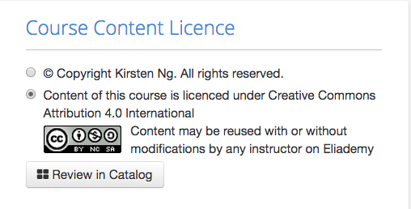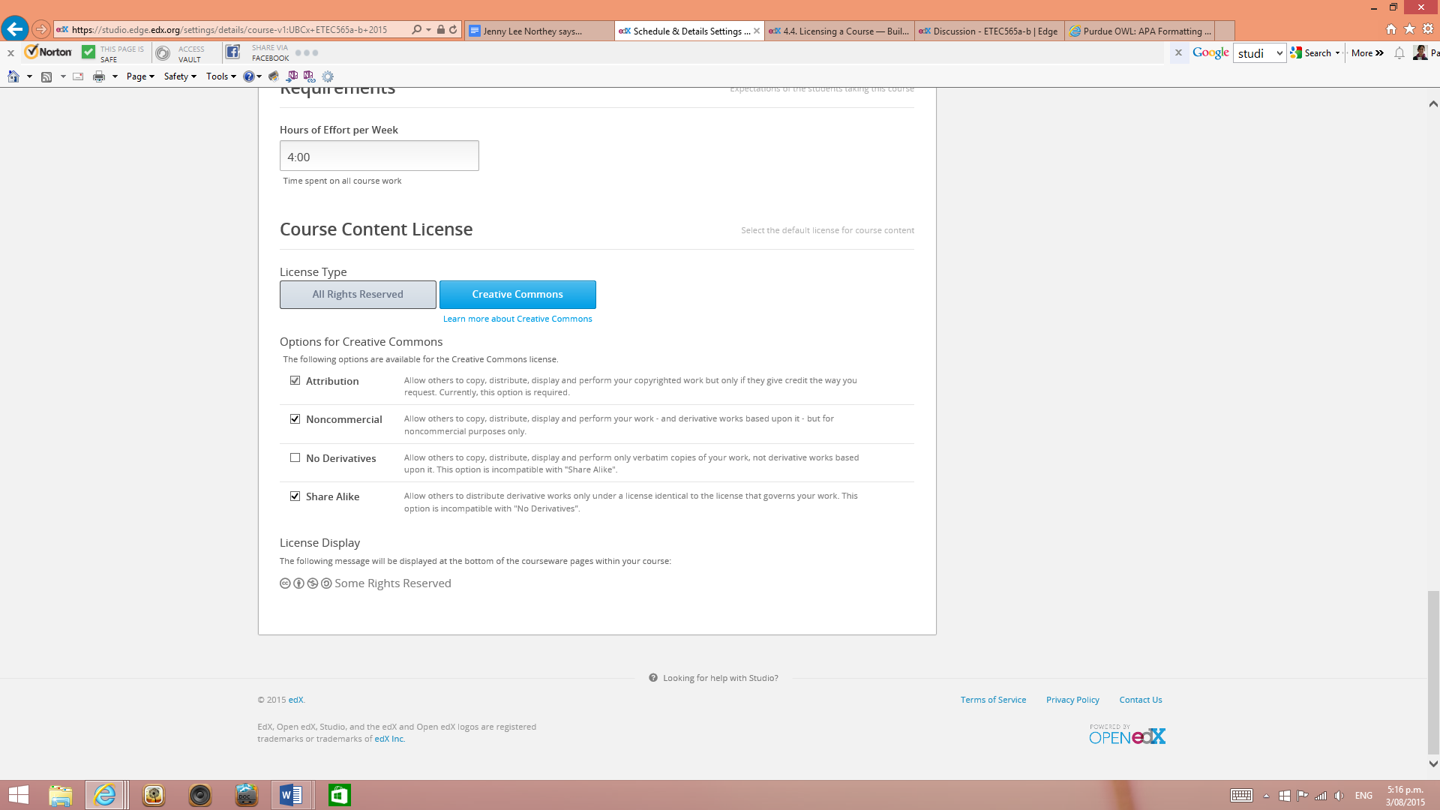

References

Alberta Assessment Consortium. (n.d.). Q & A: Assessment tools. Retrieved from [http://www.aac.ab.ca](http://www.aac.ab.ca/)

Anderson, T. (2004). Towards a theory of online learning. In T. Anderson and F. Elloumi (Eds.), *The theory and practice of online learning* (pp. 33-60). Athabasca, AB: Athabasca University Press. Retrieved from<http://cde.athabascau.ca/online_book/pdf/TPOL_chp02.pdf>

Bates, A. W. (2014). Teaching in a digital age. Retrieved from<http://opentextbc.ca/teachinginadigitalage/>

Clark, R. C., & Mayer, R. E. (2008). E-learning and the science of instruction: Proven guidelines for consumers and designers of multimedia learning (2nd ed.). San Francisco, CA: Pfeiffer.

Fink, L. D. (2003). A self-directed guide to designing courses for significant learning*.* Retrieved from<http://www.deefinkandassociates.com/GuidetoCourseDesignAug05.pdf>

Kelly, R. (2014, January 7). Creating a sense of instructor presence in the online classroom [Blog post]. Retrieved from<http://www.facultyfocus.com/articles/online-education/creating-a-sense-of-instructor-presence-in-the-online-classroom/>

Mandernach, B. J. (2009). Effect of instructor-personalized multimedia in the online classroom. *International Review of Research in Open and Distance Learning*, 10(3)

McTighe, J., and Wiggins, G. (2004). Introduction: The logic of backward design. Understanding by design: Professional development workbook.Alexandria, VA:Association for Supervision and Curriculum Development.

Ontario. Ministry of Education. (2010).Growing success: Assessment, evaluation, and reporting in Ontario Schools. First Edition, Covering Grades 1 to 12. Toronto: Author. Retrieved from http://edu.gov.on.ca/eng/curriculum/elementary/index.html

Raffo, D. M., Brinthaupt, T. M., Gardner, J. G., & Fisher, L. S. (2015). Balancing online teaching activities: Strategies for optimizing efficiency and effectiveness. *Online Journal of Distance Learning, 18(*1). Retrieved from [http://www.westga.edu/~distance/ojdla/spring181/raffo_brinthaupt_gardner_fish181.html](http://www.westga.edu/~distance/ojdla/spring181/raffo_brinthaupt_gardner_fish)

Wiggins, G. (2012). *7 keys to effective feedback*. Alexandria: Association for Supervision and Curriculum Development.

**Appendix A**

List of learning objects, success criteria, and instructional activities for “Express Yourself!”

|  |  |
| --- | --- |
| **Learning Objectives** | **Success Criteria**  The success criteria are accomplished in each activity noted with an upper case letter in square brackets, as seen in the instructional activities that follow. |
| **Learning Goal #1. I can understand and respond to poetry.** | * I can read a poem and understand that it has a surface meaning and a deeper meaning. * I am able to compare two poems and to explain my comparison. * I am able to explain my preferences and connections to poetry. |
| **Learning Goal #2. I can read, or watch, slam poetry and identify effective literary tools and strategies that the poet chose to use.** | * I know the difference between a simile and a metaphor. * I understand how to spot symbolism, irony, and hyperbole in a written poem. * I can observe the use of literary strategies by watching videos of slam poets. |
| **Learning Goal #3. I can write and present poetry to convey an idea, a thought, or a feeling using my unique voice.** | * I understand symbolism, irony, hyperbole, metaphor, and simile and I can identify examples in a written poem. * I post my poetry to the discussion forum to share my unique voice. * I look for the best word to fit what I am trying to say. |
| **Learning Goal #4. I can reflect on, and identify my strengths in poetry and next steps for improvement in my writing.** | * I write my poems at least two days before they are due. This gives me time to think of a better word, or a better way to share my ideas. * I find the parts in my poems that I like, and I analyse them to figure out what makes those parts effective. * I find the part of my poem that need work and determine what could make them better. * I use several strategies to improve my writing including rereading my work, conferencing with the instructor, conferencing with a friend, and comparing it to the works of another poet I respect. |
| **Learning Goal #5. I can provide positive feedback and constructive criticism for the written work of my peers.** | * I underline a specific part of a poem and I explain the connections I made. * I underline a specific part of a poem and I share what I think has been done well. * I underline a specific part of a poem and I give my opinion about what could be improved. * I read and respond to the posts of my classmates when they share their poetry at least twice a week. |

|  |
| --- |
| **Instructional Activities**  Individual activities are coded with an uppercase letter in square brackets, i.e. [X] |
| **Unit 1 - Week 2 - POETRY & POEMS ABOUT ME**  Poet: George Ella Lyon  Content:   1. What is poetry? What are the characteristics of a poem? 2. How can I read and respond to poetry?     To do:   1. Read all of the information presented on the website for this week. 2. Complete the poetry reading activity. 3. Post your responses to the two discussion questions. 4. Complete your written poetry assignment. 5. Watch the YouTube Video of the week. 6. Video record your own presentation of the poetry assignment. 7. Self-assess your poem and your performance.     Poetry Reading Assignment:   1. Three poems are presented. Read all three poems and consider the following:   a. Which seems to be a poem, which do not, and what are the characteristics of a poem  b. What is each of these poems about  c. Which do you like, dislike, and why    Discussion Questions: (Post responses in the appropriate discussion forum)   1. Which texts are poems and which are not? What are the characteristics of poems? 2. Which poem(s) do you like or dislike, and why?     Written Poetry Assignment:   1. POEM 1: Complete the ‘where i’m from’ poem framework (poem 1) 2. Save your completed poem in a folder in your Google Drive. 3. Share your poem in the discussion forum if you wish     Watch YouTube and Record video:   1. Watch<https://youtu.be/QGb4oiUqlhA> (Where I’m From, by Julia Daniel.) Focus on the poet’s *use of voice*. Prior to watching the video, read the ‘Performance Rubric’ to know what to look for. 2. Video record yourself reading your written poem of the week. Re-watch your video and re-record it to improve it if necessary, focus on *voice*.     Assessment:   1. Use the ‘Poetry Rubric’ to assess your written poem and write feedback to yourself. Feedback should include one positive comment, one piece of constructive criticism, followed by one more positive comment. This is your first self-assessment. 2. Use the ‘Performance Rubric’ to assess the video performance of your poem. Again, write feedback to yourself. Feedback should include one positive comment, one piece of constructive criticism, followed by one more positive comment. This is your second self-assessment. 3. Write a self-reflection on your Unit 1 - Week 2 poem in your Google Slides portfolio. |
| **Unit 1 - Week 3 – LITERARY AND POETIC DEVICES & POEMS WITH TRICKS**  Poet: Testament  Content:   1. What is a poetic device? How can poetic devices be identified? How can I use poetic devices in my poetry? 2. What is simile, metaphor, symbolism, irony, sensory images, and hyperbole? How do poetic devices contribute to sharing my voice?     Assignments:   1. Read all of the information presented on the website for this week. 2. Complete the poetry reading activity. 3. Post your responses to the two discussion questions. 4. Complete your written poetry assignment. 5. Watch the YouTube Video of the week. 6. Video record your own presentation of the poetry assignment. 7. Self-assess your poem and your performance. 8. Join a group using the Discussion Forums.     Poetry Reading Assignment:   1. Three poems are presented. Read all three poems. Consider the following about each poem:    1. Poem 1: What is this poem about? Find one example of simile and one example of hyperbole. Which do you consider more powerful? Why?    2. Poem 2: What is this poem about? Identify the symbolism in this poem. Explain how the symbolism ‘works’ in this poem.    3. Poem 3: Activities for poems with irony/hyperbole/sensory images.     Discussion Questions: (Post responses in the appropriate discussion forum) [B]   1. Choose one poetic device from the list of five and define it. Then explain it in your own words, with examples from the presented poems. You may pick more than one example from one or more of the poems presented. 2. Choose an example of a poetic device that speaks strongly to you, and one that doesn’t seem very strong in your opinion. Explain your opinion with at least one written paragraph.     Written Poetry Assignment:   1. POEM 2: Poetry assignment for poetic devices. Choose one of the following objects, activities, or situations. Write at least two different examples of all five poetic devices to begin to describe your chosen subject. Use the Poetic Devices Poem Framework if you like. Finish a completed poem about the object, activity, or situation using your written poetic devices. 2. Save your completed poem in a folder in your Google Drive. 3. Share your poem in the discussion forum if you wish.     Watch YouTube and Record video:   1. Watch<https://youtu.be/FWwFBGOBAQI> (‘Poetic Devices’, by Testment) Focus on the poet’s *expression*. Prior to watching the video, read the ‘Performance Rubric’ to know what to look for. 2. Video record yourself reading your written poem of the week. Re-watch your video and re-record it to improve it if necessary, focus on *expression*.     Assessment:   1. Use the ‘Poetry Rubric’ to assess your written poem and write feedback to yourself. Feedback should include one positive comment, one piece of constructive criticism, followed by one more positive comment. This is your second self-assessment. 2. Use the ‘Performance Rubric’ to assess the video performance of your poem. Again, write feedback to yourself. Feedback should include one positive comment, one piece of constructive criticism, followed by one more positive comment. This is your second self-assessment. 3. Put all of your self-assessments into one Google Document called “Student Name - Self-assessments”. Example: “Jason Smith - Self-assessment”     Join a group for the poetry slam   1. This group will be the group who watch and peer assess your final poetry slam performance. 2. Provide instructions |
| **Unit 2 - Week 4 - FINDING YOUR *OWN* VOICE & MAKING A STATEMENT**  Poet: Shanye Koyczan  Content:   1. How does a poem make a point? 2. What point do I have to make? What point do I want to make? How can I make my point?     Assignments:   1. Read all of the information presented on the website for this week. 2. Complete the poetry reading activity. 3. Watch the YouTube Video of the week. 4. Post your responses to the two discussion questions. 5. Complete your written poetry assignment. 6. Video record your own presentation of the poetry assignment. 7. Self-assess your poem and your performance. 8. Meet with your poetry Slam Group in Google+ Hangouts     Poetry Reading Assignment:   1. Read Shayne Koyczan’s poem: ‘Instructions for a Bad Day’ 2. Poem 1: What is this poem about? What are the poet’s thoughts and feelings on this topic? Identify poetic devices used to make his or her point. How did you react to this poem? How might others react to this poem? How would you like others to react to your poetry?     Watch YouTube and Record video:   1. <https://youtu.be/VXfzKAv8ea4> This is a performance of Instructions for a Bad Day. (This poem is performed with music. Slam poems do not include music.) 2. <https://youtu.be/cnFAGgKB-wA> This is a video for the poem Instructions for a Bad Day. 3. Video record yourself reading your written poem of the week. Re-watch your video and re-record it to improve it if necessary, focus on your *clarity*.     Discussion Questions: (Post responses in the appropriate discussion forum) [B]   1. How did reading the poem and hearing the poem differ for you? What can you learn from this to use in your own poetry performance? 2. How did the video of the poem compare to the performance of the poem? Which did you prefer? Why?     Written Poetry Assignment:   1. POEM 3: Choose one of the following feelings, colours or ideas. Use the given framework if you like. Finish a completed poem about the feeling, colour, or idea of your choice. 2. Save your completed poem in a folder in your Google Drive. 3. Share your poem in the discussion forum titled Poem #3. (In weeks 2 & 3 this was optional. This week you are expected to share one of your original poems.)     Assessment:   1. Use the ‘Poetry Rubric’ to assess your written poem and write feedback to yourself. Feedback should include one positive comment, one piece of constructive criticism, followed by one more positive comment. This is part of your third self-assessment. 2. Use the ‘Performance Rubric’ to assess the video performance of your poem. Again, write feedback to yourself. Feedback should include one positive comment, one piece of constructive criticism, followed by one more positive comment. This is part of your third self-assessment. 3. Use the ‘Poetry Rubric’ to assess three of the written poems of your classmates. Write feedback for the author. Mail this feedback to your instructor. It will remain anonymous (to the class poet) this way. Feedback should include one positive comment, one piece of constructive criticism, followed by one more positive comment. This is your first peer-assessment. 4. Put all of your self-assessments into one Google Document called “Student Name - Self-assessments”. Example: “Jason Smith - Self-assessment.” Be sure to share this file with the instructor. 5. Add your peer assessments to your file called “Student Name – Peer assessments.” Example “Jason Smith – Peer assessments” Be sure to share this file with the instructor. |
| **Unit 2 - Week 5 – MORE ABOUT MAKING A STATEMENT**  Poet: Prince EA  Content:   1. How can I make my point more clearly? How can I make my point more emphatically? What word will make my poem be heard? 2. How can I make my point more mine?     Assignments:   1. Read all of the information presented on the website for this week. 2. Complete the poetry reading activity. 3. Post your responses to the two discussion questions. 4. Complete your written poetry assignment. 5. Watch the YouTube Video of the week. 6. Video record your own presentation of the poetry assignment. 7. Self-assess your poem and your performance. 8. Meet with your poetry Slam Group in Google+ Hangouts for at least the second time     Poetry Reading Assignment:    Discussion Questions: (Post responses in the appropriate discussion forum) [B]    Written Poetry Assignment:   1. POEM 4: Write a poem in response to Prince EA’s poem. Consider some of the themes in his poem. These themes include human connection in a digital world, the effects of social media, and our reliance on our screens. 2. Save your completed poem in a folder in your Google Drive. 3. Share your poem in the discussion forum titled Poem #4. (In weeks 2 & 3 this was optional. This week you are expected to share one of your original poems.)     Watch YouTube and Record video:   1. Watch<https://youtu.be/dRl8EIhrQjQ> (‘Can we auto-correct humanity?’ by Prince EA) 2. Focus on the poet’s *use of voice, expression and clarity*. Prior to watching the video, read the ‘Performance Rubric’ to know what to look for. 3. Video record yourself reading your written poem of the week. Re-watch your video and re-record it to improve it if necessary, focus on your *use of voice, expression and clarity*.     Assessment:   1. Use the ‘Poetry Rubric’ to assess your written poem and write feedback to yourself. Feedback should include one positive comment, one piece of constructive criticism, followed by one more positive comment. This is part of your fourth self-assessment. 2. Use the ‘Performance Rubric’ to assess the video performance of your poem. Again, write feedback to yourself. Feedback should include one positive comment, one piece of constructive criticism, followed by one more positive comment. This is part of your fourth self-assessment. 3. **Use the ‘Poetry Rubric’ to assess three of the written poems of your classmates. Write feedback for the author. Mail this feedback to your instructor. It will remain anonymous (to the class poet) this way. Feedback should include one positive comment, one piece of constructive criticism, followed by one more positive comment. This is your first peer-assessment.** |
| **Unit 3 - Week 6 - SLAM POETRY - Using your own voice to make an impact**  Poet: Omari Newton [performing an original piece (<90sec), focusing on inspiration and the writing process with an eye to the end product of a slam poem that will be performed]  Content:   1. How do I pick a topic that shares my unique voice? 2. How can I use my previously written work, my self-assessment, peer-assessment, and the feedback from my instructor to improve my writing?     Assignments:   1. Read all of the information presented on the website for this week. 2. Complete the poetry reading activity. 3. Post your responses to the two discussion questions. 4. Complete your written poetry assignment. 5. Watch the YouTube Video of the week. 6. Video record your own presentation of the poetry assignment. 7. Self-assess your poem and your performance. 8. Meet casually with your poetry Slam Group in Google+ Hangouts for at least the third time. 9. Let the instructor know when your group would like to perform for one another. Schedule this time with your instructor so that the instructor can participate in the Google+ Hangout on Air.     Poetry Reading Assignment:   1. Read the following two poems. (Poem #1 and #2 are different poems but on the same topic.) Consider what makes these poems similar and different. Is one easier to read? Is one harder to understand?     Discussion Questions: (Post responses in the appropriate discussion forum) [B]   1. In your opinion, which poem was more effective in sharing its message? Although each author experienced the same event, their unique personalities shone through each of their poems. How does you being you make your poems special? 2. Post a question for Omari about your own (draft) slam poem or recorded performance. With some expert feedback along the way, you’re sure to succeed in your slam poem performance!     Written Poetry Assignment:   1. POEM 5: Write a poem to be performed in your group Poetry Slam next week. 2. Share your poem in the discussion forum titled “*Poem #5 – Draft slam poem*”. Read and respond to at least three, but as many as you like, poems from your classmates. Be sure to provide effective feedback in the form of a positive comment, a piece of constructive criticism based on the rubric, and another positive comment. (Remember, all positive comments and constructive criticisms should be based on criteria in the ‘Poetry Rubric.’)     Watch YouTube and Record video:   1. Watch (‘**OMARI’S VIDEO’ by Omari Newton)** 2. Focus on the poet’s *use of voice, expression and clarity.* Prior to watching the video, read the ‘Performance Rubric’ to know what to look for. 3. Re-watch<https://youtu.be/9f8VcV8v2LE> (‘Become a slam poet in five steps’ by Gayle Danley) 4. Video record yourself reading your written poem of the week. Re-watch your video and re-record it to improve it if necessary, focus on your *use of voice, expression and clarity*.     Assessment:   1. Use the ‘Poetry Rubric’ to assess your written poem and write feedback to yourself. Feedback should include one positive comment, one piece of constructive criticism, followed by one more positive comment. This is part of your fourth self-assessment. 2. Use the ‘Performance Rubric’ to assess the video performance of your poem. Again, write feedback to yourself. Feedback should include one positive comment, one piece of constructive criticism, followed by one more positive comment. This is part of your fourth self-assessment. 3. Use the ‘Poetry Rubric’ to assess three of the written poems of your classmates. Write feedback for the author. Mail this feedback to your instructor. It will remain anonymous (to the class poet) this way. Feedback should include one positive comment, one piece of constructive criticism, followed by one more positive comment. This is your first peer-assessment. 4. Put all of your self-assessments into one Google Docs folder called “**Student Name - Self-assessments**”. Example: “**Jason Smith - Unit X Self-assessment**.” Be sure to share this file with the instructor. 5. Start a new document for peer-assessments in Google Drive. Call this file “Student Name – Peer assessments.” Example “Jason Smith – Peer assessments” Be sure to share this file with the instructor. |
| **Unit 3 - Week 7 – PERFORMING SLAM POETRY**  Poet: YOU!  Content:   1. What makes a slam poem effective? How can I improve my performance to make my point?     Assignments:   1. Read all of the information presented on the website for this week. (introduce to slam poet (tips and tricks from a poet - getting students ready to perform, introduce summative assignment) 2. Complete your written poetry assignment. 3. Watch the YouTube Video of the week. 4. Video record your own presentation of the poetry assignment. 5. Self-assess your poem and your performance. 6. Meet with your poetry Slam Group in Google+ Hangouts on Air for your Poetry Slam Performance Event 7. Post your responses to the two discussion questions.     Discussion Questions: (Post responses in the appropriate discussion forum) [B]   1. How did it feel to perform your slam poem for your group? 2. What did you enjoy most about watching your other group member perform their poems?     Written Poetry Assignment:   1. Create your best and final version of slam poem. 2. Post your completed poem in your poetry portfolio [Google Doc/Slides.] 3. Share your poem in the discussion forum titled Poem #4. (In weeks 2 & 3 this was optional. This week you are expected to share one of your original poems.)     Watch YouTube and Record video:   1. Video record yourself reading your written poem of the week. Re-watch your video and re-record it to improve it if necessary, focus on voice.     Assessment:   1. Use the ‘Poetry Rubric’ to assess your written poem and write feedback to yourself. Feedback should include one positive comment, one piece of constructive criticism, followed by one more positive comment. This is part of your fourth self-assessment. 2. Use the ‘Performance Rubric’ to assess the video performance of your poem. Again, write feedback to yourself. Feedback should include one positive comment, one piece of constructive criticism, followed by one more positive comment. This is part of your fourth self-assessment. 3. Use the ‘Poetry Rubric’ to assess three of the written poems of your classmates. Write feedback for the author. Mail this feedback to your instructor. It will remain anonymous (to the class poet) this way. Feedback should include one positive comment, one piece of constructive criticism, followed by one more positive comment. This is your first peer-assessment. 4. Put all of your self-assessments into one Google Document called “Student Name - Self-assessments”. Example: “Jason Smith - Self-assessment.” Be sure to share this file with the instructor. 5. Start a new document for peer-assessments in Google Drive. Call this file “Student Name – Peer assessments.” Example “Jason Smith – Peer assessments” Be sure to share this file with the instructor. |

Appendix B - rubrics  
Appendix B

**1. Poetry Rubric**

This is the rubric to be used for assessing a written poem. You may use this rubric to assess your own poems (self-assessment) or to assess poems written by your classmates (peer assessment.) Read the rubric several times to begin to understand what is expected in your written work.

|  |  |  |  |  |
| --- | --- | --- | --- | --- |
| **Criteria** | **Level 4** | **Level 3** | **Level 2** | **Level 1** |
| Knowledge: Understanding of content  **Poems share ideas** | Ideas show a high degree of insight, connection, thoughtfulness, and creativity.  The topic has been thoroughly considered and shared with emotion, feeling and shared human experiences. | Ideas show a considerable degree of insight, connection, thoughtfulness, and creativity.  The topic has been well thought out considered and shared with emotion, feeling and shared human experiences. | Ideas show some degree of insight, connection, thoughtfulness, and creativity.  The topic has been somewhat thought out considered and shared with emotion, feeling and shared human experiences. | Ideas show a limited degree of insight, connection, thoughtfulness, and creativity.  The topic has been vaguely considered and shared with emotion, feeling and shared human experiences. |
| Communication: Expression and organization of ideas and understandings  **Poems provide a unique perspective** | The author presents the poem in their own way, thoroughly demonstrating their unique voice, perspective, thoughts, and feelings in an purposefully organized manner.  Their poem thoroughly demonstrates how and why they came to believe their ideas as they are. | The author presents the poem in their own way, considerably demonstrating their unique voice, perspective, thoughts, and feelings in an purposefully organized manner.  Their poem mostly demonstrates how and why they came to believe their ideas as they are. | The author presents the poem in their own way, somewhat demonstrating their unique voice, perspective, thoughts, and feelings in an purposefully organized manner.  Their poem somewhat demonstrates how and why they came to believe their ideas as they are. | The author presents the poem in their own way, demonstrating in a limited way their unique voice, perspective, thoughts, and feelings in an purposefully organized manner.  Their poem demonstrates in a limited way how and why they came to believe their ideas as they are. |
| Thinking: Use of Critical/ Creative thinking processes  **Poems use language intentionally.** | The author has purposefully used many poetic devices, examples of rich language, and carefully chosen words in their poem.  The poem incorporates rhythm and the sound of language. | The author has logically used poetic devices, examples of rich language, and carefully chosen words in their poem.  The poem incorporates rhythm and the sound of language. | The author has generally used poetic devices, examples of rich language, and carefully chosen words in their poem.  The poem incorporates rhythm and the sound of language. | The author has vaguely used many poetic devices, examples of rich language, and carefully chosen words in their poem.  The poem incorporates rhythm and the sound of language. |

|  |  |  |  |  |
| --- | --- | --- | --- | --- |
| Application: Making connections  **Poems help make connections between people, ideas, thoughts, and feelings.** | This poem links ideas, thoughts, and feelings according to the unique perspective of the author with a high degree of effectiveness. | This poem links ideas, thoughts, and feelings according to the unique perspective of the author with a considerable degree of effectiveness. | This poem links ideas, thoughts, and feelings according to the unique perspective of the author with some degree of effectiveness. | This poem links ideas, thoughts, and feelings according to the unique perspective of the author with a limited degree of effectiveness. |
| Knowledge: Conventions  **Poems have rules too! (Well, some rules…)** | The author has used the stylistic conventions of poems like stanzas, line breaks, capitalization, and punctuation,  with a high degree of effectiveness. Where it has not been used, it has been for effect. | The author has used the stylistic conventions of poems like stanzas, line breaks, capitalization, and punctuation, with a considerable degree of effectiveness. | The author has used the stylistic conventions of poems like stanzas, line breaks, capitalization, and punctuation,  with some degree of effectiveness. | The author has used the stylistic conventions of poems like stanzas, line breaks, capitalization, and punctuation. Where it has not been used, it has been for effect, with a limited degree of effectiveness. |

**2. Slam Performance Rubric**

Use this rubric to evaluate yourself and others on the style in which they perform their poems.  You may use this rubric to assess your own poems (self-assessment) or to assess the poems performed by your poetry slam group members (peer assessment.) Read the rubric several times to begin to understand what is expected in your poetry slam performance.

|  |  |  |  |  |
| --- | --- | --- | --- | --- |
| **Criteria** | **Level 4** | **Level 3** | **Level 2** | **Level 1** |
| **Preparedness**  Have I memorized my entire poem? Can I recite it without notes?  Have I practiced recording myself performing poems for self-assessment? Did I rehearse ahead of my final performance? | Student is completely prepared and has obviously rehearsed. | Student seems mostly prepared but might have needed a couple more rehearsals. | Student is somewhat prepared, but it is clear that rehearsal time was lacking. | Student does not seem at all  prepared to present. |
| **Voice**  Do I speak at an appropriate volume?  Do I vary my volume for performance effect? | Student uses variance in volume effectively and appropriately throughout the presentation to enhance the meaning of the poem. | Student uses variance in volume  well and appropriately throughout the presentation to enhance the meaning of the poem. | Student uses variance in volume  inconsistently and somewhat appropriate throughout the presentation to enhance the meaning of the poem. | Volume is either too loud/soft and distracts from the meaning of the poem. |
| **Expression**  Do I use enthusiasm, eye contact, and body language to captivate my audience? | Student uses enthusiasm, eye contact, voice pitch, intonation and body language purposefully to captivate the audience. | Student uses enthusiasm, eye contact, voice pitch, intonation and body language considerably to captivate the audience. | Student uses enthusiasm, eye contact, voice pitch, intonation and body language generally to captivate the audience. | Student uses enthusiasm, eye contact, voice pitch, intonation and body language vaguely to captivate the audience. |
| **Clarity**  Can my classmates understand the words that I’m saying?  Am I pacing my poem appropriately? | Student speaks  clearly and distinctly for the entire performance, with no noticeable errors. | Student speaks  clearly and  distinctly most of  the time, with minor errors that do not detract from the performance. | Student speaks  clearly and  distinctly most of  the time, with errors that sometimes detract  from the performance. | Student often mumbles or cannot be understood, with errors that detract from the performance. |
| **Tech skills**  Do I know how to use Google Hangouts?  Do I adjust my voice, expression, and clarity to the context of a video conference? | Student demonstrates a thorough understanding of how to use Google Hangouts when working with peers, including adjustment of voice, expression and clarity in a video conference. | Student demonstrates a considerable understanding of how to use Google Hangouts when working with peers, including adjustment of voice, expression and clarity in a video conference. | Student demonstrates a general understanding of how to use Google Hangouts when working with peers, including adjustment of voice, expression and clarity in a video conference. | Student demonstrates a limited understanding of how to use Google Hangouts when working with peers, including adjustment of voice, expression and clarity in a video conference. |

**Appendix C**

Parental permission form outlining online collaborative work expectations.

|  |
| --- |
| **Strathcona Public School**  Date: Monday, September 7, 2015  Dear Parent/Guardian,  Our class will be participating in a Virtual Poetry Slam via Google Hangout on Air. This letter will inform you of the details of the Hangout and may ask for permission for your child to participate on screen and/or be recorded and shared.  **Date of Google Hangout on Air:** Week of October 19th, 2015  **Purpose of the Hangout on Air:** Summative assessment for ETEC 565 Grade 8 Poetry course.  The Google Hangouts video conferencing tool may allow video conferences to be recorded on YouTube. Please see below to learn whether or not the video conference session will be recorded or not.  **Session Details**  Teachers, please indicate all that apply.  ▢ This session will be not be recorded or broadcast on **YouTube**.  ▢ This session will be recorded on **YouTube** for future **private** access.  ▢ This session will be recorded on YouTube for future **public** access.  ✓ This session will be recorded on YouTube for future **unlisted** access.*  ▢ This session will be **publicly** broadcast live on **YouTube**.  *Making a video unlisted means that anyone who has the link to the video can view it. Your unlisted videos won’t appear to others who visit the Videos tab of your channel page and shouldn't show up in YouTube's search results unless someone adds your unlisted video to a public playlist.  We recognize that there are instances where parents may not wish their children to be recorded or broadcast on YouTube and that students at age of majority and other adults may have the same wishes.  Please feel free to contact me if you have any questions.  Sincerely,  Your ETEC 565 Grade 8 Poetry Instructor  Please read and return the form below by **Monday, September 14, 2015**.  **Consent for Release – Parent/Legal Guardian or Adult Student/Adult**  I, being the parent/legal guardian of the student named below, have read and understand the information provided on this form.  ▢ I **consent** to have my child participate in the video conference on screen use as described above.  ▢ I **DO NOT consent** to have my child participate in the video conference on screen use as described above  Name of student (please print): ______________________________________________________________  Name of Parent/Guardian (please print): ______________________________________________________  Signature of Parent/Guardian: ______________________________________________________________  Date: ______________________________________________________________  *Personal information is collected under the authority of the Education Act and will be used to manage the disclosure of student information. Contact the school principal for more information.*  FILE: LEG – Consents or in OSR. Valid for 12 months from date of last use/application |

**Appendix D**

Omari Newton’s Video Transcript from Unit 3, Week 6

PRESSURE MAKES A POEM

By Omari Newton

*Spoken Poem like volcanoes erupt*

*due to density and pressure.*

*Friction, turns, fiction coal of the soul to diamonds*

*Glistening unheard words into battle cries from the precipice of*

*feelings and thoughts.*

*They call it slam cause that how it hits. BAM. A Sobering*

*ssshhhhhhhhhhot.*

*Whether whispered or strangely stated the impetus is unfaded, burn it*

*down slowly, grinded out holy.*

*Poetry pops and crackles in the pits of your soul, owing to the scars gifted by life,*

*growing in urgency, leaving memories of your plight*

*pressure and density have a propensity to push poems into flight*

*like, Lava from Volcanoes unsuspecting upon night.*

*Falls,*

*Calm on the surface for eons, till like neon lights, the skies are emblazoned with the spectacular sight, of urgency personified, both awesome and horrific*

*The specifics of the words crafted in a way unscientific*

*No formula can contain, the molten rain when it drains from the depths of despair making changes inhumane upon listeners whose hearts are maimed. As your words find their mark, stark, reality, naked lays bare, on the grizzled minds of those who witnessed your piece unprepared.*

*An You are all Vesuvius, Krakatoa, St Helens,*

*Yellin from the abyss like a crazed solitary felon, who has reached a mental breaking point, amplified emotions, sample sized, Yelling messages into metaphorical bottles and tossing them into the vast ocean*

*Of all that came before till that fire burns no more. Your piece is dispelled to crowds in pieces,*

*Then you rest. Till the pressure bursts again as it did before.*

*And new work is concocted from beneath the rocks once more.*

SLAM POETRY TIPS

PICK A TOPIC THAT MOVES YOU

Choose something that moves you emotionally. Something that is born in the pit of your soul. It can make you wanna shout in anger, jump for joy, cry in despair. Poems can channel any emotion you desire, they’ve just got to move you.

PERFORMANCE TIPS

If you can, don’t just memorize your text, devour it. Have it branded into your soul and memory as deeply as your name and birthday. Only then will you be able to channel your piece through you and infuse it with the passion it deserves. If you must read a piece, that ok. Just ensure that you still connect with the words, sounds and meaning. You’ll have to be even more focused to ensure the power and meaning transfer to the audience without the benefit of liberated movement and eye contact.

*Pick your poetic devices*. Poems that get attention are ones that incorporate simple, but powerful poetic elements. Repetition is a device that can help a writer generate exciting poems with just repeating a key phrase or image. Rhyming can enrich your diction and performance. (Check out other poetic devices while you’re at it.)