Feasibility Analysis for Enhancing Community

Safe Medication Handling and Disposal Practices

for
Bryce Wong
Director of Pharmacy Practice Support and Special Projects
British Columbia Pharmacists Association
Vancouver, British Columbia

by
Michael Ly
English 301 Student

March 29, 2023

Table of Contents

- ABSTRACT
- INTRODUCTION
  - Definition of Safe Medication Storage and Disposal
  - Background Information on Proper Medication Handling
  - Description on Common Medication and Medical Waste Pathways
  - Purpose of Report
  - Description of Data Sources
  - Scope of Inquiry
- DATA SECTION
  - Overview of Study Design
  - Health Product Waste Streams
  - Public Survey Results
  - Pharmacist Survey Results
  - Health Product Storage and Disposal Survey Discussion
  - Views on Separated Medication Waste Containers Discussion
  - Limitations of Survey and Data
- CONCLUSION
  - Summary of Findings
  - Recommendations
- APPENDICES

I. Abstract

II. Introduction
A. Definition of safe medication storage and disposal.
The safe storage and disposal of health products, such as medications, in homes can prevent accidental poisonings, diversions, and medication administration errors (ISMP Canada, "Safe Storage and Disposal of Medications"). Properly storing and disposing medications also ensure that children continue to be safe. Safe storage of medications can be considered as storing medications in not only child resistant packaging, but also in a secure location that prevents unintended access by other individuals, particularly children (ISMP Canada, "Safe Storage and Disposal of Medications"). Safe disposal can be considered as taking unused medications to a community pharmacy when they are no longer needed due to treatment change or product expiry (ISMP Canada, "Safe Storage and Disposal of Medications").
B. Background information on proper medication handling.
Health products such as prescription medications, over-the-counter medications, vitamins, and minerals are becoming more accessible for residents across British Columbia through improved accessibility measures introduced by the BC Government. These changes include allowing further broad based medication coverage for BC residents such as for contraceptives and allowing pharmacists to prescribe for minor ailments. The result of improved access to medications will increase the demand and consumption for health products across the province, which may increase the risk for unintentional drug poisonings or improper drug disposals among the public. This provides the opportunity for the BC Pharmacists Association to engage with the pharmacist community and the BC Government to produce a public education campaign on medication handling, as well as potentially consider introducing the distribution of personal medication disposal bins to BC residents.
Health products that are improperly stored or disposed of can be harmful to children or others who may use them inappropriately. These health products include items such as prescription drugs, over-the-counter medications, and vitamins and minerals that are purchased from pharmacies or health food stores (Ministry of Environment and Climate Change Strategy, “Recycle Pharmaceuticals.”). The improved ease of purchasing health products without educational material on proper storage and handling may result in the development of knowledge gaps in the public. For prescription drugs, pharmacists are the main source of information for proper medication administration and handling. However, there are many health products such as cough and cold medications or vitamins and minerals that do not require pharmacist interaction that can potentially be mishandled by the public.
C. Description on common medication and medical waste pathways.
The inappropriate disposal of health products can cause harm to the environment through contamination of waterways and ingestion by wildlife. The common routes that health products take to enter the environment are through trash and waste water (Bound, “Household Disposal of Pharmaceuticals as a Pathway for Aquatic Contamination in the United Kingdom”). The issue with these pathways is it can potentially introduce these contaminants to landfills sites, water supplies, and marine waterways (Bound, “Household Disposal of Pharmaceuticals as a Pathway for Aquatic Contamination in the United Kingdom”). The public has several methods on disposing of health products in British Columbia. The ideal option would be to return the health product to community pharmacy locations for proper storage and eventual destruction. However, health products can often be found to be disposed of through residential trash and down drains.

Residential
Sewage System
Landfills

Pharmacies
Unused
Pharmaceuticals
Fig. 1. Common Pathways of Pharmaceutical Waste

D. Purpose of report.
This report will conduct a feasibility study to determine whether the BC Pharmacist's Association should consider implementing a public medication and medical waste education campaign. It will also assess whether there is a need for additional personal medication waste containers for the public to protect the environment and enhance community safety.
E. Description of data sources.
The feasibility of introducing an improvement in medication handling and waste management through a public education campaign is dependent on the current knowledge of the public and the current educating practices at community pharmacies. This report will investigate the current understanding of public handling and disposal of health products through two general surveys to determine the feasibility for broad public education measures. One survey will investigate the current practices and opinions of community pharmacists in public handling and disposal of medications. The second survey will be completed by the public and investigate current medication handling opinions and practices.
F. Scope of inquiry.
In order to investigate the need for a medical wastage awareness campaign in the community, the study will address these inquiries.
- What proportion of patients that make medication returns are returned promptly once expired?
- How often are pharmacists educating the public on how to properly store and dispose of unused health products?
- How important is it for the public to have a dedicated medication disposal or medical sharps container that is separate from garbage, compost and recycling?
- Would there be an interest in the addition of a dedicated medication disposal bin in place to safely store expired or old unused medications?
- How available is information on how to properly store and discard health products?
- How are patients storing and discarding old expired medications?
- How often are health products being reviewed for disposal?

III. Data Section
A. Overview of Study Design
The study will investigate the feasibility for a public campaign on medication waste management through the distribution of two anonymous online surveys. The objectives of the study is to assess public knowledge of medication handling, investigate pharmacist frequency of educating public on proper medication handling, as well as determining the public opinion of the importance of having personal health product waste containers. One survey will be provided to the public and the other will be distributed to pharmacists. The surveys are designed to provide preliminary data on the current public opinion on health product storage and disposal, as well as to determine the current practices and opinions of pharmacists on public medication handling.
B. Health Product Waste Streams
According to the World Health Organization in a situation report published in 2012, raw sewage and wastewater effluents are a major source of pharmaceuticals found in surface waters and drinking water (Cotruvo, "Pharmaceuticals in Drinking-Water"). The report indicated that wastewater and drinking-water treatment processes at the time are not designed specifically to remove pharmaceuticals, rather they have demonstrated varying rates for removal of pharmaceuticals from less than 20% to greater than 90% (Cotruvo, "Pharmaceuticals in Drinking-Water"). The report also indicated that advanced treatment technology will not be able to completely remove pharmaceuticals to below detection limits of the most sensitive analyses (Cotruvo, "Pharmaceuticals in Drinking-Water"). The authors of the report concluded that human exposure through drinking water is best reduced by regulations, public guidance, and consumer education to minimize introducing pharmaceuticals into the environment due to the prohibited cost of monitoring and low risk for harm in humans if ingested because of its low concentrations (Cotruvo, "Pharmaceuticals in Drinking-Water").
C. Public Survey Results
The public survey asked a series of eight questions pertaining to medication storage and disposal. Two out of eight questions in the survey assessed how important dedicated containers for medication waste and sharps are for the individual to assess need. The series of 8 questions are listed below with their respective results.
A large proportion of respondents (72.73%) indicated that medications returned are often unlabelled with the expiration date (see fig. 2).
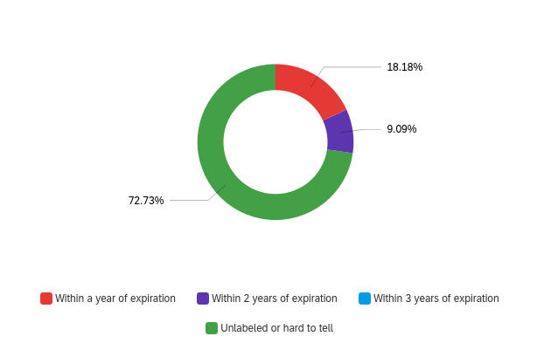
Fig. 2. Time from Medication Expiration to Disposal

The frequency of instructions provided to respondents appeared to be mixed between "Every Single Time" (36.36%) and "Not Often" (36.36%) (see fig. 3), demonstrating a lack of consistency when it comes to medication storage and disposal education.
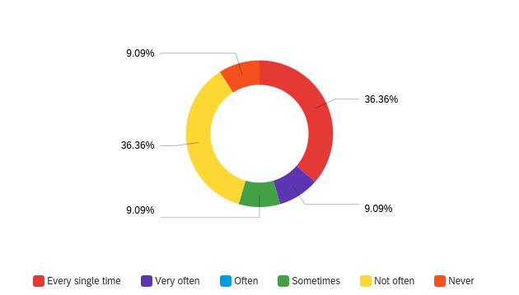
Fig. 3. Frequency of Instructions Provided During Medication Pick Up
The public opinion regarding the frequency of reviewing medications for disposal also appears to be mixed between "Once a year" (36.36%) and "More than once a year" (27.7%) (see fig. 4).
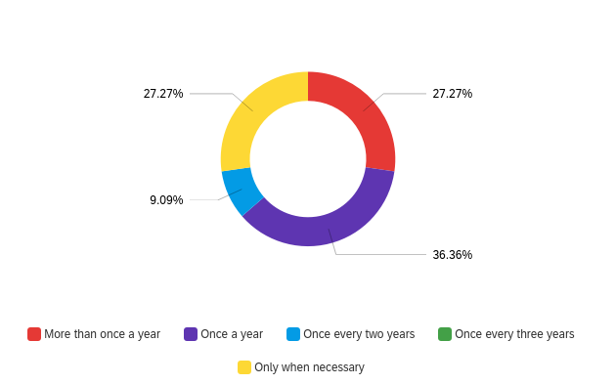
Fig. 4. Public Opinion On How Often Medication Should be Reviewed for Disposal
There is a larger proportion of respondents (63.64%) that indicate that they keep their medications in their respective containers and store them together with other medications in use (see fig. 5).
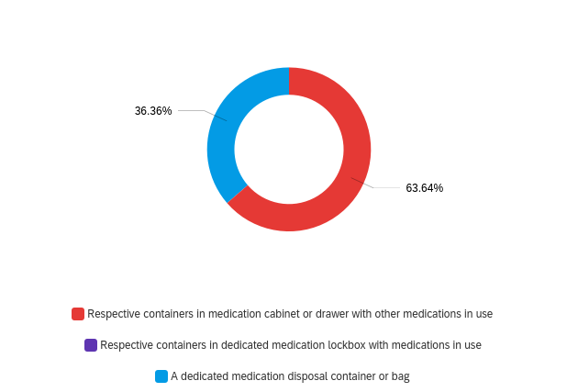
Fig. 5. Location where Medications Are Stored
Majority of respondents (81.82%) indicate that medication procedures for proper storage can sometimes be unclear (see fig. 6). This presents as an area that can be improved in providing more resources or labeling that can enhance information on proper storage instructions.
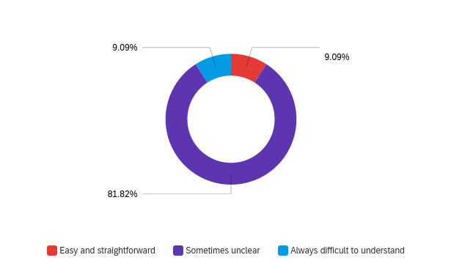
Fig. 6. Clarity of Current Procedures for Storing Medications
There are mixed opinions on the importance of a dedicated unused medication container, with the majority of respondents indicating either "Not at all important" (25%) or "Moderately important" (25%) (see fig. 7).
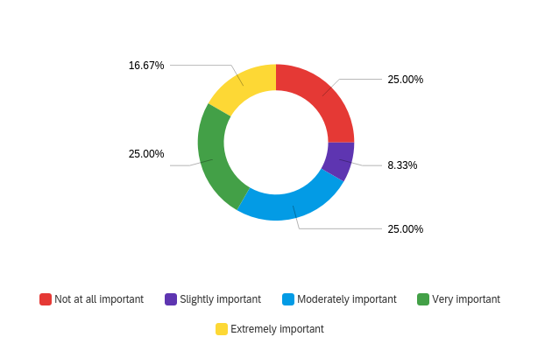
Fig. 7. Public Opinion on Importance of Dedicated Unused Medication Container
Majority of respondents (83.33%) agree that it is extremely important that there is access to dedicated sharps containers.
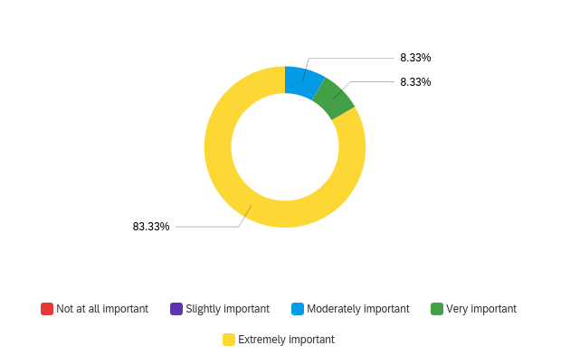
Fig. 8. Public Opinion on Importance of Dedicated Used Sharps Container
Most respondents agree that access to resources on medication storage and disposal instructions are important with the majority indicating "Extremely important" (27.7%) and "Moderately important" (36.36%) (see fig. 9).
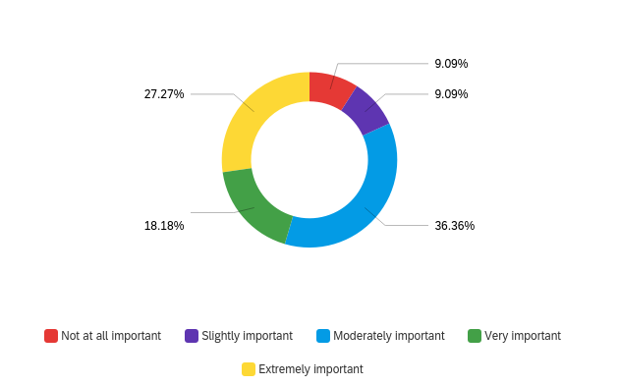
Fig. 9. Public Opinion on Importance of Access to Storage and Disposal Instructions
D. Pharmacist Survey Results
Majority of pharmacists indicate that the public returns medications "Sometimes" (57.14%) and "About half the time" (28.57%) in a proper sealed container or bag to the pharmacy (see fig. 10).
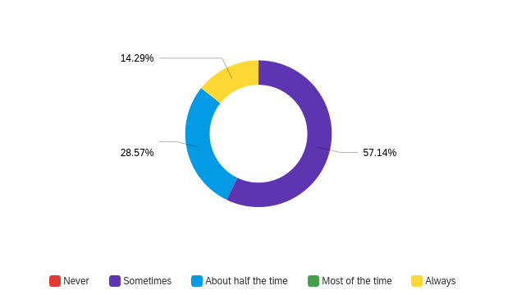
Fig. 10. Pharmacist opinion on how often the public returns medications safely packaged to the pharmacy
There are mixed opinions between how often patients are provided with handling instructions at the pharmacy. The results are evenly split between "Sometimes" (42.86%) and "Always" (42.86%) (see fig. 11).
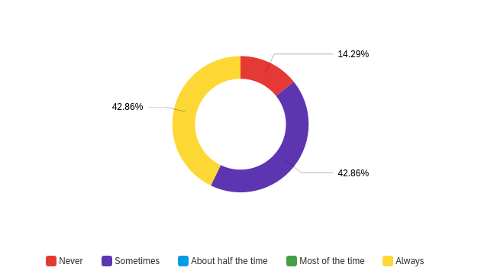
Fig. 11. Pharmacist opinion on how often public is provided with handling instructions at the pharmacy
Majority of pharmacists agree that it is Moderately to Extremely important for dedicated medication disposal containers for the public (see fig. 12).
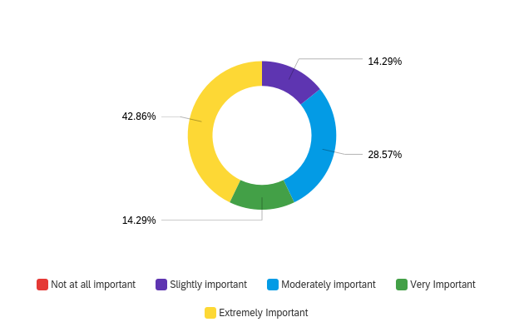
Fig. 12. Pharmacist opinion on how important it is for the distribution of medication disposal containers for the public
Pharmacists agree that it is important for there to be a public awareness campaign on medication and medical waste disposal for the public. Majority indicate that it is "Very Important" (42.86%) and "Extremely Important" (28.57%) for there to be a public awareness campaign (see fig. 13).
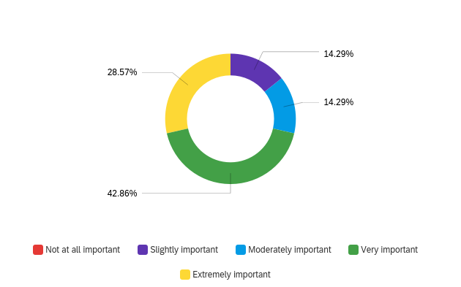
Fig. 13. Pharmacist opinion on need for public awareness campaign on medication and medical waste disposal
There are mixed opinions on whether there is a need for more public resources on medication and medical waste disposal with 42.86% respondents indicating it is "Very important" and 42.86% respondents indicating it is only "Slightly important" (see fig. 14).
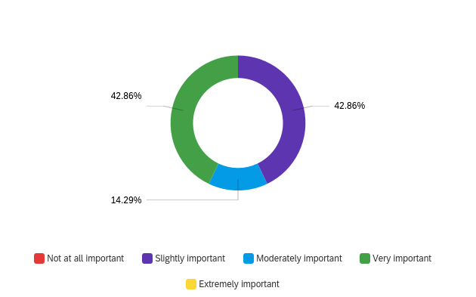
Fig. 14. Pharmacist opinion on need for more public resources on medication and medical waste disposal
Pharmacists believe that the level of medication returns have either stayed the same or increased (see fig. 15).
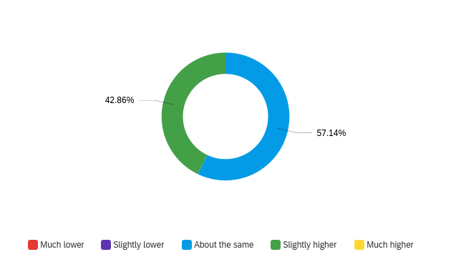
Fig. 15. Pharmacist opinion on change in level of medication returned to pharmacy over time

Most pharmacist respondents indicate that safe medication storage and handling are only a concern for patients "About half the time" (42.86%) or less (see fig. 16).
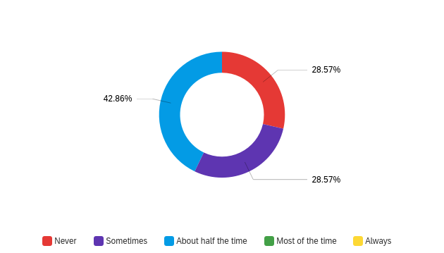
Fig. 16. Pharmacist opinion how much safe medication storage and handling been a concern for their patients
Majority of pharmacists agree that pharmacies play an important role in ensuring the public returns used and old medications safely (see fig. 17).
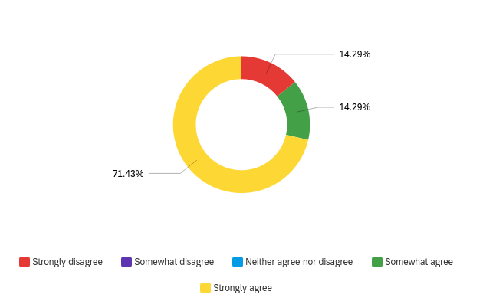
Fig 17. Pharmacist opinion on how important pharmacies play in ensuring the public returns used and old medications safely
E. Health Product Storage and Disposal Survey Discussion
The results for both the public and pharmacists surveys both agree that there are inconsistencies on how education on proper medication storage and disposal is being provided considering how divided the results are within both groups.
Pharmacists respondents agree that their patients only appear to be concerned about safe medication storage and disposal about half the time or less. While the public indicated that instructions for proper storage and disposal can sometimes be missing or unclear. However, both groups agree that it is important that more resources should be available for the public on proper medication storage and disposal. Pharmacists also agree that there is a need for a public awareness campaign to improve safe medication storage and handling.

F. Views on Separated Medication Waste Containers Discussion
The results for between the public and pharmacist surveys indicate mixed opinions on the importance of adding additional dedicated containers for unused medications. Pharmacists indicate that introducing dedicated medication disposal containers as very important and that the public often make returns in unsealed containers. Whereas, the public results show mixed opinions on the importance of a dedicated unused medication container. However, the public strongly considers the need for access to dedicated medication sharp containers for used needles to be extremely important.

G. Limitations of Survey and Data
The study is limited by the small size of the study and simplicity of the questions. Because of these limitations, the results of the study will only help provide a basis for further exploratory questions for future studies.
The study is subject to a biased convenience sampling through online distribution of the survey to a small group of pharmacists and small community groups in Vancouver. This sampling process is not a randomized sample across the entire population of British Columbia. The respondents to the survey are likely to be skewed to be younger because the survey is being provided in a digital format only.

IV. Conclusion
A. Summary of Findings
- There are inconsistencies between information provided to the public on proper medication handling, storage and disposal
- Both the public and pharmacists agree that it is important that more resources for proper storage and disposal of health products should be provided
- Pharmacists agree that it is important that it is important for there to be public campaign for educating the public on proper health product storage and disposal
B. Recommendations
- Enhancing public educational resources across pharmacies on proper medication storage and handling
- Improving consistency of pharmacist procedures for educating public on safe medication storage and disposal
- Investigating feasibility of cost for implementing dedicated personal health product waste containers

Appendices

Works Cited
Bound, Jonathan P, and Nikolaos Voulvoulis. “Household Disposal of Pharmaceuticals as a Pathway for Aquatic Contamination in the United Kingdom.” Environmental Health Perspectives, U.S. National Library of Medicine, Dec. 2005, https://www.ncbi.nlm.nih.gov/pmc/articles/PMC1314909/.
Cotruvo, Joe, et al. "Pharmaceuticals in Drinking-Water." Pharmaceuticals in Drinking-Water, World Health Organization, 2012, https://apps.who.int/iris/bitstream/handle/10665/44630/9789241502085_eng.pdf?sequence=1.
“ISMP Canada.” Safe Storage and Disposal of Medications, Institute for Safe Medication Practices Canada, 27 June 2018, https://ismpcanada.ca/wp-content/uploads/ISMPCSB2018-06-StorageDisposal.pdf.
Ministry of Environment and Climate Change Strategy. “Recycle Pharmaceuticals.” Province of British Columbia, Province of British Columbia, 30 July 2018, https://www2.gov.bc.ca/gov/content/environment/waste-management/recycling/extended-producer-responsibility/pharmaceuticals.

