Measuring Lung Capacity[23]
Background Info:
The amount of air that you move in and out of your lungs while breathing normally is referred to as your tidal volume. This amount of air provides enough oxygen for a person who is resting. It is possible to inhale and exhale more forcefully, such as by over contracting your intercostal muscles when exhaling. The absolute maximum amount of air that that is moved in and out of the lungs is called your vital capacity. Many conditions can lead to differences in vital capacity, such as size, fitness, and elevation lived at.

An average human breathes in ~500 ml of air per breath while relaxed (tidal volume). Only about 350 cc of the 500 cc normally breathed in actually gets down deep enough to reach the Alveoli. The other part of this air is stuck in bronchioles and doesn’t get to the alveoli. This area is called the "Dead Air Space". Breathing through a long tube increases the amount of dead space beyond maximum inspiratory capacity. The vital capacity is the maximum that can be breathed in per breath, and averages as much as 6000 ml.

We also have a residual volume that stays in our lungs at all times. This allows our lungs to stay open and not collapse. Other values we need to take into account are:
- The inspiratory reserve volume (IRV) is the additional air that can be forcibly inhaled after the inhaling of a normal tidal volume.
- The expiratory reserve volume (ERV) is the additional air that can be forcibly exhaled after the expiration of a normal tidal volume.
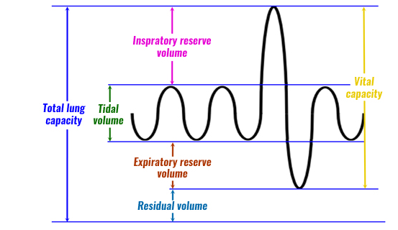

The goal for this assignment is to examine your own vital capacity through laboratory trails while learning how to use a spirometer and then compare this with the theoretical calculated number. We can calculate this theoretical number by estimating our body surface area – research has shown that the capacity of a person’s lungs is proportional to the surface area of their body. If you have any breathing difficulties (asthma etc.), you should not participate in this activity, instead use the data from your lab partner.

Pre-lab Questions:[6]
- Define: Tidal volume and Vital Capacity. [2]

- Is the vital capacity the same as total lung capacity? Why or why not? [2]

- My average tidal volume is 530 cc per breath. Does all of this air reach my alveoli for gas exchange? Why or why not? [2]

Procedure:
Measuring vital capacity:

- Use the spirometer to measure your vital capacity.
- Take three measurements, with at least some time in between each trial. Record them in the data table below.

Estimating vital capacity:

- Estimate your vital capacity – use either the equation below to get your body surface area or google ‘body surface area calculator’ to get an automatic reading.

Body Surface Area = ( [height(cm) x weight(kg)] ) / 3600^{1/2}

- With your calculated surface area, use the value below to calculate your estimated vital capacity.

Males: SA x 2500
Females: SA x 2000

Results: [4]
Measured Vital Capacity | Estimated Vital Capacity
Trial 1 = | Height (cm) =
Trial 2 = | Mass (kg)* =
Trial 3 = | Surface Area =
Average = | Vital Capacity =
*Please use your mass during your estimation, but if you are uncomfortable sharing this you may leave it blank at no penalty
Analysis: [13]

- Did everyone have the same vital capacity? What could account for the differences between members of the class (i.e. think about physiology, activities, and conditions). [3]

- How does your measured vital capacity compare to the vital capacity you estimated using the formula? Which do you think is more accurate and why? [2]

- Examine the data table of a person who entered into a training program. This person’s vital capacity was measured over a 60 day period. Use the data to construct a graph. Don’t forget: title, x/y-axis titles, and colour! [6]
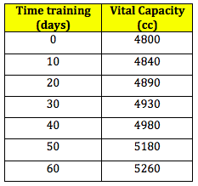

2. What do you think could cause the change in a person’s vital capacity over the course of the training period? Think about what structures are involved in respiration. [2]

