Cladogram Practice: Comparing Genetic Sequences

1. Draw a cladogram depicting the evolutionary relationships among all five species (including humans) according to their gene or protein similarity in the
GAPDH gene shown in the table below.

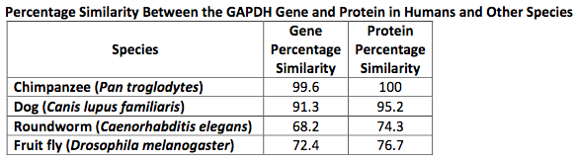
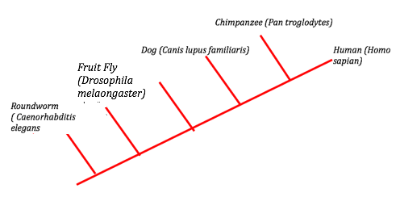

2. The following table shows the percentage similarity in sequences of nucleotides from a gene derived from five different species of mammals compared to that of a human gene. In simpler terms, the percentage similarity between the human gene and the chimpanzee gene is 99.7%. Draw a cladogram depicting the evolutionary relationships among all six species (including humans) according to their percentage similarity in the gene shown in the table. | 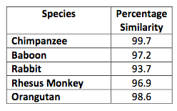

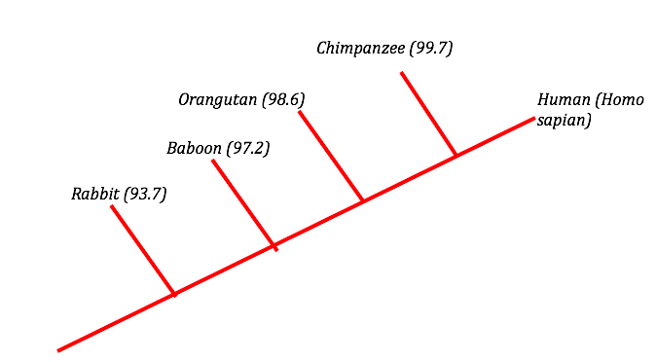
An outgroup is a species of organism that acts as a reference group when determining the evolutionary relationships between three or more other species of organisms. It is to related to the species in question but less closely than any of the other species are to each other. In a cladogram, the line for the outgroup should branch from the ancestral lineage before any of the other groups.

- What probably explains the inclusion of rabbits in this research from Question 2?

- Their short generation time provides a ready source of DNA.
- They possess all of the shared derived characters as do the other species.
- They are the closes known relatives of the rhesus monkeys.
- They are the outgroup

- What conclusions can be drawn from the data shown in Question 2?

- Humans and other primate evolved from rabbits within the past 10 million years.
- Most of the genes of other organisms are similar to human genes.
- Among the species listed, humans shared a common ancestor most recently with chimpanzees.
- Humans evolved from chimpanzees somewhere in Africa within the last 6 million years.
- Both B and C are correct.

- Five new species of bacteria were discovered in Antarctic ice core samples. The nucleotide (base) sequences of RNA subunits were determined for the new species. The table below shows the number of nucleotide differences between the species:

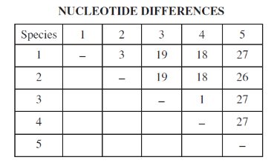 | 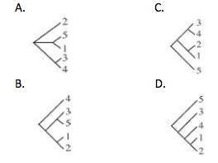

C – 5 IS THE OUTGROUP. It has many differences with all other species. 1-2 are very closely related, they diverged recently. Same with 3-4, therefore D cannot be correct. We would see a consistent increase in differences if D was correct.

