Science Fair: Assignment 3: Procedure and Materials (Rough Draft) [5] Name:
Due October 4th
Procedure Tips:
- This is to be step-by-step instructions on how to carry out your experiment (OR IN THE CASE OF A STUDY – HOW THEY GOT THEIR DATA)
- You can use a numbered series of steps, but it must be in full sentences.
- Be detailed and exact – make sure your variables are clear (especially control variables)
- Ex. “We watered our plants” is too vague! DON’T DO THIS
- “We watered our plants with 100ml of tap water at 4pm every second day for the course of our experiment” DO THIS!
- Your procedure should be repeatable. This means if another person wanted to do EXACTLY what you did all they need is your procedure!

To submit this assignment you may:
- Follow this template and write it by hand on this sheet
- Type it up and print it out or email to spletsch@vsb.bc.ca
After it is submitted, I will give feedback and corrections – it is your job to use this feedback to create your good copy

Step 1: Identify your Variables – Remember: your hypothesis (assignment 2) should be in the format “If…(Independent Variable)…than…(dependent variable)…” That should help you here

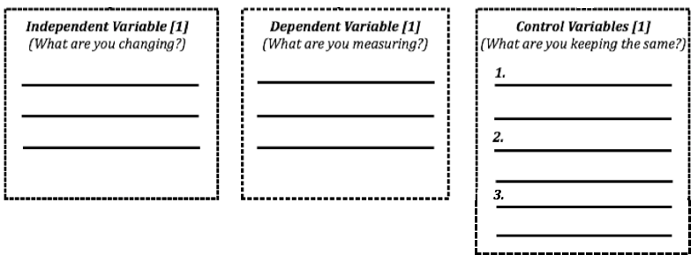
Step 2: Materials – What do you need? You do not need to fill each box
Step 3: Procedure [2]– How are you going to do your experiment? Don’t forget to be specific and make your controls clear! How many times are you going to do each test? Remember our bouncy ball lab we did each thing three times.

1.
2.
3.
4.
5.
6.
7.
8.
9.

