**EDCP 570: Seminar in Teaching ICT  
Lecture Notes**S. Petrina (19 November 2018)

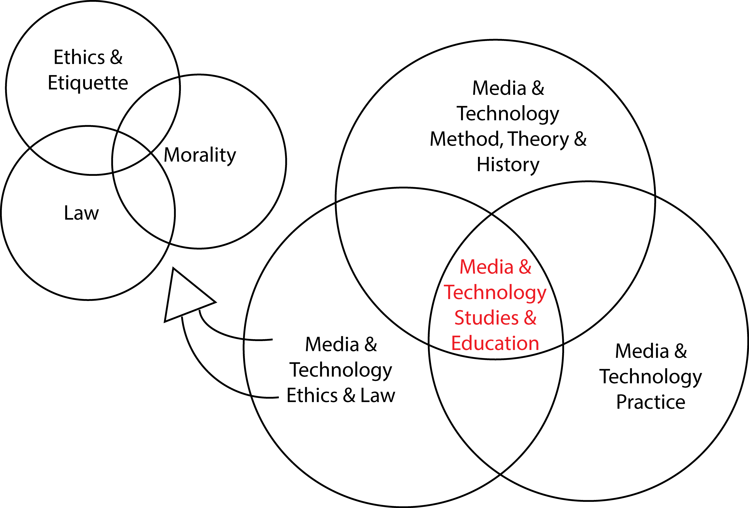

**Taxonomy of ICT**

1. Taxonomies of ICT
   1. Petrina (2007, pp. 383-386):

Macintosh HD:Users:stephenpetrina:Desktop:IT&CS&DD copy.pict

* 1. ICT
     1. IT
        1. Application Design and Development
        2. Web Design & Development
        3. Software Analysis and Design
        4. Data Management
        5. Data Mining and Data Warehouse Management
        6. Telecommunication Systems Administration
        7. Networking
        8. Data Communications
        9. Human-Computer Interface Design
        10. Equity
        11. Ethics, Privacy and Rights
            1. Cybersecurity
        12. Cognitive and Affective Computing
     2. Computer Engineering and Science
        1. Digital Logic
        2. Programming Languages
        3. Applications
        4. Digital Systems Design and Networks
        5. Robotics
           1. Animatronics & Mechatronics
        6. Artificial Intelligence and Virtual Reality
           1. Machine Learning
        7. Human-Computer Interaction
     3. Digital Design
        1. Animation
        2. Computer-Aided Design and Imaging
        3. Digital Audio and MIDI
        4. Digital Video
        5. Digital Graphics and Web Design
        6. Gaming
        7. Scientific & Technical Visualization
        8. Cybercultural Studies