Increasing Available Co-op Positions for UBC Students

For
Deborah Buszard
Interim President and Vice-Chancellor
University of British Columbia
Vancouver, BC

By
Tanya Mozafari
English 301 Student
University of British Columbia
Vancouver, BC

March 29th, 2023

Table of Contents

I. Introduction………………………………………………………...…3
- Definition of co-op………………………………………………………………………...3
- Background on the benefits of co-op placements…………………………………………3
- Description of barriers to getting a co-op placement……………………………………...4
- Purpose and intended audience……………………………………………………………4
- Brief description of research and sources…………………………………………………5
- Scope of inquiry…………………………………………………………………………5

II. Data Section………………………………………………………….6
- Overview of current co-op program structure…………………………………………….6
- Barriers to landing a co-op placement…………………………………………………….7
  - Time-consuming applications……………………………………………………..7
  - Lack of relevant work experience…………………………………………………7
  - Limited available opportunities…………………………………………………...7
  - Unpaid positions…………………………………………………………………..7
- Analysis of student surveys……………………………………………………………….8
- Strategies to increase placement rate for co-op students………………………………...11
  - Current approaches to training co-op students……………………………...……11
  - Pros and cons of creating co-op jobs on UBC campus………………………..…11
- Feasibility of proposed solution……………………………………………………….…12
  - Estimated cost………………………………………………………………...….12
  - Creative process for new co-op roles…………………………………………….12

III. Conclusion…………………………………………………………13
- Summary of findings………………………………………………….…………………13
- Recommendations……………………………………………………………………….14

VI. References………………………………………………………….15

Introduction

Definition Of Co-Op
Co-operative Education, known as Co-op, is a form of education that combines classroom-based learning with supervised, paid work experience. At UBC Science Co-op, students take part in three work terms throughout the year - Fall, Winter, and Summer - and earn a Co-operative Education designation by completing the required number of work terms and academic requirements (UBC, 2023). During the work terms, students are supervised, evaluated, and paid by their employers while gaining practical experience in their chosen fields. A Co-op Coordinator regularly visits students at their job sites to provide guidance and assess their performance (UBC, 2023). At the end of each work term, both the student and supervisor evaluate the student's work performance and assignment (UBC, 2023). Co-op programs offer students an opportunity to gain valuable industry experience, develop professional skills, and build connections in their field.

Background On The Benefits Of Co-Op Placements
Co-op placements offer several benefits to students that can significantly impact their career trajectory. Research shows that co-op graduates earn 15% higher starting salaries than non-co-op graduates, and are more likely to land more prestigious, better paying jobs than their non co-op peers (UBC, 2023). Additionally, 80% of employers surveyed report that co-op and internship students are a source of new talent and potential future employees, indicating that co-op placements are an effective way to build industry connections and gain valuable work experience (UBC, 2023).

Description Of Barriers To Getting A Co-Op Placement
There are several barriers that students may face when trying to secure a co-op placement. The first is a lack of relevant work experience, which can make it challenging to stand out among other applicants. Additionally, there may be limited available opportunities in certain fields or industries, which can further reduce the chances of securing a placement. Another barrier is the time-consuming nature of the application process, which can involve submitting resumes, cover letters, and attending interviews. Finally, some co-op placements may be unpaid, which can pose a financial barrier for students who rely on paid work to support themselves during their studies.

Purpose And Intended Audience
The purpose of this communication is to identify gaps in the current co-op system and suggest opportunities for improvement to help co-op students succeed in their work placements and beyond graduation. The intended audience for this communication is Deborah Buszard, Interim President and Vice-Chancellor at the University of British Columbia. It is expected that she will notify and communicate with Deans and Co-op Coordinators of all Faculties at UBC that participate in the co-op program. By identifying areas of improvement in the co-op system, UBC can better support students in securing relevant work experience, developing professional skills, and building connections in their chosen fields. Ultimately, the goal is to help co-op students succeed in their work placements and achieve long-term career success after graduation.

Brief Description Of Research And Sources
This research project aimed to investigate the experiences of UBC students and alumni in co-op programs and their career outcomes after graduating. To collect data, a survey was designed and administered to participants who have had experience with co-op placements. In addition, information on UBC's co-op programs was accessed online through UBC’s website. A news article was also utilized to understand the general sentiment surrounding co-op programs from the perspective of students and employers. Furthermore, academic articles were consulted to explore the benefits of internships and co-ops, as well as the current barriers and problem areas within co-op programs. The sources used in this research provided a comprehensive understanding of the co-op program, its benefits, and potential areas for improvement.

Scope Of Inquiry
To evaluate the demand for and feasibility of implementing more co-op, internship, and part-time positions for students at UBC, the following areas of inquiry will be explored:
- What are the current challenges UBC students face when seeking to secure relevant work experience?
- What are the potential benefits of expanding co-op programs at UBC?
- How many UBC students are unable to secure a co-op position even after adequately attending all conferences, workshops, and applying to over the specified number of co-op positions?
- What are the potential drawbacks of expanding co-op programs at UBC?
- What are the most effective ways to ensure that all UBC students have the opportunity to gain relevant work experience?

Data Section

Overview Of Current Co-Op Program Structure
Co-op programs are structured to provide students with rigorous application, assessment, and interview processes to gain admission. Once accepted into the co-op program, students receive access to co-op portals and are required to participate in mandatory workshops on resume building, cover letter writing, and interview preparation. Students must apply to a minimum number of placements during their search term, typically around 20 applications. These practices aim to increase student success; however, there is no guarantee that students will land a placement. As part of their degree program, co-op students have the opportunity to participate in multiple work terms with different employers throughout the year. This allows them to gain significant practical experience in their chosen field by graduation. According to the Canadian Association for Co-operative Education, co-op students across Canada completed about 80,000 work terms during the 2015-2016 academic year (US News, 2017). Although participating in a co-op program may extend a student's degree program by a year or more, the majority of co-op students are paid for their work, which can help to alleviate their financial burden upon graduation (US News, 2017).

Barriers To Landing A Co-Op Placement
Accessing co-op work placements can be a challenging task for many college students. One major barrier to obtaining such internships is the time-consuming application process. According to recent research, many students face time pressures and scheduling conflicts when trying to balance their academic work, paid employment, and internship opportunities (Billett, 2009). This can be particularly challenging for students from marginalized communities who are more likely to face financial, institutional, and sociocultural obstacles. In addition, students may find it difficult to locate internships that fit their schedules or are located nearby, which can make the process of securing an internship difficult and time-consuming.
Landing a co-op placement can be challenging due to several barriers that students may face. One of the biggest barriers is the lack of relevant work experience. This creates a vicious cycle where students are unable to gain work experience due to the lack of opportunities, which then puts them behind other candidates who have work experience. As Dr. Katharine Brooks, director of Liberal Arts Career Services at The University of Texas at Austin points out, not acquiring experience while you’re a student can put you at a disadvantage (Smith, 2013). Another barrier is the limited availability of opportunities, as not all students who are accepted into co-op programs are able to secure a work placement. Additionally, students are often encouraged to engage in unpaid volunteer activities that are relevant to the jobs they are applying for, but this is a privilege that many students do not have.
Another significant barrier that many students face is the issue of unpaid positions. This is a problem that disproportionately affects marginalized students who are already financially disadvantaged (Billett, 2009). Students from low-income families, those who identify as minorities, and working students, among others, may find it difficult to accept unpaid internships due to financial constraints. Unfortunately, this often means that these students miss out on valuable learning opportunities and experience that can help to further their careers. One recommended solution is that universities should take proactive steps to provide financial support to low-income students and offer outreach and coaching to employers to support internship opportunities for students from marginalized communities (Billett, 2009). Additionally, universities should provide advising and support to help students navigate the internship application process and ensure that all students have access to valuable internship opportunities regardless of their financial background.

Analysis Of Student Surveys
The analysis of student surveys aimed to investigate the effectiveness of UBC's co-op program and its impact on students' career outcomes. The results revealed two key findings. Firstly, there were 18 students enrolled in co-op, and out of those 18 students, only 9 were able to successfully land a work placement (Figure 1 and Figure 2). Note that 2 out of the 18 respondents did not attend mandatory events and requirements, and thus unsurprisingly did not land a work placement. However, it is shocking that in the sample population, 44% of co-op students were not able to secure a work placement despite putting in the time-consuming effort of getting into the co-op program, attending workshops, conferences, and applying to a high quantity of positions. This indicates that there may not be enough companies willing to hire co-op students or that first-time co-op students are not as attractive to employers as those with prior co-op experience. One potential solution to increase placement rates is for UBC to prioritize hiring first-time co-op students in order to provide them with the experience they need to be more competitive in the job market.
Secondly, the survey showed that graduates with co-op work experience were more likely to find full-time employment within three months of graduating. 17% of co-op students had full-time offers before graduating, and 42% found jobs within three months of graduating (Figure 3). In contrast, the majority of graduates without co-op work experience were still searching for a job in their desired field after three months (Figure 4). Interestingly, 17% of graduates without co-op experience still had full-time job offers before graduating, which suggests that they may have completed internships or had pre-existing professional networks outside of the co-op program. To ensure a comprehensive analysis, it is crucial to take into account the possible influence of external factors, such as the ongoing COVID-19 pandemic and the subsequent economic downturn, on the job market (Gould and Kassa, 2020). Thus, one must exercise caution when interpreting the results, as other confounding variables could exist, potentially impacting the findings in unforeseen ways.
Overall, the analysis of student surveys suggests that there is room for improvement in UBC's co-op program. Increasing the number of co-op opportunities available and prioritizing hiring first-time co-op students may help to increase placement rates and improve students' career outcomes. Additionally, it may be beneficial to offer guidance to co-op students on how to search for jobs that match their qualifications and provide more networking opportunities to help them build professional connections, as well as to get a better sense of realistic opportunities available to them.

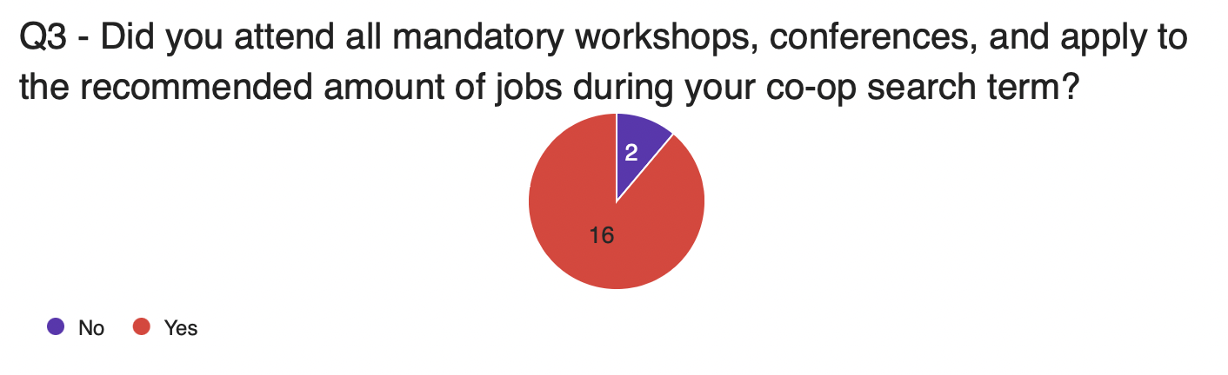
Figure 1: Question regarding participation in workshops, conferences, and application quantity presented to UBC students and UBC alumni who were enrolled in co-op

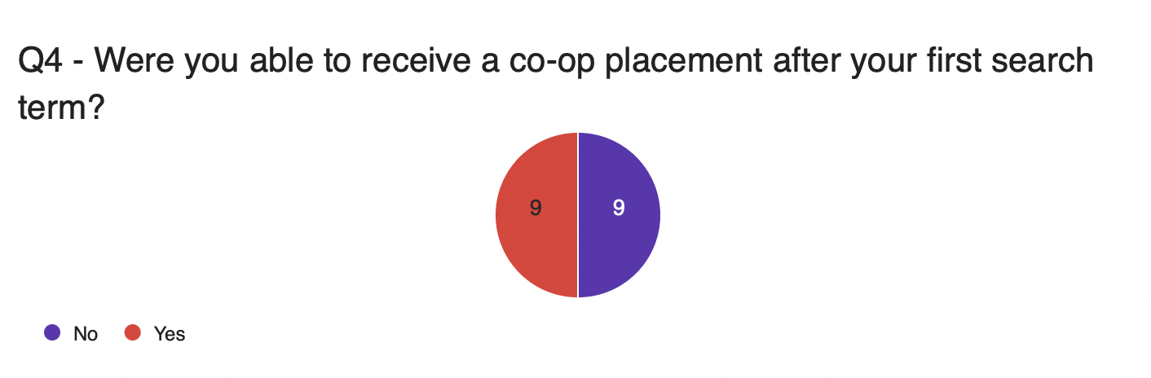
Figure 2: Question regarding co-op placement success rate presented to UBC students and UBC alumni who were enrolled in co-op

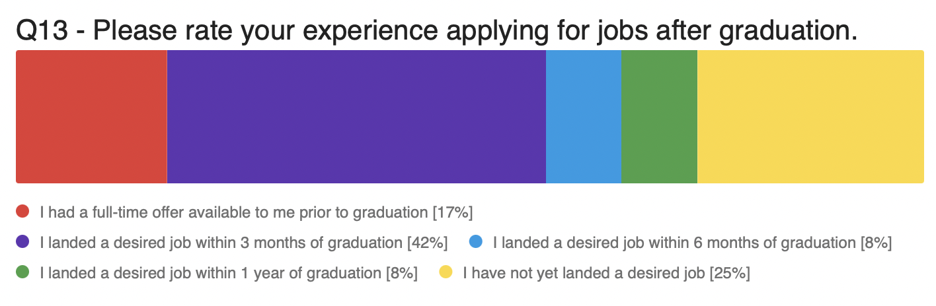
Figure 3: Question regarding job prospects after graduating presented to UBC alumni who were enrolled in co-op

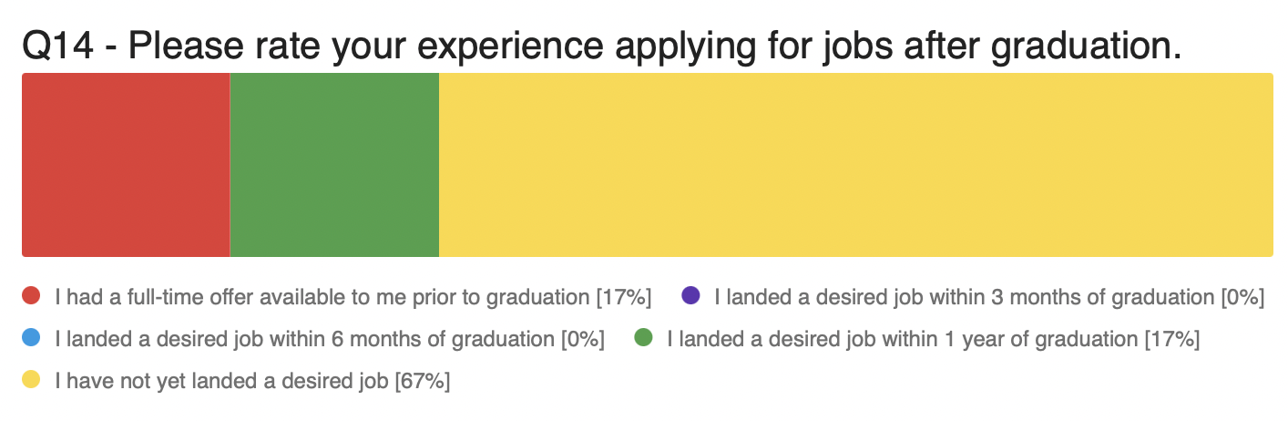
Figure 4: Question regarding job prospects after graduating presented to UBC alumni who were not enrolled in co-op

Strategies To Increase Placement Rate For Co-Op Students
One strategy to increase the placement rate for co-op students is to offer automatic work placement on UBC campus for those who have been unsuccessful in securing a co-op position despite attending all workshops and conferences and applying to more than the minimum required amount of jobs. In addition, conferences should include guidance on how to search for jobs that students are realistically qualified for, as many first-time co-op students may not have a clear understanding of what types of companies and positions are suitable for them. UBC already has part-time worklearn positions, volunteer positions, and some full-time opportunities, but the suggestion is to prioritize students who have never had a co-op term and increase the number of full-time co-op opportunities. The benefits of increasing on-campus jobs include happier students, higher employability after graduation, and potentially higher salaries. While there may be some costs associated with creating these positions, they can be offset by creating positions that provide value to the UBC campus and community.
Graduates from co-op programs also report a better job-education match, indicating that their co-op experiences helped prepare them for their chosen career paths. Overall, co-op placements are a valuable tool for students to gain practical experience, build professional networks, and increase their employability in the job market. Furthermore, co-op placements provide students with the opportunity to apply their academic learning in a practical setting and develop industry-specific skills. Through co-op placements, students are able to explore different career paths and industries, and make informed decisions about their future career goals (Helyer and Lee, 2014). In addition, co-op placements provide students with a chance to network with professionals in their field of interest, which can lead to future job opportunities (Helyer and Lee, 2014). Overall, work experience is very important in developing graduate employability.

Feasibility Of Proposed Solution
The proposed solution for providing automatic work placement for UBC co-op students who do not secure a job despite attending workshops and conferences and applying to a minimum required number of jobs is feasible. The estimated cost of the proposed program was calculated based on the assumption that each student would be paid the minimum wage rate of $15.65 CAD per hour, which is the current minimum wage in British Columbia. This rate would apply to full-time hours worked from May through June, resulting in a total cost of approximately $10,016 in wages per student for the entire co-op term (before tax). It is important to note that this is just an estimation and the actual cost may vary depending on factors such as the number of participating students, the length of the co-op term, and any changes in the minimum wage rate.
In order to make the program more feasible, one suggestion is to explore the possibility of providing automatic placement into revenue-generating projects on campus, which could offset the cost of paying students minimum wage and even create a financial gain for UBC. For example, If UBC launches a new initiative on campus, they could consider hiring a significant number of co-op students as a standard practice to provide valuable opportunities for students to develop their project management skills. Moreover, by utilizing a creative mindset, it is plausible that there are many areas on campus that would benefit from co-op students. Various businesses on campus could be provided with incentives from UBC to hire co-op students to help with their business. For example, food businesses on campus could offer digital marketing co-op positions and hire students to improve their online presence. The possibilities are truly vast, as UBC is an enormous and thriving campus. Overall, with proper planning and execution, the proposed solution to increase placement rates for co-op students is a feasible and worthwhile investment for UBC.

Conclusion
In conclusion, this research project aimed to identify gaps in the current co-op system and suggest opportunities for improvement to help co-op students succeed in their work placements and beyond graduation. The findings indicate that while co-op programs offer valuable benefits to students, there are still several barriers that students may face when trying to secure a placement, including a lack of relevant work experience, limited available opportunities in certain fields, and the time-consuming nature of the application process. Additionally, some co-op placements may be unpaid, posing a financial barrier for students who rely on paid work to support themselves during their studies.
To address these barriers, it is recommended that UBC explore opportunities to expand co-op programs and create more co-op, internship, and part-time positions for students. This could include partnering with more employers to provide a wider range of work placement options and investing in resources to support students in their search for relevant work experience. Furthermore, UBC could consider providing financial support for students participating in unpaid co-op placements to ensure that all students have equal opportunities to gain practical experience in their chosen fields.
Overall, by identifying areas of improvement in the co-op system and implementing changes to address these barriers, UBC can better support students in securing relevant work experience, developing professional skills, and building connections in their chosen fields. Ultimately, the goal is to help co-op students succeed in their work placements and achieve long-term career success after graduation.

References
Billett, Stephen. "Realising the Educational Worth of Integrating Work Experiences in Higher Education." Studies in Higher Education (Dorchester-on-Thames), vol. 34, no. 7, 2009, pp. 827-843.
“Canadian Co-Op Programs Blend Classroom, Work Experience.” US News, https://www.usnews.com/education/best-global-universities/articles/2017-02- 24/canadian-co-op-programs-blend-classroom-work-experience.
Gould , Elise, and Melat Kassa. “Young Workers Hit Hard by the COVID-19 Economy: Workers Ages 16–24 Face High Unemployment and an Uncertain Future.” Economic Policy Institute, 2020, https://www.epi.org/publication/young-workers-covid-recession/.
Helyer, Ruth, and Dionne Lee. “The Role of Work Experience in the Future Employability of Higher Education Graduates.” Higher Education Quarterly, vol. 68, no. 3, 2014, pp. 348– 372., https://doi.org/10.1111/hequ.12055.
“How Does Co-Op Work?” How Does Co-Op Work? | UBC Science Co-Op Programs: Work Experience for Science Students at the University of British Columbia, University of British Columbia, https://sciencecoop.ubc.ca/prospective/what.
Smith, Jacquelyn. “When the Employer Requires Experience and You Have None.” Forbes, Forbes Magazine, 8 Oct. 2013, https://www.forbes.com/sites/jacquelynsmith/2013/05/10/when-the-employer-requires- experience-and-you-have-none/?sh=24e8ad7a4256.
“Why Co-Op.” UBC Co-Op Programs, University of British Columbia, https://coop.ubc.ca/students/why-co-op.

