Lesson Plan
Grade: 1 Subject: P.E. Length: 30 min
By: Puvandeep Jatana, Tracy Flesher, Hayley McDonald, Harprina Sahota

Topic | Cross Curricular- Math and P.E.
Pre-requisite skills | -Students will know simple addition and be able to double that number  -Loco motor movements
Rationale | This cross-curricular lesson gives students the opportunity to develop their movement skills and proficiency in adding one-digit numbers together. Creating a connection between subject areas makes learning more concrete for students. Integrating mathematics with physical education is an entertaining and less intimidating approach to mathematics. Partnership is encouraged in the lesson to promote teamwork and student-centered learning. The importance of safety is stressed as early primary students are learning how to move through space while maintaining control and need to be aware of their surroundings.
Lesson Objectives | Students will be able to:  - Do addition of basic numbers and perform loco motor movements
Motor | Different movements:  -Walking forward and backward  -Skipping  -Hopping  -Crawling  -Side stepping  -Galloping  -Stretching  -Lunges
Cognitive | -Self awareness  -Space awareness
Affective: | -Respect boundaries  -Support partners  -Teamwork
PLO’s | Physical Education:  B1 move through general space while maintaining control.  B3 demonstrate proper technique for performing specific locomotor movement skills.  Mathematics:  A9 demonstrate an understanding of addition with answers to 20 and their corresponding subtraction facts, concretely, pictorially, and symbolically
Teaching Materials | - Math worksheet  - Whistle  - Pencils for class
Teaching Procedure | Hook:  Today we will be combining our addition skills with movements that we have learnt the last couple of classes that include hopping, skipping, walking, crawling, sidestepping, and galloping, and lunges. You will be working with a partner and I will number you off after the warm up.  Warm Up: 5 minutes  Everyone find a space around the black circle to learn about our warm-up. You will skip around half of the gymnasium. Remember to keep your eyes up and look for open space to skip into. When I blow the whistle, stop and listen. I will call out a body part and you will find a partner and touch that body part to theirs. If I call out “Knees!”, find a partner and touch your knees together. When everyone has a partner, we will continue skipping around the gym and stop when you hear the whistle.  The body parts the teacher will call out are: knees, elbows and fingers.  Activity: 20 minutes  -Thanks for your wonderful participation everyone! Now come and sit along this back black line so we can move onto our lesson activity. Today we are going to be incorporating math into our PE activity. You are to be working in partners, which I will put together in a minute, to get from this side of the gym to the other side. However, there is a catch! In order to get to the other side of the gym you will have to use this math sheet to figure out what you have to do.  -For example: A questions could be 2+2=___ hops, so you would fill in the answer that is 4 and then do whatever it says. So in this case you would do 4 hops forward. If you do all of the questions right you will end up at the other end of the gym. One strategy students can use is counting on.  -Work together to read the questions and figure out the answers. If you are stuck on a question or unsure of what something says then ask for help. Remember, if I blow the whistle that means stop what you are doing and freeze so you can listen to my instructions. Okay, let’s have some fun with math and movement. I will pair you off and then one of you can come and get a sheet of paper from me and when we are all ready we will get started. Once you have crossed the gym to the other side, you will double your answers and perform the movements again and see where you end up !  Cool Down: 5 minutes  Everyone will get into a circle and stretch out his or her arms so they have enough body space.  Neck Rotations- count up to ten.  (relax shoulders, arms, and face)  - circle head in figure 8 motion  - count up to 10 first direction  - count up to 10 in other direction  *adaptation- students can move head to left and then right (2 separate motions)  Rocking Horse-  -bring knees close to body and wrap your arms around them  - make back as round as possible  -kick backwards with both feet at one time and roll onto back  -kick forward and return to sitting position  *adaptation- students can bring themselves up after falling instead of doing this in one motion  Ankle Circles-  -draw circles with feet  -count up to 15 one way  -count up to 15 the other way  *adaptation- students can move feet up and down instead of in circles
Assessment | Assessment will take several different forms:  - Students will be filling out the answers on a math sheet in partners; therefore, we will check their completed sheet for correctness in order to assess their addition ability.  - Observation: The students will be asked to perform different loco-motor movements so the teacher will observe the students as they perform each movement. The teacher can take mental notes or write them down. The teacher will also be looking for how well the movements are performed, what the student can and cannot do and whether or not they can follow directions.  - Self-reflection: The teacher will give students a simple self-reflection sheet to fill in once the lesson is completed. This will give the teacher an idea of how the students felt they did with the lesson and where their level of ability is sitting. The teacher would need to explain the self-assessment sheet. Students color in the face that correlates to how they feel. Happy face=totally agree/really well; straight face=middle; sad face=not happy/not well  - The summative assessment would be the self evaluation
Extensions | Extensions to this lesson would include adding subtractions to the worksheet to create it more challenging. Another extension would be to get students to double their answer and do that many loco motor movements.
Adaptations | - During the warm-up, if students are uncomfortable touching another classmate, adjust the size of the playing area to the entire gym and ask the students to touch their own body part instead of a partner’s.  - For the activity, the teacher can pair up stronger students with struggling ones so that they can work together to answer the questions and move across the gym. Can also tell the students that if they aren’t comfortable doing a move or can’t do one to just do it to their best ability or to just walk forward the amount of steps it says to.
Cross-Curricular | This lesson incorporates mathematics and builds on students’ knowledge of the addition of one-digit numbers.
Safety Concerns | - Students should be careful not to hold on to partners when trying to perform loco motor movements  - Students should look backward as they are walking backward
Application of Principals of Learning | - Student Centered Learning- teaching the students loco motor movements with the addition of mathematics
Management/ Organization  Strategies | - Number off students so they are paired 1 and 2 and are partnered together  - Blowing the whistle means freeze  - Observing and watching that students are answering questions and staying on task to get across the gym
Resources | 1. Robinson, D. & Randall, L. (2014). Teaching Physical Education Today. Canada: Thompson Educational Publishing, Inc.  2. Lexi Yoga. (2015). Retrieved February 11, 2015, from http://www.lexiyoga.com/warming-up-and-cooling-down

Can You Get Across the Gym??

- 2 + 2 = ___________ Steps Backwards
- 1 + 5 = ___________ Walking Steps
- 8 + 2 = ___________ Hops
- 4 + 3 = ___________ Skips
- 1 + 9 =____________ Crawl Steps
- 6 + 2 = ___________ Steps
Sideways
- 1 + 1 = ___________ Lunges
- 5 + 5 = ___________ Hops

Self Reflection:
Directions: Color in the face that applies to your answer

How do I feel I participated? |  | 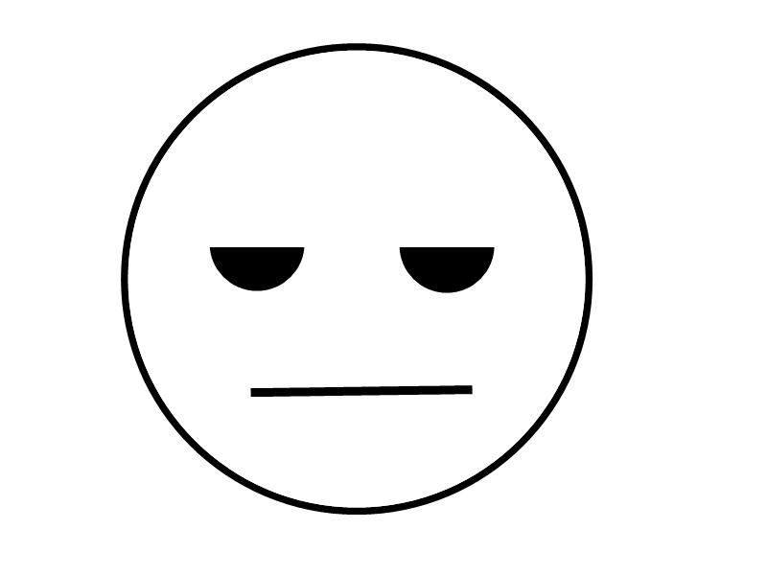

How do I feel I
worked with my
partner?

I was able to
answer all the
math questions

I was able to do
all the
movements

How do I feel I
followed
directions?

