Instructions:
- By default, all sections in this template are required, unless explicitly denoted as optional.
- Grey shaded text denotes instructions and should be deleted before distributing.
- Square brackets [ ] denote hints and notes that should be replaced, modified, or deleted.
- Don’t forget to complete the footer. Remember to update the version date after each revision.
- This template should be used for all UBC DAP courses
- The Office of Student Academic Services (OSAS) should be able to assist with formatting issues.
- All required information must be contained in this formal syllabus; don’t direct students to a course website or Canvas for required information.

Course Information
Course title: | [course title as shown in UBC Calendar (except pilot courses)]
Course code: | [e.g. BUSI 101] | Credits: | [1.5, 3, etc.]
Session and term: | [e.g. 2025W1, 2025S1] | Class location: | [building code and room no.]
Section(s): | [section number(s)] | Class times: | [days of week and times]
Course duration: | [start and end dates] | Pre-requisites: | [course codes or n/a]
Division: | DAP | Co-requisites: | [course codes or n/a]

Instructor information
Instructor: | [name, credentials]
Phone: | [phone number or n/a] | Office location: | [building code and room no.]
Email: | [email address] | Office hours: | [days of week and times]  [Zoom link]

Course Description
[Provide a detailed but succinct description of the course. Ensure consistency between this course description and the brief course description in the UBC Calendar. Avoid repeating what will be in the learning objectives below.]

Course Format
[Additional information on course structure. Typical use of class time (lecture, discussion, cases, flipped classroom). Tutorials or labs if any. Is this a blended online + face-to-face course? Is this an approved flex course that meets less frequently than typical?]

Learning Objectives
By the end of this course, students will be able to:
- [Identify / explain / apply / analyze / integrate / evaluate / etc.] …
- …
…
[Use actions and outcomes that are observable and measurable. Avoid unobservable outcomes such as “understand,” which can be reworded as “describe” or “explain.” Refer to Bloom’s Taxonomy. Here is an explainer complete with examples (University of Arkansas)]

[the following section on SDGS is optional for DAP]
SUstainable development goals (SDGs)
[We are including SDGs in course syllabi to show where they are addressed in coursework. This is a part of Sauder’s commitment to contributing meaningfully to global sustainability and resilience. For assistance or questions on SDG’s or their inclusion, please contact deasnoffice.reception@sauder.ubc.ca.]

At UBC Sauder, we are committed to responsible business practices that can have transformative impacts on society. One of the ways we are reinforcing our commitment to responsible business is by showcasing relevant content in our courses via the lens of the United Nations Sustainable Development Goals. In this course, we will touch on topics that relate to the following goals:

[Below is an example for an accounting course. Revise the example for your course. Please copy and paste between two to five SDG goals from the list following the example into the table for your own course. Then fill in your own description of where the goal is covered in your course.]

Sustainable Development Goal | Description of how and when the goal is covered in the course.
Goal 4: Quality Education   | This course will provide education and training to students, equipping them with the knowledge and skills needed to excel in financial management, auditing and reporting.
Goal 8: Decent Work and Economic Growth   | This course will provide a strong understanding of financial accounting principles and how they are essential for creating sustainable economic growth.
Goal 9: Industry, Innovation and Infrastructure   | Financial accounting plays a crucial role in assessing the financial health of organizations, guiding investment decisions, and ensuring efficient resource allocation, all of which are essential for infrastructure development and innovation.
Goal 16: Peace, Justice, and Strong Institutions   | Financial accounting contributes to strong institutions by promoting accountability, transparency, and the rule of law. It helps prevent corruption and fraud by ensuring that financial transactions are properly documented and reported. Students will discuss the financial accounting principles around these types of transactions.
Goal 17: Partnerships for the goals   | Financial accounting fosters partnerships between governments, businesses, and civil society organizations by providing a common language for financial reporting. It supports collaboration in achieving various SDGs. Students will analyze and discuss these partnerships with various stakeholders involved in financial accounting.

[Below is the complete SDG goal list to copy and paste from to use for the table above. Delete the below list once you have included your applicable goals in the table above.]

Goal 1: No Poverty   | End poverty in all its forms everywhere  Global Examples: access to basic goods and services, financial security, poverty elimination, income poverty, social services, poverty elimination, homelessness, thriving wage, skills training, income support, charitable donations
Goal 2: Zero Hunger:   | End hunger, achieve food security and improved nutrition and promote sustainable agriculture  Global Examples: food security, malnutrition, equitable land access, healthy food, child obesity, regional food systems, farmer livelihoods, international food trade, urban agriculture, food waste, food byproducts use, food procurement, retail and distribution, food supply chains, circular food economy
Goal 3: Good Health and Well-being   | Ensure healthy lives and promote well-being for all at all ages  Global Examples: disease prevention and response, addiction prevention and treatment, healthcare access, reproductive health, medication, mental health, aging, physical activity, quality of life, public health, workplace health and safety, health equity, pandemic response consumer, well-being, employee well-being, negative effects of advertising/consumption, health care optimization
Goal 4: Quality Education | Ensure inclusive and equitable quality education and promote lifelong learning opportunities for all  Global Examples: eliminating disparities in access to education, skill development, literacy and numeracy, equity in education, Indigenous education, responsible management topics, quality university education, safe, inclusive, and effective learning environments, financial literacy, climate literacy, life-long learning
Goal 5: Gender Equality   | Achieve gender equality and empower all women and girls  Global Examples: women’s rights and safety, violence against women, unpaid/domestic work recognition and support, women leadership and ownership, gender pay gap, non-binary gender rights, gender equity, women in entrepreneurship, LGBTQIA+ issues, employment and pay equity, diverse leadership, reproductive health, gender pay gap, gender disparities in promotions
Goal 6: Clean Water and Sanitation  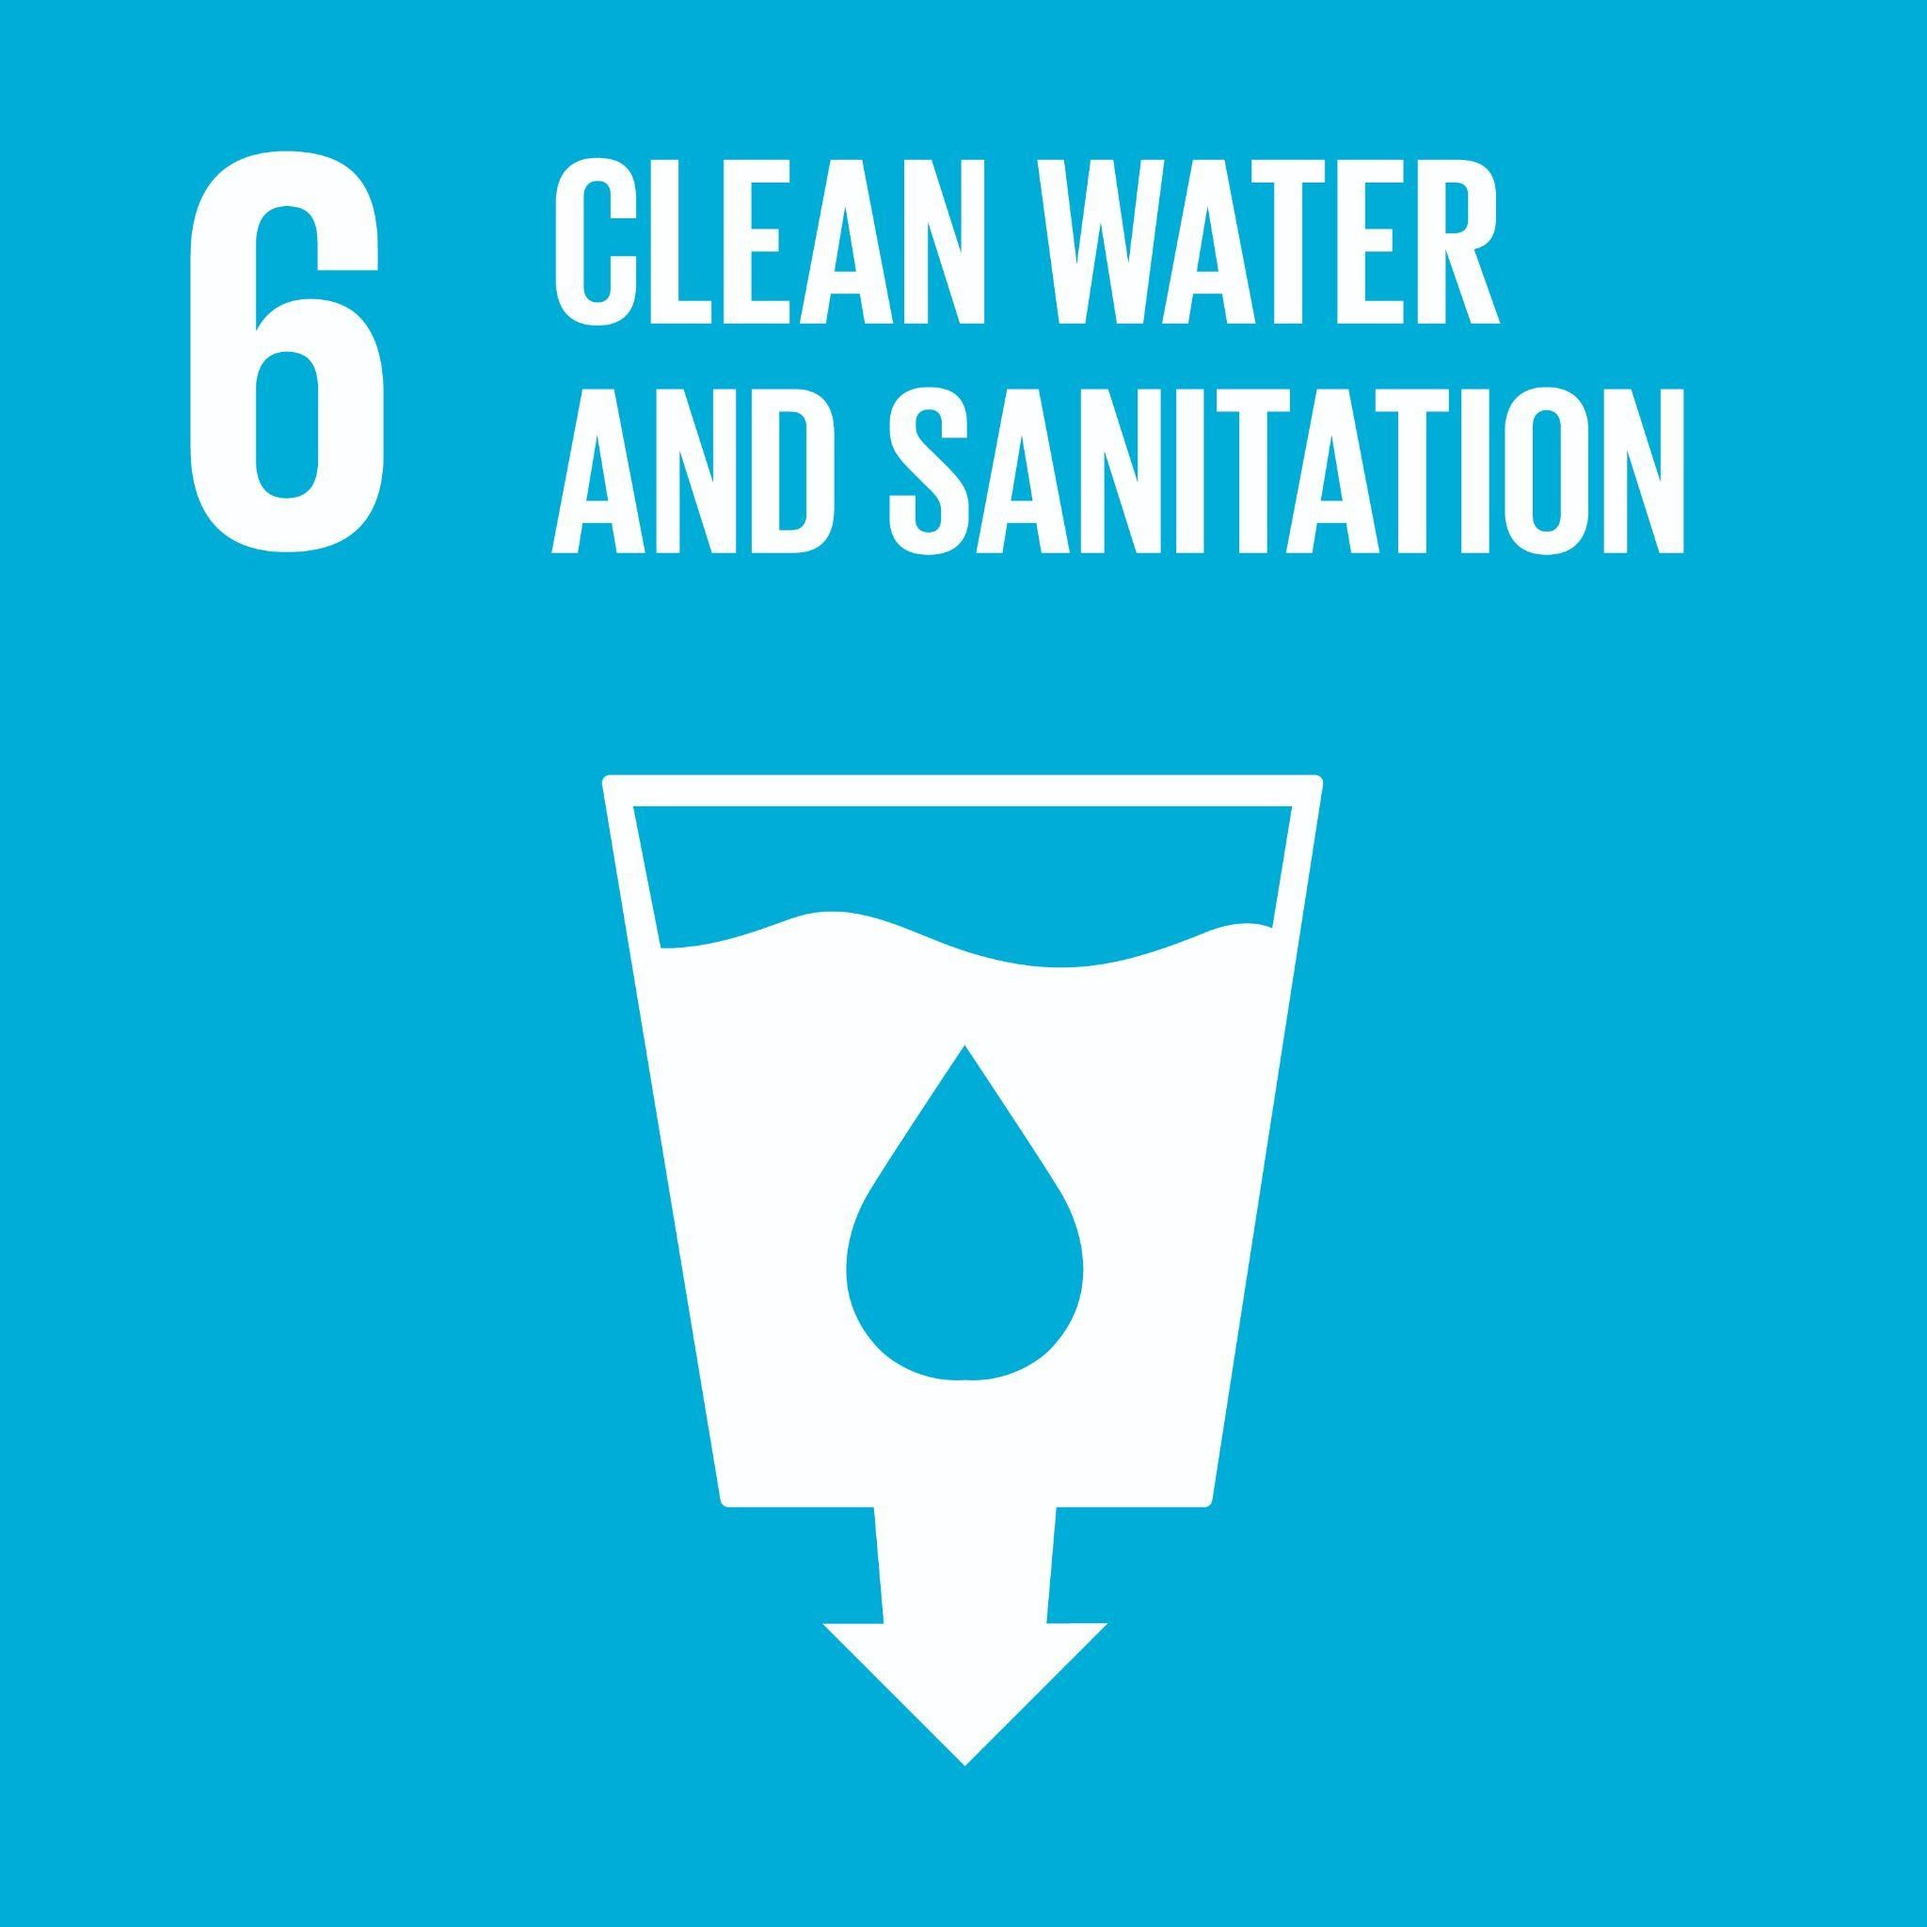 | Ensure availability and sustainable management of water and sanitation for all  Global Examples: access to clean drinking water, adequate waste water treatment, integrated water resources management, water reuse and recycling, watersheds, rivers, streams, ground water, water treatment, conservation
Goal 7: Affordable and Clean Energy   | Ensure access to affordable, reliable, sustainable and modern energy for all  Global Examples: access to clean energy, energy efficiency, energy policy, renewable energy, affordable clean energy, energy infrastructure upgrades, energy conservation, fossil fuel divestment, energy efficient buildings, renewable energy, community energy infrastructure
Goal 8: Decent Work and Economic Growth | Promote sustained, inclusive and sustainable economic growth, full and productive employment and decent work for all  Global Examples: economic diversification, small and medium businesses, fair trade, access to financial services, decent job creation, entrepreneurship, creativity and innovation, meaningful work, employment equity, income equity, labour rights, micro-finance, social finance, safe & inclusive workspace, alternatives to never-ending growth
Goal 9: Industry, Innovation and Infrastructure | Build resilient infrastructure, promote inclusive and sustainable industrialization and foster innovation  Global Examples: resilient infrastructure, inclusive and sustainable industrialization, innovation, access to transportation, micro-finance, access to credit, small-scale industry support, research and technology, entrepreneurship, access to technology, social enterprise
Goal 10: Reduce Inequality   | Reduce inequality within and among countries  Global Examples: income equality, income support, inclusive employment policies, anti-racism, anti-discrimination, Indigenous reconciliation, disability, religion, race, equity, diversity and inclusion, wealth inequality, bias in AI, price discrimination, discrimination in segmentation, Indigenous inclusion, Indigenous participation
Goal 11: Sustainable Cities and Communities  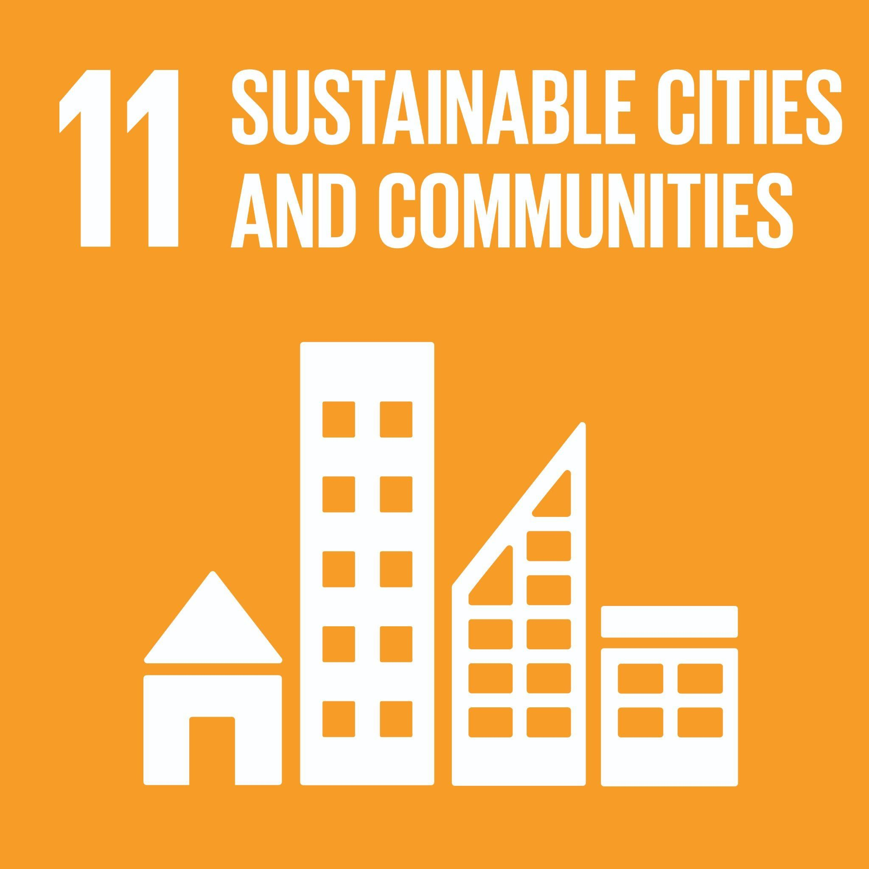 | Make cities and human settlements inclusive, safe, resilient and sustainable  Global Examples: transportation access, road safety, cultural/natural heritage, safe and affordable housing, urban planning, air quality, inclusive/safe/healthy public spaces, urban containment, urban governance, sustainable land use, effects of climate change on cities, valuing risk, sustainable transportation
Goal 12: Responsible Consumption and Production   | Ensure sustainable consumption and production patterns  Global Examples: sustainable and equitable sourcing and production, sustainable procurement, sustainable distribution, food waste, life cycle analysis, recycling and reuse, ecological footprint, corporate social responsibility, fair trade, circular economy, consumer well-being, responsible sourcing, low emission supply chain design, responsible/ethical supply chain
Goal 13: Climate Action   | Take urgent action to combat climate change and its impacts  Global Examples: natural disaster response, climate change mitigation, climate change adaptation, climate justice, climate policy, resilience, environmental externalities, low emission supply chain design, Environmental Disclosure, ESG accounting and reporting, Cap and Trade, Carbon Markets, Carbon Pricing;
Goal 14: Life Below Water  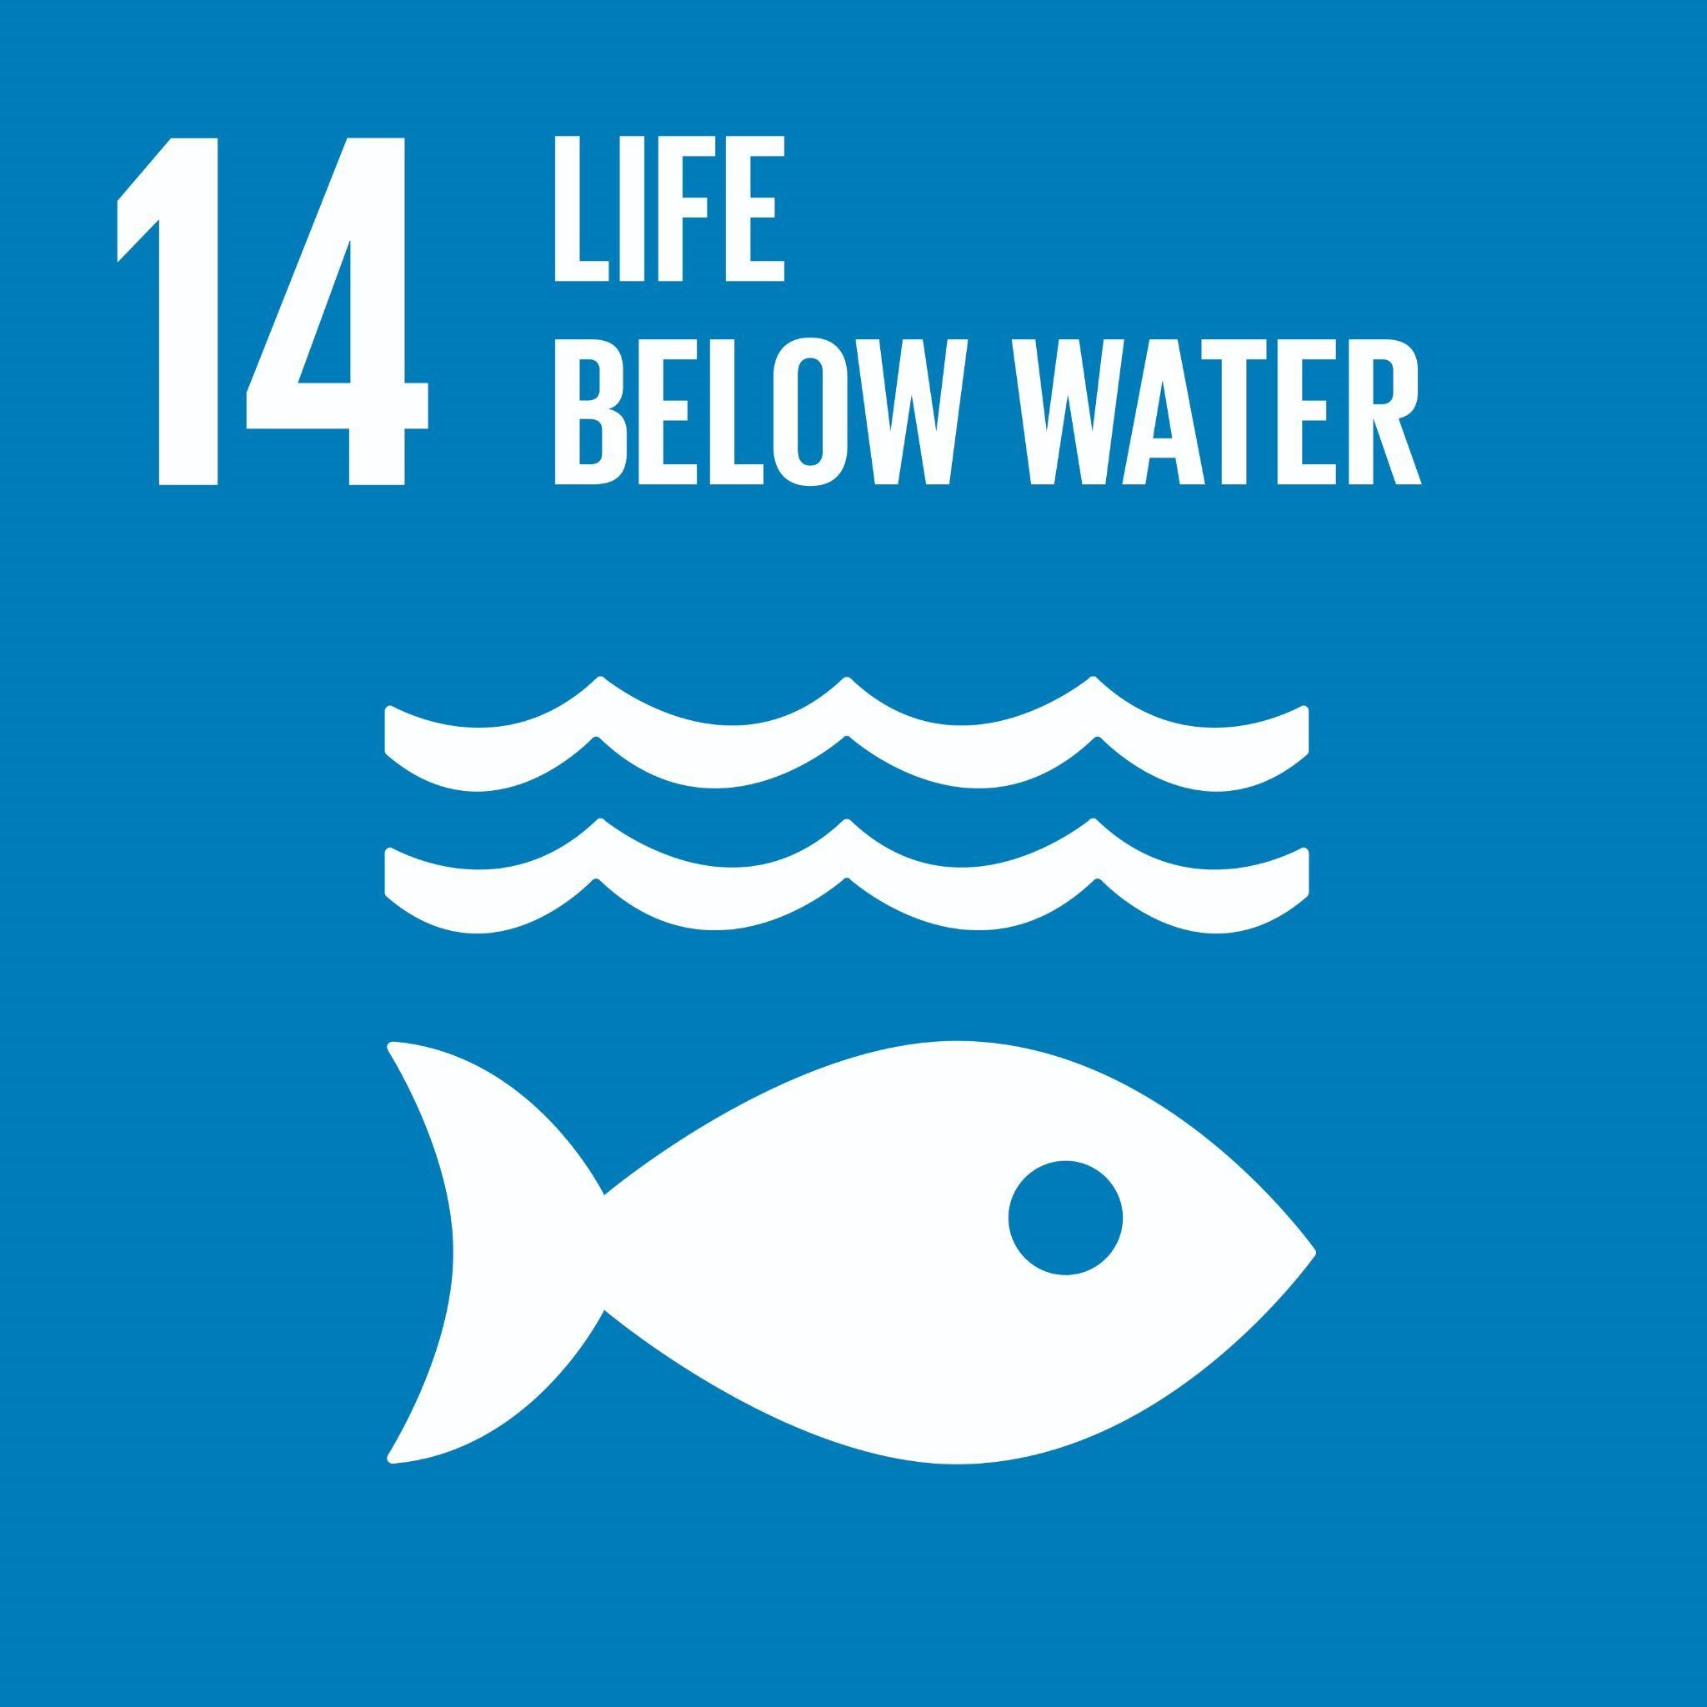 | Conserve and sustainably use the oceans, seas and marine resources for sustainable development  Global Examples: fishing and fisheries, ocean and freshwater pollution, coastal laws and water regulation, water conservation, aquatic ecosystem health
Goal 15: Life On Land   | Protect, restore and promote sustainable use of terrestrial ecosystems, sustainably manage forests, combat desertification, and halt and reverse land degradation and halt biodiversity loss  Global Examples: forests, wetlands, mountain and alpine ecosystems, sensitive ecosystems, biodiversity, soil health, endangered species, invasive species
Goal 16: Peace, Justice, and Strong Institutions | Promote peaceful and inclusive societies for sustainable development, provide access to justice for all and build effective, accountable and inclusive institutions at all levels  Global Examples: violence, corruption, government spending, public engagement, equity, advocacy, governance, leadership, laws and regulations, civic engagement, policy, accountable and transparent institutions, ethical institutions, responsive and inclusive decision making, ESG, data usage and transparency, transparency in financial reporting, environmental disclosure, codes of ethics
Goal 17: Partnerships for the goals | Strengthen the means of implementation and revitalize the Global Partnership for Sustainable Development  Global Examples: international cooperation, trade, taxes, access to technology, data collection and sharing, cross-sector collaboration, cooperation, collaboration, partnerships, collective action, inter-disciplinary

Assessments

Summary
Component | Weight
Assignments | %
Group project | %
Midterm exam(s) | %
Final exam | %
Class participation | xx%
Total | 100%

Details of Assessments
[Explanation of each category in the Summary of Assessments above. Please note that the midterm and final exams must be in-person. Exams held in-person may be online, e.g. in Canvas, but students must be physically present and invigilated. If UBC cancels in-person exams for campus closures (e.g. inclement weather), OSAS will contact instructors with impacted exams to discuss alternate options.]

Learning Materials
Required: [books, reading package, etc.]
Estimated cost of required materials: $xxx
Additional materials recommended but not required: [insert if required]

Technology Requirements
Students are expected to have access to a computer to support learning activities and assessments.

[insert if your in-person exam is computer-based] In particular, a laptop will be required for in-person exams.

[insert if you’re teaching a hybrid (live online) section and your midterm exam requires a second device for the video feed to Zoom] For the midterm exam, you will need to use a second device for video streaming to Zoom.

Canvas
We will be using Canvas for this course. The course site will be accessible starting [insert date Canvas page will be available to students]. Please visit UBC’s Canvas Student Guide for more information on using Canvas, along with system requirements. If you experience any technical difficulties with your login to Canvas, please contact the UBC IT Service Centre.

[if Zoom will be used for any component of your course, insert the following section; if not, remove this section]

Zoom
We will be using Zoom for online delivery of [insert description of planned Zoom usage]. Please visit UBC’s Zoom Student Guide for more information on using Zoom.

[add the following text if you’re using Zoom for polls, attendance and pre-set breakout groups; if not remove] You will need a Zoom account for this component of the course. If you do not have a Zoom account, you can create one here: https://zoom.us/signup. Note: creating a Zoom account requires that you provide a first name, last name, and email address to Zoom. For privacy purposes, you may consent to using your existing email address and your real name. Alternatively, if you prefer, you may sign up using an alternative email address and an anonymized name that does not identify you (i.e. Jane Doe, jane.doe@email.com). If you have trouble creating an account, or accessing a Zoom session, please contact CLCHelp@sauder.ubc.ca. You will be required to provide the email address associated with your Zoom account in a Canvas quiz for identification purposes.

[if Zoom will be used for synchronous lectures, insert the following text highlighted in yellow; if not, remove this section] To help replicate the classroom experience create an engaging and interactive learning environment, make sessions more dynamic and hold each person accountable, both students and instructors are encouraged to have their cameras on during Zoom sessions. Students who are not able to have their “camera on” should contact their instructors in advance of the first class to discuss options. Students are expected to conduct themselves professionally by joining sessions on time, muting mics when not speaking, refraining from using any other technology when in-session, attending in attire you would normally wear to school, and participating from a quiet environment. Content from synchronous sessions will be selectively recorded per instructor discretion and made available to students on Canvas for a maximum duration of the course length. This is done to allow students the opportunity to return to lecture content to solidify learnings.

[if any other learning tools will be used for any component of your course, list below with a link to the corresponding UBC student guide for the given tool (available guides can be found here: UBC Tool Guides | Learning Technology Hub. The example given below is for Respondus Lockdown Browser. Delete if you are not using RLDB or any other additional learning tools]

Respondus Lockdown Browser
We will be using Respondus Lockdown Browser during exams. Please visit UBC LockDown Browser Student Guide | Learning Technology Hub for more information on using Lockdown Browser, including minimum hardware and system requirements.

Reliable internet connection
For the seamless delivery of online course content, students should have regular, reliable access to a strong internet connection. UBC recommends 5 mbps download speed and 1 mbps upload speed are needed at minimum.

[the following section on recordings is optional for DAP – delete if you don’t want to use]
NO DISTRIBUTION OF RECORDINGS
There is no distribution of recordings of class. Classes are designed as and are intended to be attended as scheduled and your attendance is expected. If you are unable to attend, the policy regarding missed classes described in this syllabus applies. It is your responsibility to ensure that you have the materials you need for missed classes. It is strongly recommended that you make arrangements at the start of the semester for materials in case you miss class. For instance, you may wish to exchange contact information with a classmate who can provide you with notes in the event you miss class. If you believe you are an exceptional case that merits special consideration, please promptly reach out to your instructor to advise them of your circumstances.

Academic Concessions
Academic Concession Policy
[Include a description of how the course responds to cases of valid academic concessions. The policy on academic concessions is contained in Senate Policy V-135; do not create your own policy. However, you are required to describe the alternate options available for cases of valid academic concessions; e.g., provision of a supplement midterm exam, reweighting to other course components. See paragraph 9(a) of Policy V-135.
Ideally, there should be a reasonable approach to missed coursework without placing undue administrative load on instructors. For example:
- students may be permitted to miss a threshold number of minor assessments (e.g. clickers, quizzes, participation, attendance) without consequence. For example, to lessen the administrative load of excusing each individual clicker, an instructor may choose to automatically drop x number of lowest clicker scores automatically for all students at the end of the semester; or
- designating minor assessments as “practice only” during the add/drop period to account for students who register after classes have commenced.]

Requesting Academic Concessions
[Academic concession process (information for instructors):
All concessions requests require that a webform be submitted to OSAS. This means that a record of all concessions is collected by OSAS. This record is meant to provide data on the number/type of requests and as necessary, some detail on individual student cases. However, OSAS will not be reviewing all requests that are submitted for eligibility.

OSAS will only review whether a student is eligible for a concession in the following instances of missed attendance or coursework:
- Absences of 2 or more weeks for 3-credit courses; 1 or more weeks for 1.5-credit courses
- A coursework component that is worth 15% or more of the total course grade (this excludes minor assessments, i.e. coursework worth less than 15% such as participation, attendance, clicker, individual quizzes or assignments); or
- Any midterm or final exam regardless of course grade weight
In any other case that is not described above, such as for shorter absences or missed minor assignments, the instructor will evaluate the concession request. It will not be OSAS making a decision in these instances.]

If you experience unanticipated events or other circumstances that constitute valid grounds for academic concession as defined by UBC’s Academic Concession Policy, complete the concession request webform. Concessions are time-sensitive and the webform should be submitted within 48 hours of the missed deadline. Upon submission, your request will be recorded by the Office of Student Academic Services (OSAS) and you will also receive an email with further instructions. Please read this email carefully and be sure to also refer to the relevant course syllabus for each concession that you have requested. Please know that you should continue to work on the coursework for the course(s) which you submitted a concession for. You should anticipate being asked to submit work or write an exam as soon as the circumstances affecting your ability to fulfil your academic responsibilities are resolved.

Course-specific Policies and resources
Use of GenAI
[A statement on the use of generative AI must be included. We recommend that you use the following policy. If you choose to alter this policy or to write your own policy, please try to ensure that you are reducing opportunities for academic misconduct, supporting student equity, and generally able to provide evidence if misconduct does occur.
Note that separate instructions on attribution / citation have been distributed for your reference along with this syllabus.]

Generative Artificial Intelligence (GenAI) technologies are widely available and are increasingly intertwined with teaching and learning. The term “GenAI” refers to the following tools as well as any other similar models that create content using sophisticated learning algorithms: ChatGPT, Claude, Copilot, Gemini, Llama, DeepSeek, and many translation tools. GenAI also refers to such tools that may be integrated into other services like Notion, Canva, and Grammarly.

Sauder considers it essential that 1) students develop proficiency with GenAI; and 2) students are able to learn and practice the foundational critical thinking skills, unaided by GenAI, that are essential to a university education. To achieve both of these goals requires a mix of assessments that use GenAI and those that do not. Therefore each assessment will include GenAI instructions that are best suited to its learning objectives and that uphold Sauder’s commitment to academic integrity. Your instructor will specify, for each assessment, which one of the following usage rules is in effect.
- GenAI is Permitted, with attribution. Your instructor will explain what form of attribution, or what citation format, is required. [OPTIONAL: Your instructor will also explain how GenAI may be used if/when it isn’t fully permitted.]
- GenAI is Prohibited, in a controlled environment. Your instructor will provide a controlled environment for the assessment, such as an exam using lockdown browser or a pen and paper classroom activity.
- GenAI is Required, as part of the assessment. Your instructor will provide instructions describing how GenAI is expected to be used (including instructions regarding attribution/citation, if applicable).
- [REMOVE D UNLESS YOU NEED IT.] GenAI is Discouraged, for a low-stakes formative assessment. Students are expected to work on the assessment without GenAI assistance, e.g., in order to practice or increase knowledge/skills on course content. [NOTE: If you must alter the GenAI policy, the suggestion is to alter D to suit your pedagogical needs, while still upholding Sauder standards.]

After review, if it is determined by the instructor that submitted work likely violates the Use of GenAI policy and/or the specific usage rule, the work may receive a zero and may be subject to further misconduct measures set out in the UBC Academic Calendar.

[OPTIONAL: Only include if the course includes group work.] GenAI and groups/teams: Group work is an important part of this course, however, it introduces additional challenges around GenAI use. Therefore, whenever GenAI is permitted for a group assessment, the group must hold a discussion, with all members present, when beginning the work. During this discussion the group must agree on whether, how, and by whom GenAI tools will be used (to be documented in a shared file or email). All group members are expected to then communicate honestly with their group about their own use of GenAI. If it is determined that GenAI was used in a way that violates the assessment’s rules, the entire group may be held responsible.

Missed or late assignments, and regrading of assessments
[Policies on missed or late assignments, and regrading of assessments.]
Note that in the case of missed midterm exams, the weight of the midterm should only be transferred to a final exam if the final exam is cumulative. In all other cases, an alternate midterm exam should be offered approximately 1 week after the original midterm exam date; alternate exam logistics and scheduling are at the discretion of the instructor. Please refer to the UBC Calendar Use of the Formal Examination Periods with regards to the holding of any examination, formal or in-term, restrictions (including that any examination, formal or in-term, may not be held in the two weeks preceding a Winter Session formal exam period or in the one week preceding a Summer Session formal exam period).]

Academic accommodations

Centre for Accessibility (CfA)
The Centre for Accessibility (CfA) facilitates disability-related accommodations and programming initiatives designed to remove barriers for students with disabilities and ongoing medical conditions. If you are registered with the CfA and are eligible for exam accommodations, it is your responsibility to book your exam writing with the CfA using its exam reservation system: for midterm exams or quizzes, at least 7 days in advance; and final exams, 7 days before the start of the formal exam period.

Other Course Policies and Resources
[Include the following policies and resources as appropriate.]
- Policies on assessment due prior to students joining the course (i.e., during the add/drop period).
- Policies on use of clickers or other interactive devices
- Policies on attendance, punctuality, etc.
Note that course policies must be reasonable and fair. For example, it is not reasonable to award zero to a student who missed an assignment due to registering into the class during the add/drop period. Policies cannot be punitive; only UBC’s President is authorized to impose discipline, and only after a finding of misconduct. For example, a grade deduction of 10% of the course grade for poor contribution to a group project when the student’s group members would have each earned 7% would be considered punitive. Unreasonable or punitive policies are appealable to the Dean’s Office and the Senate’s Committee on Appeals on Academic Standing.]

policies applicable to ubc sauder dap courses
At UBC Sauder, professional behaviour aligns with the school’s guiding values – rigour, respect and responsibility.

Respectfulness in the online and in-person classroom
Students are expected to be respectful of our community at all times, including community members, faculty, staff and peers. This means being attentive and conscious of words and actions and their impact on others, listening to people with an open mind, treating all UBC Sauder community members equally and understanding diversity. Students who act disrespectfully toward others will be asked to leave the class and be marked as absent for the day. They may also be removed from a team, lose credit for in-class assessments and activities, or be asked to complete a group assignment individually. Incidents of misconduct or suspected misconduct will be investigated.

Respect for Equity, Diversity, and Inclusion
The UBC Sauder School of Business strives to promote an intellectual community that is enhanced by diversity along various dimensions including Indigeneity (including identification as First Nation, Métis, or Inuit), race, ethnicity, gender identity, sexual orientation, religion, political beliefs, social class, and/or disability. It is critical that students from diverse backgrounds and perspectives be valued in and well-served by their courses. Furthermore, the diversity that students bring to the classroom should be viewed as a resource, benefit, and source of strength for your learning experience. It is expected that all students and members of our community conduct themselves with empathy and respect for others.

University Policies and resources
UBC provides resources to support student learning and to maintain healthy lifestyles but recognizes that sometimes crises arise and so there are additional resources to access including those for survivors of sexual violence. UBC values respect for the person and ideas of all members of the academic community. Harassment and discrimination are not tolerated nor is suppression of academic freedom. UBC provides appropriate accommodation for students with disabilities and for religious observances. UBC values academic honesty and students are expected to acknowledge the ideas generated by others and to uphold the highest academic standards in all of their actions. Details of the policies and how to access support are available on the UBC Senate website at https://senate.ubc.ca/policies-resources-support-student-success.

Academic Integrity
The academic enterprise is founded on honesty, civility, and integrity. As members of this enterprise, all students are expected to know, understand, and follow the university policies and codes of conduct regarding academic integrity. At the most basic level, this means consistently submitting only original work done by you and acknowledging all sources of information or ideas and attributing them to others as required. This also means you should not cheat, copy, or mislead others about what is your work; nor should you help others to do the same. For example, it is prohibited to: share your past assignments and answers with other students; work with other students on an assignment when an instructor has not expressly given permission; or spread information through word of mouth, social media, or other channels that subverts the fair evaluation of a class exercise, or assessment. Violations of academic integrity (i.e., misconduct) lead to the breakdown of the academic enterprise, and therefore serious consequences arise and harsh sanctions are imposed. For example, incidences of plagiarism or cheating may result in a mark of zero on the assignment or exam and more serious consequences may apply if the matter is referred to the President’s Advisory Committee on Student Discipline. Careful records are kept in order to monitor and prevent recurrences.

copyright [optional]
All materials of this course (course handouts, lecture slides, assessments, course readings, etc.) are the intellectual property of the instructor or licensed to be used in this course by the copyright owner. Redistribution of these materials by any means without permission of the copyright holder(s) constitutes a breach of copyright and may lead to academic discipline and could be subject to legal action. Any lecture recordings are for the sole use of the instructor and students enrolled in the class. In no case may the lecture recording or part of the recording be used by students for any other purpose, either personal or commercial. Further, audio or video recording of classes are not permitted without the prior consent of the instructor.

aCknowledgement
UBC’s Point Grey Campus is located on the traditional, ancestral, and unceded territory of the xwməθkwəy̓əm (Musqueam) people, who for millennia have passed on their culture, history, and traditions from one generation to the next on this site.

Course Schedule
(Subject to change)

Class  [or week] | Asynchronous or Synchronous |  | Date | Topic | Readings or Activities | Assessments due
1
2
3
4
5
6
7
8
9
10
11
12
13
 |  | Final exams will be held from exam start date to exam end date and are scheduled by the University. Please note that all final exams are held in-person at the UBC Point Grey campus. The final exam schedule will be available in expected publish date.

