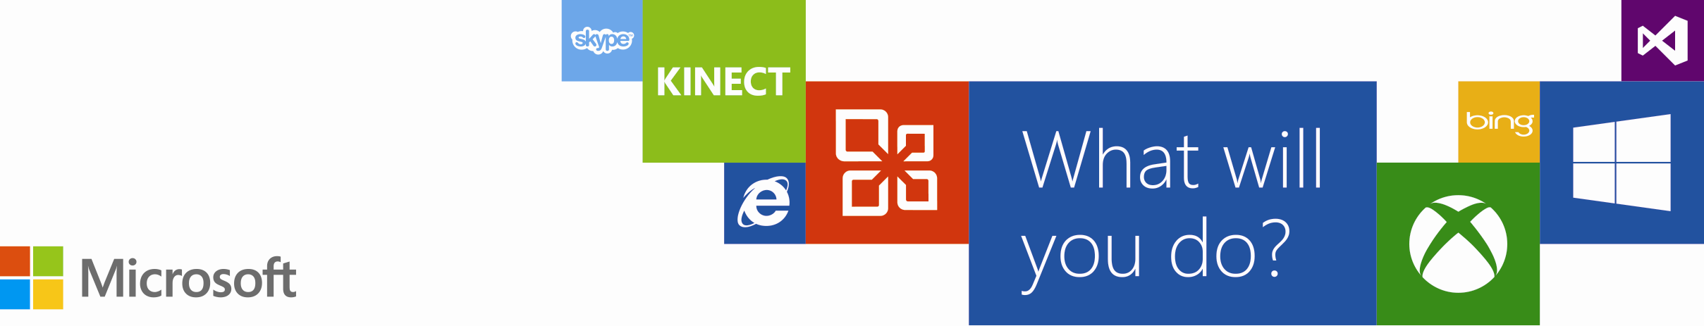
Microsoft Sales
Webinar
Sales @ Microsoft – October 2 and October 4, 2012
Do you want to get hands-on experience driving significant impact and gaining key skills for a successful career in technology? If so, a role as a Microsoft Sales professional may be for you. You can learn more about full-time Sales roles at Microsoft by attending one of these upcoming webinars.
On October 2 and 4, recent Microsoft hires and managers will discuss their career paths, why they chose a career in tech sales, and the challenges they face every day.

Register for the time that works best for your schedule!
October 2, 9:00am-10:00am PDT
(What time is this in my region?) | Register here

October 4, 5:00pm-6:00pm PDT
(What time is this in my region?) | Register here

Review Sales job descriptions at www.microsoft.com/university

