An Analysis of the Relationship between Children's Language Skills and Early Development Level of the Children and Their Neighborhood using Geographically-Weighted Regression.

Author: Tingyi Liu

Student Number: 44152163

Course Code: Geob479

**Abstract**

This research analysis how children's language skills level related to their and their neighbourhoods' development level based on the Vancouver area. In order to understand their spatial correlation properties, the GWR (geographically-weighted regression) is used for modelling. The results indicate that GWR can provide relatively accurate results of local relations amongst a set of variable for spatially examining the data spatially with the use of ArcGIS software. Also, how a child's language skills related to some important Early Development Instrument (a small set of variables related to that child and to their neighbourhood) explored in this lab can be helpful in understanding the neighbourhood development and distribution pattern of the development conditions.

**Method Introduction - Geographically-Weighted Regression**

Geographically weighted regression (GWR) is a spatial analysis technique widely used in geography and related disciplines related to spatial pattern analysis. GWR explores spatial changes and related drivers at a certain scale by establishing local regression equations at each point in the spatial range and can be used to predict future results. As it takes into account the local effects of spatial objects, its advantage is the higher accuracy. It detects the non-smoothness of spatial relations by embedding spatial structures into linear regression models. Because the method is not only simple and easy, the estimation results have a clear analytical representation, and the resulting parameter estimate can also be statistically tested, so more and more research and application.

In the spatial analysis, observational data is generally sampled as sampling units according to a given geographic location, and as the geographical location changes, the relationship or structure of the variables changes, i.e. the "space non-smoothness" referred to in GIS. This spatial non-stability is commonly found in spatial data, such as the incidence of AIDS in different provinces, the TN content of different depths of lakes, pm2.5 concentrations in urban and non-industrial areas, etc. If the traditional linear regression model is used to analyze spatial data, it is generally difficult to obtain satisfactory results, because the global model assumes that the relationship between variables is "anionic" before analysis, and the result is only some "average" in the study area. Therefore, it is necessary to adopt a new local regression method to deal with the nature of spatial data itself. Geographically weighted regression extends the traditional regression framework by allowing taking non-stationary variables into consideration (e.g., climate; demographic factors; physical environment characteristics) and models the local relationships between these predictors and an outcome of interest. In other words, GWR runs a regression for each location, instead of a sole regression for the entire study area. It is applied under the assumption that the strength and direction of the relationship between a dependent variable and its predictors may be modified by contextual factors. GWR has high utility in epidemiology, particularly for infectious disease research and evaluations of health policies or programs. The GWR model is proposed by researchers and has been practiced and verified extensively.

Limitations of GWR include problems of multicollinearity (the local regression coeﬃcients are potentially collinear even if the underlying exogenous variables in the data generating process are uncorrelated) and the approaches to calculating goodness of fit statistics. Results and Discussion

**Results and Discussion**

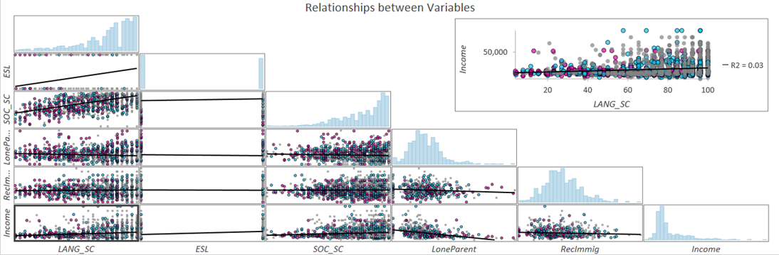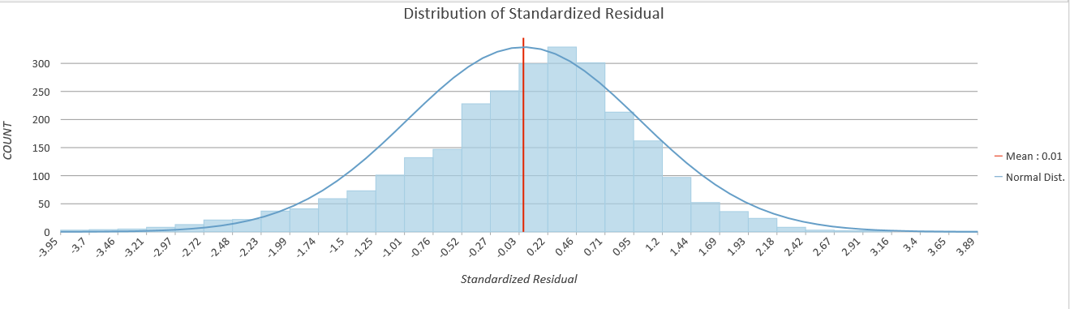

Figure 1: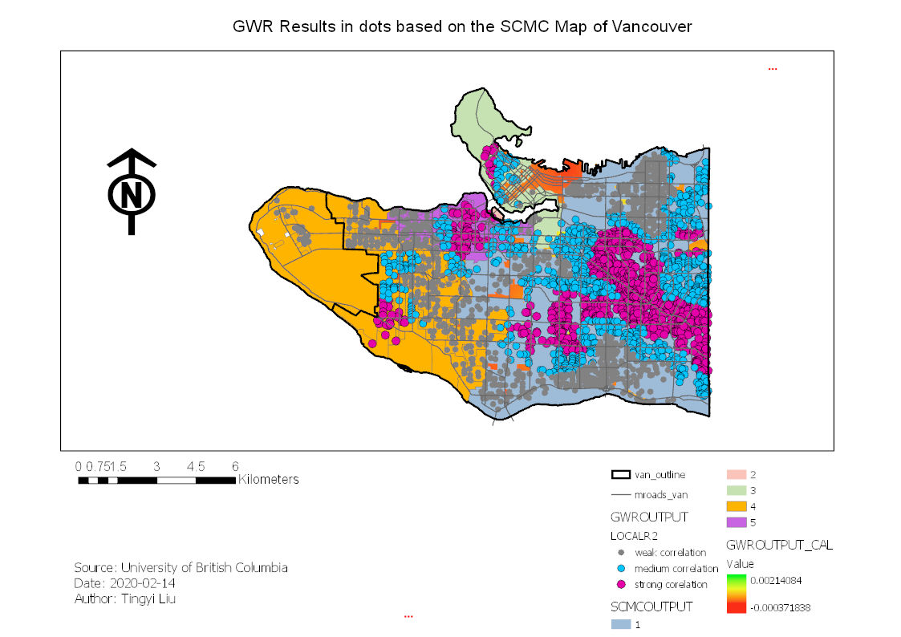

Figure 2:

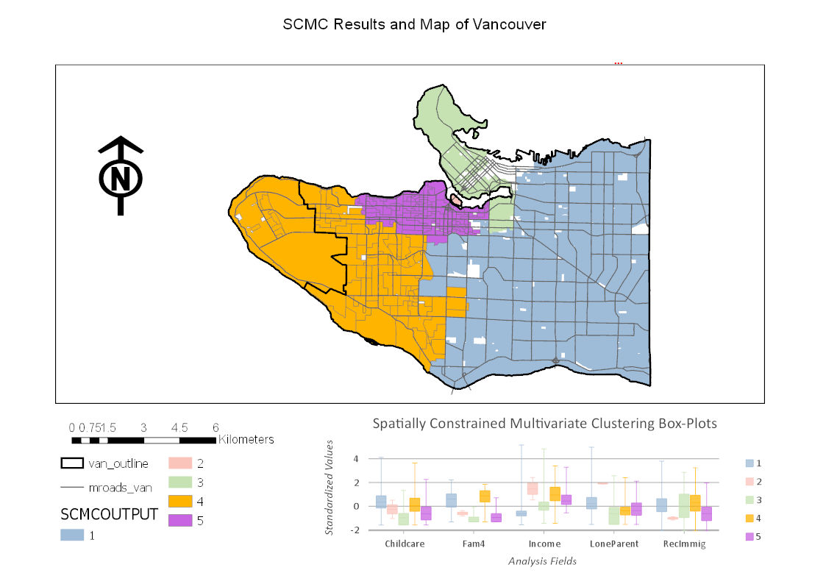

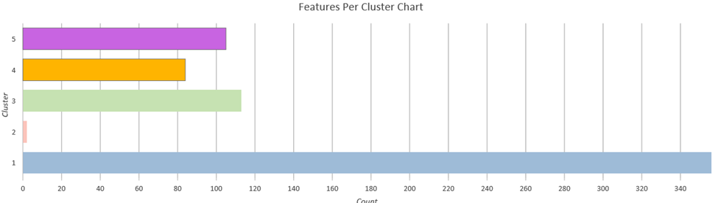

Figure 3: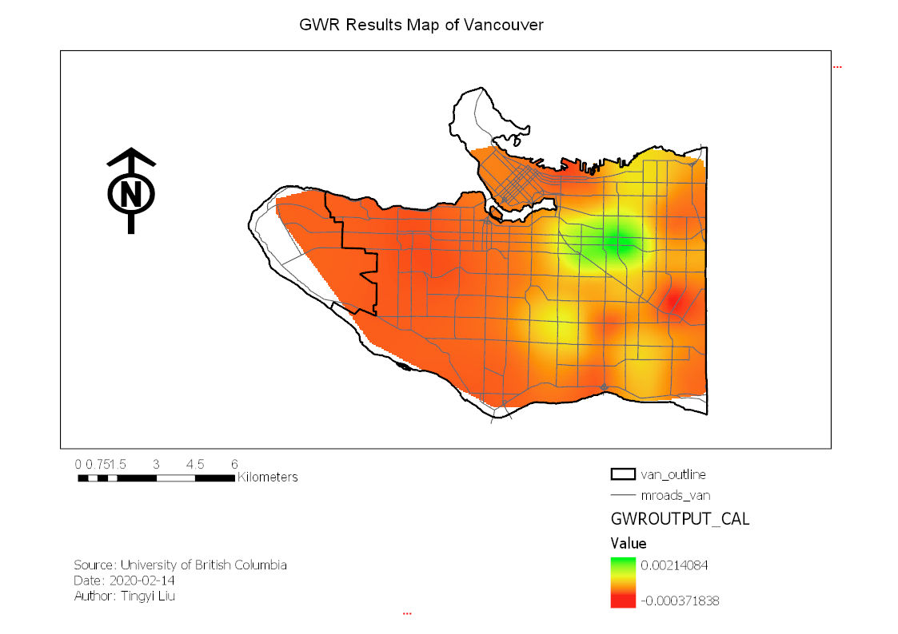

**Further Discussion on different Usage of GWR**

The Geographically weighted Regression method is also broadly used in many researches associated with spatial analysis. For instance, GWR can be used for modelling in soil chemical content or physical charachteristics pattern. A research doneby Zhang, Tang, Xu, and Kiely in 2011 use a geographically weighted regression (GWR) method for the spatial modelling of soil organic carbon contents in Ireland. The scientists included environmental factors of rainfall, land cover and soil type were investigated as the independent variables to establish the GWR model. They used GWR to create comparable and reasonable results while making use of the other chosen methods of ordinary kriging (OK), inverse distance weighted (IDW) and multiple linear regression (MLR). In this research, patial geochemical modelling was achieved using geographically weighted regression (GWR) as a basic step. The GWR also provided a promising method for spatial geochemical modelling of SOC and potentially other geochemical parameters.

GWR is also seen used in more social scientce sccociated research. An simple and typical example can be a case study based on a small town called Menghe in Changzhou, China(2010). The scientists did simulation on regional spatial sand sse patterns using Geographically Weighted Regression. The spatial non-stationary of the impact on the land use patterns change of the driving factors was considered.The simulation result was compared with OLS Logistic regression model. Geographically Weighted Regression model is not only able to improve simulation accuracy of regional land-use patterns,but also able to obtain spatial differentiation of the impact of the driving factors on land use patterns.The result of this study can support the government decisions on land use management for Menghe Town and similar areas.

GWR has good potential in helping studies associated with landscape, geochemistry and other phisical or chemical properties of the environment of an area (not only the propertoes on the ground, but also suitable in analysis the pattern of the properties of water; air weather, etc.).And then, researches in many fields (both in social and natural science) that needs spatial analysis especially which require higher accuracy probabaly need including GWR in the data analysis process in researches.

**Reference**

Nazeer, M., & Bilal, M. (2018). Evaluation of ordinary least square (OLS) and geographically weighted regression (GWR) for water quality monitoring: A case study for the estimation of salinity. Journal of Ocean University of China, 17(2), 305-310.

SHAO, Y. X., LI, M. C., CHEN, Z. J., YANG, K., & CAI, D. (2010). Simulation on Regional Spatial Land Use Patterns Using Geographically Weighted Regression: A Case Study of Menghe Town, Changzhou [J]. Scientia Geographica Sinica,

Wheeler, D., & Tiefelsdorf, M. (2005). Multicollinearity and correlation among local regression coefficients in geographically weighted regression. *Journal of Geographical Systems*, *7*(2), 161-187.

Zhang, C., Tang, Y., Xu, X., & Kiely, G. (2011). Towards spatial geochemical modelling: Use of Geographically weighted regression for mapping soil organic carbon contents in Ireland. Applied Geochemistry, 26(7), 1239-1248.