Ride Sharing in Vancouver

Amanda Burke

English 301

Table of Contents

1. Introduction
   1. Background of Vancouver public transit, and ride sharing
   2. Purpose of this report
   3. Scope
   4. Methods
2. Data
   1. Current transportation options
   2. Survey results
   3. Public information
3. Proposed solution
   1. Ride sharing
4. Conclusion
   1. Summary of findings and recommendations

**Introduction**

*Background of Vancouver public transit, and ride sharing*

Over the past 10 years, ride sharing services have emerged as one of the first and fastest growing sectors in the growing “sharing economy”. Uber was founded in 2009, and Lyft was founded in 2012. Although these services have become mainstream in the major cities all over the world, Vancouver has yet to allow them to operate in the city. Vancouver has continued to portray itself as a blossoming technology hub, as exemplified recently as the Municipal and Provincial governments campaigned for Vancouver as a worthy candidate for Amazon’s second headquarters. In Mayor Gregor Robertson’s bid for the HQ2, he called the city a “world class innovation eco-system”. However, Vancouver has failed to allow and embrace ride sharing services that are both innovative, and eco friendly in nature.

*Purpose of this report*

The purpose of this report is to bring attention and insight to the problems that Vancouverites are facing regarding the use of public transit, specifically, taxi cabs. I will also include feedback and recommendations as to how ride sharing could help solve these issues.

*Scope of report*

This report not only investigates and looks to solve issues of convenience for Vancouver residents, but also issues of public safety, and eco-friendliness. This report is intended to advise the government on a solution that is best for ALL parties involved.

*Methods*

In order to provide recommendation to the government, I have gathered data on the prevalence of the issues Vancouverites face with pubic transportation, and the demand for ride sharing. I have created a survey assessing the above, and distributed it to Vancouver residents. I have also gather information and data that has been recorded and published by the government, and local news sources. I have analyzed all of this information, and will present my recommendations based on this data.

**Data**

*Current transportation options*

Vancouver currently offers a number of public transportation options, however, many of them have limited service that leaves Vancouverites without many options. Vancouver pubic transportation currently consists of Blue Bus, Sky Train, Sea Bus, and Taxi cabs. In the late hours of the night, and on the weekends, services of Blue Bus, Sky Train, and Sea Bus are very limited (if available at all). This leaves Vancouverites only option for public transportation to Taxi cabs. Many Vancouverites find the current taxi system inconvenient, over-demanded and under-supplied, unpleasant, and sometimes unsafe.

*Survey results*

In the data listed below, you will see that my survey results imply a dissatisfaction with Vancouver taxi services. 28 Vancouver residents filled out this survey anonymously and voluntarily.

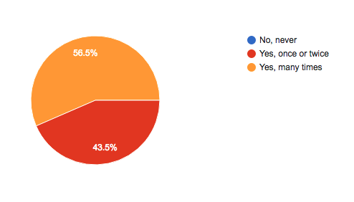

Figure 1. Answers to survey question “Have you ever been unable to get a taxi cab in Vancouver?

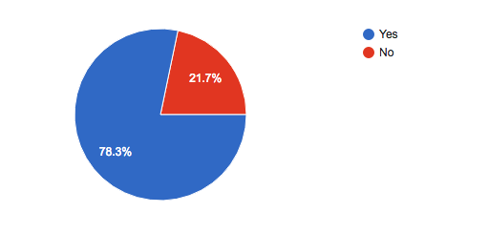

Figure 2. Answers to the survey question “Have you ever had an unpleasant experience with a taxi in Vancouver?

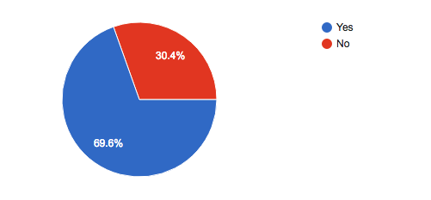

Figure 3. Answers to the question “Have you ever considered driving when you may be impaired, because you were unable to find adequate transportation?

Figures 1, 2, and 3 all indicate that satisfaction with the current systems is low, and that it is not meeting the needs of Vancouver residents. Not only are residents having unpleasant experiences with Vancouver taxi’s, but more importantly, they are potentially putting themselves, and the public, at risk. This should be a concern of the governments, and they should be investing and accepting ways that could limit this public safety hazard.

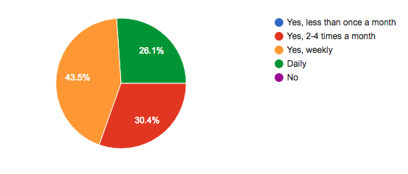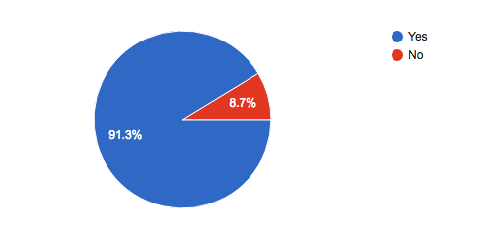

Figure 4. Answers to the question “Have you ever used ride sharing in a city other than Vancouver?”

Figure 5. Answers to the question “If ride sharing were available in Vancouver, how often would you use it?

Figures 4 and 5 both indicate that Vancouverites have used ride sharing services in other cities, and that if they were available in Vancouver, they would use them. This demand is a clear indicator that Vancouver is keeping an in-demand market, out of the city.

*Public information*

*include info from Dan O’Hara’s 2015 report*

* estimated 9-16% of taxis operating on weekend evenings in Downtown Vancouver  are unlicensed suburban taxis.
  + This clearly indicates a supply shortage

*include public records from census Canada on public transit use*

**Proposed Solution**

I propose that the municipal and provincial governments introduce ride sharing services to Vancouver.

*discuss Vancouver taxis and how to assist them in the transition*

**Conclusion**

There are a number of benefits to be realized by operating ride sharing services in Vancouver. Economically, in a city that has one of the highest costs of living in the world, ride sharing offers a reliable and affordable transportation option. In addition to offering an affordable option for customers, it also offers income earning opportunities for Vancouver residents (either full time, or as an additional source of income to subsidize the cost of living in Vancouver). The economic benefits are not just extended to Vancouver residents, but also to the government. With the implementation of ride sharing services, it reduces the need for provincial and municipal spending on transportation. The introduction of ride sharing services also benefits the public, and the government as a matter of public safety. The free market ensures that there is enough supply to maximize safety (limit drunk drivers, unsafe walking, etc). In addition to economical and safety reasons, ride sharing services provide an eco-friendly solution to driving. In a “car heavy” city that is committed to the environment, any way to reduce traffic and emissions should be well received by the government.

Overall, I think that there is a significant list of reasons as to why Vancouer should introduce car sharing services. The market of transportation is unsatisfied, there are economical and ecological benefits, and the demand is proved. In my opinion, it is in the best interest of the provincial and municipal governments, as well as the Vancouver residents, to allow ride sharing to operate in Vancouver.