Revised Definitions assignment

Here is my revised definition, according to Usman’s peer review.

Hello Team!

For the Definitions Assignment, I decided to explore a term in my creative writing class: Podplays. When I first encountered this term, I had no idea what it meant and it wasn’t until I was assigned the task of creating one that I truly began to understand what it was.

My assignment includes a parenthetical and sentence definition, along with an expanded definition that explores the origins of the name “Podplay”, how they work, how it is being applied, and what it does not mean.

The objectives of this assignment were to understand the importance and the role of definitions in technical writing, comprehend how audiences require definitions, differentiate between different levels of definitions, and include the appropriate amount of information depending on
the situation.

Term
Podplay

Parenthetical definition
Podplays (immersive audio stories created for location-based experiences) are a new form of interactive storytelling.

Sentence definition
Podplays are location-based audio stories that encourage listeners to explore their surroundings by guiding them down specific routes.

Podplays are interactive audio stories that guide listeners throughout a particular location. This encourages listeners to explore their surroundings while also immersing them in theater.

Expanded definition
Podplays are a new form of interactive storytelling that originate from a mix of podcasts and theater to create an immersive audio experience. They are audio stories that take place in specific locations and direct listeners throughout the area. This encourages listeners to engage with the environment and experience it through new eyes.

Experienced through headphones or earphones, listeners first download the podplay onto their smartphones and travel to a specific location. Once there, the podplay will instruct listeners on which direction to walk, where to turn or stop, and even speed up or slow down. This happens all while an engaging story unfolds.

Podplays have been used as exploratory and interactive entertainment, but more importantly, they have the power to engage listeners on important issues. Some are created to increase cultural awareness, such as “Ashes on the Water”, which recounts Indigenous efforts to aid victims of the Great Vancouver Fire of 1886 and walks listeners through the very ground of the devastating event. Some podplays are also created to increase spatial awareness, like Adrienne Wong’s “Look Up”, which encourages listeners to explore Gastown through a heartbreaking love story.

Unlike podcasts, podplays are not meant to be experienced passively. Listeners cannot simply just press play and listen to them on their morning commute. Podplays must be experienced at a specific location and listeners must be prepared to walk around and interact with their environment. For example, listeners may be asked to enter buildings they never would have if they hadn’t listened to the podplay or they may be asked to traverse roads or areas of the city they’d never explored before. Each podplay has a different message and intention, so there is a lot of freedom to instruct listeners to do whatever the creator sees fit to tell their story. It could encompass anything from approaching random strangers to admiring a monument.

You can think of podplays as an audio adventure. An interactive story that requires active participation and an open mind.

Sources
McGlynn, JP. “Remembering The Great Vancouver Fire .” Gastown , 13 June 2018, gastown.org/remembering-the-great-vancouver-fire/.
“Podplays.” Neworld Theatre, 2011, neworldtheatre.com/portfolio-item/podplays/.
van der Gracht, Valerie. “Etienne: a PodPlay.” My VanCity, 5 Feb. 2014, myvancity.ca/2014/02/05/etienne-podplay/.

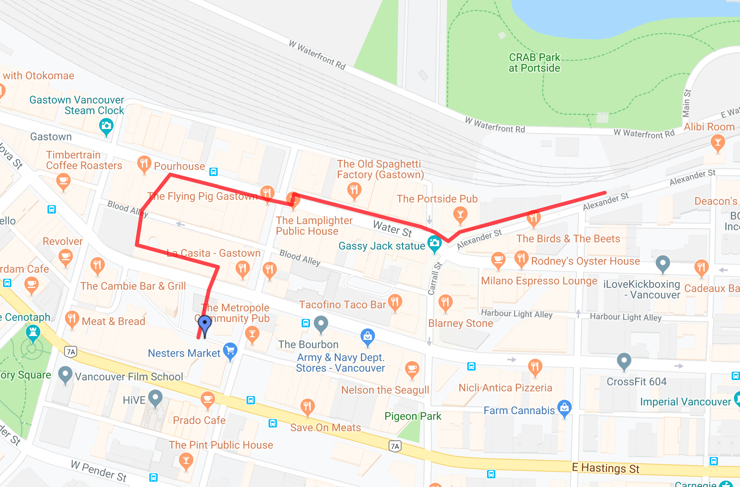

*This is the route for the “Look Up” Podplay. It is approximately 10 minutes long and takes listeners on a journey through Gastown, Vancouver.

