Considering an Independent Social Media Strategy for AMS Vice

For Ian Stone, AMS Services Manager
AMS Nest
Vancouver, BC

By Adrienne Yap
English 301

Dec, 4, 2019

Table of Contents

Introduction…………………………………………………………………………………………3

Report………………………………………………………………………………………………..4
The Importance of a Holistic Social Media Strategy…………………………………………….4
Relevant Service Example……………………………………………………………………...….4
Vice’s Current Social Media…………………………………………………………………...…...4
The importance of Multiple Social Media Channels………………………………………...…...5
Proposed Solution……………………………………...…..........................................................5

Conclusion……………………………………...…....................................................................7

Introduction
Through education, guidance, and support, Vice is an AMS program that helps individuals find balance amidst bad habits. The program’s interdisciplinary approach emphasizes well being, destigmatization, and harm reduction. The end goal is to equip students with the necessary tools and information to make informed decisions. Created in 2015, Vice has strong ties with other AMS programs like Speakeasy and SASC (sexual assault support center). This year, is Vice’s largest overhaul, with more volunteers and initiatives than ever before.

The AMS Vice program is extremely underrated and overlooked. Last year, only nine individuals attended the peer support dialogue sessions. This extremely low conversion rate left AMS with no choice but to evaluate Vice to determine whether it is financially feasible to offer the program next year.
AMS wants to consolidate all of its services under a single roof. The idea of each service controlling its own social media brings up the very valid concern of brand unity. However, this severely limits each service’s reach. Vice is forced to share a single Facebook page with six other services. This often bottlenecks the marketing process and increases the chances of Vice’s voice being drowned out.
I suggest that Vice follow in the footsteps of SASC and be granted its own social media freedom. Specifically, it’s own Facebook page and the ability to market on whatever platform will benefit potential participants.

Through Instagram analytics, surveys, and market research, this proposal will examine the validity of whether Vice should be given social media control.

Considering the power of social media, I recommend Vice be given permission to express its unique voice through an in-house marketing strategy.

Report Section
The Importance of a Holistic Social Media Strategy
Instagram is extremely saturated, making it incredibly difficult for pages to stand out. Having a presence on multiple platforms is the gold standard for any business or service’s marketing strategy. While the majority of undergraduate students at UBC likely use Instagram as their main social media platform, others like Youtube and Twitter are valuable as well. In a way, having a presence on several platforms is a foolproof way for a service to cover all its bases. Certain individuals prefer some platforms over the other. A holistic approach is a way of ensuring that Vice’s services are broadcasted to as many students as possible.

Relevant Service Example
SASC (Sexual Assault Support Center) is one of AMS’s seven services. It is the only one that has complete autonomy over its outreach and marketing. Not only does SASC have its own website and blog where it can outline its services in detail, but it has its own Facebook page.
SASC’s personal website enables a deep dive of their services, mission and goals, all in a cohesive setting. As opposed to using just a single platform where users may have to sift through mounds of content to discover the service’s “where, why, and how”, SASC has effectively compiled its information into a succinct site. Not only does it direct users to its other platforms, but it is a space for longform content (ie: blogs, articles, interviews). This helps build trust around the service, as students can browse through a site created with care and intention.

SASC’s holistic marketing approach has established it as a trustworthy and respected service. I believe Vice should follow in its footsteps as it has unique services to offer.

Vice’s Current Social Media
Vice created an Instagram nearly a month and a half ago and it has definitely had an impact. Ever since it launched, event turnout and service usage has increased dramatically compared to previous years. While growing a following has been slow, engagement is high. This means many students are learning about the service and using it.

As mentioned before, Vice shares a Facebook page with the other AMS services. The benefits are that all the services are consolidated under one roof which houses a large audience and following. However, this is almost rendered redundant as there is a huge issue of bottlenecking when it comes to posting content. This can result in inconsistent content and delayed posting, on top of Vice’s Identity being lost in the shuffle.

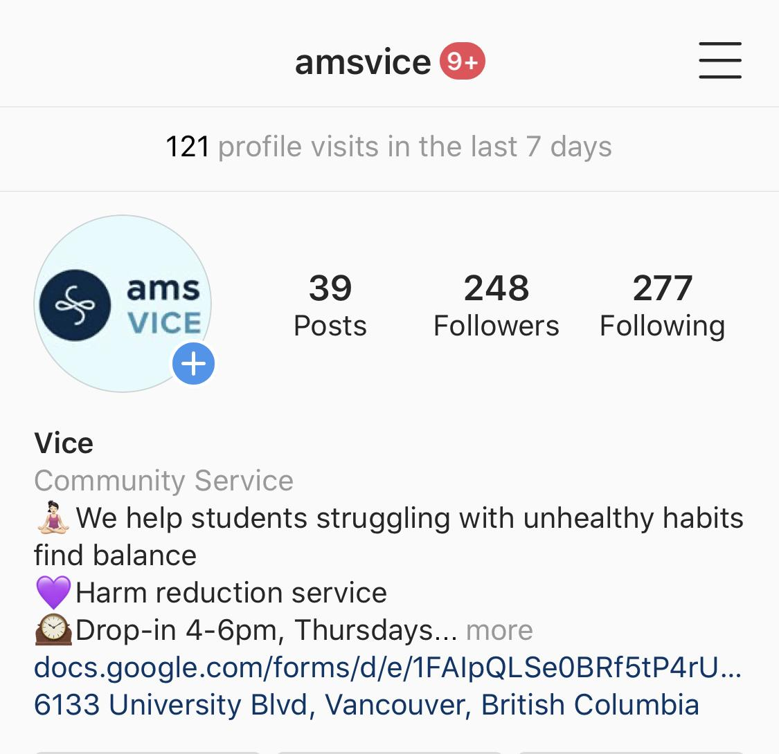
Figure 1.
Current following for AMS Vice on Instagram since October, 17, 2019

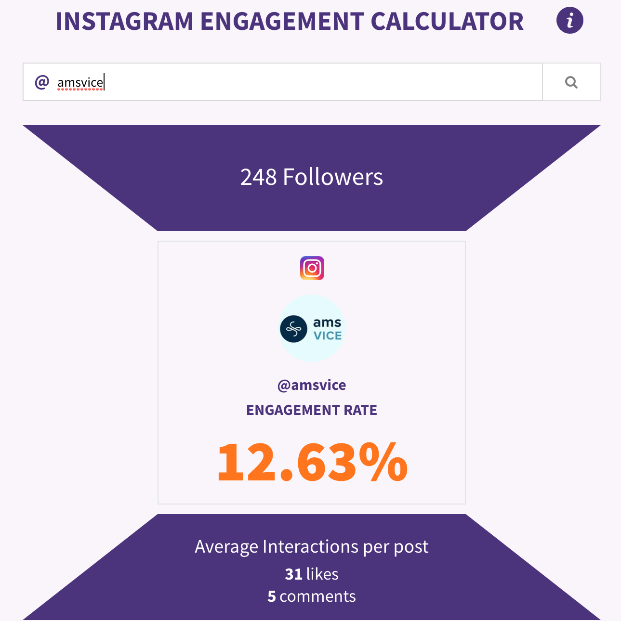
Figure 2.
Current engagement rate for AMS Vice
*Note, most accounts fall somewhere between 1-6%

The importance of Multiple Social Media Channels
Still being written

Proposed Solution
AMS should consider allowing its services to be marketed independently by an in-house team of volunteers. That is essentially what is being done with the Instagram page, so why not extend it to other platforms?

This would give Vice more control over its voice, image, allow unity in campaigns, and provide it with the opportunity for more in-depth and engaging content. The creation of a blog should take no longer than a week and could easily be done free of charge. Many computer science students would likely be willing to take on the project and I have a few recommendations if we were to go ahead with this. A Youtube channel could be established where volunteers interview students on campus regarding Vice-related themes (Substance use, addiction, harm reduction, mental health, unhealthy habits, etc). And of course, a corresponding Facebook page should be linked to the Instagram account, ensuring cohesion of marketing campaigns.

Conclusion
Findings
- A holistic social media and marketing approach is the most effective strategy for increasing brand/service awareness, as demonstrated by services like SASC
- Findings from surveys
- Vice’s current social media channel (Instagram) has solid engagement and has helped increase usership of the service
- Platforms like Youtube, Facebook, and Twitter can help drive traffic to one another. This would ensure Vice’s reach is optimized.

Recommendations
- AMS should consider giving some of its services marketing and social media autonomy
- A corresponding Facebook and blog should be created to further enhance Vice’s reach and provide it with the opportunity to showcase its purpose and services in a variety of forms (ex: video form on Youtube, longform articles on Blog)
- AMS could provide general brand guidelines if there are any concerns with continuity,
- If there are any concerns with brand continuity, AMS could provide services with guidelines to adhere to

