Culture Jamming an Advertisement
Aixin Sheng
GRSJ 300
June 5th, 2020

The original ad that I chose is an ad by Weight Watchers, a weight loss program. They focus on helping people lose weight by providing fitness activities, diet plans, and workshops. In their ad, they feature a house with two doors. The large door has the word entrance whereas the smaller door says exit. The ad implies that one will enter the door as a larger person while exiting the door as a skinnier person. There are several ways this ad can be analyzed interjectionally. On a surface level, this ad is clearly targeting women. An ad targeting men would focus more on masculine activities such as a gym, rather than a weight loss program. The pressure for women to stay thin is part of the heteropatriarchal system that encourages women to look and behave a certain way. However, this also intersects with other factors. Fausto-Sterling (2005) highlights the difference between bone density in men and women as a function of hormones, diet, body weight, and physical activity (Fausto-Sterling, 2005). As normative culture encourages a lower food in-take within women, it can have negative long-term health effects. Suggesting that women should eat less to fit a social standard not only harms their physical health, but there are mental health effects as well. Intersecting with diet, the ad implies that each doorway is a choice yet for many people, poverty is not a choice. Childhood poverty is often a factor in adult obesity (Hernandez & Pressler, 2014). Poverty itself is linked to class, ethnicity, and gender disparities as many people are unable to afford healthy diets. When all these different identities of a person intersect together, they are already at a larger risk of not fitting the normative body standards in society. It becomes even more absurd to assume that the people who would need help from a program such as weight watchers would be able to afford their services. Moreover, this ad is exclusionary. The doorways suggest that this ad is targeted towards able-bodied people and thus, disregards those who fall outside of the pattern such people who exist in wheelchairs.
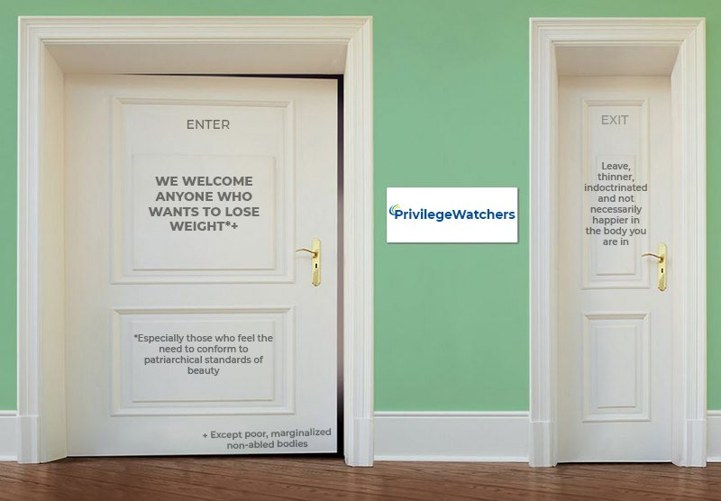
I wanted to point out the exclusionary aspects of the jammed ad. It is both absurd and injurious to not only send out a harmful message that women should fit within doors to believe that their value and worth is based on their weight. Changing the name of the company from Weight Watchers to Privilege Watchers the goal is to highlight the role of privilege in maintaining a thin, desirable body. A deeper look into their ad allows one to question how to understand the female body. According to Butler (2011), matter is a material form of constructed naturalness and maintained by norms performed on bodies. Therefore, weight loss is not a natural prescription of bodily matter, rather it consists of norms that shame female bodies. The true message is to become skinny because Weight Watchers is aware that there are certain privileges associated with the skinny and feminine body. They are hoping to attract members who may be easily influenced by the societal standards of beauty. Thus, the message on the left door highlights the demographic that Weight Watchers is targeting – those who are willing to spend money because they feel like they are not attractive enough for society. A cursory glance at their website reveals that images of happy and attractive young women are who they hope to target (Weight Watchers, n.d.). In addition, privilege also includes who is invited to join and become a member of their program and who is not invited. The text that is added on the bottom of the door highlights the exclusions to the program, revealing that who they are not including. This non-exhaustive exclusionary list includes on-abled bodies as well as people who suffer from obesity as a function of systemic inequalities rather than those who just made poor life decisions. If Weight Watchers cared about improving wellness for everyone, the message would not focus on merely weight loss in the form of size but creating an inclusive ad that highlights ways that people can become healthier. The consumption of female bodies in complicity with bodily shame on fat is what I find the most ridiculous thing in the ad.

References
Butler, J. (2011). Bodies that matter: On the discursive limits of sex. Taylor & Francis.
Fausto-Sterling, A. (2005). The bare bones of sex: part 1—sex and gender. Signs: Journal of Women in Culture and Society, 30(2), 1491-1527.
Hernandez, D. C., & Pressler, E. (2014). Accumulation of childhood poverty on young adult overweight or obese status: race/ethnicity and gender disparities. J Epidemiol Community Health, 68(5), 478-484.
Thompson, J. (2018). Weight Watchers Doors Ad [Digital Image]. Retrieved from http://sustainablestartup.net/2018/04/19/weight-watchers-doors-ad-reinforces-the-impact-of-their-program-magazine-ad-analysis-1/
Weight Watchers. (n.d.). WW (Weight watchers): Weight loss & wellness help. Retrieved from https://www.weightwatchers.com/us/

