Analysis for
Assessing staff’s software education in an E-commerce company

Prepared for
Dr. Ricky Wong, Chief Executive Officer
Ms. Jelly Chan, Associate Manager
Miss Priscilla Chan, Marketing Manager
Mr. Simon Cheuk, Business Analyst Leader
at HKTV Group

By
Alison Ma
UBC ENGL 301 Student

August 1, 2020

TABLE OF CONTENTS
ABSTRACT…………………………………………………….…………………………………3

INTRODUCTION………………………………………………………………...………………4
Definition of E-commerce ………………………………………………………..………4
Background………………………………………………………………………..………4
Statement of the Problem………………………………………………………………….4

DATA SECTION...………………………………………………………………………….…….5
Assessment of Staff’s Education on Software Knowledge………………………………..6
The opinions from normal staff members on the usage of different computer software….8
Survey result from management officials upon future plan to use software for company business …………………………………………………………………..………..…….10

PROPOSED PLAN………………………………………………………………………….…...11

CONCLUSION…………………………………………………………………………………..12

BIBLIOGRAPHY……..……………………………………………………………..…………..13

APPENDIX………………………………………………………………………………………14

Abstract
Information technology has been playing a vital role in the way of doing business. Companies ranging from small start-ups to multinational big corporations have developed electronic commerce (e-commerce) platform to further push their sales transaction. In order to further capture sales, companies usually employ workers with superb software knowledge to accomplish digital business strategies. This report is to examine the completeness, necessity and transparency of different software used for e-commerce platform.

Primary data collected, through survey and interviews, provided descriptive empirical data about the current software education in the company, HKTV Group (HKTVmall). This data will be used for further proposed suggestions in order to improve the current business model of the company.

Introduction
Definition of E-commerce
Among the global intergovernmental organization, the definition of e-commerce is trade oriented. OECD (2013) defines e-commerce transaction as “sale or purchase of goods and services, conducted over computer networks by methods specifically designed for the purpose of receiving or placing orders”. WTO (1998) reports that “electronic commerce is understood to mean the production, distribution, marketing, sale or delivery of goods and services by electronic means.”
Authors of academic research papers have a more diverse definition. Zwass’s (1996) definition of e-commerce is “the sharing of business information, maintaining business relationship, and conducting business transactions by means of telecommunications networks”. Shahjee (2015) defines e-commerce as “the process of buying and selling or exchanging of product, services and information via computer networks including the internet”.
In this study, since we are studying the concept e-commerce of a specific company, i.e. HKTVmall, the term would be defined as the online platform to distribute and deliver orders placed online via internet, thereby activating business-to-customers or customers-to-customers transaction through the online platform on HKTVmall.

Background of HKTVmall
Established in 1992, HKTVmall possesses successful businesses over telecom market liberalization, popularizing advanced technology and applications. HKTVmall is now the largest 24-hour online shopping mall in Hong Kong, providing a “one-stop shop” platform to Hong Kong citizens to take care of most of their necessities, including groceries, entertainment and insurance etc. The mall also provides delivery service either straight to home upon $500 HKD purchase (around $87 CAD) or to O2O shop (Online to Offline shop) upon $150 HKD purchase (around $26 CAD).
There are currently around 300 workers in HKTVmall. The roles include but are not limited to: Product Marketing, Social Media Marketing, Resource Management, Supply Chain Management, Design and Speculation Team, Information Technology Team, Delivery Team, Human Resources and Customer Service Team etc. All workers have to access certain portal and software in order to deliver services on the e-commerce website.

Statement of Problems
The company holds certain expectation to pick up skills using certain software in order to deliver services online. However, it was found that a majority of colleagues in the company do not understand the basic software application while repeating daily office work. Most of them rely on the coding system set up by technicians from the Information Technology Department, thus missing crucial knowledge on computer software.
It was also found that a lot of people do not hold any valid certificate upon knowledge of some profound software. While company has purchased subscriptions to access a variety of programs, it was found that a lot of programs have hardly been used for daily office work.

Data Section

Scope
This report is written to propose a feasible plan for the company in order to raise its effectiveness in using different programs. The following plan includes:
- The assessment of staff’s education on software knowledge
- The opinions from normal staff members on the usage of different computer software
- Survey result from management officials upon future plan to use software for company business

Assessment of Staff’s Education on Software Knowledge

Fig. 1: List of software that staff members are using
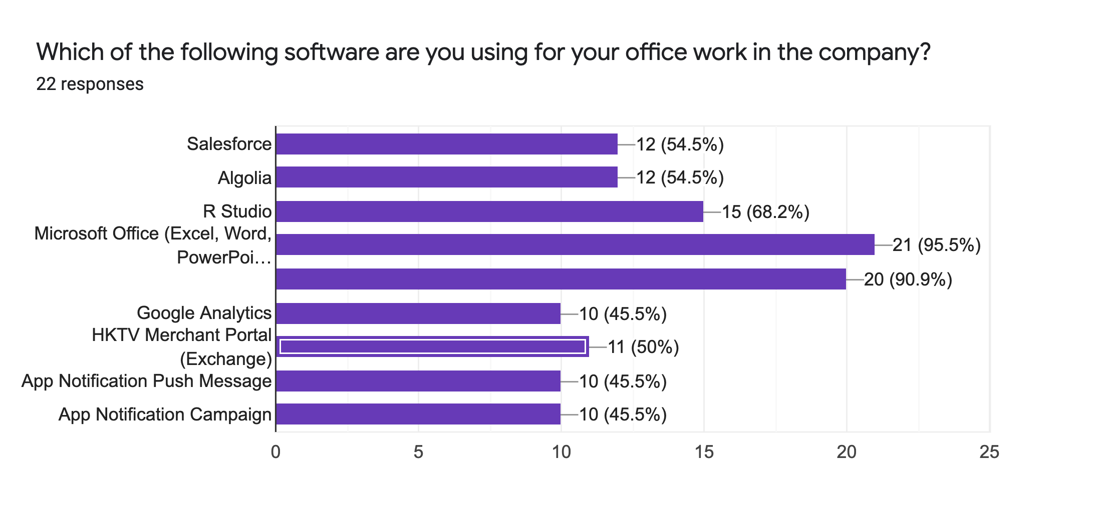

From Fig. 1, we could see that a majority of staff members are using Microsoft Office and G Suites for the data analysis and cross-team communication.

Fig. 2: Important factors from worker’s perspective to learn a new software
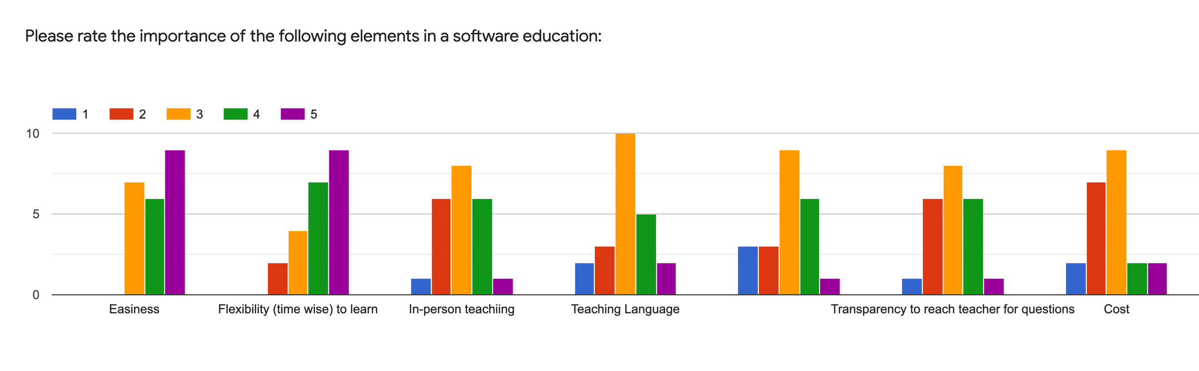

From Fig. 2, we could see that the two most important factors to the workers to learn new software are easiness and flexibility of time to learn. Workers have to manage a huge amount of work in the office, it is not ideal to learn a new software at a fixed time since they will need to work extra hours to finish their work. Setting an expectation and a deadline to fit in worker’s schedule would be more ideal.

Fig. 3: Familiarity of software
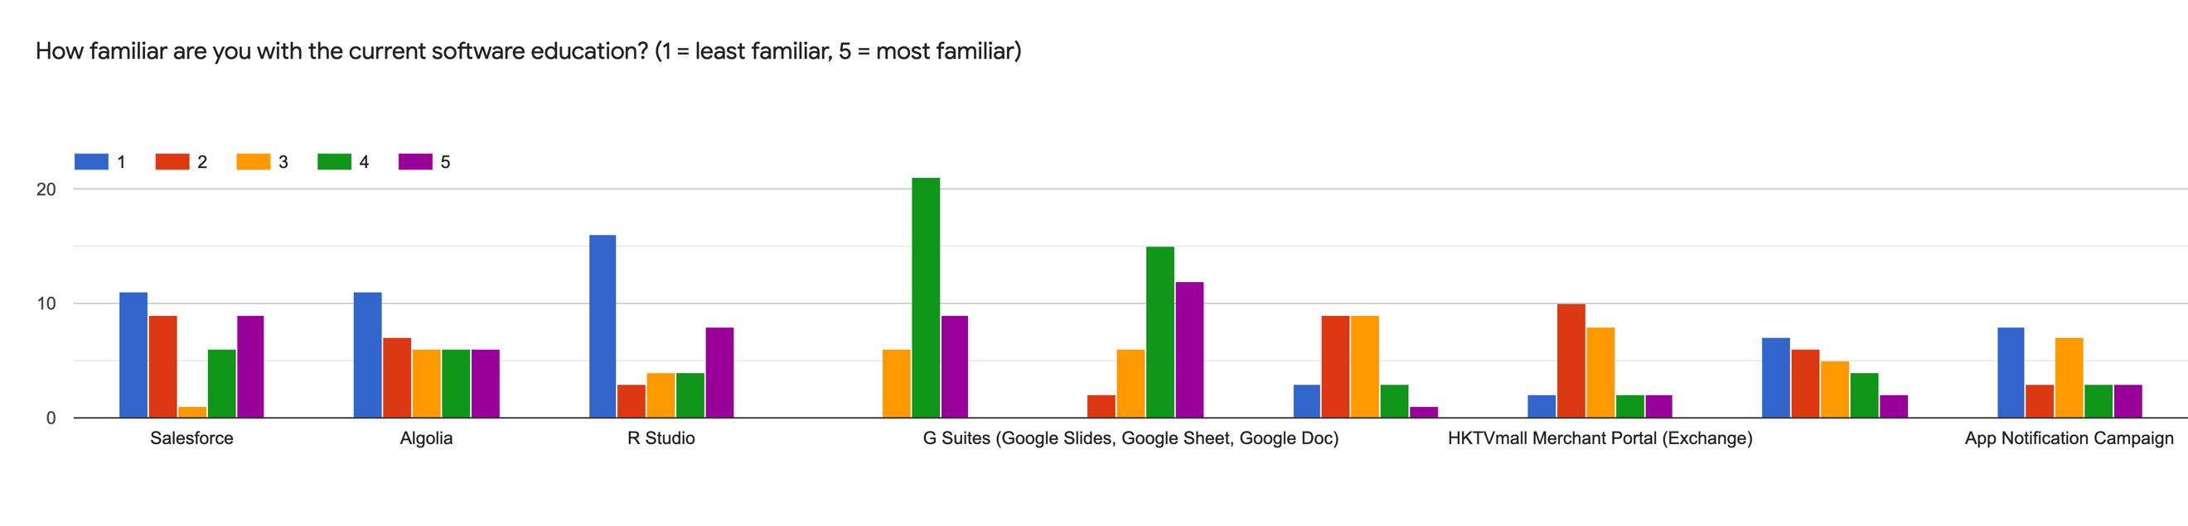

According to Figure 3, most of the people are familiar with Microsoft Office Applications and G Suites (having the highest rating of 4 in fourth and fifth section on the graph). As mentioned above, workers need to use Microsoft Office and G Suites very often to foster more convenient communication, as well as to manage tasks easier. Both applications require a lot of techniques, such as formulae and function familiarity.

It is worth to note that the rating of 1 is the highest in Salesforce, Algolia and R Studio. E-commerce companies require a lot of digital marketing strategies and data management. Salesforce is used most often for customer relationship management (CRM) through email campaigns. There are a lot of coding and IT technical languages that only professional workers would know. Normally, colleagues would just replace certain code to output different products. Thu, not many people know the coding language on Salesforce. Algolia is a back-end system to improve the digital platform of the e-commerce website, such as improving the sequence of the product listed, the product search result and choices of product selection (e.g. origin, brand selection etc.) Similar to Salesforce, Algolia also requires coding language that only professional workers understand, so it is not surprising to see the result that most of the workers do not know how to write coding language on Algolia. R Studio is a data analytics system for workers to analyse product score and performance in a set period of time. The program does not require coding system, but certain knowledge is required to interpret the language of the result. Not many people in the company are using R Studio, thus there are a lot of ratings of 1 for this program.

Fig 3: Worker’s willingness to learn a new software
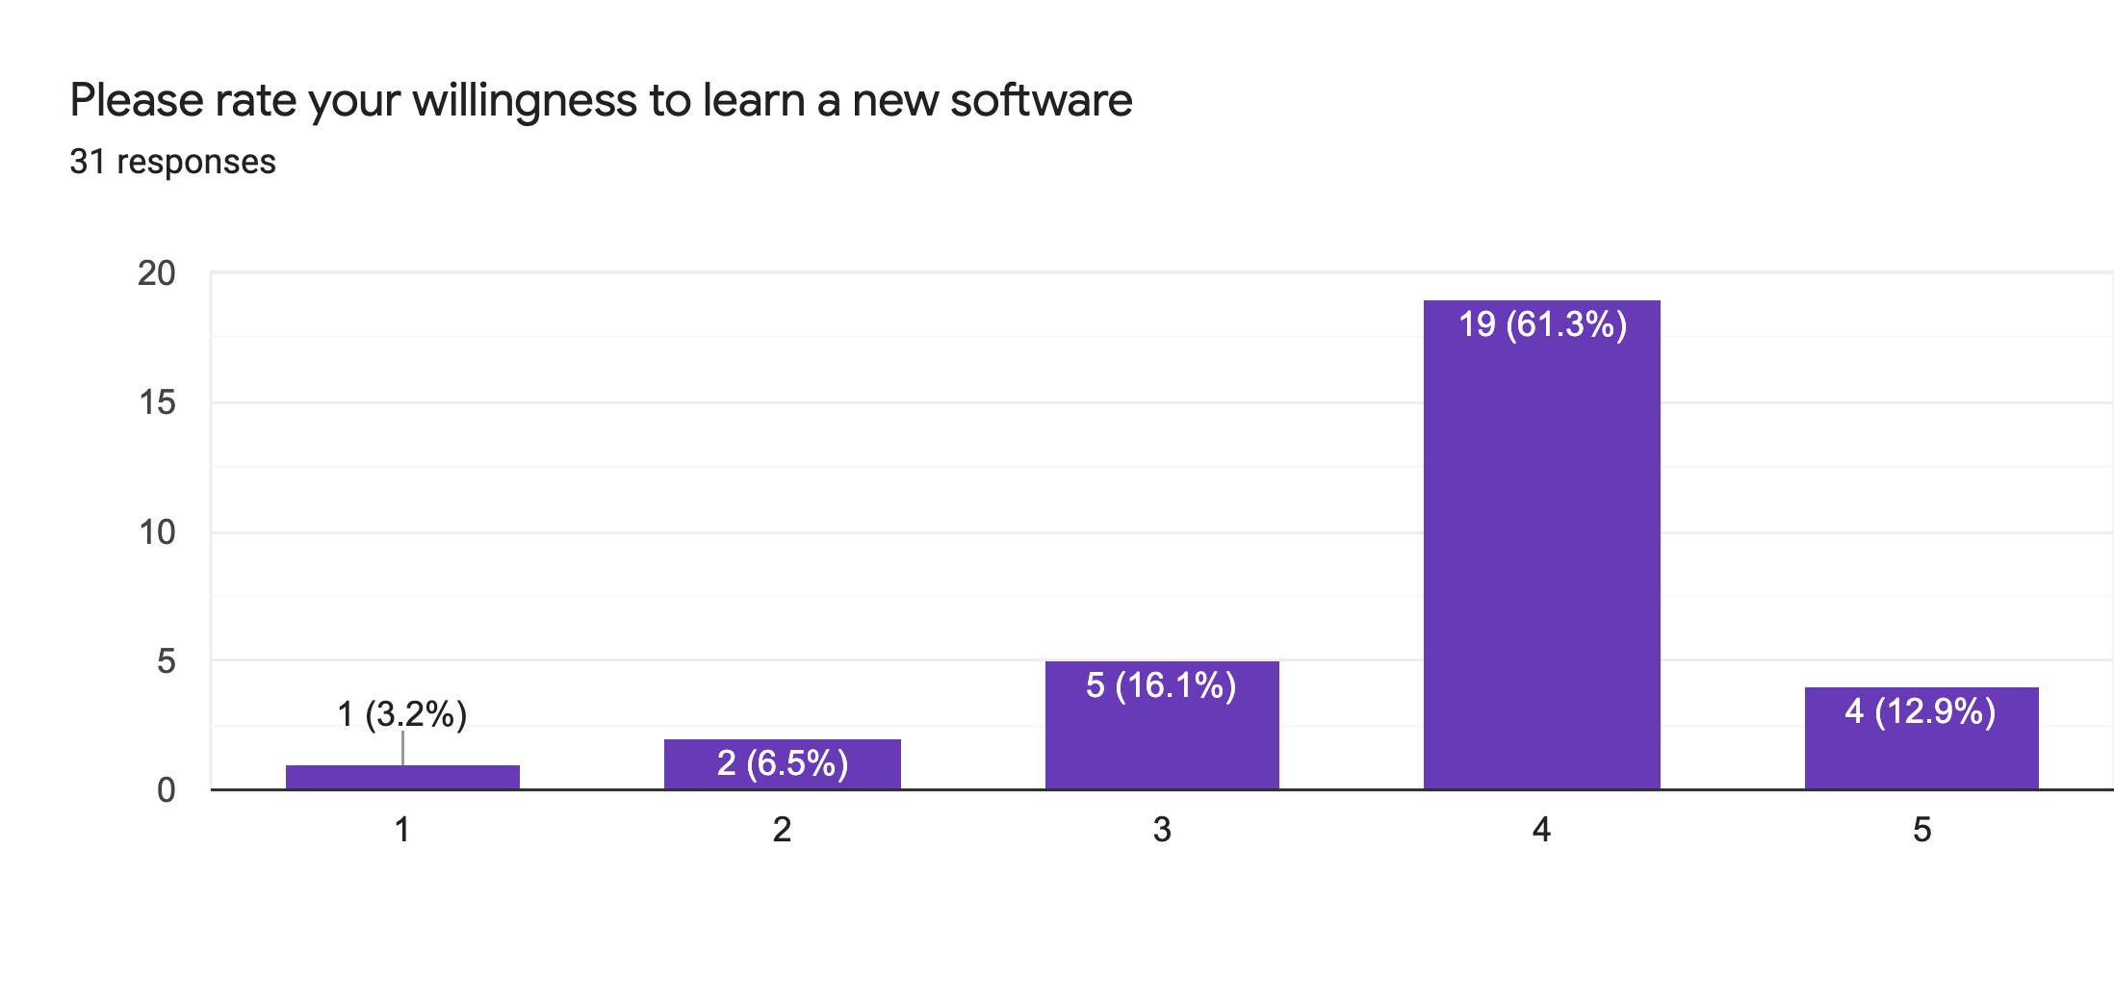
Luckily, most of the workers are willing to learn a new software. Therefore, HKTVmall could arrange to implement new software for worker’s use in order to improve the long-term business development.

The opinions from normal staff members on the usage of different computer software

Fig. 4: Important elements when considering software education
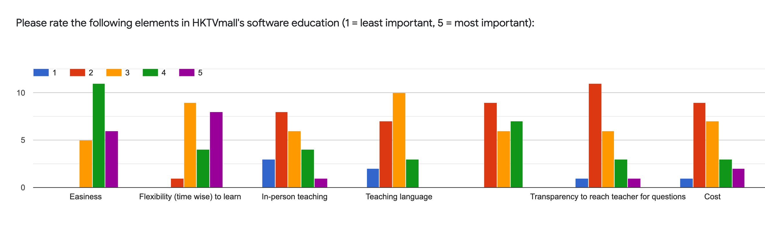

According to Fig 4, most of the workers think that HKTVmall’s software education is relatively well managed in terms of easiness and flexibility to learn, which corresponds to Fig 2 that the two most important factors are achieved in HKTVmall. This is a milestone for the company.

In-person teaching has a moderately low importance in worker’s perspective, so HKTVmall could consider recording a tutorial with a screen, then broadcast to members in the company in order to fit in to different people’s schedule better. Also, a majority of people are using desktop in the office. Therefore, in-person teaching is not feasible unless each student has a notebook or laptop that enables them to have higher mobility and attend classes physically. Or else, a recorded tutorial is more preferred.

Fig 5: Opinions to the new software

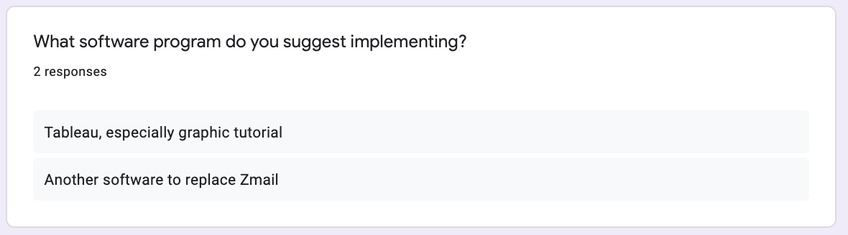

Some workers have suggested using another software to replace Zmail. Zmail is a major communication system for workers to foster conversations like email. It is reported that Zmail has been having malfunctional features, hindering workers’ work efficiency and performance. Some examples include failure to receive email from Talent Acquisition Department and very limited attachment capability to send files with slightly bigger attachment.

Survey result from management officials upon future plan to use software for company business

One of the interviewees has reflected that HKTVmall encourage all the employees to take the examination of Google Analytics Certificate. The company has purchased the premium version called Google Analytics 360, which is a paid version of Google Analytics with a tier-based pricing. Having the certificate not only helps the company to identify the talents of its workers, it also strengthens workers’ competitiveness compared to other people in the job market. Usually the certificate expires after one year, so taking the exam once a year also helps workers refresh their memories about the technical language in this software.

Another interviewee has also reflected that if HKTVmall decides to use a program, all the cost will be covered by the company, including all the features and tutorial videos. It is for the potential business development in the e-commerce market in order to raise its status of being the largest 24-hour online shopping platform that takes care of every Hong Kong citizen.

Proposed Plan

After the thorough interview process and summarization of the result, there are three main conclusions for the software education for HKTVmall:

- Implement new software if there is high flexibility of time for staff to learn
Since HKTVmall is the largest online shopping platform in Hong Kong, there is a high workload for staff members to work on every day. They go to work early and often work extra hours to finish their work. They also need to stay alert on weekends should there be any emergency task to work on (due to the fact that people do online shopping more often on weekends).
If the company has to introduce new programs for the betterment of the company’s business development, staff members will usually be willing to learn given that they can choose when to learn in their work hours. Most of them would like to finish their tasks on time in order to avoid working late. Therefore, I suggest having a colleague from the IT department or who is very familiar with the new software, share screen and record the lesson, thus allowing the rest of the colleagues to watch the video and learn it in their own time. This way, they could accommodate their time and work better while achieving the company’s expectation of picking up skills of a new software.

- Purchase full subscription of software to maximize utility of the software
A number of colleagues reflect that they do not have full access to some of the software due to the fact that the company did not purchase full subscription for workers to use. Workers think that in order to maximize the business development, the company could purchase the full version and share the company code to workers. To name a few: Zoom and Algolia etc. This way, they would not be disrupted while delivering online services on behalf of the company and raise the overall effectiveness and performance quality.

Conclusion

According to the current staff members in the company, HKTVmall has been applying useful software to help its business attain the highest efficiency and development. However, there are some software that require updates and replacement to foster better and higher working efficiency in the company.

After that, the company could provide better e-commerce services in Hong Kong and be the top online shopping platform that could hardly be replaced in the local market.

Bibliography
“Awards and Achievements.” About HKTV. Hong Kong Television Network Limited, 2017. AAAAAWeb. 30 July 2020.

“Company Profile.” About HKTV. Hong Kong Television Network Limited, 2017. Web. 30 July AAAAA2020.

Shahjee, Rajneesh. “The Impact of Electronic Commerce on Business Organization”. Scholarly AAAAAResearch Journal’s, vol. 4, no. 27, 2016, pp. 3130-3140.

Zwass, Vladimir. “Electronic Commerce: Structures and Issues”. International Journal of AAAAAElectronic Commerce, vol. 1, no. 1, 1996, pp. 3-23, AAAAAhttps://www.semanticscholar.org/paper/Electronic-Commerce%3A-Structures-and-AAAAAIssues-Zwass/9f36c5cea1838378b66b102c6afb996b77e78233. Accessed 30 July. 2020.

Appendix

APPENDIX A.1: Worker’s working year in HKTVmall
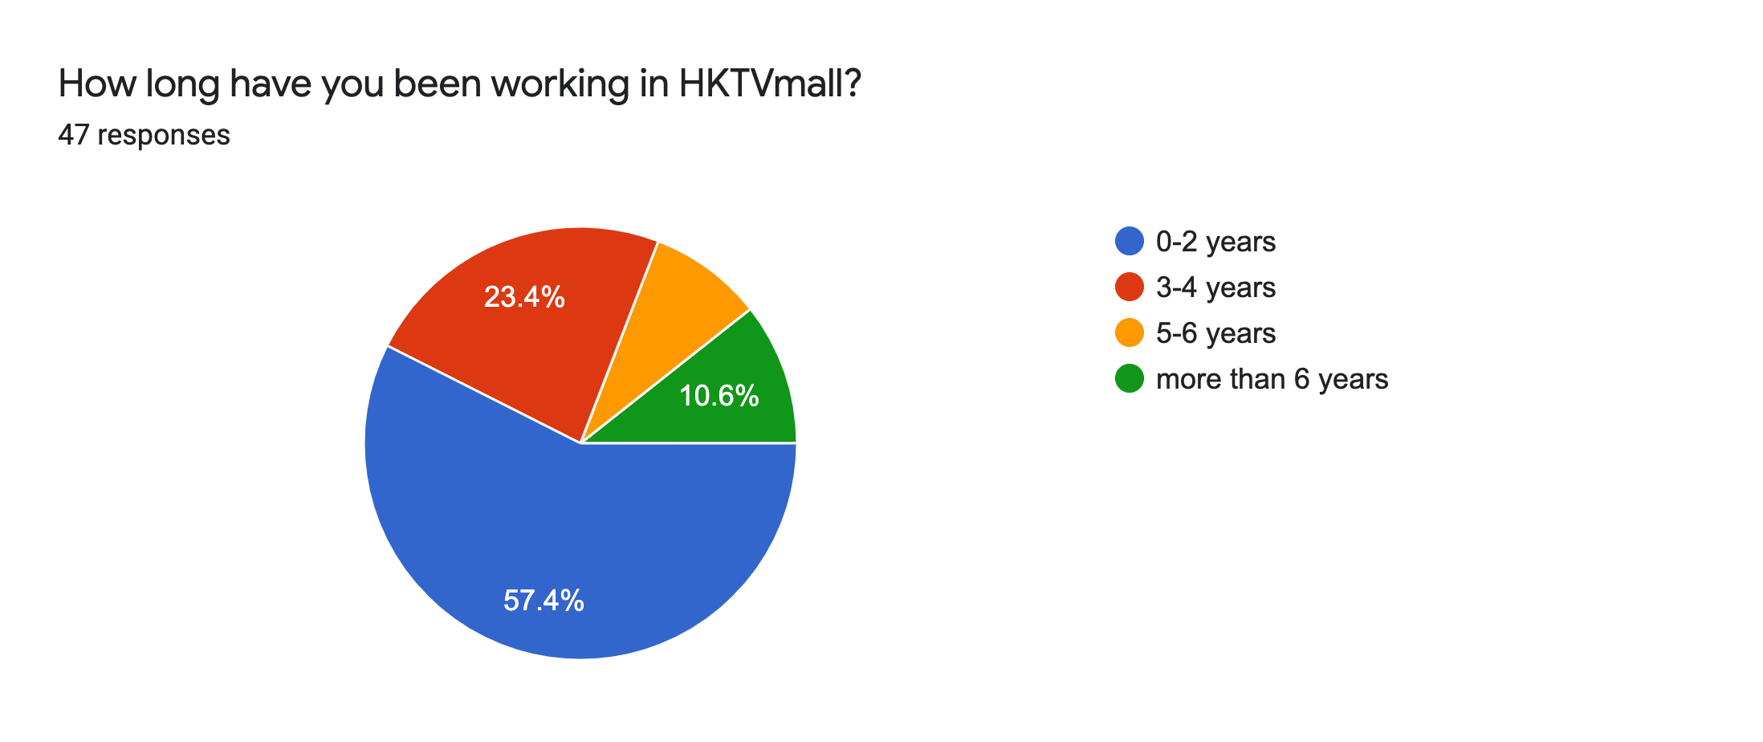

APPENDIX A.2: Worker’s satisfaction to the current software education
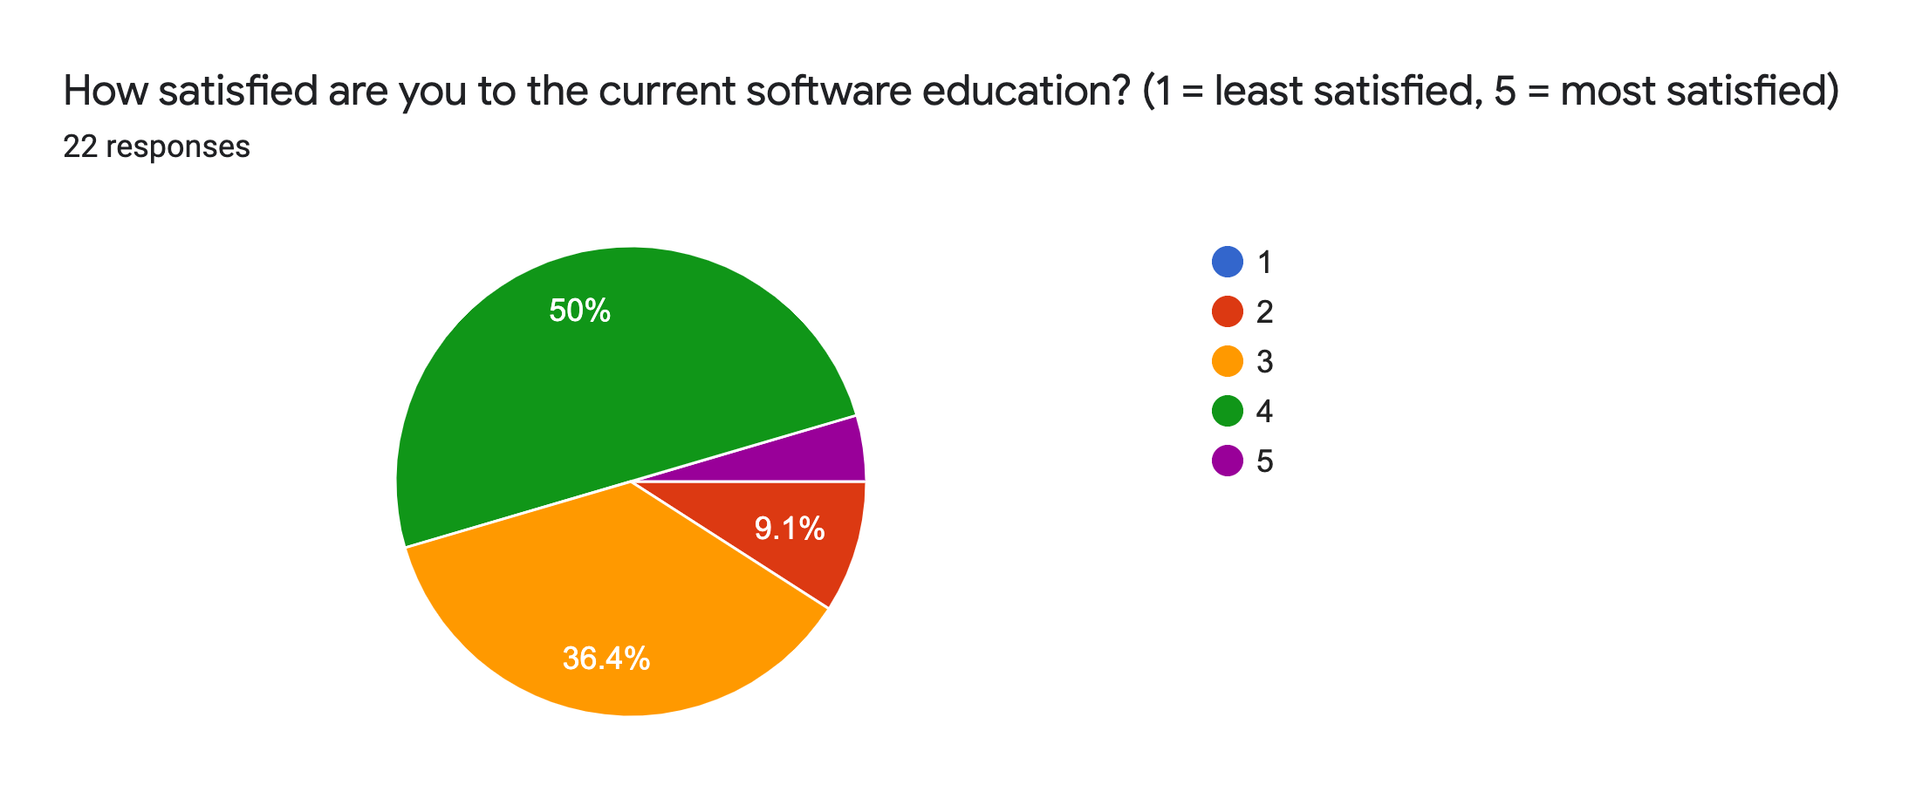

APPENDIX A.3: Workers’ response to the implementation of new software in HKTVmall
