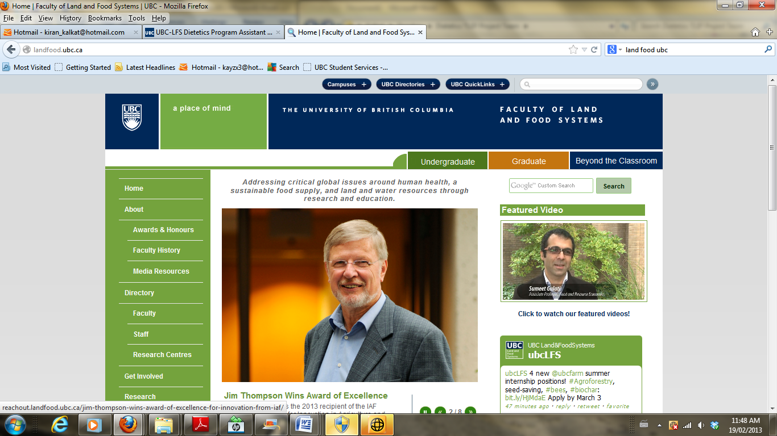
FNH 381: Professional Dietetic Practice II
School Nutrition Education Assignment
Lesson Plan Form

In collaboration with your partner, prepare this lesson plan form by Wednesday, May 13, 2015, in advance of your education session.

Include enough details so that you (or a colleague) could relatively easily utilize your lesson plan on a future occasion. See samples from a previous year on the course website (note that assignment requirements have evolved so these are not perfect examples).

Important: Please assign a file name as follows, Lastname 1, Lastname 2, Lesson Plan 2015 (ie., if the last names of the students are Jones and Smith, save the file as: Jones, Smith, Lesson Plan 2015.

As indicated on the assignment document, submit the Lesson Plan as follows:
- Email Lesson Plan to course instructor and workshop facilitators: Wednesday, May 13, 2015
- Upload Lesson Plan and Summary of Experience Form onto your professional practice course blog, along with your personal reflections by: Sunday, May 24, 2015

LESSON PLAN
Date of Report: |  | Students: | 1. Kelsey Dosanjh  2. Amanda Ellis
School: | Ridgeway Elementary | Teacher: | Andrew Wiet, Scott Gale
Descriptive Lesson Plan Title:
The Importance of Healthy Snacks and Lower Sugar Drink Alternatives
Target Audience Description (class(es), grade level(s)):
Two classes each of twenty nine grade five students
Education Session Learning Outcomes:
-The students will be able to demonstrate an understanding to the importance of having healthy snacks in their diet
-The students will be able to classify basic beverage types as high or low sugar.
-The students will be able to list low sugar beverage alternatives.
Describe how these Learning Outcomes link to age-specific Instructional Resource Package guidelines (provincially-mandated curriculum):
C2 describe strategies for contributing to a healthy, balanced lifestyle, including healthy eating, integrating regular physical activity, and maintaining emotional health
- Accurately describe why healthy eating practices are important (e.g., to ensure adequate energy and key nutrients for growth, development, and optimum health and disease prevention)
- Describe a variety of strategies for making food choices that contribute to healthy eating (e.g., following guidelines in Canada’s Food Guide to Healthy Eating, planning food choices in advance, not skipping meals, understanding appropriate serving sizes, bringing healthy snacks instead of relying on unhealthy snacks from vending machines)
Detailed schedule of learning activities (insert rows as needed):
TIME | ACTIVITY |  |  | WHO?
5 min | Introduce that we are dietetics students from UBC and we will be talking to them about healthy snacks and drinks  - put up an outline of the course  - ask them what makes them want to go get a drink? |  |  | BOTH
5 min | Explain the ranking of drinks from highest to lowest sugar and get them into groups |  |  | Amanda
10 min | To organize, complete activity and show the correct answers |  |  | Kelsey
2 min | Suggesting healthy drink alternatives |  |  | Amanda
3 min | Ask them if they can name the food groups |  |  | Kelsey
5 min | Ask them what are examples of healthy snacks and unhealthy snacks (make a T chart)  - explain that there are 2 or more food groups in a healthy snack, discuss how variety and whole food are key (all colors of the rainbow) |  |  | BOTH
10 min | Write a goal on their worksheet we will hand out (includes recipe) and have some students share theirs with the class  - tell them what the snack is and allow them to taste it after washing their hands  - get them to take home their worksheet and share their goal and work towards it with their parents |  |  | BOTH
Teaching resources used (use Canadian resources and tools):
-Canada’s food guide
-Dairy Farmers of Canada
Describe how your session is innovative/original:
-We are going to bring in the supplies to have the children make their own healthy snack to get them involved and excited about healthy eating.
-We are going to provide an interactive environment having the children work in groups to brainstorm what beverages are higher in sugar, and which are lower.
What strategies will you use to encourage students to take action as a result of this session?
-Provide them with a handout to take home and share with their parent summarizing what was discussed
-Provide sources where parents can find more healthy snack ideas
Describe how student achievement of learning outcomes will be assessed:
-We will look for the students level of engagement
-Hand out pieces of paper at the end and get children to write down one thing they are going to change or try after our presentation and share it with the class
Describe your strategies for obtaining student/teacher feedback about the session (note: in addition to any other feedback strategies you may have, please ask teachers to complete a Teacher Feedback Form during the sessions and return to you):
-From the student we are going to have them share their goals with the class to see if their goals are reflective of the lesson we taught.
-For the teachers we will gain feedback through the feedback form they fill out, and through our conversations with the teachers after our presentations.

