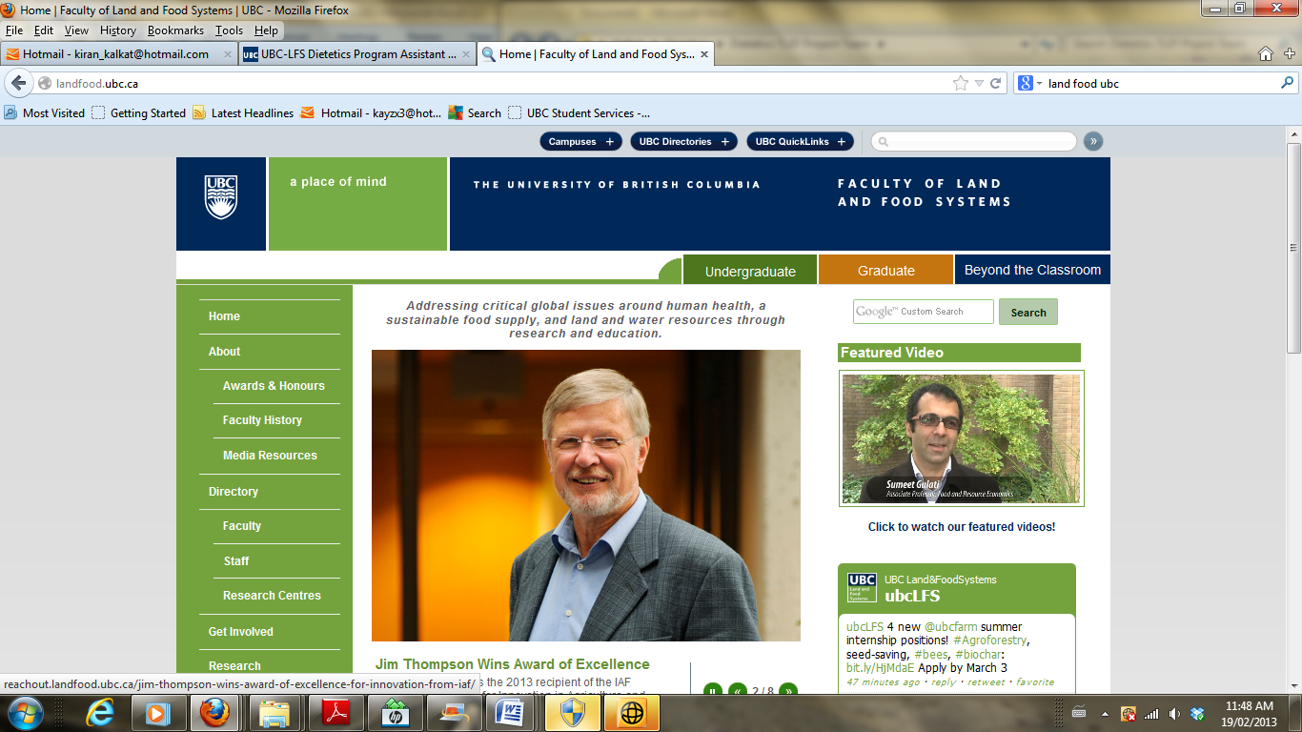

**FNH 480 Professional Dietetic Practice III**

**May 2-20, 2016**

**Educational Program Plan Worksheet**

**Date:** May 11th, 2016

**Group number:** Fraser I

**Topic:** Counselling topic: “Effective approaches to addressing client questions”   

**Description**

As you know from your past educational involvements, an educational program plan is a plan for development and delivery of education to address the identified learning needs of an audience.

**Instructions**

1. Complete this worksheet as a team in follow-up to the needs assessment phase of planning.
2. Consult with the course technology advisor as needed as your media development plans unfold.
3. Per the Educational Needs Assessment and Plan Assignment, document is due on **Friday, May 13, 2016**. See assignment document for submission details. Course instructor will provide you with feedback over the weekend to inform your final plans.

|  |  |
| --- | --- |
| **OVERALL PLAN (Educational Media and Related Resources for Online Sharing, In-class Workshop)** | |
| 1. Topic focus | |
| Addressing Questions For Different Types of Clients | |
| * 1. Rationale based on needs assessment findings | |
| Based on personal group experience in the program, as well as feedback from fellow classmates, it was felt that there was a lack of experience in how to approach different clients and their unique questions. Although the learning experience in the program is very comprehensive in instilling the fundamental concepts surrounding nutrition and counselling, there is limited exposure on how to effectively counsel either difficult clients, or clients that pose difficult questions. Based on this knowledge gap, as a group we decided to focus our presentation to address this gap and increase the comfort of students dealing with such cases as we all move forward into internship. | |
| 1. Define Learning Outcomes (knowledge, skills and/or attitudes you want participants to acquire as a result of your educational initiatives)   *To remind yourself on approaches to developing effective learning outcomes, consult references on preparing learning outcomes, such as these two resources from University of Toronto:* [*Developing Learning Outcomes*](http://teaching.utoronto.ca/teaching-support/course-design/developing-learning-outcomes/)*,* [*Examples of Learning Outcomes*](http://teaching.utoronto.ca/teaching-support/course-design/developing-learning-outcomes/appendix-a-examples-of-learning-outcomes/) | |
| By participating in these education initiatives, students will: | |
| Provide an understanding, and framework to help effectively manage difficult patients. | |
| Provide methods to addressing client questions for which there is not a concrete, or the answer is unknown by the dietitian. | |
| Provide methods for addressing difficult client questions not commonly seen in daily practice. | |
| Provide methods for identifying and coping with questions that are beyond the scope of a dietitians practice. | |
|  | |
| 1. Role delineation: Describe how program plan tasks will be shared equitably within your team | |
| TASK | TEAM MEMBER(S) |
| 1. Contribute to Needs assessment research, completed a portion of the education plan, researched methods to deal with difficult patients and sourced a program to create an info graphic. | Amanda |
| 1. Preliminary research on topic (needs assessment), draft info graphic roadmap, contributed to the needs assessment & program plan worksheets. | Gloria |
| 1. Preliminary research, call Healthlink BC for information, contributed to needs assessment and program plan, added information for road map info graphic | Kelsey |
| 1. Contributed to Needs assessment , preliminary research for presentation content, Contacting and liasoning with mentors (RDs and interns) | Stephanie |

|  |  |
| --- | --- |
| **Plan for Educational Media and Related Resources for Online Sharing** | |
| 1. Choice of educational media and related resources for online sharing | |
| Info graphic | |
| 1. Rationale for your choices | |
| The class expressed a need for a guideline or roadmap as to how to deal with difficult client questions. Visual charts and graphs were mentioned as their favoured education model. By using an info graphic roadmap, we will be able to visually demonstrate how to approach and handle tough client questions in a comprehensive manner. This will provide reference material to the students as they complete the in class activity in the class presentation. | |
| 1. Describe how you will ensure compliance of posted material with [copyright requirements](http://copyright.ubc.ca/guidelines-and-resources/copyright-guidelines/) | |
| [We will ensure that all material used in both the presentation and handouts are correctly referenced. We will also ensure to use only copyright free images to ensure that there is no infringement on copyright laws, for example, by using free sourced images from Flickr. If we are unsure about the copyright requirements after research, we will consult with Duncan to determine the appropriate procedure.](http://copyright.ubc.ca/guidelines-and-resources/copyright-guidelines/) | |
| 1. Which of your overall learning outcomes (documented in the Overall Plan, above) will be addressed with these materials? | |
| The info graphic roadmap will address learning outcomes by providing a reference framework for addressing different types of client questions. Specifically it would address learning outcomes #1, #2 & #3. | |
| Provide exposure to potential questions and/or scenarios that could be seen in future practice. | |
| 1. Describe how adult learning principles will be integrated | |
| PRINCIPLE | DESCRIPTION OF HOW IT WILL BE INTEGRATED |
| 1. Consider your learners’ existing knowledge and experience. | It was determine through the needs assessment that the class would benefit from a set of concrete guidelines in which they can refer to when addressing difficult client questions. |
| 1. Build upon learner motivations; don’t force learning. | Media will provide suggestions for methods/responses to use in counselling session, not necessarily a must-follow route |
| 1. Focus on need to know information; avoid information overload. | To avoid information overload, we will be providing a single resource to act as a reference for the students to address difficult client questions. |
| 1. Help learners to see the relevance and applicability of new knowledge. | To put all the information on one document, making it easier for the learners to see the connections and ways to apply the new knowledge. |
| 1. Provide practical problems and activities to enhance learning. | Although there will not be any practical problems on the info graphic, there will be opportunities for the class to apply the framework in the in-class activity during our participation. |
| 1. Create informal learning environments. | The framework will be used during small group discussions during the activity (Around the World) to guide the appropriate action. |
| 1. Include opportunities to provide feedback to learners | The road map will have suggestions and feedback within the framework itself. |
| 1. Include strategies for evaluation. | Will ask the class during our presentation how effective they believe our info graphic was. |
| 1. Utilize varied teaching methods. | Visual appealing graphics, minimal text, necessary information only |
| 1. Describe your evaluation plan (to assess if learning outcomes were achieved and how audience members felt about the resources) | |
| A short discussion will take place towards the end of the session to evaluate the knowledge acquired as well as the effectiveness of the media tool. | |
| 1. Other notes: | |
| Contacted RD and interns provided in depth information on relevant frameworks, guidelines, frequently asked questions and responses to them. | |
| 1. Key resource materials used to prepare the session: | |
| Information from Helen Yeung, RD, Dietitians of Canada, Picto Chart, Healthlink BC | |

|  |  |  |  |  |
| --- | --- | --- | --- | --- |
| **Plan for In-class Educational Session** | | | | |
| 1. Brief overview of the planned session (topic, approach) | | | | |
| Our session will utilize multiple delivery methods to provide students with a meaningful learning experience. We will be starting off the presentation by looking at the goals of the presentation, go through an initial assessment case study, introduce the info graphic and go through the question answering framework, have students participate in an in class “Around the World” activity, go over each of the questions in the activity as a class, revisit the initial case study, and reflect back on the initial goals before completing the presentation. | | | | |
| 1. Rationale for your choices | | | | |
| The class previously expressed a desire to have a practical learning session with active participation of all learners. Therefore, to keep audiences engaged, we will be using multiple delivery methods. The practical component of the session will assist with the retainment of the presented information. An initial assessment will be administered to assess the baseline knowledge of the learners. In addition, a final assessment will help us determine how the class feels the presentation furthered their learning. The educational media (info graphic) will be used to guide the learners throughout the session. | | | | |
| 1. Which of your established learning outcomes (documented in the Overall Plan, above) will be addressed by the educational session? | | | | |
| 1. Provide an understanding, and framework to help refocus a counselling session that is not going to plan. | | | | |
| 2. Provide methods to addressing client questions for which there is not a concrete , or the answer is unknown by the dietitian. | | | | |
| 3. Provide methods for addressing difficult client questions not commonly seen in daily practice. | | | | |
| 4. Provide methods for identifying and coping with questions that are beyond the scope of a dietitians practice. | | | | |
| 1. Describe how adult learning principles will be integrated | | | | |
| PRINCIPLE | | DESCRIPTION OF HOW IT WILL BE INTEGRATED | | |
| 1. Consider your learners’ existing knowledge and experience. | | This will be integrated by having an initial assessment activity at the beginning of the presentation. This will provide students with an opportunity to take their current knowledge and skills and apply them to a case study involving a client that has posed difficult questions. | | |
| 1. Build upon learner motivations; don’t force learning. | | This will be achieved by having all class members participate in both small and large group discussions, as well as by having them participate in the “Around the World” Activity described in part e. | | |
| 1. Focus on need to know information; avoid information overload. | | Providing only 1-2 resources to the class will do this. Through limiting the number of resources, it will focus the class’s attention on the information we feel is the most important, and not overwhelm them. | | |
| 1. Help learners to see the relevance and applicability of new knowledge. | | This will be achieved by having the class participate in an “Around the World” activity. This activity will have multiple stations each with a different question that could be seen in practice. Two members of each group will then role-play the scenario, and then the group will discuss the best methods to address the given question using the provided framework from the presentation. They will then write their ideas on the provided chart paper and rotate stations so that each group has a chance to answer each question. This method will help students see the applicability of the information taught in the presentation. | | |
| 1. Provide practical problems and activities to enhance learning. | | Activities will include both an initial assessment case study, as well as a follow up activity at the end of the presentation. Multiple opportunities will be provided to apply the given framework in the “Around the World Activity” described in section e. | | |
| 1. Create informal learning environments. | | This will be achieved by using the “Around the World” activity provided above, and fostering inclusive group discussions rather than having a lecture based presentation. | | |
| 1. Include opportunities to provide feedback to learners | | This will be achieved by having each group present one of the questions and ideas for addressing the question to the class. After presenting each question, there will be a short class discussion to provide feedback as to whether the question was completely addressed, or if there are additional factors to be considered. | | |
| 1. Include strategies for evaluation. | | Evaluation will be done by revisiting the initial assessment case study presented at the beginning of the class. This will be done by having a class discussion of how their responses may change after the presentation and activities. Evaluation will also be done by revisiting each of the objectives at the end of the presentation to get feedback from the class to see how well they felt each was met. | | |
| 1. Utilize varied teaching methods. | | There will be a variety of teaching methods including a short PowerPoint presentation, “Around the World” activity providing exposure to different client questions, small and large group discussions, and an info graphic outlining a framework for addressing client questions. | | |
| 1. Provide detailed lesson plan | | | | |
| TIME | ACTIVITY | | WHO | Learning Outcome This Links To |
| 1: 00 pm | Intro; go over the goals of the presentation | | Stephanie | 1 |
| 1:05pm | Group Assessment | | Gloria | 3 |
| 1:10pm | Tools to use (Info graph and framework) | | Amanda | 1,2 |
| 1:15 pm | Group Activity (Around the world) | | Kelsey | 4 |
| 1:30pm | Class debrief/ present findings | | Stephanie | 3,4 |
| 1:50pm | Input from panel (if present) | | Gloria | 1-4 |
| 2:00pm | Group reassessment | | Amanda | 3 |
| 2:10pm | Conclusion/ Questions | | Kelsey | 1-4 |
| 1. Describe your evaluation plan (to assess if learning outcomes were achieved and how audience members felt about the session and related resources) | | | | |
| This will be done by revisiting the initial assessment case study from the beginning of the presentation. The case will be revisited in a class discussion to see how the class feels their responses may change following the presentation and “Around the World” activity. Additional evaluation will be done by revisiting the lecture objectives at the end of the presentation get feedback from the class in regards to if they feel as though the objectives were achieved. | | | | |
| 1. Other notes: | | | | |
| N/A | | | | |

|  |
| --- |
| **Instructor Feedback on Plan** |
| Strengths: |
| Issues: |
| Recommendations: |
| Instructor: Karol Traviss  Date: May 15, 2016 |