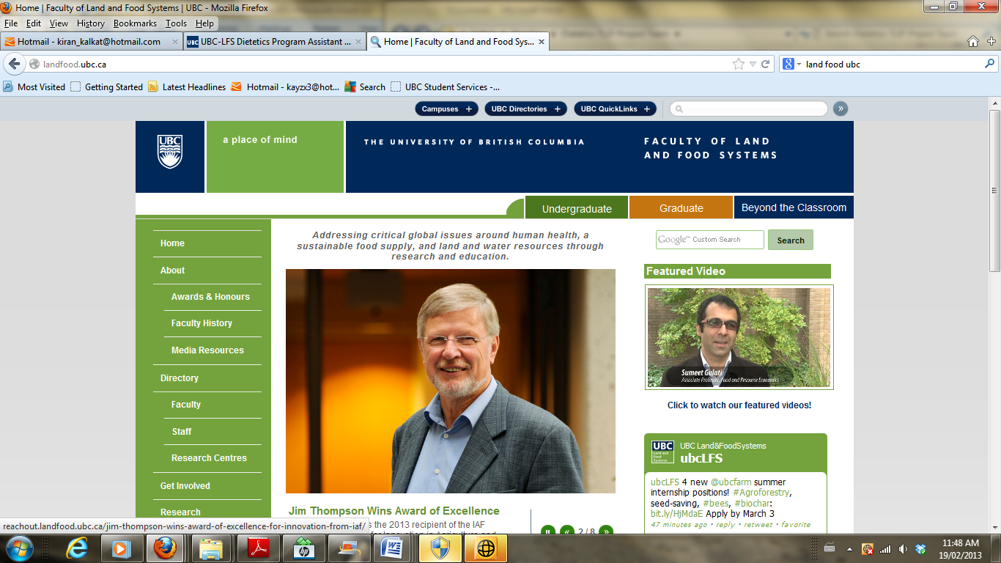

**FNH 480 Professional Dietetic Practice III**

**May 2-20, 2016**

**Educational Needs Assessment Worksheet 2016**

**Date:** May 5th, 2016

**Group number:** Fraser I

**Topic:** Counselling topic: “Effective approaches to addressing client questions”

**Introduction**

As you are aware from past educational involvements, an educational needs assessment is a systematic approach to studying the state of knowledge, ability, interest, and/or attitude of a defined audience or group related to a specific subject area. The purpose is to inform design of educational programs that address audience-learning needs and are delivered in an audience-appropriate manner.

**Instructions**

1. Complete this worksheet as a team to summarize plans related to and key findings from your needs assessment.
2. To align form completion with course activities, prepare **Part A for use in class on Tuesday, week 2 of the course**. This does not have to be handed in.
3. Per the Educational Needs Assessment and Plan Assignment, final version is due on **Friday, May 13, 2016**. See assignment document for details.

|  |  |
| --- | --- |
| **A. NEEDS ASSESSMENT PLAN (complete in early days of course)** | |
| * 1. Audience Characteristics (e.g., knowledge, abilities, interests/motivations, attitudes, concerns) | |
| What is known:   * Copious amounts of information surrounding science and nutrition are known by individuals in this course. * Basic principles of motivational interviewing and counselling. * Motivation to help client and dedication to the field. * Able to interact effectively and appropriately with clients.   What needs to be explored:   * Application of relevant knowledge to specific counselling scenarios. * How to translate the information into a form that is easily understood by the client. * Methods to deal with questions asked that are outside of the scope of practice or they do not know the answers to. * A more depth understanding of motivational interviewing and how to use it in practice. | |
| * 1. Audience learning needs (what they need to learn on the topic)  Note: As a starting point, all groups are to prepare a concept map for their topic on a piece of flip chart paper. This will be used on Tuesday, week 2 of class. | |
| What concept map suggests about audience learning needs:   * Addressing client questions * GAPS: Applying knowledge, obtaining experience, translating/simplifying the information, constructive environment (feedback without judgement and critique), appropriate referrals (if necessary), MI/use in practice skills * STRENGTHS: Basic MI knowledge, some counselling experience, science/nutrition knowledge base (FNH 470/475, CAPS, BIOC) * WHAT WE WANT TO DO:   + Initial knowledge assessment ie. Scenario of a multi-dimensional client to reassess knowledge at the end   + Potential guidelines to follow   + Activity: adjusting delivery based on client   + What clients are you most scared to encounter and address questions   + What is within the scope of a dietician’s practice   What needs to be explored to further assess the learning needs?   * See GAPS above * Asking the class during the road-map presentation | |
| * 1. Audience learning preferences (how they wish to learn the information) | |
| Initial assessment (of suitable educational media, other learning resources, and workshop focus) based on your knowledge of the audience:   * Apply a multiple methods approach incorporating both lecture based and participatory-based activities.   What needs to be explored to finalize the plan?   * What methods are the most relevant to presenting our topic, and which would not be as effective. | |
| * 1. Determine data collection approaches: | Details: |
| * + - * 1. Document review | Review all of the documents linked and/ or referenced on the Wiki page. |
| * + - * 1. Literature review | Review all of the papers referenced on the Wiki page, as well as on the UBC database. |
| * + - * 1. Group information gathering session | Get together as a group and discuss the research done independently and how it can be applied to our presentation. |
| * + - * 1. Key informant interviews or role observation (advisor(s), current interns, fellow students, others) | Review contact list and contact any individuals that could supply pertinent information to our topic. |
| * + - * 1. Survey(s) (existing or new) | N/A |
| * + - * 1. Review of existing online content | Review the existing Wiki page and all links on the page. |
| * + - * 1. Other (please describe) | Review existing lectures and presentation notes (i.e. Karen Mornin, and note from FNH 380, 381) on motivational interviewing and boosting client confidence |
| * 1. Role delineation: How will the needs assessment tasks be shared amongst your team? | |
| All will participate equally in literature review and group discussions.  Stephanie: Present the strengths section of our needs assessment  Gloria: Discuss half of “what we will do” & get the audience's opinion on their needs  Amanda: Present half of the “What we will do” section of our needs assessment  Kelsey: Discuss gaps we would like to address for our presentation | |

|  |
| --- |
| **B. NEEDS ASSESSMENT FINDINGS (complete after class input session and other needs assessment information has been gathered)** |
| 1. **Learning needs:** What does your research, including class input session, tell you about the key learning needs of your audience related to your assigned topic area? |
| * There is a desire to gain experience in addressing client questions and dealing with different types of questions and different types of clients. * Exploring what is beyond the scope of a dietitian’s role, and when referral to another health care professional may be needed. * Discuss how to use appropriate language when counselling different clients; being sensitive to the client's unique information. |
| 1. **Audience learning gaps:** What gaps exist between current knowledge and required knowledge of the audience? |
| * There is a lack of experience with and exposure to counselling clients with multidimensional health problems. * There is a gap in understanding that would be an appropriate referral for other medical concerns (though this may be site specific). * How to make the session productive yet is an empathic counsellor. * Knowing how to not respond right away and taking the time to determine the underlying cause of the question. |
| 1. **Audience learning assets:** What knowledge, skills, and/or resources does the audience already have that could assist them to achieve required learning? |
| * Basic science knowledge from FNH, CAPS, BIOC courses * Previous counselling practice (minor) * Basic motivational interviewing skills |
| 1. **Potential delivery approaches:** What does your needs assessment suggests about suitable ways of delivering the content, both online (original educational media plus other related resources) and in the classroom teaching session? |
| * Keeping the audience engaged ie. multiple activity styles * Combination of information delivery and hands on activities * Media--audio recording: recording of patient response, looking for tones and key words, generally have to listen to a patient opposed to reading their scenario on a PowerPoint * Media--info graphic: roadmap or guidelines as to how to deal with difficult client questions * Small counselling groups/stations * Professional panel of interns and practicing dieticians |
| 1. **Learning resources:** What resources already exist that could be adapted or used as is? What new resources are needed? |
| * Wiki page * Intern and dietitian feedback/input * ICDEP competencies * Dietitians of Canada * HealthLink BC (811) |
| 1. **Conclusion:** What will the specific topic focus of the educational session be (i.e. what learning needs will it seek to fulfill?) What learning needs identified in this needs assessment will not be addressed? What can you incorporate into your plan that might help the students to pursue that learning on their own? |
| * How to appropriately address different client questions, focussing on specific learning needs identified by classmates in the Needs assessment presentation. * Will not be able to address every single difficult client question we could potentially be asked, we are merely presenting scenarios in order for our fellow students to gain experience how to approach them * We will encourage students to reach out to family and friends and take every opportunity to respond to questions they ask you in a thought provoking and appropriate way |
| **Other notes:** |