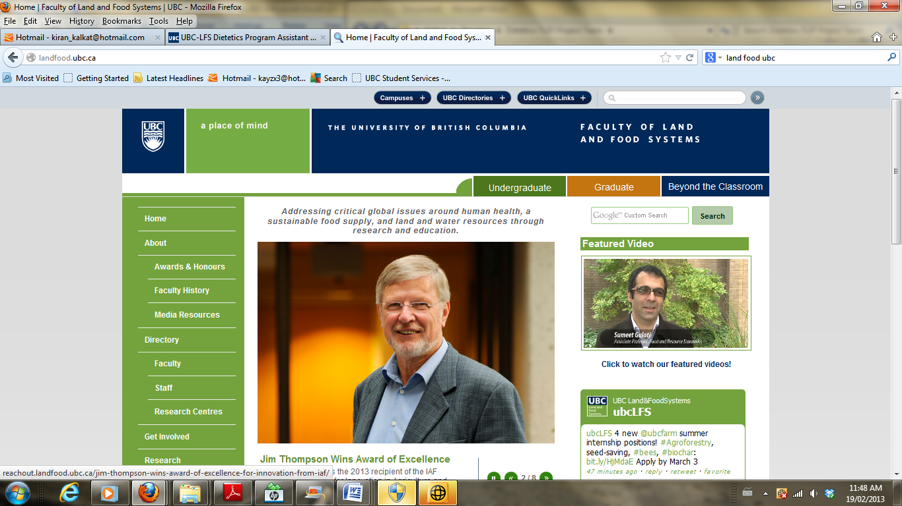

**FNH 480 Professional Dietetic Practice III**

**May 2-20, 2016**

**Summary of Media Reviewed and Created**

**Date:** May 18th, 2016

**Group number: 1 (Fraser I)**

**Assigned 2015 Wiki for review:** Nutrition Counselling

**2016 Topic:** Effective Approaches to Addressing Client Questions

**Description:** A document template for use as part of the *Educational Media Assignment*, to summarize educational media reviewed and created.

**Instructions:**

Complete this worksheet as a team to document the existing educational media you have reviewed, and new educational media you have created.

**Due Date:**

**Sunday, May 22, 2015 (Midnight):**

* + - Upload document to the Educational Media tab within your FNH 480 topic blog

|  |  |
| --- | --- |
| **A. REVIEW OF ASSIGNED CONTENT AREA FROM THE PREVIOUS YEAR** | |
| **TOPIC:** Effective Approaches to Addressing Client Questions **WIKI:** Nutrition Counselling | |
| **TASK** | **EXPLANATORY NOTES** |
| 1. Critical review of the posted material: |  |
| * 1. Is material posted centrally relevant to the learning needs of pre-internship students? | * Yes, it is very comprehensive and split into clear categories: self-reflection for learning, knowledge, skills, tips for talking to patients, building confidence. All these were identified as areas of interest/learning needs of pre-internship students in the initial needs assessment presentation. |
| * 1. Is the material current and based on evidence? | * Yes, for example the building confidence section includes book references that are from 2007 or newer * The YouTube video was from 2015 * The books and web links are all open and accessible through the wiki page after our adjustments were made |
| * 1. Does the material align to principles of adult education? (E.g., focus on need to know information, varied approaches to learning used – not just a block of text, material organized to facilitate ease of access and review) | * The material in this wiki come in a variety of formats ranging from videos, handouts, voice recordings and info graphics. The information was presented in clear concise points and not in a large block of text, making the navigation of the wiki page user friendly. Links were also split into sections that promoted easy access and books/articles/puff links are useful. The short bullet points under the links summarizing the document were effective for adult learning, which may be time sensitive learning. * Sections are bolded and topics easily found in each of the sections |
| * 1. Does the material comply with [copyright requirements](http://copyright.ubc.ca/guidelines-and-resources/copyright-guidelines/)? | * Yes, based on the information provided all copyright laws are met. |
| 1. As needed, based on the findings of your review: |  |
| * 1. Revise the wiki. | * We added our info graphic on approaches to addressing client questions, as there was not any information regarding this specific topic. The info graphic was based on input from current dieticians and interns. * We removed any inactive links * We did some formatting to make it look more visually appealing * We looked into each of the resources to check the material for relevancy |
| * 1. Revise pertinent section of [master wiki landing page.](https://wiki.ubc.ca/Dietetics:Student_Created_Resources) | [Not necessary. The wiki is still under section 3, professional development and is paired with the critical thinking section. We did not need to add a wiki page for our assignment.](https://wiki.ubc.ca/Dietetics:Student_Created_Resources) |
| * 1. Remove links to resources that have low relevance to student learning, are out of date, not presented according to adult learning principles, and/or are not compliant with [copyright requirements](http://copyright.ubc.ca/guidelines-and-resources/copyright-guidelines/). | * Part 2 and 3 under the self-reflection for learning section were not working so we removed them. As they discussed a lot of similar things we have covered in the info graphic already we did not feel the need to replace them * Under the knowledge section: Removed PEN and weight management links as they were inactive * Under the tips for talking to patients: Added several additional points that were highlighted from our class discussion, two links (specified below) were added, as well as our info graphic. To ensure that everything was uniform, the bullet points in this section were correct to match and spacing errors were corrected. * Under building confidence: nothing was changed, as all the links were still active and relevant. Added a newer edition of “Counselling Skills for Dieticians” As it has more recent research etc. * Under Skills: removed link to MIA step to MI, as it was inactive link. Remove article from MI Institute about MI because inactive link.   + Replaced link with actual PDF file for Motivational Interviewing in Health Settings: A review |
| * 1. Add new/updated resource links. | We added a new nutrition based source we found useful in coping with difficult clients and questions was:   * 1. <http://www.nutrition411.com/articles/difficult-patients-how-cope-them> |

|  |  |
| --- | --- |
| **B. REVIEW OF ASSIGNED CONTENT AREA FOR THE CURRENT YEAR** | |
| **TOPIC:** Effective Approaches to Addressing Client Questions **WIKI:** Nutrition Counselling | |
| **TASK** | **EXPLANATORY NOTES** |
| 1. Create a new wiki page to serve as an overview of your topic and a repository of links to topic resources (not applicable if your topic aligns directly with the wiki you have been assigned to review and update). | Not applicable for us. We added our information to the original Nutrition Counselling wiki page. |
| 1. Create at least one related media product, such as a narrated slide show or screencast, video, animation, and/or audio segment.  **Note: I**f you used a program to create your educational media that requires a login and password, be sure to provide that information here, in case there is a future need to edit the materials. You may wish to create an account that is unique to FNH 480, versus using an account you may be using for ongoing purposes. | For this portion of the assignment we completed an info graphic using “Pickto Chart”. This info graphic was designed to provide a framework for students to use as a reference when it comes to addressing difficult client questions in practice. |
| 1. Compile related resources, to contribute to student learning and to complement your planned educational session (e.g., handouts, articles, links to existing online resources). | Handout of our info graphic with related resources for them to refer to during the Around the World activity. We also are showing them the wiki page and what related resources are available from there. |
| 1. Conduct a critical review of your posted material: |  |
| * 1. Is material posted centrally relevant to the learning needs of pre-internship students? | Yes the information provided in this material on addressing difficult client questions is relevant to the learning needs of students. We were able to determine this through the needs assessment, where student expressed a desire for a framework to apply in situations where they are faced with difficult client questions. |
| * 1. Is the material current and based on evidence? | Yes. We received an email from Helen Yeung and a few other dietitians laying out some guidelines for addressing difficult client questions. Also, resources such as a phone conversation with HealthLink BC and the Dietitians of Canada web-page served as up to date, valuable resources. |
| * 1. Does the material align to principles of adult education? (e.g., focus on need to know information, varied approaches to learning used – not just a block of text, material organized to facilitate ease of access and review) | Yes this material does align with the principles of adult learning. This Info graphic uses visual aids, as well as a flowchart design to help facilitate the ease of use by students. This mode of delivery also provides a unique source of information that is not in the form of a paper or article. |
| * 1. Does the material comply with [copyright requirements](http://copyright.ubc.ca/guidelines-and-resources/copyright-guidelines/)? | Yes this does comply with the copyright agreements as the images used were clip art from the Pickto Chart application, and the info graphic contains the “Pickto Chart” trademark at the bottom. |