January 12th, 2016

Dear classmates of the English 301 Technical Writing Class,

Please consider my application as a professional writing partner in your English 301 group as advertised in the posting for Lesson 1:2. I am a fourth year student majoring in Computer Science paired with Fine Arts. I also possess degrees in Art History and have over ten years experience working as a Collections Manager in a museum. These achievements make me an ideal candidate and an able team player for a professional writing team.

My strength in writing comes from hours spent composing historical papers and an MA

thesis. This effort bettered my writing so that I was able to clearly argue a point in a

formal academic setting. I built on this skill — and in some ways, stripped it down — in my museum career when I drafted exhibit text, described historical documents and wrote archival policies and procedures. In this environment, I peeled away the layers of affected language and pushed myself to communicate in a genuine and direct manner.

It was also during my museum career where I learned to naturally work in a group putting together grant applications with colleagues. In this role, I acquired the skill to cue into areas that required my attention as well as improve on my work with advice from my colleagues. Through all of this, I would argue that, my weakness is trying to take on too much when it comes to a project I am attached to. With this awareness, I now know when to step back and simply be a reliable cooperative teammate.

My learning philosophy can be summoned up in a word: curious. I am always delighted

to discover new things and hope I can share this enthusiasm with my prospective writing team.

Thank you for taking the time to read over my application. I look forward to sharing an exciting work experience this semester with my prospective teammates and welcome an invitation to your professional writing group. You can contact me through email at jensen.alexis@gmail.com. I look forward to hearing from you.

Kind Regards,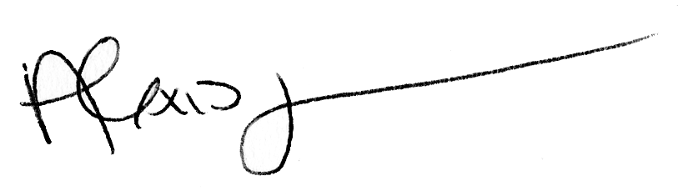

Alexis Jensen