**Improving Gender Disparity in Department of Computer Science**

**in UBC**

For Jenica Frisque

Equity Education Strategist

Equity and Inclusion Office at UBC

By Anna Li

ENGL 301 student

March 16th,2022

**Table of Content**

**I. Introduction**

A. Definition of gender disparity

B. Background on gender disparity for the computer science major in UBC

C. Purpose of this report

D. Brief description of the data sources

E.Scope of this inquiry

**II. Collected Data**

A. Factors that contribute to the low enrollment rate of female computer science students

1. Historic reason

2. Different perceptions towards the computer science major between male and female

3. Information accessibility in UBC

B. Study on measurements

1. Research on the past measurements taken in universities

2. Evaluate the most effective measurement

**III. Conclusion**

A. Summary and overall interpretation of findings

B. Recommendations

**I.Introduction**

1. **Gender disparity in Education**

The gender gap in university education between males and females has been existed for decades, according to Statistics Canada, in 2014/15, for example, only 42% of students attending university in Canada were men (Statistics Canada). While it seems that there are more female than male enrolled in university, it is very strange to find men continues to earn higher wages than women in the labor market under the impression of a lower university enrolment rate for male. While there are many factors that lead to this phenomenon, I would argue that even though women outnumber males in many programs in university, however, one of the most important fields nowadays, which involves higher-paid prestigious jobs – the STEM program has been historically male-dominated. According to Statistics Canada, females only takes up 35.2% in Mathematics, computer, and information sciences in 1992, and to ratio continues to drop, in 2008, only 30.4% of Mathematics, computer, and information sciences students are female. (Statistics Canada, 2015)

1. **Background on gender disparity for the computer science major in UBC**

For past decades, computer science has increased its popularity among many freshmen; however, according to statistics Canada, females still take a small proportion in the computer science programs even nowadays. (Statistic Canada, 2021). It is hard to find a university without gender disparity issues in the computer science program, UBC is no exception.

According to Statistics from The Faculty of Science, Computer Science website(n.d.), BC has experienced a low female enrollment rate in computer science and software engineering majors over the last past 20 years. In 2000, female enrolment to CS Majors & Software Eng. Majors accounts for 25.9%, and it started to decrease yearly to the lowest point at 16.8%, the latest data collected in 2015 suggests that female takes up still only 21.6% in CS Majors & Software Eng. Majors in UBC. According to the latest data collected on female enrolment in CS Double & Combined Majors in 2015, female students take up about 40.5%, almost 10% lower than their male counterparts. Computer science and software engineering program is undeniably male-dominated for recent decades.

1. **Purpose of this report**

As UBC still has had a low female enrollment rate for the computer science major for past years, this report is designed to provide measurements to the Equity and Inclusion Office in UBC to bridge the gender gap in the computer science major.

1. **Brief description of the data sources**

The primary data presented in this report are collected through surveys with both male and female cs and non-cs students in UBC to investigate students' experience in terms of gender ratio in computer science courses and look for recommendations suggestions from students on gender disparity issue.

The secondary resource will include publications around dilemmas for women to succeed in the computer science program and measurements for bridging the gender gap within the field and also past implements that have been conducted at other universities to bridge the gender gap.

1. **Scope of this inquiry**

To assess the feasibility of creating supportive resources for females, I plan to investigate:

* To what extent does gender disparity exist in computer science programs in UBC?
* What are the reasons causing the current phenomenon?
* What is UBC students’ experience in regard to gender ratio in computer science class?
* Reasons that hinder female students from taking computer science classes?
* What kind of resources did UBC students use when selecting their major?
* What are the measurements that have been implemented to help women engage in the computer science field?

**II. Collected Data**

1. **Factors that contribute to the low enrollment rate of female computer science students:**
2. **Historic reason**

The division of labor has existed for hundreds of years plays a role in women’s career choices. The division of labor means employees are divided according to the certain assumption about “men’s work” and “women’s work”, for example, women are supposed to do shoulder the responsibility of caring jobs or repeated skilled-required manufacturing jobs which can be the nurse, child care, factory worker, etc, while men are expected to take part in ambitious job field which can show their masculinity, such as political leader, scientific researcher or businessman, etc. Also, studies show that mathematics is a masculine domain that can date back to Pythagoras, who in the 5th century BC founded a society in which abstract thought and matters of the mind were seen as inherently male. Femaleness, in contrast, was associated with bodily matters and mundane aspects of earthly existence. Despite the fact that we no longer live in a world where women are actively discouraged from pursuing careers in math and science, math is still seen as a realm better suited to men (Zhang et al. 130).

1. **Different perceptions towards the computer science major between male and female**

According to Willms and Corbett, Canadian girls have somewhat less access to computers than boys, and boys use computers in more diverse ways. Overall, the odds that a male teenager has access to a computer and the Internet in Canada is about 15% higher than it is for a female teenager. Thus, males are more comfortable entering computer science majors as they have familiarized themselves with the machines while girls may feel a bit strange to go into a major that she knows little about.

Besides, people born in recent 50 years grew up upon being bombarded by all kinds of different implicit or explicit information about what kind of behavior is appropriate to their genders. Children at an early age were affected by implicit messages sent by society, such as movies about smart male scientists leader inventing Turing machine, and how kind and caring female heroine support her husband and children by sacrificing her life. In light of this exposure, it would not be surprising to learn that boys and girls begin forming different beliefs about their competencies at an early age—beliefs that shape their choices and behaviors regarding different careers (Zhang et al. 130).

1. **Information accessibility in UBC**

Accessible information about computer science programs should play an important role in recruiting more female students to CS programs since it is the first time for an individual to decide their career but with little experience of information on different programs. It is a fact that UBC offers many resources to students in terms of student life, career resources, and degree information. However, according to the primary data collected from the survey, 20% of students suggest that they did not get any help from UBC when they are selecting a major, rather they used other external resources, such as talking to other friends, getting advice from the Internet. Only a few students say they talked to an academic advisor or used UBC resources when selecting programs.

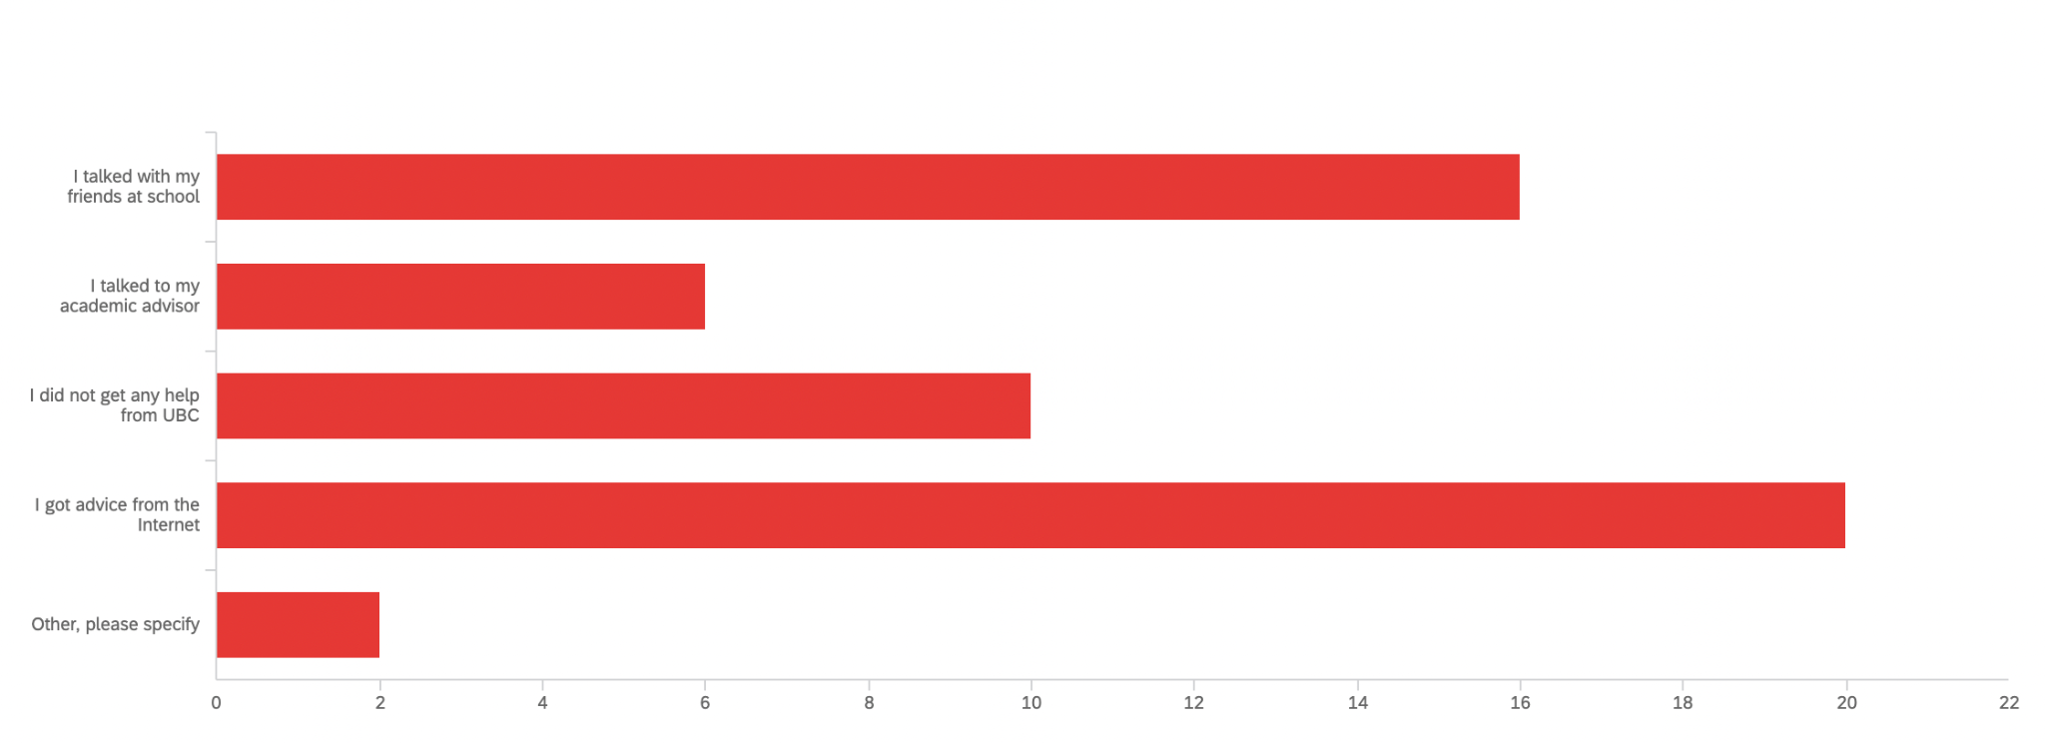

**Figure 1** Survey result forQ6 - What kind of resources did you use in UBC when selecting program?

As the survey result suggests, the reason some students did not go into CS major is that they believe CS course would require too much technical knowledge. This is misinformation that spread among students, while the truth is for basic CS course never requires only technical skills. Without proper introduction and guidance to students, these kinds of misinformation hindered many female students from taking CS courses, as they would think they are not qualified enough for the courses.

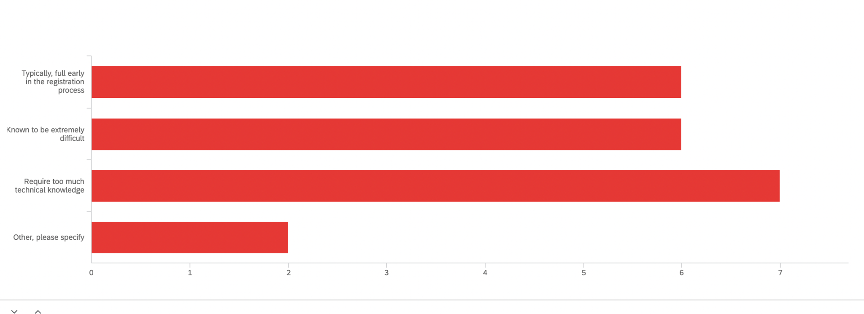

Figure 2 Survey result for Q9 - If you never took a CS course, what are the reasons that hinder you from taking them?

To sum up, there are many contributing factors to this phenomenon. First and foremost, gender division of labor that has rooted in people’s minds has exceptionally affected women’s career choice which results in a low percentage of female student representation in computer science. Also, the lack of resources, for example, studies have shown that women have less access to computers as to their male, which has also deferred women’s success in the tech field. Besides, limited access to program information has also caused students to avoid taking computer science courses. These factors grew and gave born to each other for the past decades which inevitably causes gender disparity in the computer science program.

**B. Study on measurements**

1. **Research on the past measurements taken in other universities**

A research program called REU which identifies and addresses issues of women’s underrepresentation in computer science was conducted and yielded listful promising practices in engaging women in computer science and engineering for long-term impact. The program has many program activities, two of them are receiving good feedback from students and deserve mention here is that REU programs routinely offer professional development workshops about applying to graduate school and career options. Also, nearly half of all REUs in computer science and engineering had 50% or more women participants, and they are provided with hands-on research experience and access to faculty mentors. According to REU research result, it suggests several important findings that help engage women in the tech field, which include having a critical mass of women participants in the program, providing role models and mentors, which supports women’s participation and long-term interest in the field, introducing gender equity topics indirectly, in part by discussing “safe” topics (i.e., work/family balance issues, introducing the topics of “implicit bias” and “stereotype threat”) that relate to both men and women(Kim et al. 2).

Further, according to their follow-up with program participants, many of the participants suggests that having a women role model in leading the support group is most effective in promoting women participants’ self-confidence and long-term commitment to the tech field(Kim et al. 2).

1. **Evaluate the most effective measurement**

According to my survey conducted to UBC students, in terms of recommendations to bridge the gender gap in the computer science field, more than 40 percent of participants maintain that Host more informative workshops on computer science programs to students would be helpful, while also more than 40 percent of surveyee suggests that Improve supporting network, such as running mentorship program and recruiting more female mentors/leaders would be effective too.

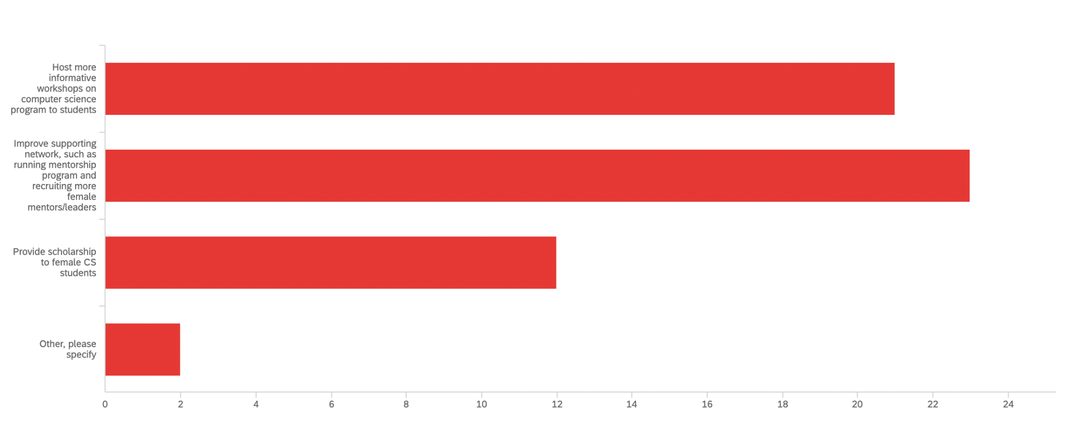

**Figure 3** Survey result for Q8 - Which measurements would be effective to engage more female in Computer Science program at UBC?

**Conclusion**

1. **Summary and overall interpretation of findings**

Overall, most of the surveyees (80%) who have taken computer science courses think the gender ratio is off-balanced, and for those who never took computer science courses over 30% of them think CS courses require too much technical knowledge, and they do not feel confident enough to take it. Over 80% of participants think it is important to engage women in computer science programs. And more than half of the students suggest that running the informative workshop and organizing a support system would be beneficial to include more females in the computer science program.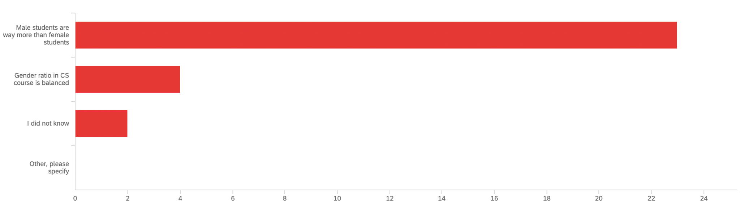

Figure 4 Survey result for Q3 - If you have taken computer science courses in the past? What was your experience in regards to gender ratio in class?

1. **Recommendations**

Combining with all the information gathered from REU and the survey conducted to UBC students, it is suggested that running an informative workshop is helpful in terms of making information about the tech industry accessible to everyone while making sure to include as many female participants as possible will creating a more welcoming space to female students. The workshop content should also be carefully designed, not only including computer science program information but also should include the real world of computer science, letting students have more hands-on experience with computer science instead of sitting and listening to information. More importantly, the workshop should also address gender equity topics in an explicit way, such as introducing how gender stereotypes have been confined to people’s choices to raise students’ awareness toward the fight against gender bias and encourage them to try new areas.

What is more, a stronger supporting system is also crucial to engage women in tech. Women role models exemplify the values, attitudes, and behavior associated with a position, and in so doing make it possible for other women to imagine themselves in a similar role(Kim et al. 2). As the tech industry has been heavily dominated by males, there are still numerous exceptional female leaders in the tech industry who can be role models or mentors for female students. In UBC, there are many great female professors in the Computer science department, they should also be invited to be mentors or guest speakers for prospective students. While organizing mentor to mentee network. Female peer-to-peer support is also important, helping students to get to know each other and creating a space for them to communicate and share information.

**Work Cited:**

Kim, Karen A., et al. “Engaging Women in Computer Science and Engineering.” *ACM Transactions on Computing Education*, vol. 11, no. 2, 2011, pp. 1–19. *Crossref*, <https://doi.org/10.1145/1993069.1993072>.

Willms, J. D., and Bradley A. Corbett. "Tech and Teens: Access and use [2000 Data]." *Canadian Social Trends*, no. 69, Summer, 2003, pp. 15-20*. ProQuest*, <https://www.proquest.com/magazines/tech-teens-access-use-2000-data/docview/224132136/se-2?accountid=14656>.

Statistics Canada. [Table 37-10-0163-02 Proportion of male and female postsecondary enrolments, by International Standard Classification of Education, institution type, Classification of Instructional Programs, STEM and BHASE groupings, status of student in Canada and age group](https://www150.statcan.gc.ca/t1/tbl1/en/tv.action?pid=3710016302)

*Statistics*. (n.d.). Computer Science at UBC. https://www.cs.ubc.ca/our-department/diversity/statistics

Zhang, Shen, et al. “The Effects of Gender Stereotypes on Women’s Career Choice: Opening the Glass Door.” *The Glass Ceiling in the 21st Century: Understanding Barriers to Gender Equality.*, 2009, pp. 125–50. *Crossref*, https://doi.org/10.1037/11863-006.