_____ Name:_____________________
16

Linear Relations Quiz
MFM 2P1

- State the slope and the y-intercept of the following lines.
[ 2 marks each ]

  - $y=\frac{−1}{2}x+\text{10}$ b. $y=3x−2$

slope: slope:

y-intercept: y-intercept:

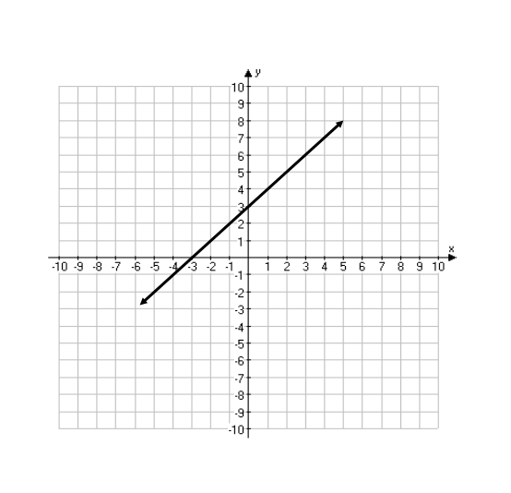
2. Find the slope of the following line. [ 2 marks ]

- Graph the following lines on the grids provided. [ 3 marks each ]
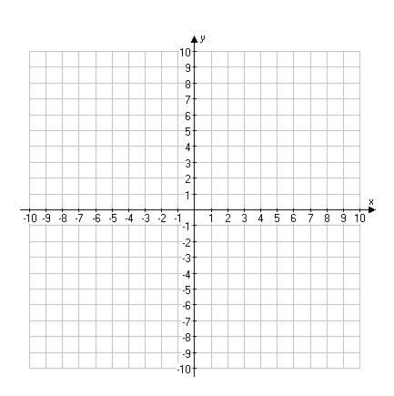
  - $y=\frac{−3}{5}x+6$ b. $y=4x−5$

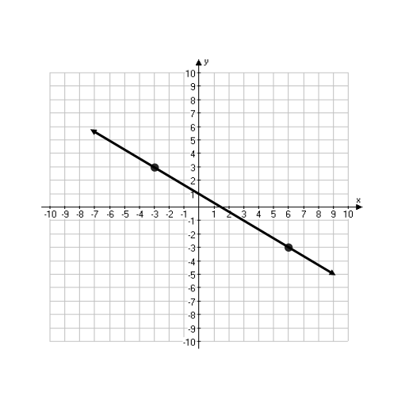
- State the equation of the line in the form y = mx + b. [ 4 marks ]

