Three Definitions
English 301
Aran Chang
May 28, 2020
Assignment 1-3 Definitions
Term: Deixis
Introduction
I am writing this post for the purpose of defining deixis, a relatively complex term used in my area of study to a non-technical audience. The situation is an instructor who is explaining to a student, the presence of deixis in his/her sentence. In order to achieve effective communication in this scenario, it is critical to tailor the message with a specific audience in mind. I will provide three types of definitions: parenthetical, sentence, and expanded. The information will be extracted from my personal knowledge on the topic as well as online resources. This assignment’s overall evaluation will be based on the clarity of my explanations, the suitability of details used in my examples, the suitability of visual and expansion strategies, and quality of references used.
Parenthetical definition:
The deixis (a word or phrase, such as this, that, then, yesterday, or at this point, that refers to a time, place or situation which a speaker is speaking) in this sentence includes the use of yesterday, at this point, and here.
Sentence definition:
A deixis is a word or phrase that refers to the time, place or situation which a speaker is referring to when speaking. These words can include, but are not restricted to: this, that, then, yesterday, at this point, etc. (Stapleton)
Expanded definition:
Etymology: Deixis comes from the Greek word deiknynai which means “to show” (Online Etymology Dictionary). Likewise, the principle of deixis is “to show” a time, place or situation.
Analysis of Parts: There are many forms of deixis which are all referred to as deixis, but can be categorized into place deixis, time deixis, and personal deixis (Josh)
Personal Deixis: Personal deixis refers to the term used to refer to someone. Words such as I, you, he and they are primarily used to describe personal deixis as they refer to the speaker, someone, or a group of people. (Josh)
Place Deixis: Place deixis refers to the term used to refer to a location in space. Words such as there are often used to describe place deixis as they point to a location. (Josh)
Time Deixis: Time deixis refers to the term used to refer to a time in space. Words such as today, yesterday, etc. are used to describe a particular point in time. (Josh)
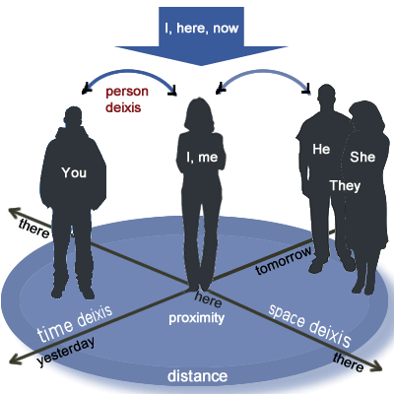
Figure: A physical representation of the different axis in which deixis encompasses.

Negation: Deixis show up throughout a variety of speech that occur throughout everyone’s daily lives. It is not a special term or method of English used by the upper class, or the highly educated. It is a group of words or terms that describes a position (time, place, or situation) which speakers consciously or subconsciously interprets as they listen in a conversation. (Stapleton)
Examples: An example of deixis are them, here, there, in fact, yesterday, etc. In the following sentence, there are three deixis: “I went to the park, over there, yesterday. The first example, “I”, is a personal deixis that point to who is speaker, which is the speaker. The second example, “there”, is a place deixis that refers to a location that the speaker is referring to. Lastly, the last example, “yesterday,” refers to the time that the speaker is referring to when speaking.

Works Cited:
Josh. “What is Deixis? (Definition with examples).” Linguistic Study Guide. Accessed June 2, 2020 https://linguisticsstudyguide.com/what-is deixis/#:~:text=Person%20Deixis&text=For%20example%2C%20if%20I%2C%20Josh,meaning%20will%20remain%20the %20same.
“Deixis (n.).” Online Etymology Dictionary. Accessed June 2, 2020 https://www.etymonline.com/word/deixis
Stapleton, Andreea. Deixis in Modern Linguistics. Vol. 9. Essex Student Research Online. Accessed June 2, 2020 https://www1.essex.ac.uk/journals/estro/documents/issue9/vol-9-no-12.pdf

