**UBC English 301**

**Assignment 1:3 Definitions**

**Due Date:** Wednesday May 30, 2018

**Submitted to:** Professor Erika Paterson

**Submitted by**: Barbara Dobes

**Nocturnal Bruxism**

The English 301 Definitions Assignment is designed to teach the students 3 different methods of writing a definition for a specialized term from our area of study or profession. This document will give an example of a parenthetical definition, a sentence definition and an expanded definition of a dental condition in layman terms for the novice reader. I have chosen “nocturnal bruxism” since this is a common dental condition in my clinical practice.

**Specialized term:** Nocturnal Bruxism

**Parenthetical Definition:**

Nocturnal bruxism (the clenching and grinding or gnashing) of one’s teeth during sleep.

**Sentence Definition:**

Nocturnal bruxism is the involuntary clenching and grinding of one’s teeth during sleep. This oral habit is characterized by the squeezing together of the upper and lower jaws, along with the side to side and/or the backward and forward movements.

**Expanded Definition**

The dental term “nocturnal bruxism’ is made up of 2 words. The first word, nocturnal is an adjective that describes when this condition takes place. Nocturnal comes from the Late Latin *nocturnalis,* and from the Latin *nocturnus* meaning belonging to the night or during sleep. (Definition of nocturnal, 2018) The second word, Bruxism, comes from the Greek *brukhein*  meaning the gnashing of teeth. (Definition of bruxism, 2018).

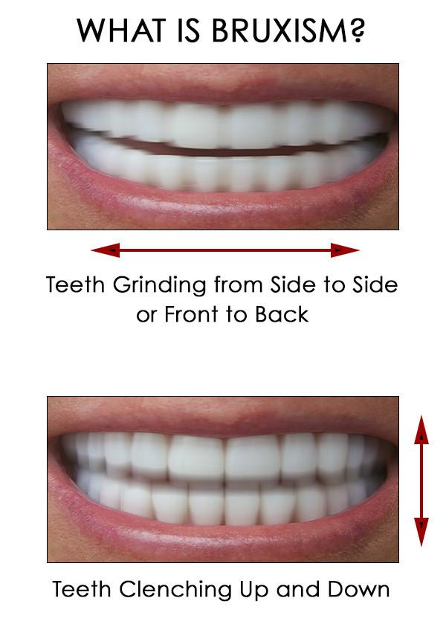

Figure 1: Clenching and grinding

*Source:* Adapted from Brux Night Guard 2016

www.bruxnightguard.com/blogs/bruxism/what-is-bruxism

**Causes**

Some of the reasons for teeth grinding and clenching include stress, anxiety, missing or crowded teeth and sleep disorders.

Clenching and grinding during sleep can cause the following:

* Teeth that are chipped and/or worn down
* Teeth that appear short and flattened
* Teeth hurt and seem loose
* Others tell you they hear the grinding sounds at night
* Frequent headaches or pain near the ear
* Sore achy jaw and face muscles
* Grinding, popping and clicking sounds in the jaw joint

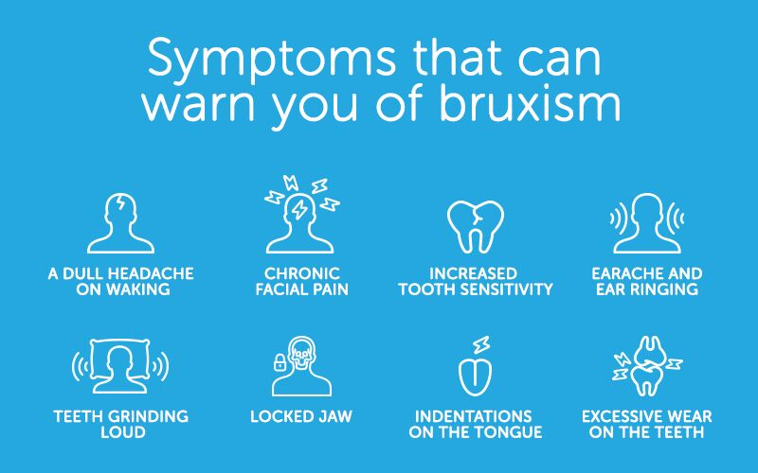

Figure 2: Symptoms of bruxism

*Source:* Adapted from The Cerezen Team

<https://www.cerezen.eu/blog/tell-tale-signs-that-you-grind-your-teeth-while-sleeping>.

**What can be done?**

The goal of treatment for nighttime clenching and grinding is to protect the teeth and the gums from damage and wear. Learning ways to reduce or limit stress and anxiety, learning methods of changing behavior and wearing a mouth guard when sleeping. (Darby & Walsh, 2010).

References

Bruxism*.* (2018). *Online Etymology Dictionary.* Retrieved from <https://www.etymonline.com/word/bruxism>

Darby, M., & Walsh, M. (2010) *Dental Hygiene Theory & Practice.* (4th ed.). St. Louis, Mo: Saunders/Elsevier.

Image of clenching and grinding. Retrieved 28 May 2018, from <https://www.bruxnightguard.com/blogs/bruxism/what-is-bruxism>

Image of symptoms of bruxism. Retrieved 30 May 2018, from <https://www.cerezen.eu/blog/tell-tale-signs-that-you-grind-your-teeth-while-sleeping>.

James, L. The Grind of the Matter. Retrieved from <https://www.dentalcare.com/en-us/professional-education/ce-courses/ce485/history-of-bruxism>

Nocturnal*.* (2018). *Online Etymology Dictionary*. Retrieved from <https://www.etymonline.com/word/nocturnal>

Singh, K.P., Alvi, H.A., Singh, B.P., Singh, R.D., Kant, S., & Jurel, S. (2015).Evaluation of various treatment modalities in sleep bruxism*.* *Journal of Prosthetic Dentistry*. *114,* 426-431.

What is Nocturnal Bruxism. Retrieved from

<https://www.colgate.com/en-us/oral-health/conditions/bruxism/what-is-nocturnal-bruxism-0715>