**UBC English 301**

**Revised Definitions**

**Due Date:**Wednesday June 6, 2018

**Submitted to:**Professor Erika Paterson English 301 Blog

**Submitted by**: Barbara Dobes

**Nocturnal Bruxism**

The English 301 Definitions Assignment is designed to teach the students 3 different methods of writing a definition for a specialized term from our area of study or profession.  This document will give an example of a parenthetical definition, a sentence definition and an expanded definition of a dental condition in layman terms for the novice reader.  I have chosen “nocturnal bruxism” since this is a common dental condition observed in my clinical practice.

**Specialized term:**  Nocturnal Bruxism

**Parenthetical Definition:**

Nocturnal bruxism (the clenching and grinding or gnashing) of one’s teeth during sleep.

**Sentence Definition:**

Nocturnal bruxism is the involuntary clenching and grinding of one’s teeth during sleep.  This oral habit is characterized by the squeezing together of the upper and lower jaws, along with the side to side and/or the  backward and forward movements.

**Expanded  Definition**

The dental term “nocturnal bruxism’ is made up of 2 words.  The first word, nocturnal is an adjective that describes when this condition takes place. Nocturnal comes from the Late Latin *nocturnalis,* and from the Latin *nocturnus*meaning belonging to the night or during sleep. (Definition of nocturnal, 2018) The second word, Bruxism,  comes from the Greek *brukhein* meaning the gnashing of teeth.  (Definition of bruxism, 2018). The chewing surfaces on the teeth grind against each other as the jaw moves from side to side and backwards and forwards. The teeth can start to look flattened, shortened, chipped and cracked. These are some of the signs of more than normal tooth wear. This night time mouth habit also involves the squeezing of the lower jaw into the upper jaw. clenching action. (Colgate, nd)

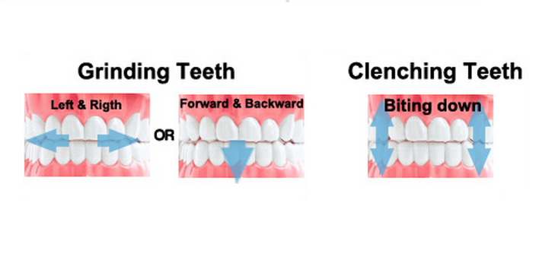

Figure 1: Clenching and Grinding

*Source:* http://www.dentagama.com

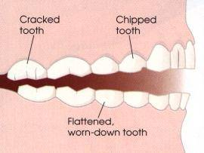

Figure 2: Flattened, chipped and cracked teeth.

*Source:* http://www.dentistryfortheentirefamily.com

**What can cause clenching and grinding?**

Some of the causes for teeth grinding and clenching include stress, anxiety, missing teeth, crowded teeth and sleep disorders.

**What can happen from clenching and grinding?**

* Teeth are chipped and/or worn down
* Teeth appear short and flattened
* Teeth hurt and seem loose
* Others telling you they hear the grinding sounds at night
* Frequent headaches or pain near the ear
* Sore achy jaw and face muscles
* Grinding, popping and clicking sounds in the jaw joint (Singh, 2015)

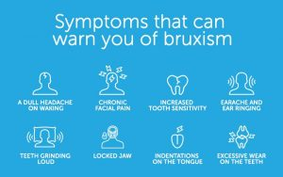

Figure 2: Symptoms of bruxism

*Source:*Adapted from The Cerezen Team

<https://www.cerezen.eu/blog/tell-tale-signs-that-you-grind-your-teeth-while-sleeping>. Last update 25-01-2017. Renew health limited

**What can be done?**

The goal of treatment for nighttime clenching and grinding is to protect the teeth and the gums from damage and wear.  Learning ways to reduce or limit stress and anxiety, learning methods of changing behavior and wearing a mouth guard when sleeping can all help decrease the amount of clenching and grinding someone does during their sleep (Darby & Walsh, 2010).

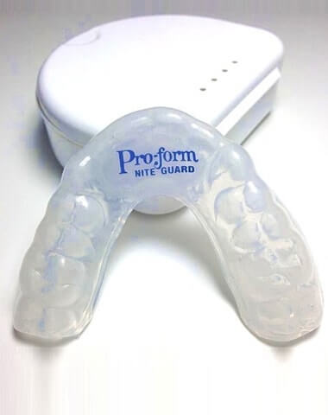

Figure 3: Example of a night guard

*Source:* http:// www.mouthguardsforteethgrinding.com

**References**

Bruxism*.*(2018). *Online Etymology Dictionary.*Retrieved from <https://www.etymonline.com/word/bruxism>

Darby, M., & Walsh, M. (2010) *Dental Hygiene Theory & Practice.*(4th ed.).  St. Louis, Mo: Saunders/Elsevier.

Image of clenching and grinding.  Retrieved 28 May 2018, from  <https://www.bruxnightguard.com/blogs/bruxism/what-is-bruxism>

Image of flattended, chipped and cracked teeth. Retrieved 4 June 2018 from http://www.dentistryfortheentirefamily.com

Image of night guard. Retrieved 4 June 2018 from <http://www.mouthguardsforteethgrinding.com>

Image of symptoms of bruxism. Retrieved 30 May 2018, from <https://www.cerezen.eu/blog/tell-tale-signs-that-you-grind-your-teeth-while-sleeping>.

James, L.  The Grind of the Matter. Retrieved from <https://www.dentalcare.com/en-us/professional-education/ce-courses/ce485/history-of-bruxism>

Nocturnal*.*(2018). *Online Etymology Dictionary*. Retrieved from   <https://www.etymonline.com/word/nocturnal>

Singh, K.P., Alvi, H.A., Singh, B.P., Singh, R.D., Kant, S.,  & Jurel, S. (2015). Evaluation of various treatment modalities in sleep bruxism*. Journal of Prosthetic Dentistry*. *114,*426-431.

What is Nocturnal Bruxism.  Retrieved from

<https://www.colgate.com/en-us/oral-health/conditions/bruxism/what-is-nocturnal-bruxism-0715>

Hi Barbra,  
I reviewed your assignment of definition. Good job on the definition. Your definitions are clear and neat. However, I think the causes of nocturnal bruxism is a little bit lacking. With a more detailed causes would give the readers a clearer idea on the term.

Name of the Reviewer: Steven Lui

Author’s Name: Barbra Dobes

Title of the Expanded Definition: Nocturnal Bruxism

**Initial Impressions:**  After my first time reading the article, I understand most of the material. The only thing I do not understand is in the picture of bruxism, the way of the teeth clenching up and down was a little bit confusing.

**Purpose:**The purpose of the definition was clearly and neatly defined. All parts of the documents are closely related to the intended purpose. However, more details for the causes of nocturnal bruxism will provide a greater insight for the readers.

**Audience:** As an audience without any dental knowledge, I found myself very easy to understand what nocturnal bruxism. In the sentence definition, the whole nocturnal bruxism process is clearly explained with simple and non-specific words. Jargon was not used in the article, so It is easier for audience without any dental knowledge to understand the article.

**Organization:**For the structure of the document, the introduction clearly described the reason of writing the definition of the term. The body includes multiple definition for the term. Adding a conclusion for the term might be helpful to explain the term to audience. One of the visual is a little bit confusing as the picture did not clearly illustrate how the clenching of the teeth actually works. Methods of expansion are used in the document, the causation of nocturnal bruxism, the meaning the two words, what can be done afterwards and the results of nocturnal bruxism are used as the expansion of the definition.

Addition comments: I think a little bit more in depth information for the causes of nocturnal bruxism would greatly help improving the documents. The results of nocturnal bruxism is the most effective element of this document, it is because bullet point of the result are clear and easy to understand. The word choice used are simple and the visual helped the audience to understand the whole term.